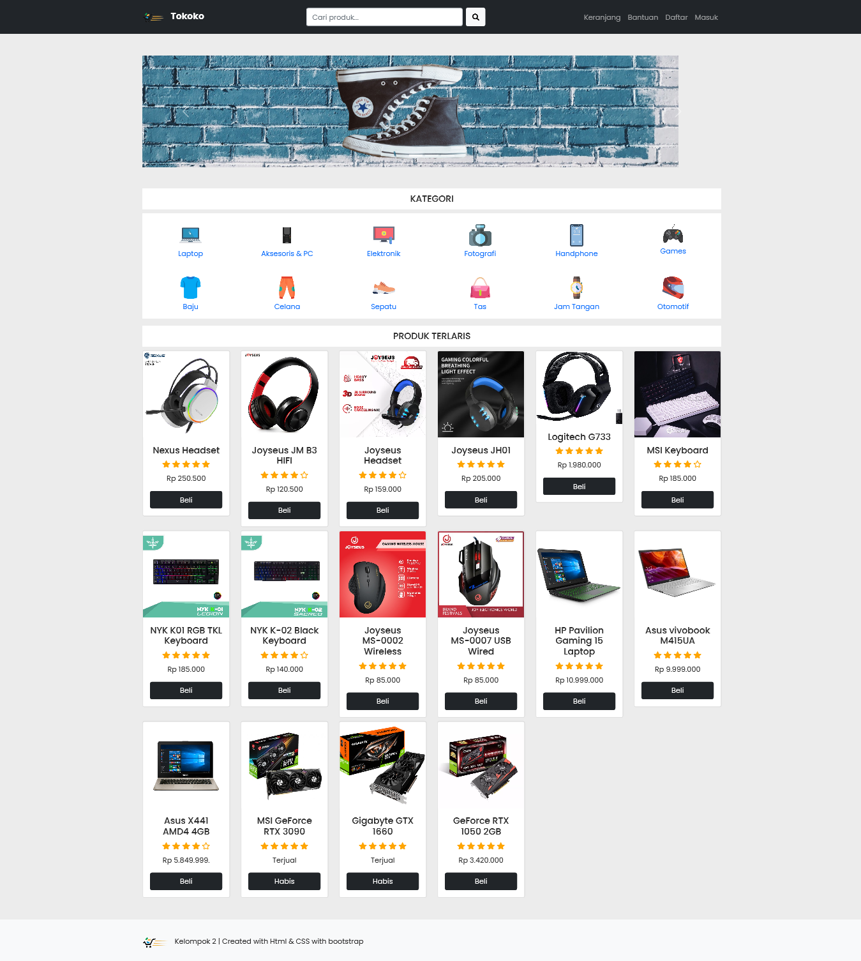

<!doctype html>

<html lang="en">

<head>

<!-- Required meta tags -->

<meta charset="utf-8">

<meta name="viewport" content="width=device-width, initial-scale=1">

<!-- Bootstrap CSS -->

<link href="https://cdn.jsdelivr.net/npm/bootstrap@5.0.2/dist/css/bootstrap.min.css" rel="stylesheet" integrity="sha384-EVSTQN3/azprG1Anm3QDgpJLIm9Nao0Yz1ztcQTwFspd3yD65VohhpuuCOmLASjC" crossorigin="anonymous">

<link rel="stylesheet" type="text/css" href="css/index.css">

<!---->

<link rel="stylesheet" type="text/css" href="https://cdnjs.cloudflare.com/ajax/libs/font-awesome/6.0.0-beta2/css/all.min.css">

<!-- favico -->

<link rel="shortcut icon" href="https://res.cloudinary.com/izuye/image/upload/v1635379458/prakerin.izzdevs.tk/favicon_pc2sgm.png">

<title>Toko</title>

</head>

<body class="body">

<!--Navbar nya-->

<nav class="navbar navbar-expand-lg navbar-dark bg-dark">

<div class="container">

<a class="navbar-brand" href="#">

<!-- Logonya -->

<img src="assets/logo.png" alt="" width="50" height="50" class="me-2">

<strong>Tokoko</strong>

</a>

<!---->

<button class="navbar-toggler" type="button" data-bs-toggle="collapse" data-bs-target="#navbarNav" aria-controls="navbarNav" aria-expanded="false" aria-label="Toggle navigation">

<span class="navbar-toggler-icon"></span>

</button>

<div class="collapse navbar-collapse" id="navbarNav">

<form class="d-flex ms-auto my-4 my-lg-0">

<input class="form-control me-2" type="search" placeholder="Cari produk..." aria-label="Search">

<button class="btn btn-light" type="submit"><i class="fas fa-search"></i></button>

</form>

<ul class="navbar-nav ms-auto">

<!-- class="nav-link active" aria-current="page" -->

<!-- buat page active -->

<li class="nav-item">

<a class="nav-link" href="#">Keranjang</a>

</li>

<li class="nav-item">

<a class="nav-link" href="#">Bantuan</a>

<li class="nav-item">

<a class="nav-link" href="form.html">Daftar</a>

<li class="nav-item">

<a class="nav-link" href="form.html">Masuk</a>

</li>

</ul>

</div>

</div>

</nav>

<!---->

<!-- gambar carousel -->

<div class="container">

<div id="carouselExampleCaptions" class="carousel slide mt-5" data-bs-ride="carousel">

<div class="carousel-indicators">

<button type="bu2tton" data-bs-target="#carouselExampleCaptions" data-bs-slide-to="0" class="active" aria-current="true" aria-label="Slide 1"></button>

<button type="button" data-bs-target="#carouselExampleCaptions" data-bs-slide-to="1" aria-label="Slide 2"></button>

<button type="button" data-bs-target="#carouselExampleCaptions" data-bs-slide-to="2" aria-label="Slide 3"></button>

</div>

<div class="carousel-inner">

<div class="carousel-item active">

<img src="assets/img1.jpg" class="d-block img-fluid">

<div class="carousel-caption d-none img-fluid">

</div>

</div>

<div class="carousel-item">

<img src="assets/img2.jpg" class="d-block img-fluid">

<div class="carousel-caption d-none img-fluid">

</div>

</div>

<div class="carousel-item">

<img src="assets/img3.jpg" class="d-block img-fluid">

<div class="carousel-caption d-none img-fluid">

</div>

</div>

</div>

<button class="carousel-control-prev" type="button" data-bs-target="#carouselExampleCaptions" data-bs-slide="prev">

<span class="carousel-control-prev-icon" aria-hidden="true"></span>

<span class="visually-hidden">Previous</span>

</button>

<button class="carousel-control-next" type="button" data-bs-target="#carouselExampleCaptions" data-bs-slide="next">

<span class="carousel-control-next-icon" aria-hidden="true"></span>

<span class="visually-hidden">Next</span>

</button>

</div>

</div>

<!-- carousel end -->

<!-- Kategori -->

<div class="container mt-5">

<div class="judul-kategori" style="background-color: #fff; padding: 5px 10px">

<h5 class="text-center" style="margin-top: 5px;">KATEGORI</h5>

</div>

<div class="row text-center row-container mt-2">

<div class="col-lg-2 col-md-3 col-sm-4 col-6">

<div class="menu-kategori">

<a href="kategori/laptop.html" class="text-decoration-none"><img src="assets/kategori/laptop.png" class="img-kategori mt-4">

<p class="mt-1">Laptop</p></a>

</div>

</div>

<div class="col-lg-2 col-md-3 col-sm-4 col-6">

<div class="menu-kategori">

<a href="kategori/pc.html" class="text-decoration-none"><img src="assets/kategori/computer.png" class="img-kategori mt-4">

<p class="mt-1">Aksesoris & PC</p></a>

</div>

</div>

<div class="col-lg-2 col-md-3 col-sm-4 col-6">

<div class="menu-kategori">

<a href="kategori/elektronik.html" class="text-decoration-none"><img src="assets/kategori/elektronik.png" class="img-kategori mt-4">

<p class="mt-1">Elektronik</p></a>

</div>

</div>

<div class="col-lg-2 col-md-3 col-sm-4 col-6">

<div class="menu-kategori">

<a href="kategori/fotografi.html" class="text-decoration-none"><img src="assets/kategori/Fotografi.png" class="img-kategori mt-4">

<p class="mt-1">Fotografi</p></a>

</div>

</div>

<div class="col-lg-2 col-md-3 col-sm-4 col-6">

<div class="menu-kategori">

<a href="kategori/hp.html" class="text-decoration-none"><img src="assets/kategori/hp.png" class="img-kategori mt-4">

<p class="mt-1">Handphone</p></a>

</div>

</div>

<div class="col-lg-2 col-md-3 col-sm-4 col-6">

<div class="menu-kategori">

<a href="kategori/games.html" class="text-decoration-none"><img src="assets/kategori/games.png" class="img-kategori mt-4">

<p class="mt-1">Games</p></a>

</div>

</div>

<div class="col-lg-2 col-md-3 col-sm-4 col-6">

<div class="menu-kategori">

<a href="kategori/baju.html" class="text-decoration-none"><img src="assets/kategori/baju.png" class="img-kategori mt-4">

<p class="mt-1">Baju</p></a>

</div>

</div>

<div class="col-lg-2 col-md-3 col-sm-4 col-6">

<div class="menu-kategori">

<a href="kategori/celana.html" class="text-decoration-none"><img src="assets/kategori/celana.png" class="img-kategori mt-4">

<p class="mt-1">Celana</p></a>

</div>

</div>

<div class="col-lg-2 col-md-3 col-sm-4 col-6">

<div class="menu-kategori">

<a href="kategori/sepatu.html" class="text-decoration-none"><img src="assets/kategori/sepatu.png" class="img-kategori mt-4">

<p class="mt-1">Sepatu</p></a>

</div>

</div>

<div class="col-lg-2 col-md-3 col-sm-4 col-6">

<div class="menu-kategori">

<a href="kategori/tas.html" class="text-decoration-none"><img src="assets/kategori/tas.png" class="img-kategori mt-4">

<p class="mt-1">Tas</p></a>

</div>

</div>

<div class="col-lg-2 col-md-3 col-sm-4 col-6">

<div class="menu-kategori">

<a href="kategori/jamtangan.html" class="text-decoration-none"><img src="assets/kategori/jamtangan.png" class="img-kategori mt-4">

<p class="mt-1">Jam Tangan</p></a>

</div>

</div>

<div class="col-lg-2 col-md-3 col-sm-4 col-6">

<div class="menu-kategori">

<a href="kategori/otomotif.html" class="text-decoration-none"><img src="assets/kategori/otomotif.png" class="img-kategori mt-4">

<p class="mt-1">Otomotif</p></a>

</div>

</div>

</div>

</div>

</div>

<!--Kategori End-->

<!-- Tampilan Produkk-->

<div class="container mt-3">

<div class="judul-kategori" style="background-color: #fff; padding: 5px 10px">

<h5 class="text-center" style="margin-top: 5px;">PRODUK TERLARIS</h5>

</div>

<div class="row">

<div class="col-lg-2 col-sm-4 col-6 mt-2">

<div class="card text-center">

<img src="assets/produk/pc/hset-1.jpg" class="card-img-top" alt="...">

<div class="card-body">

<h5 class="card-title">Nexus Headset</h5>

<div class="icon-bintang">

<i class="fas fa-star"></i>

<i class="fas fa-star"></i>

<i class="fas fa-star"></i>

<i class="fas fa-star"></i>

<i class="fas fa-star"></i>

</div>

<p class="card-text mt-2">Rp 250.500</p>

<a href="produk/pc/hset-1.html" class="btn btn-dark d-grid">Beli</a>

</div>

</div>

</div>

<div class="col-lg-2 col-sm-4 col-6 mt-2">

<div class="card text-center">

<img src="assets/produk/pc/hset-2.jpg" class="card-img-top" alt="...">

<div class="card-body">

<h5 class="card-title">Joyseus JM B3 HIFI</h5>

<div class="icon-bintang">

<i class="fas fa-star"></i>

<i class="fas fa-star"></i>

<i class="fas fa-star"></i>

<i class="fas fa-star"></i>

<i class="far fa-star"></i>

</div>

<p class="card-text mt-2">Rp 120.500</p>

<a href="produk/pc/hset-2.html" class="btn btn-dark d-grid">Beli</a>

</div>

</div>

</div>

<div class="col-lg-2 col-sm-4 col-6 mt-2">

<div class="card text-center">

<img src="assets/produk/pc/hset-3.jpg" class="card-img-top" alt="...">

<div class="card-body">

<h5 class="card-title">Joyseus Headset</h5>

<div class="icon-bintang">

<i class="fas fa-star"></i>

<i class="fas fa-star"></i>

<i class="fas fa-star"></i>

<i class="fas fa-star"></i>

<i class="far fa-star"></i>

</div>

<p class="card-text mt-2">Rp 159.000</p>

<a href="produk/pc/hset-3.html" class="btn btn-dark d-grid">Beli</a>

</div>

</div>

</div>

<div class="col-lg-2 col-sm-4 col-6 mt-2">

<div class="card text-center">

<img src="assets/produk/pc/hset-4.jpg" class="card-img-top" alt="...">

<div class="card-body">

<h5 class="card-title">Joyseus JH01</h5>

<div class="icon-bintang">

<i class="fas fa-star"></i>

<i class="fas fa-star"></i>

<i class="fas fa-star"></i>

<i class="fas fa-star"></i>

<i class="fas fa-star"></i>

</div>

<p class="card-text mt-2">Rp 205.000</p>

<a href="produk/pc/hset-4.html" class="btn btn-dark d-grid">Beli</a>

</div>

</div>

</div>

<div class="col-lg-2 col-sm-4 col-6 mt-2">

<div class="card text-center">

<img src="assets/produk/pc/hset-5.jpg" class="card-img-top" style="height: 163px" alt="...">

<div class="card-body">

<h5 class="card-title">Logitech G733</h5>

<div class="icon-bintang">

<i class="fas fa-star"></i>

<i class="fas fa-star"></i>

<i class="fas fa-star"></i>

<i class="fas fa-star"></i>

<i class="fas fa-star"></i>

</div>

<p class="card-text mt-2">Rp 1.980.000</p>

<a href="produk/pc/hset-5.html" class="btn btn-dark d-grid">Beli</a>

</div>

</div>

</div>

<div class="col-lg-2 col-sm-4 col-6 mt-2">

<div class="card text-center">

<img src="assets/produk/pc/keyboard-1.jpg" class="card-img-top" alt="...">

<div class="card-body">

<h5 class="card-title">MSI Keyboard</h5>

<div class="icon-bintang">

<i class="fas fa-star"></i>

<i class="fas fa-star"></i>

<i class="fas fa-star"></i>

<i class="fas fa-star"></i>

<i class="far fa-star"></i>

</div>

<p class="card-text mt-2">Rp 185.000</p>

<a href="produk/pc/keyboard-1.html" class="btn btn-dark d-grid">Beli</a>

</div>

</div>

</div>

<div class="col-lg-2 col-sm-4 col-6 mt-2">

<div class="card text-center">

<img src="assets/produk/pc/keyboard-2.jpg" class="card-img-top" alt="...">

<div class="card-body">

<h5 class="card-title">NYK K01 RGB TKL Keyboard</h5>

<div class="icon-bintang">

<i class="fas fa-star"></i>

<i class="fas fa-star"></i>

<i class="fas fa-star"></i>

<i class="fas fa-star"></i>

<i class="fas fa-star"></i>

</div>

<p class="card-text mt-2">Rp 185.000</p>

<a href="produk/pc/keyboard-2.html" class="btn btn-dark d-grid">Beli</a>

</div>

</div>

</div>

<div class="col-lg-2 col-sm-4 col-6 mt-2">

<div class="card text-center">

<img src="assets/produk/pc/keyboard-3.jpg" class="card-img-top" alt="...">

<div class="card-body">

<h5 class="card-title">NYK K-02 Black Keyboard</h5>

<div class="icon-bintang">

<i class="fas fa-star"></i>

<i class="fas fa-star"></i>

<i class="fas fa-star"></i>

<i class="fas fa-star"></i>

<i class="far fa-star"></i>

</div>

<p class="card-text mt-2">Rp 140.000</p>

<a href="produk/pc/keyboard-3.html" class="btn btn-dark d-grid">Beli</a>

</div>

</div>

</div>

<div class="col-lg-2 col-sm-4 col-6 mt-2">

<div class="card text-center">

<img src="assets/produk/pc/mouse-1.jpg" class="card-img-top" alt="...">

<div class="card-body">

<div>

<h5 class="card-title">Joyseus MS-0002 Wireless</h5></div>

<div class="icon-bintang">

<i class="fas fa-star"></i>

<i class="fas fa-star"></i>

<i class="fas fa-star"></i>

<i class="fas fa-star"></i>

<i class="fas fa-star"></i>

</div>

<p class="card-text mt-2">Rp 85.000</p>

<a href="produk/pc/mouse-1.html" class="btn btn-dark d-grid">Beli</a>

</div>

</div>

</div>

<div class="col-lg-2 col-sm-4 col-6 mt-2">

<div class="card text-center">

<img src="assets/produk/pc/mouse-2.jpg" class="card-img-top" alt="...">

<div class="card-body">

<div>

<h5 class="card-title">Joyseus MS-0007 USB Wired </h5></div>

<div class="icon-bintang">

<i class="fas fa-star"></i>

<i class="fas fa-star"></i>

<i class="fas fa-star"></i>

<i class="fas fa-star"></i>

<i class="fas fa-star"></i>

</div>

<p class="card-text mt-2">Rp 85.000</p>

<a href="produk/pc/mouse-2.html" class="btn btn-dark d-grid">Beli</a>

</div>

</div>

</div>

<div class="col-lg-2 col-sm-4 col-6 mt-2">

<div class="card text-center">

<img src="assets/produk/laptop/laptop-3.jpg" class="card-img-top" alt="...">

<div class="card-body">

<h5 class="card-title">HP Pavilion Gaming 15 Laptop</h5>

<div class="icon-bintang">

<i class="fas fa-star"></i>

<i class="fas fa-star"></i>

<i class="fas fa-star"></i>

<i class="fas fa-star"></i>

<i class="fas fa-star"></i>

</div>

<p class="card-text mt-2">Rp 10.999.000</p>

<a href="produk/laptop/laptop-3.html" class="btn btn-dark d-grid">Beli</a>

</div>

</div>

</div>

<div class="col-lg-2 col-sm-4 col-6 mt-2">

<div class="card text-center">

<img src="assets/produk/laptop/laptop-1.jpg" class="card-img-top" alt="...">

<div class="card-body">

<h5 class="card-title">Asus vivobook M415UA</h5>

<div class="icon-bintang">

<i class="fas fa-star"></i>

<i class="fas fa-star"></i>

<i class="fas fa-star"></i>

<i class="fas fa-star"></i>

<i class="fas fa-star"></i>

</div>

<p class="card-text mt-2">Rp 9.999.000</p>

<a href="produk/laptop/laptop-1.html" class="btn btn-dark d-grid">Beli</a>

</div>

</div>

</div>

<div class="col-lg-2 col-sm-4 col-6 mt-2">

<div class="card text-center">

<img src="assets/produk/laptop/laptop-2.png" class="card-img-top" alt="...">

<div class="card-body">

<h5 class="card-title">Asus X441 AMD4 4GB </h5>

<div class="icon-bintang">

<i class="fas fa-star"></i>

<i class="fas fa-star"></i>

<i class="fas fa-star"></i>

<i class="fas fa-star"></i>

<i class="far fa-star"></i>

</div>

<p class="card-text mt-2">Rp 5.849.999.</p>

<a href="produk/laptop/laptop-2.html" class="btn btn-dark d-grid">Beli</a>

</div>

</div>

</div>

<div class="col-lg-2 col-sm-4 col-6 mt-2">

<div class="card text-center">

<img src="assets/produk/pc/vga-1.jpg" class="card-img-top" alt="...">

<div class="card-body">

<h5 class="card-title">MSI GeForce RTX 3090</h5>

<div class="icon-bintang">

<i class="fas fa-star"></i>

<i class="fas fa-star"></i>

<i class="fas fa-star"></i>

<i class="fas fa-star"></i>

<i class="fas fa-star"></i>

</div>

<p class="card-text mt-2">Terjual</p>

<a href="produk/pc/vga-1.html" class="btn btn-dark d-grid">Habis</a>

</div>

</div>

</div>

<div class="col-lg-2 col-sm-4 col-6 mt-2">

<div class="card text-center">

<img src="assets/produk/pc/vga-3.jpg" class="card-img-top" alt="...">

<div class="card-body">

<h5 class="card-title">Gigabyte GTX 1660 </h5>

<div class="icon-bintang">

<i class="fas fa-star"></i>

<i class="fas fa-star"></i>

<i class="fas fa-star"></i>

<i class="fas fa-star"></i>

<i class="fas fa-star"></i>

</div>

<p class="card-text mt-2">Terjual</p>

<a href="produk/pc/vga-3.html" class="btn btn-dark d-grid">Habis</a>

</div>

</div>

</div>

<div class="col-lg-2 col-sm-4 col-6 mt-2">

<div class="card text-center">

<img src="assets/produk/pc/vga-2.jpg" class="card-img-top" alt="...">

<div class="card-body">

<h5 class="card-title">GeForce RTX 1050 2GB</h5>

<div class="icon-bintang">

<i class="fas fa-star"></i>

<i class="fas fa-star"></i>

<i class="fas fa-star"></i>

<i class="fas fa-star"></i>

<i class="fas fa-star"></i>

</div>

<p class="card-text mt-2">Rp 3.420.000</p>

<a href="produk/pc/vga-2.html" class="btn btn-dark d-grid">Beli</a>

</div>

</div>

</div>

</div>

</div>

<!--Produk end-->

<!--footer-->

<footer class="bg-light p-3 mt-5">

<div class="container">

<div class="row">

<div class="col-md-6 text-md-start text-center pt-2 pb-2">

<a href="" class="text-decoration-none"></a>

<img src="assets/logo.png" class="anim-icon" style="width: 60px;">

</a>

<span class="ps-2">Kelompok 2 | Created with Html & CSS with bootstrap</span>

</div>

</div>

</div>

</footer>

<!-- footer end-->

<script src="https://cdn.jsdelivr.net/npm/bootstrap@5.0.2/dist/js/bootstrap.bundle.min.js" integrity="sha384-MrcW6ZMFYlzcLA8Nl+NtUVF0sA7MsXsP1UyJoMp4YLEuNSfAP+JcXn/tWtIaxVXM" crossorigin="anonymous"></script>

</body>

</html>