Designs
Izabelle Baldwin

Table of Contents
Visual Designs 2
Sitemap 2
Database Design 3
Data Dictionary 3
Flowcharts 3
Login 3
Register 4
Place Order 5
Manage Account 7
View Orders 8

Visual Designs

Sitemap
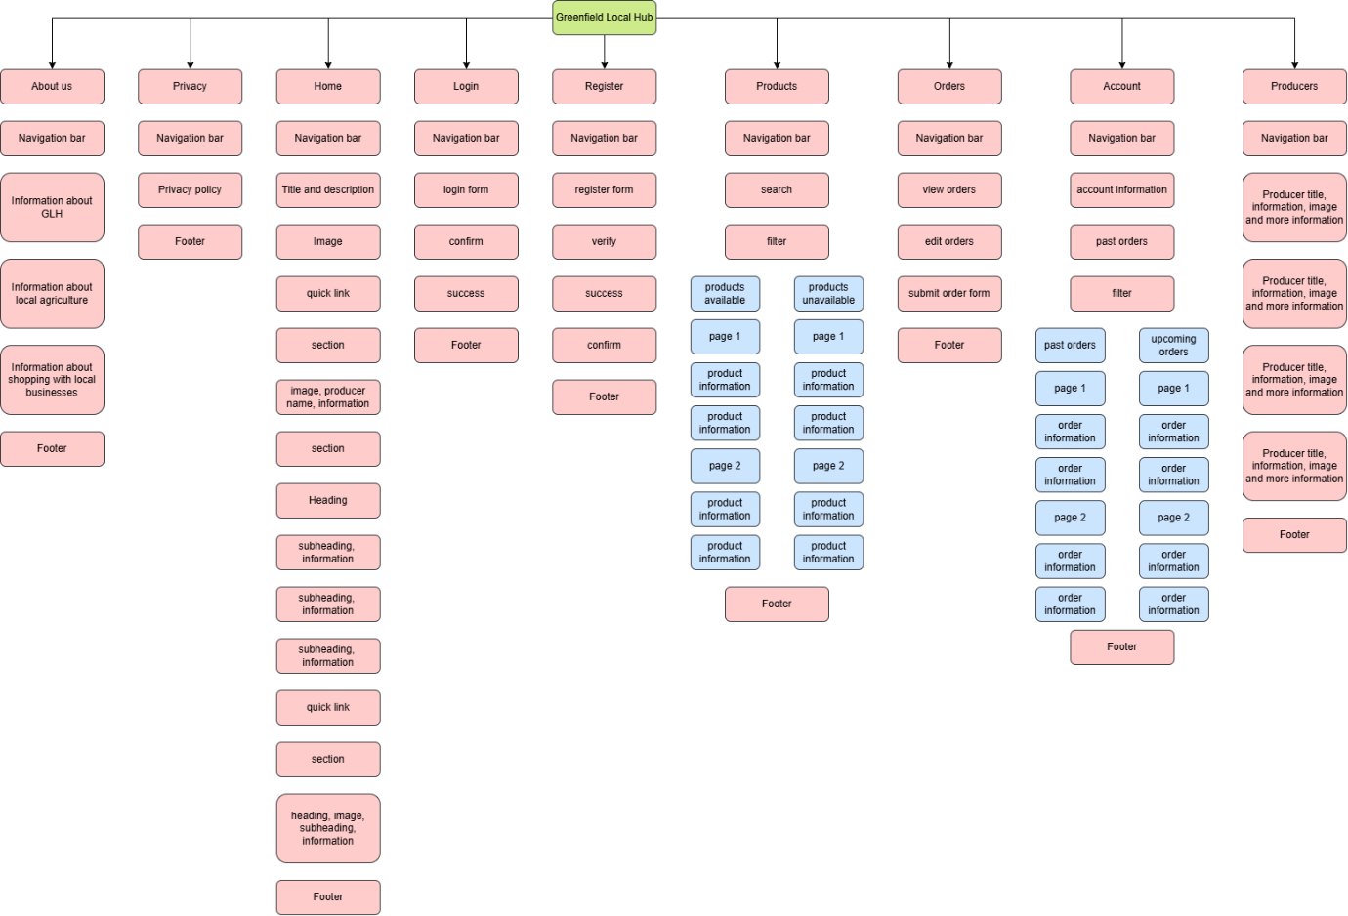

Database Design

Data Dictionary
Asp.NetUsers
Column | Data Type | Required | Default | Validation | Primary/Foregin
Id | String | Yes
UserName | String | Yes
NormalisedUserName | String | Yes
Email | String | Yes |  | Email must have a valid structure, must include “@” symbol, must have a valid domain name, must be in the correct format.
NormalisedEmail | String | yes
EmailConfirmed | Bool | Yes |  | Email must be confirmed by users.
PasswordHash | String | Yes
SecurityStamp | String
ConcurrencyStamp | String
PhoneNumber | String
PhoneNumberConfirmed  TwoFactorEnabled | Bool
LockoutEnd | Bool
LockoutEnabled | Datetime
AccessFailedCount | int

Asp.NetUserRoles
Column | Data Type | Required | Default | Validation | Primary/Foregin
Id | Int | Yes |  |  | Primary
UserId | string | Yes | Users Id |  | Foreign
RoleId | string | Yes

Asp.NetRoles
Column | Data Type | Required | Default | Validation | Primary/Foregin
Id | string | Yes
Name | string | Yes
NormaliseName | string | Yes
ConcurrencyStamp | string | Yes

Flowcharts

Login
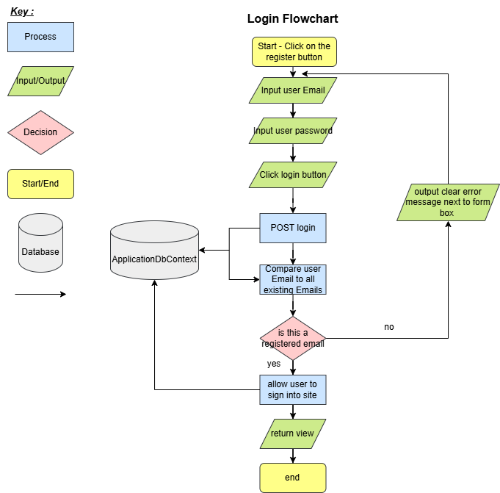
After landing on the Login page, the user will be prompted to input their username and password. Once the user clicks the login button after entering their credentials, the system will then check if the user information matches any data stored onto the database. If their information does not match pre-existing data, they will be prompted to try again or register an account, via a clear error message output next to the required data fields.

Register
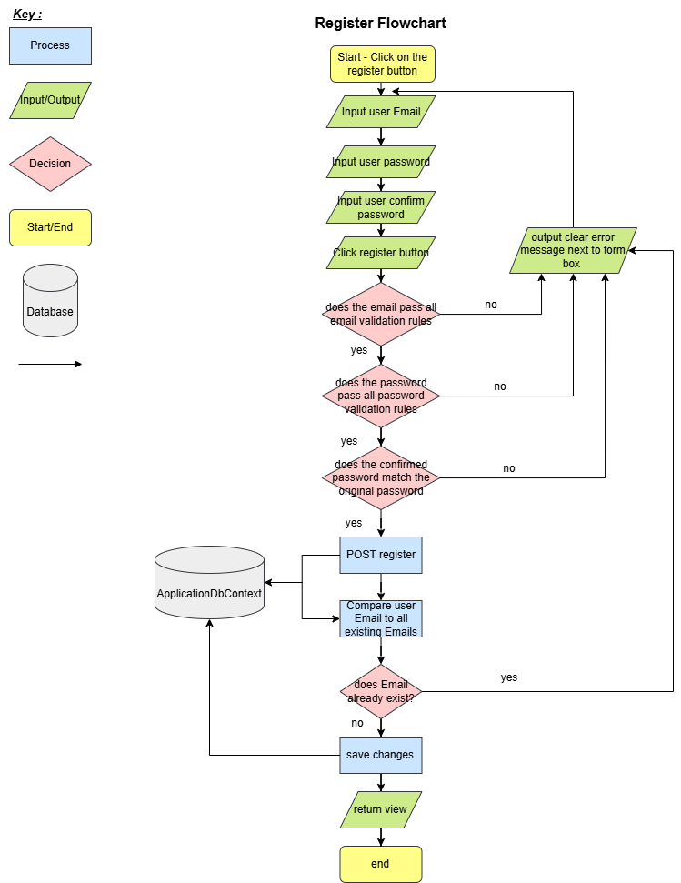
After landing on the register page, the user will be prompted to input their username and password, and will be asked to confirm their password. Once the user clicks the register button after entering their credentials, the system will then check if the user information passes all validation checks, that the passwords match, and that the email is not linked to a pre-existing account. If any of these checks fail, the user will then be prompted to try again or login to an account, if the email is already taken, via a clear error message output next to the required data fields.

Place Order
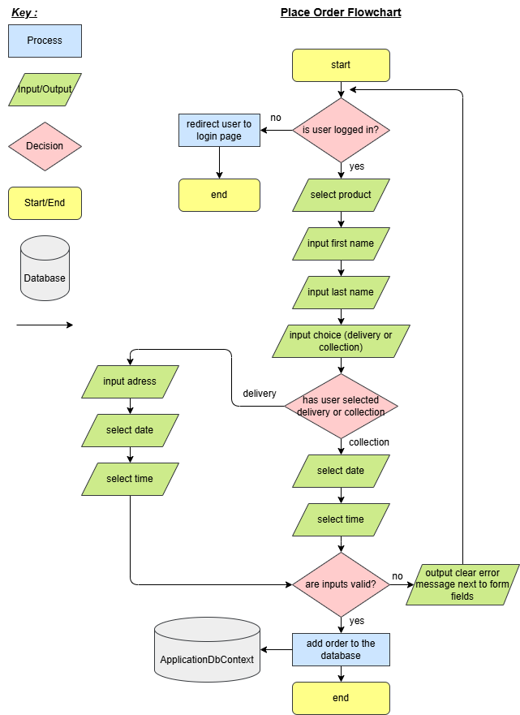
When attempting to place an order, the system will first check if the user is signed into a verified account, if the user is not, they will be redirected to the log-in page. If the user is already signed in, they will proceed with the order process, the user will first be prompted to select products for their order. They will then be asked to input their first and last name as well as a choice of delivery or collection. The system then checks which option the user has selected before proceeding to finalise the order. If the user has chosen delivery, the system will ask the user to input their delivery address, preferred delivery date, and delivery time slot. However, if the user selected collection the system will only ask for preferred collection date, and collection time slot. After this process the system will check that all inputs are valid before proceeding to add the order onto the database.

Manage Account
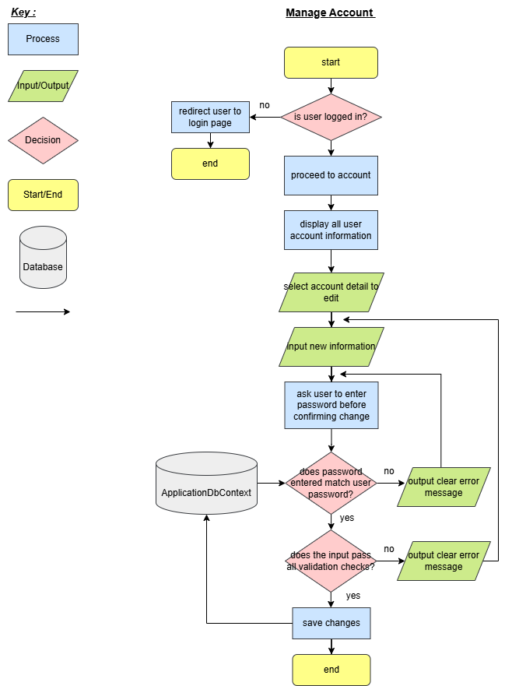
When attempting to access the accounts page, the system will first check if the user is signed into a verified account, if the user is not, they will be redirected to the log-in page. If the user is already signed in, they will proceed to the accounts page. After being directed to the accounts page, the system will display all of the user’s information, giving them the option to edit their account information. When the user selects a data field, they will be able to enter new data, once they have entered new information into the field, they are given the option to confirm their choices. After confirming the newly entered data, the system will ask the user to re-enter their current account password, if the password entered does not match the password linked to the account, the system will deny the change and ask the user to enter their password again. If the password matches the one saved to the user account, the system will verify that the data entered passes all validation checks before saving any valid data onto the database.

View Orders
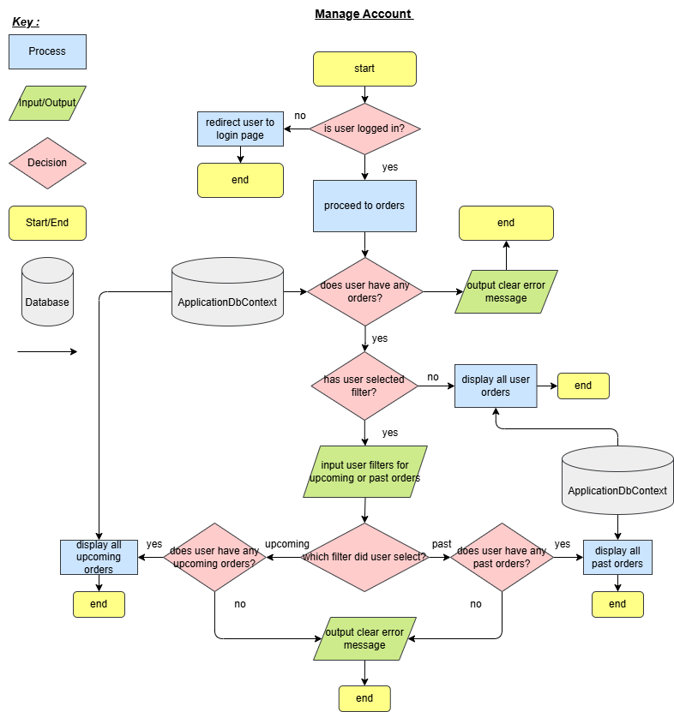

When attempting to access the orders page, the system will first check if the user is signed into a verified account, if the user is not, they will be redirected to the log-in page. If the user is already signed in, they will proceed to the orders page. After being directed to the orders page, the system will check if the user has made any orders on that account, if the user has not, they will be given a clear error message and will be given the option to make an order. If the user has made any orders, the user will be given the option to filter their order history, if the user chooses not to filter their orders, the system will output all order information for that user in order of date. If the user chooses to view past orders but they only have upcoming orders, they will be provided with a clear error message, and vice versa. Once the user has selected a valid filter, the system will output the order data that corresponds with the chosen field.

