Task 1: Activity B – AI Log
AI model used
Problem to be solved | Prompts used | Output generated | Review of generated code
My Accessibility menu was not formatted correctly and was displayed as an arrangement of buttons below the Navbar, I wanted the buttons to be displayed as a sidebar on the right-hand side. | “How can I turn my accessibility menu into a sidebar on the right-side, with images instead of text in the button containers.” | 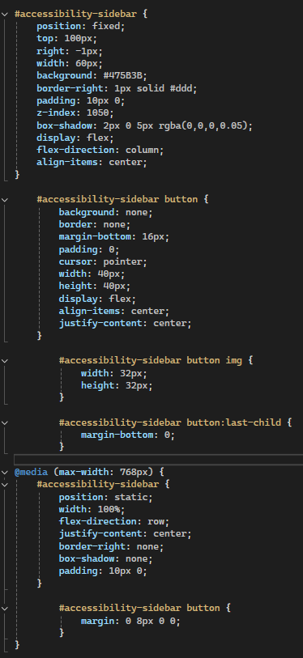  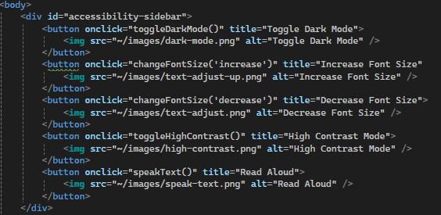 | Moved the button divider to the top of the body section to not disrupt the navigation menu, added images as an alternate for text, while still displaying text when hovering over the buttons.  Displays menu on the right side of the user’s screen and is static on the webpage so the user has constant access to the menu.
[Add additional rows as needed then delete this instruction]

Copyright and Acknowledgements
‘T-LEVELS’ is a registered trademark of the Department for Education.
‘T Level’ is a registered trademark of the Institute for Apprenticeships and Technical Education.
The T Level Technical Qualification is a qualification approved and managed by the Institute for Apprenticeships and Technical Education.
‘Institute for Apprenticeships & Technical Education’ and logo are registered trademarks of the Institute for Apprenticeships and Technical Education.
Pearson Education Limited is authorised by the Institute for Apprenticeships and Technical Education to develop and deliver this Technical Qualification.
Pearson and logo are registered trademarks of Pearson.
Copyright in this document belongs to, and is used under licence from, the Institute for Apprenticeships and Technical Education, © 2025

