Task 1: Activity B – AI Log
AI model used
Problem to be solved | Prompts used | Output generated | Review of generated code
My Accessibility menu was not formatted correctly and was displayed as an arrangement of buttons below the Navbar, I wanted the buttons to be displayed as a sidebar on the right-hand side. | “How can I turn my accessibility menu into a sidebar on the right-side, with images instead of text in the button containers.” | 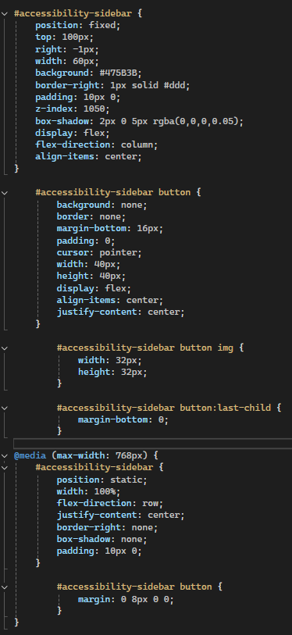  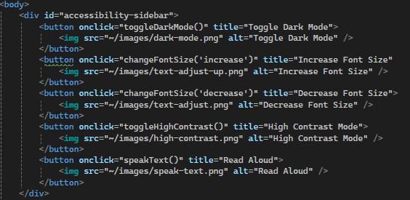 | Moved the button divider to the top of the body section to not disrupt the navigation menu, added images as an alternate for text, while still displaying text when hovering over the buttons.  Displays menu on the right side of the user’s screen and is static on the webpage so the user has constant access to the menu.
I wanted to change the accessibility sidebar to be a pop-out when clicking an accessibility button on the side of the users’ screen, to make the bar take up less space for user’s who may not be using the functions, while still being able to include them. | “How can I convert my accessibility sidebar into a pullout option from the side of the screen, that closes once the button is clicked again?” | 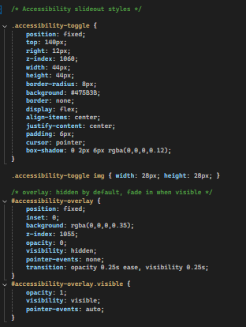  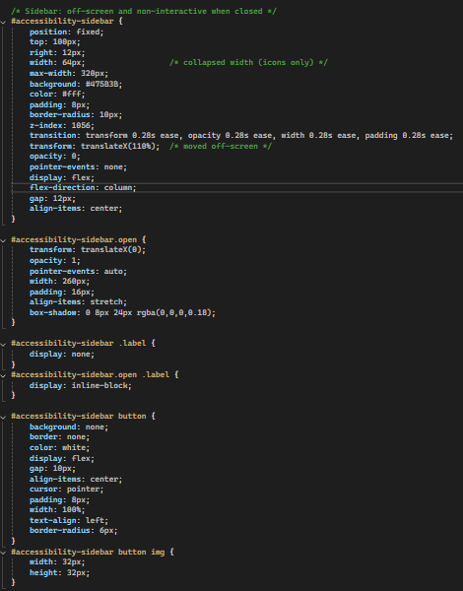  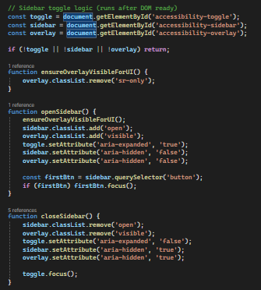 | The code presented gives the accessibility sidebar the functionality of being open and closed whenever the accessibility icon is pressed    Once this is clicked on by a user, the menu will fold out allowing them to view the accessibility options and select whatever needed, then closing the menu by pressing the button once more.  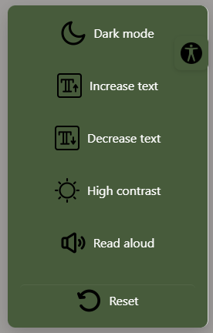
I needed a button on the basket to allow users to update the quantity of items already in their basket. | “How would I implement a functional button to update the quantity of an item within the user’s basket?” | 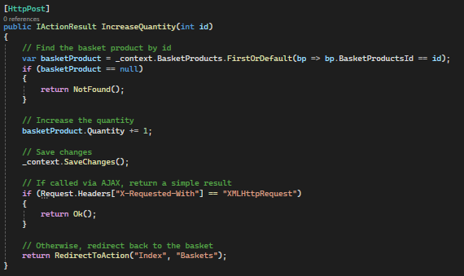 | I was able to create the button myself and link it to the HTTPPOST method created by copilot, the POST method allowed the button to actually function by updating the number of items within the basket when the button is clicked.  If there are a large enough quantity of the item remaining, it will allow the user to add another to the basket.
I was struggling to add styling to the checkout page without getting errors, or the styles not applying so I asked AI for assistance with that. | “Could you help me to add styling to my checkout process?” | 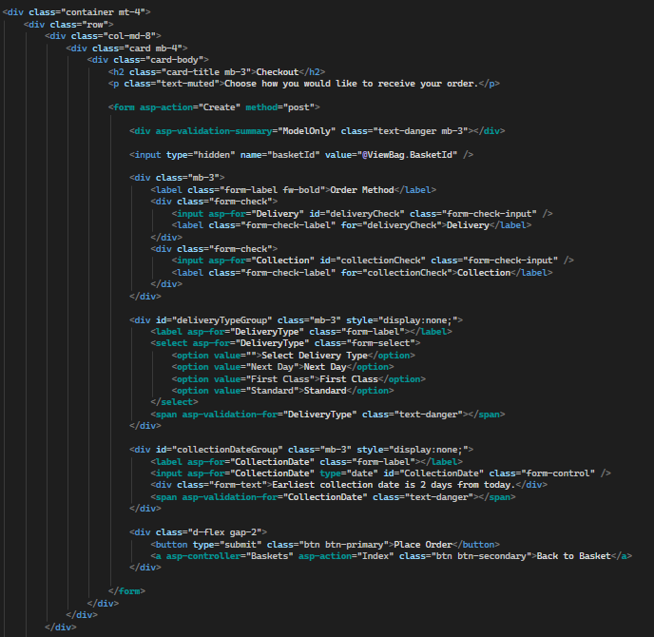  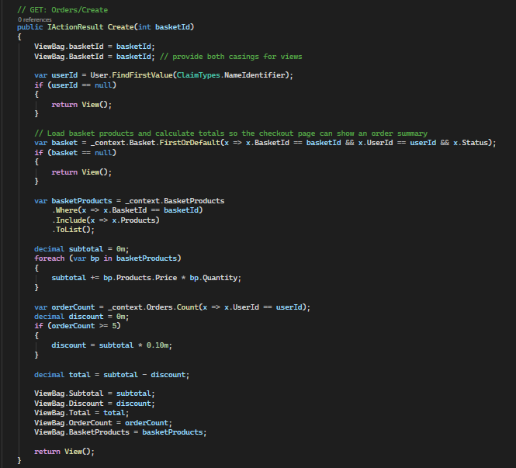 | The Orders/Create view has been converted into a bootstrap two-column layout.  On the left there is a form card with the order method, delivery type or collection date, validations, and Place Order button.  On the right there is an order summary card that lists basket items (name, quantity, line total) and shows Subtotal, Loyalty Discount, and Total.  Code was added into the Orders/Create GET to provide basket products and totals.
I used copilot to aid me in formatting my homepage to give a more modern eco look. I was struggling with adding an image into the background as my code was not working correctly. | “Can you help me with formatting my homepage?” | 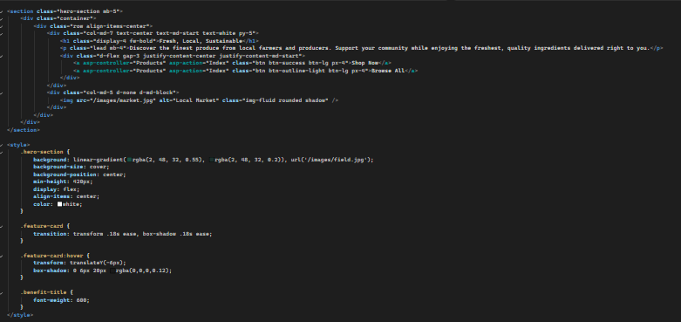  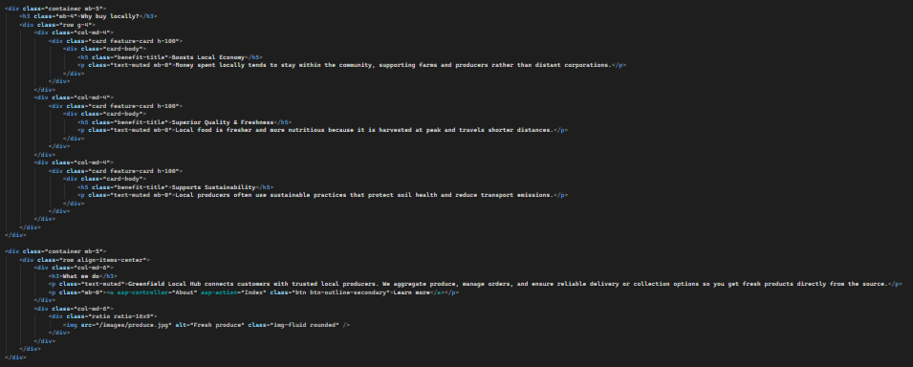 | Replaced the old content with a responsive Bootstrap layout -  Hero section with gradient over image, headline, subtext, CTA buttons and a hero image.  Three feature cards ("Boosts Local Economy", "Superior Quality & Freshness", "Supports Sustainability") with hover lift.  Improved the "What we do" section with text and an image.  Fixed the broken background CSS and improved accessibility and spacing.
[Add additional rows as needed then delete this instruction]

Copyright and Acknowledgements
‘T-LEVELS’ is a registered trademark of the Department for Education.
‘T Level’ is a registered trademark of the Institute for Apprenticeships and Technical Education.
The T Level Technical Qualification is a qualification approved and managed by the Institute for Apprenticeships and Technical Education.
‘Institute for Apprenticeships & Technical Education’ and logo are registered trademarks of the Institute for Apprenticeships and Technical Education.
Pearson Education Limited is authorised by the Institute for Apprenticeships and Technical Education to develop and deliver this Technical Qualification.
Pearson and logo are registered trademarks of Pearson.
Copyright in this document belongs to, and is used under licence from, the Institute for Apprenticeships and Technical Education, © 2025

