Task 2: Test log
Description of test | Test data to be used (if required) | Expected outcome | Actual outcome | Comments and intended actions
Testing functionality of the Register button. | No test data. | The Register button should redirect the user to the account registry page as soon as it is clicked, there should be minimal delay. | The button functions as expected. | No comments.
Testing functionality of the Login button. | No test data. | The Login button should redirect the user to the login page as soon as it is clicked, there should be minimal delay. | The button functions as expected. | No comments.
Test to see if the user can successfully register a new account (regular). | Normal:  Email - “John@example.com”  Password – Password123!  Confirm Password – Password123!  Erroneous:  Email – example@example.com (valid email)  Password – Password123!  (valid password)  Confirm Password – Password1 (passwords do not match) | Normal: Should allow the user to successfully register the account as the credentials are not already in use.  Erroneous: The user should get an error telling them that the confirm password does not match the password entered prior. | Normal: The user is able to successfully register an account using these credentials, they are redirected to the register confirmation page.  Erroneous: As expected, the user is greeted with an error message, notifying them that the Password and Confirmation Password do not match.  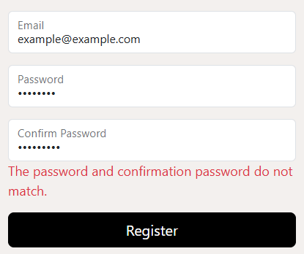 | I should implement a proper email confirmation system, as well as a button or function to redirect the user to the login page after the registration process is complete.
Test to see if the user can successfully register a new account (google). | I used my Gmail login credentials to test this function. | The user should be able to create an account using their Gmail login. | The login process with a Google account is successful. | I should implement a proper email confirmation system, as well as a button or function to redirect the user to the login page after the registration process is complete.
Test to see if the user is able to login after registering an account. (regular) | Normal:  Email - “John@example.com”  Password – Password123!  Confirm Password – Password123!  Erroneous:  Email -  John@example.com  Password –  Paasword123!  (password does not match the saved credentials) | Normal: The user should be able to sign into their account using the correct credentials.  Erroneous: The user should be greeted with an error message letting them know that their credentials are incorrect and they should not be able to login. | Normal: The user is able to login successfully and is redirected to the homepage.  Erroneous: The user is given an “invalid login attempt” error and the form box is cleared for the user to try again.  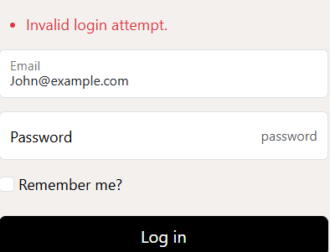 | No comments.
Test to see if the user is able to login after registering an account. (google) | Normal: I used my Gmail login credentials that I had previously registered to test this function.  Erroneous: Using a google account that is not currently registered. | Normal: The user should have no issues signing into their account.  Erroneous: The user should be given an error message and be redirected to the register page. | Normal: The user is able to successfully sign into their account.  Erroneous: The user is immediately redirected to the register page as the account does not yet exist, they can then register the account and login. | No comments.
Testing functionality of the Logout button. | No test data. | The logout button should sign the user out of their account as soon as it is clicked, there should be minimal delay. | The button functions as expected. | No comments.
The user should be able to view the products page. | No test data. | The user should be able to view the products tab on the navigation bar at the top of the page, when clicking the button, they should be redirected to the Products page. All existing products should be displayed with images and information. | The products button is displayed on the navigation bar at the top of the user’s screen. The button is responsive and directs the user to the products page. The products are displayed accordingly with prices, images, stock and names. The product cards have the option to view details about the products and to add the product to basket. | No comments.
While logged in, the user should be able to add the product to basket. | No test data.  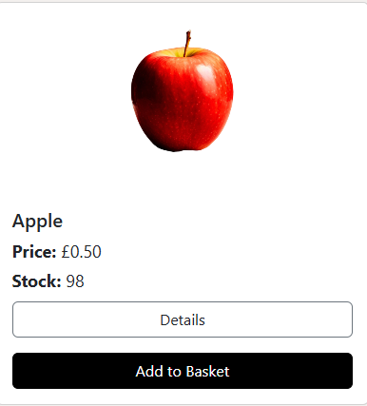 | The add to basket button should be responsive and should update the quantity of an item in the user’s basket. | Works as intended. The user is also automatically redirected to their basket. | No comments.
If the user is not signed into an account, they should not be able to create a basket. | No test data. | The user should be given an error when attempting to add a product to their basket if they are not signed into an account. | They are not provided with an error message from the website itself but are not able to create the basket.  They are greeted with a 401 Page not working error. | A built-in error page needs to be implemented, notifying the user that they need to register/login to view the page.
When signed into an account with a pre-existing basket, the “+” and “–“ buttons on the basket screen should be functional. | No test data.  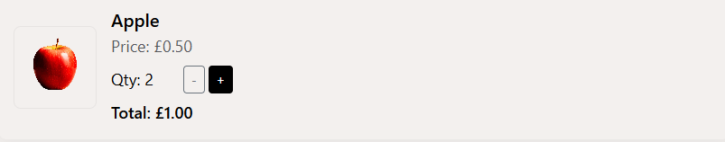 | The user should be able to update the quantity of an item in their basket using the “+” and “–“ buttons on the basket screen. | The update quantity buttons are fully responsive and update the quantity of the item as intended. When clicking the “–“ button while the quantity is at 1, it removes the item from the users basket entirely. | No comments.
Proceed to checkout functionality. | No test data.  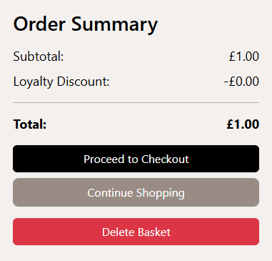 | On the baskets page, the user should be able to click the proceed to checkout button and should be redirected to the checkout page. | Button functions as expected. | No comments.
Continue shopping functionality. | No test data. | The user should be redirected to the products page when the “Continue Shopping” button is pressed. | Button functions as expected.
Delete basket functionality. | No test data. | When the user chooses to delete their basket via the “Delete Basket” button on the Baskets page, the contents of their current basket should be removed. | Button functions as expected. The user is also greeted with an empty basket message and is given the option to continue shopping.  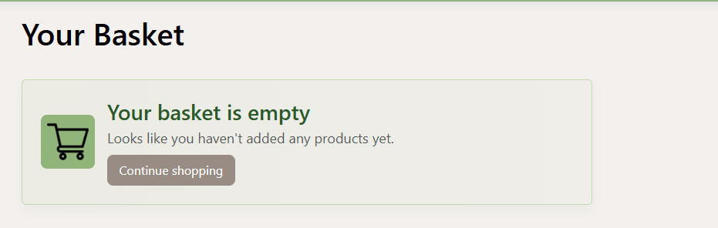 | No comments.
Empty basket message appears. | No test data. | If the user attempts to view their basket when it is empty, they should be greeted with the empty basket message. | The empty basket message appears as intended and the continue shopping button is functional. | No comments.
Delivery selection on the checkout menu should bring up a Delivery Type dropdown menu. | Valid: The delivery option should be selected | The Delivery Type menu should appear and the dropdown menu should display the correct delivery options. The user should be able to successfully select one of these choices. | 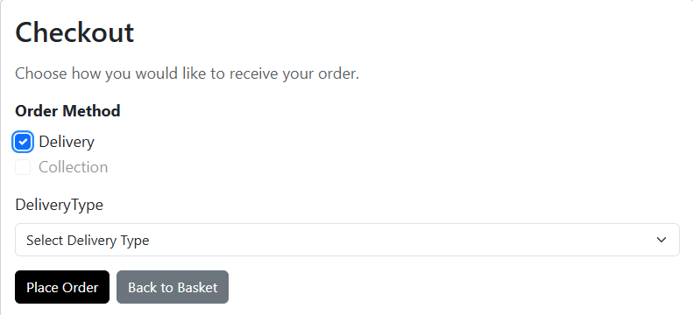  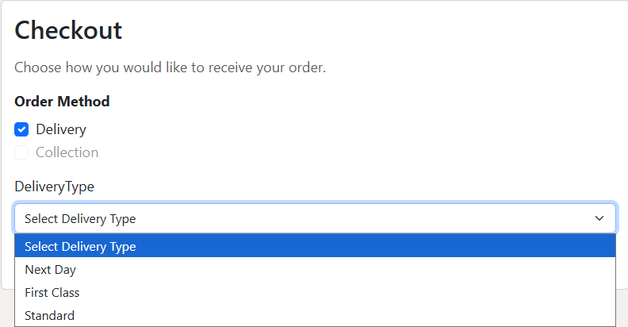  The users choice successfully saves. | No comments.
Collection selection on the checkout menu should bring up a Collection Date menu. | Valid: The collection option should be selected. | The Collection Date menu should appear and the user should only be able to select a Collection data that is a minimum of 2 days from the current date. | 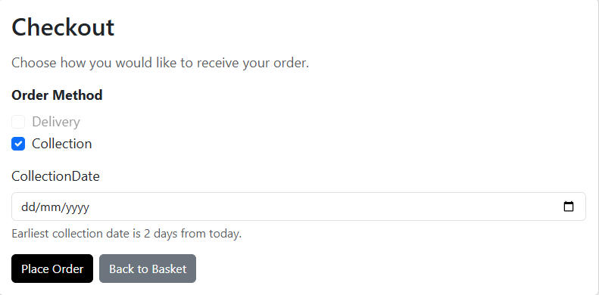 | No comments.
Only select Collection OR Delivery, not both. | Valid: The user should selected either of the options. | A user should not be able to select both delivery and collection. | The user can only select either delivery or collection, the option they do not choose is “removed” (greyed out) meaning it cannot be selcted unless they deselect their other choice. | No comments.
User should be able to successfully place an order, once selecting Delivery or Collection. | No test data.  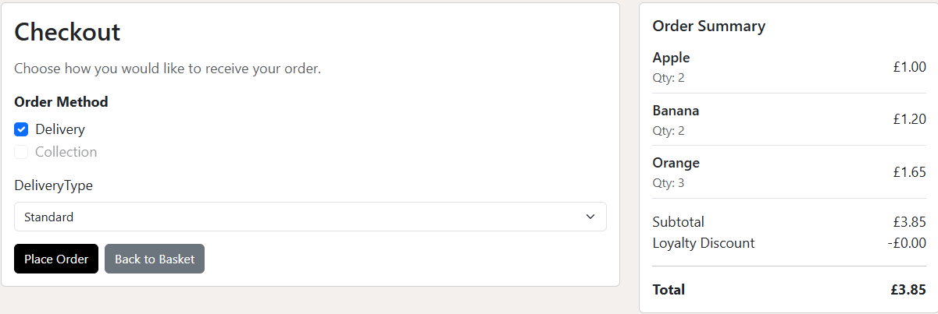 | After choosing either delivery or collection the user should be able to place an order via the Place Order button at the bottom of the checkout form. | Function works as intended. Once the basket has been submitted, the user is redirected to the empty basket page. | Potentially, the user should be redirected to the orders page to ensure the order has been processed.
User should not be able to place an order if they have not selected Delivery or Collection. | No test data.  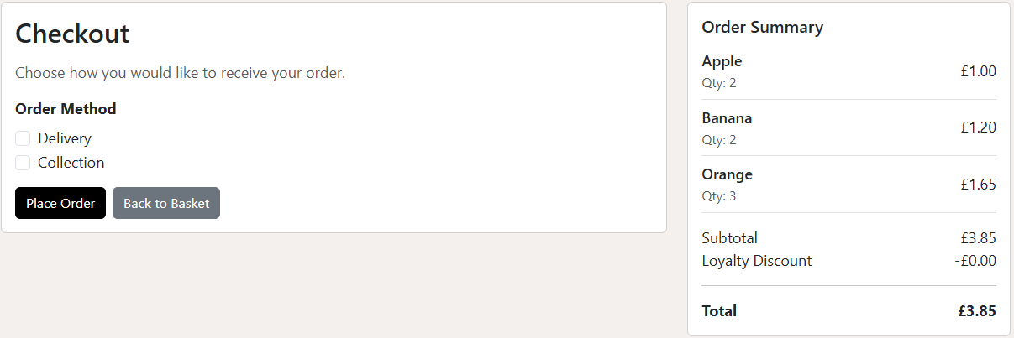 | If the user has not selected either of the options, they should receive an error message prompting them to do so, and they should not be able to go through with the order. | The user is not able to place an order. The page is unresponsive but there is no error message displayed.  The program must be reloaded as the system crashes. | There needs to be an error message rather than the page becoming unresponsive as the system crashes due to an internal error.  The program should not need to be restarted if the user makes an error.
View orders navigation should direct the user to the Orders page. | Normal: A successful order.  Invalid: No orders. | Normal: When visiting the orders page after making an order (via the navigation property at the top of the page), the users order should be displayed.  Invalid: When visiting the orders page, with no existing orders the user should be greeted with an error card, stating that they do not yet have any orders. | Normal: Works as intended.  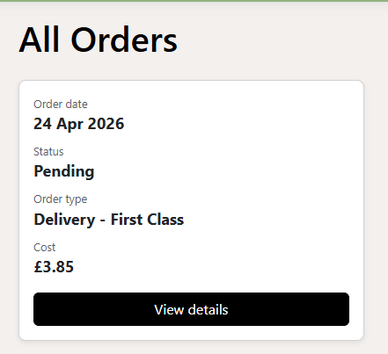  Invalid: Works as intended.  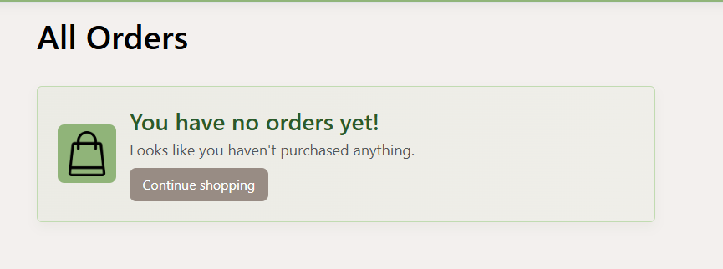 | No comments.
Images should load on the homepage | No test data. | All images should successfully render on the homepage. | Outcome is as expected. | No comments.
Browse All button on the homepage should be responsive | No test data. | The Browse All button should load, and when clicked it should take the user to the products page for them to view the products on the website. | Outcome is as expected. | No comments.
Cards in the “Why buy locally?” section load in. | No test data. | The three information cards should load in and contain the correct information. | The cards load in and all information displayed is correct. The cards have a resoonsive hover effect and information is relevant.  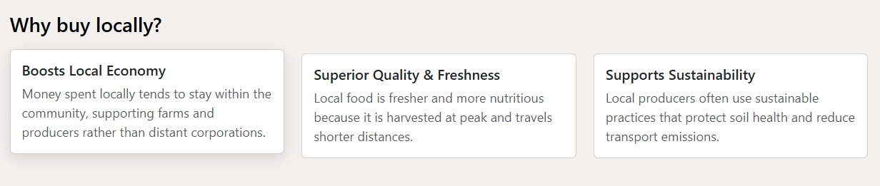 | No comments.
All navigation links should be functional. | No test data. | All of the navigation properties should be functional and should take the user to the expected endpoint. | Outcome is as expected. | No comments.
Privacy link on the footer should be functional. | No test data. | The privacy link on the footer should successfully redirect the user to the Privacy page for them to view the websites privacy policy. | Outcome is as expected. | No comments.
If a user is not logged in, they should not be able to visit the orders page. | No test data. | The user should be given an error when attempting to redirect to the Orders page if they are not signed into an account. | They are not provided with an error message from the website itself but are not able to create the basket.  They are greeted with a 401 Page not working error. | A built-in error page needs to be implemented, notifying the user that they need to register/login to view the page.
Suppliers appear on the suppliers’ page. | No test data. | When the user visits the suppliers page via the navigation property, they should be able to see the different suppliers in a card format. | Outcome is as expected. | No comments.
Details button on supplier card is functional. | No test data. | The details button should appear on the cards displayed on the suppliers’ page, when the button is clicked the user should be redirected to the details page that corresponds with the supplier of their choice. | Outcome is as expected. | There should be more variety of information displayed in future.
Back to Suppliers button is functional. | No test data. | When the user interacts with the Back to Suppliers button, they should be taken back to the suppliers’ page. | Outcome is as expected. | No comments.
User should be able to interact with the accessibility icon on the right side of the screen. | No test data. | When the user clicks on the accessibility icon, the accessibility menu should be pulled out from the side of the screen. The menu should remain static unless the button is pressed another time. | Outcome is as expected. All accessibility options are displayed on the accessibility menu, all icons and text load in accordingly.  After the menu is out the screen is darkened so the options are in focus and are clearer to read and view. | It may be useful to implement other accessibility options in future.
The Dark Mode option should be functional. | Dark mode button | After interacting with the dark mode button, the website should be transformed to fit with the appropriate colour pallet. | The dark mode button changes the background colour to black and the text colour to white where appropriate. | No comments.
The Increase Text  option should be  functional. | Increase text size button | After interacting with the increase text size button, all text on the website should be scaled accordingly. | Some text on the website does not scale. The rest of the text however, scales accordinly with the number of times the user presses on the button. | This issue should be fixed.
The Decrease Text option should be functional. | Decrease text size button | After interacting with the decrease text size button, all text on the website should be scaled accordingly. | Some text on the website does not scale. The rest of the text however, scales accordinly with the number of times the user presses on the button. | This issue should be fixed.
The High Contrast option should be functional. | High contrast button | After interacting with the high contrast mode button, the website should be transformed to fit with the appropriate colour pallet. | The high contrast mode button changes the background colour to black and the text colour to yellow where appropriate. | More text should change colour.
The Read Aloud option should be functional. | Read text aloud button | All text should be read aloud. | Works as expected. | No comments.
The Reset option should be functional. | Reset all settings button | All settings should be reset to the default settings for the website on click. | Works as expected.  Reset button also automaticallys folds the menu down. | No comments.
When signed in, the user should be able to access their account via the navigation property. | No test data.  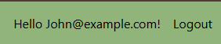 | When pressing “Hello @username” the user should be redirected to their account page where they can view and edit their information appropriately. | Works as expected.  From this menu the user can also request a copy of the data stored about them, as well as delete any data stored. | No comments.
Each link on the account settings page should take the user to the expected destination. | No test data. | When clicking each of the options on the account settings menu the form boxes should display the appropriate data. | Works as expected. | No comments.
User should be able to change their email. | Normal: example@example.com  Erroneous: exampleexample.com  (there is no @ so the email is not in a valid format) | Normal: The new email should be accepted, there should be a notification saying that a confirmation email has been sent to the user.  Erroneous: There should be an error message displayed notifying the user that the data entered in the email field is not valid. | Normal: Works as expected, since there is no email system setup the user cannot actually confirm the email change but the system is functional otherwise.  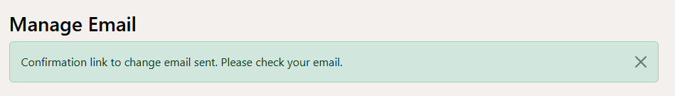  Erroneous: The error message is displayed as expected.  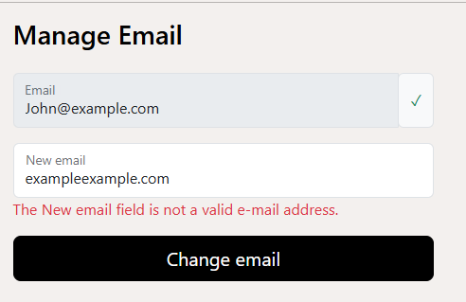
The user should be able to change their password. | Normal:  Old Password: Password123!  New Password: NewPassword123!  New Password Confirm:  Password123!  Invalid:  New password: Password123!  (new passwords cannot be the same as old passwords)  Erroneous:  Old password: Paasword123!  (password does not match existing account password)  New password: NewPassword123!  (valid)  Confirm New Password:  NewPassword123! (valid) | Normal: The user should be able to successfully edit their password  Invalid: The user should not be able to change their password and should be notified that their new password cannot match their old password.  Erroneous: The user should not be able to change their password and should be greeted with an error message notifying them that their current password does not match the password that they entered in the box. | Password is changed successfully.  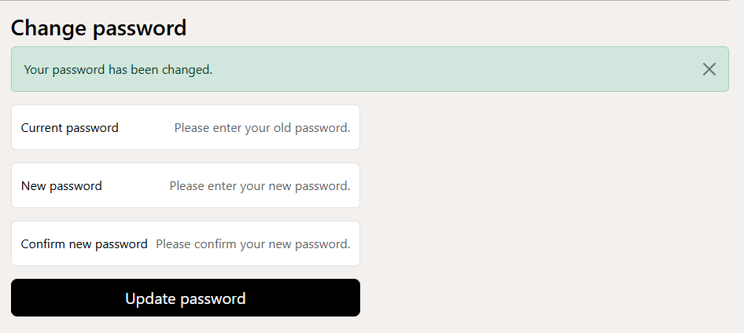  Wrong output. The user can still “change” their password despite it being the same as their currrent password.  The user is provided with an error message telling them that the password that they entered is incorrect.  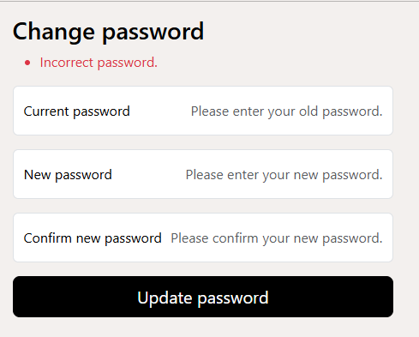 | There needs to be an error message when a user attempts to use their current password as their old one. The user should also not be able to use recent passwords.

