Threat-Aware Digital Asset Exposure Prediction System Using Machine Learning
Dissertation: Chapters 1 to 3
[Student name]
[Student ID]
Supervisor: [Supervisor name]
[Degree programme], [University]
[Date]

Chapter 1: Introduction

1.1 Problem Context
Security teams cannot patch every vulnerability. The National Vulnerability Database (NVD) now publishes tens of thousands of CVEs each year, yet very few are ever used in real attacks. In the data used for this project, only 390 of 127,580 analysed CVEs published between November 2021 and August 2025 (0.31%) were added to the CISA Known Exploited Vulnerabilities (KEV) catalogue within a year. Most teams still rank their scanner findings by CVSS score, which measures technical severity, not the likelihood of attack.
Building the system made this problem more exact in three ways. First, the useful decision is made when a CVE is published, before exploitation is confirmed, so a prediction may only use information that exists at that moment. Second, a score for a CVE does not tell an operator which machine to fix first. The score must be linked to the product versions installed on real assets and to how far an attacker could move from them. Third, public data contains reporting artefacts that can make a model look better than it is.

1.2 Research Question
This dissertation answers the following question: Can machine learning, using only information available when a vulnerability is published, predict which vulnerabilities, and therefore which organisational assets, will become actively exploited within 12 months, more effectively than severity-based (CVSS) prioritisation? [Check against your proposal. If the wording changed, keep this version and add: “The changes from the proposal are explained in Appendix B.”]

1.3 Aims and Objectives
Aim: to design, build and evaluate a machine learning system that predicts the future exploitation of vulnerabilities and uses these predictions to prioritise an organisation’s assets.
- Build a leakage-controlled temporal dataset of NVD CVEs published from November 2021 to August 2025, labelled by addition to CISA KEV within 12 months. (Chapter 4)
- Train three model families and compare them with CVSS and EPSS on a held-out 2025 test year, using PR-AUC and recall in the top 5%, with bootstrap confidence intervals and significance tests. (Chapter 5)
- Produce calibrated probabilities, measured by Brier score and expected calibration error, and a SHAP explanation for every prediction. (Chapters 4 and 5)
- Map predictions to assets by installed version and test the asset ranking in a 12-month backtest of a 30-asset organisation, delivered through an access-controlled dashboard. (Chapters 4 and 5)

1.4 Scope and Structure of the Dissertation
The delivered project covers CVE-level prediction from public data (NVD and CISA KEV, with EPSS used only as a benchmark), a 12-month prediction horizon, version-aware asset exposure assessment, attack-path and remediation planning, notices to the teams that own affected assets, live synchronisation with new KEV and NVD data, and a dashboard protected by multi-factor authentication and role-based access control. It does not cover exploit development or attacks on lab hosts, verification that fixes were applied (the owning teams are responsible for this), undisclosed (zero-day) vulnerabilities, private threat intelligence, weaknesses without a CVE such as misconfigurations, or deployment in a production network.
Chapter 2 reviews and evaluates related work and states the research gap. Chapter 3 describes the research approach, the design as built, the testbed, the evaluation protocol and the data plan. Chapter 4 describes the implementation. Chapter 5 presents the evaluation results. Chapter 6 discusses the results against the research question and the gap, and concludes the dissertation. [Adjust these chapter titles to match your final structure.]

Chapter 2: Literature Review

2.1 State of the Art
Severity scoring. CVSS version 3.1 rates technical severity from 0 to 10 (FIRST, 2019). Version 4.0 adds threat metrics, but the user must supply the threat information from an outside source (FIRST, 2023). Allodi and Massacci (2014) showed that a high CVSS score is a weak indicator of exploitation in the wild.
Machine learning for exploit prediction. Bozorgi et al. (2010) predicted proof-of-concept exploits from vulnerability text and metadata. Sabottke, Suciu and Dumitras (2015) added social media signals. Jacobs et al. (2020) showed that a model gives better remediation coverage than CVSS rules for the same effort. This work led to EPSS (Jacobs et al., 2021). Its third version uses gradient boosting with more than a thousand features, including commercial threat data (Jacobs et al., 2023). Suciu et al. (2022) showed that exploitability changes over time.
Ground truth and decision frameworks. CISA’s KEV catalogue records confirmed exploitation with an addition date (CISA, 2021). SSVC replaces scores with stakeholder decision trees (Spring et al., 2021), and NIST’s Likely Exploited Vulnerabilities metric combines EPSS history to estimate past exploitation (Mell and Spring, 2025).
Method quality, assets and explanation. Pendlebury et al. (2019) and Arp et al. (2022) showed that random splits and data snooping inflate results in security machine learning. Saito and Rehmsmeier (2015) recommend precision-recall analysis for rare events. At the network level, attack graphs model how an attacker moves between hosts (Sheyner et al., 2002; Ou, Govindavajhala and Appel, 2005). SHAP gives feature-level explanations of model outputs (Lundberg and Lee, 2017; Lundberg et al., 2020).

2.2 Critical Evaluation
CVSS is cheap and universal, but it is static and describes impact rather than likelihood. The threat metrics in version 4.0 move the prediction problem to the user instead of solving it. EPSS is the strongest public predictor and scales to every CVE. However, part of its training data is private, so its results cannot be reproduced. It does not explain individual scores, and its 30-day horizon fits short-term triage better than patch planning. Its scores also change daily, which makes a past decision hard to audit.
Many academic models report optimistic results. Random cross-validation lets a model learn from the future (Pendlebury et al., 2019), and some targets measure proof-of-concept code rather than real attacks. Features from social media can be manipulated by attackers (Sabottke, Suciu and Dumitras, 2015), which is a security weakness of the predictor itself. This project found a further leak: vendors add sentences such as “may have been exploited” to descriptions after the event. Such sentences appeared in 11% of exploited descriptions but only 0.4% of the others.
KEV is a lagging and incomplete label with a focus on US government systems, so every model trained on it inherits these biases. SSVC needs human judgement for each vulnerability and does not scale to thousands of findings. Attack-graph tools need detailed configuration data and can grow very large on big networks. Finally, all of the CVE-level predictors stop at the vulnerability. None of them tells an operator which asset to fix first.

2.3 Identified Gap
The proposal identified the lack of a transparent, leakage-controlled method, built only on public data, that predicts the future exploitation of vulnerabilities and links those predictions to an organisation’s specific assets and software versions. The updated review confirms this gap and makes it sharper. EPSS version 3 and the NIST LEV metric improve the estimate of exploitation likelihood, but both remain at the CVE level, and LEV looks backwards. The review also shows that a credible contribution must be benchmarked against EPSS, not only against CVSS.
The delivered project addresses the gap with a temporally validated model built on public data, with explanations for each prediction and calibrated risk tiers. The predictions are mapped to installed versions, attack paths and a ranked remediation plan. The model is compared directly with EPSS. Chapter 6 returns to this gap and assesses how far it has been closed.

Chapter 3: Methodology and Design

3.1 Research Approach
The project follows design science research (Hevner et al., 2004), using the process of Peffers et al. (2007), with an experimental evaluation. The artefact is the prediction and prioritisation system. Problem identification and the objectives come from Chapters 1 and 2. Design and build are described in this chapter and in Chapter 4. The evaluation is a controlled offline experiment on a held-out year plus an asset-level backtest, reported in Chapter 5. Chapter 6 communicates the results. The work was iterative: findings from evaluation, such as the leaks described in Section 2.2, were fed back into the design before the final test.

3.2 Detailed Design
The artefact is a Python pipeline with thirteen components (Table 3.1, Figure 3.1). Components exchange files with fixed names: CSV and compressed CSV for datasets, joblib for trained models, and SQLite for asset inventories, user accounts and the audit log. The whole research pipeline can be rebuilt from raw data with one command (run_pipeline.py).
Component | Responsibility | Interfaces (in → out) | Configuration
1. Extractor and integrator | Parse NVD records, drop rejected CVEs, join KEV by CVE ID | NVD JSON 2.0 yearly feeds, KEV JSON → integrated CSV, CPE version ranges | All feeds 2002–2026
2. Temporal labeller | Create future_kev; exclude CVEs already in KEV at publication | Integrated CSV → prediction dataset (127,580 CVEs) | 12-month window; study period 3 Nov 2021 to 27 Aug 2025
3. Feature builder | Build CVSS, CWE, threat-history, text and scope features; remove exploitation sentences | Prediction dataset → training and scoring feature files | Top 25 CWEs and TF-IDF (2,000 terms, 1–2 words) fitted on training years only; history strictly before publication
4. Model trainer | Train logistic regression, random forest and LightGBM; choose imbalance option and threshold | Features → models, metrics | Selected: LightGBM with text, 200 trees, 31 leaves, minimum 100 per leaf, 10:1 undersampling, seed 42
5. Calibrator | Convert scores to probabilities; assign risk tiers | Model → risk_model.joblib | Platt scaling fitted on 2024; tiers = top 1%, next 4%, next 15%, rest
6. Explainer | Global and per-CVE feature contributions | Model, features → SHAP values | TreeSHAP (LightGBM pred_contrib)
7. Evaluator | Metrics, EPSS benchmark, ablation, significance tests | Predictions, EPSS history → benchmark tables | 1,000 bootstrap samples for intervals; 2,000 paired samples for tests
8. Exposure assessor | Match services to CVEs by installed version; score each asset | Nmap XML or SQLite inventory → asset exposure | About 2.5 million NVD version ranges; criticality and internet-exposure weights
9. Attack-graph engine | Find reachable assets and the most likely path | Subnets, firewall rules, trust links → paths, containment options | Edge weight −log p; Dijkstra shortest path
10. Remediation planner | Rank upgrades by risk removed; set deadlines | Exposure, version ranges → patch plan, CSV | KEV due dates, otherwise deadlines by risk tier
11. Live sync | Fetch new or changed KEV and NVD records; score them; raise alerts | KEV feed, NVD API 2.0 → data/live | Every 6 hours; incremental bookmark
12. Notification service | Send remediation notices to owning teams | Plan → email (SMTP STARTTLS) or .eml file | Allowed recipient domains; preview before send
13. Access control and dashboard | Sign-in, roles, audit; user interface | auth.db (SQLite) → Streamlit pages | 5 roles; TOTP MFA; scrypt; lockout after 5 failures for 15 min; 30 min idle timeout
Table 3.1. Components of the artefact.
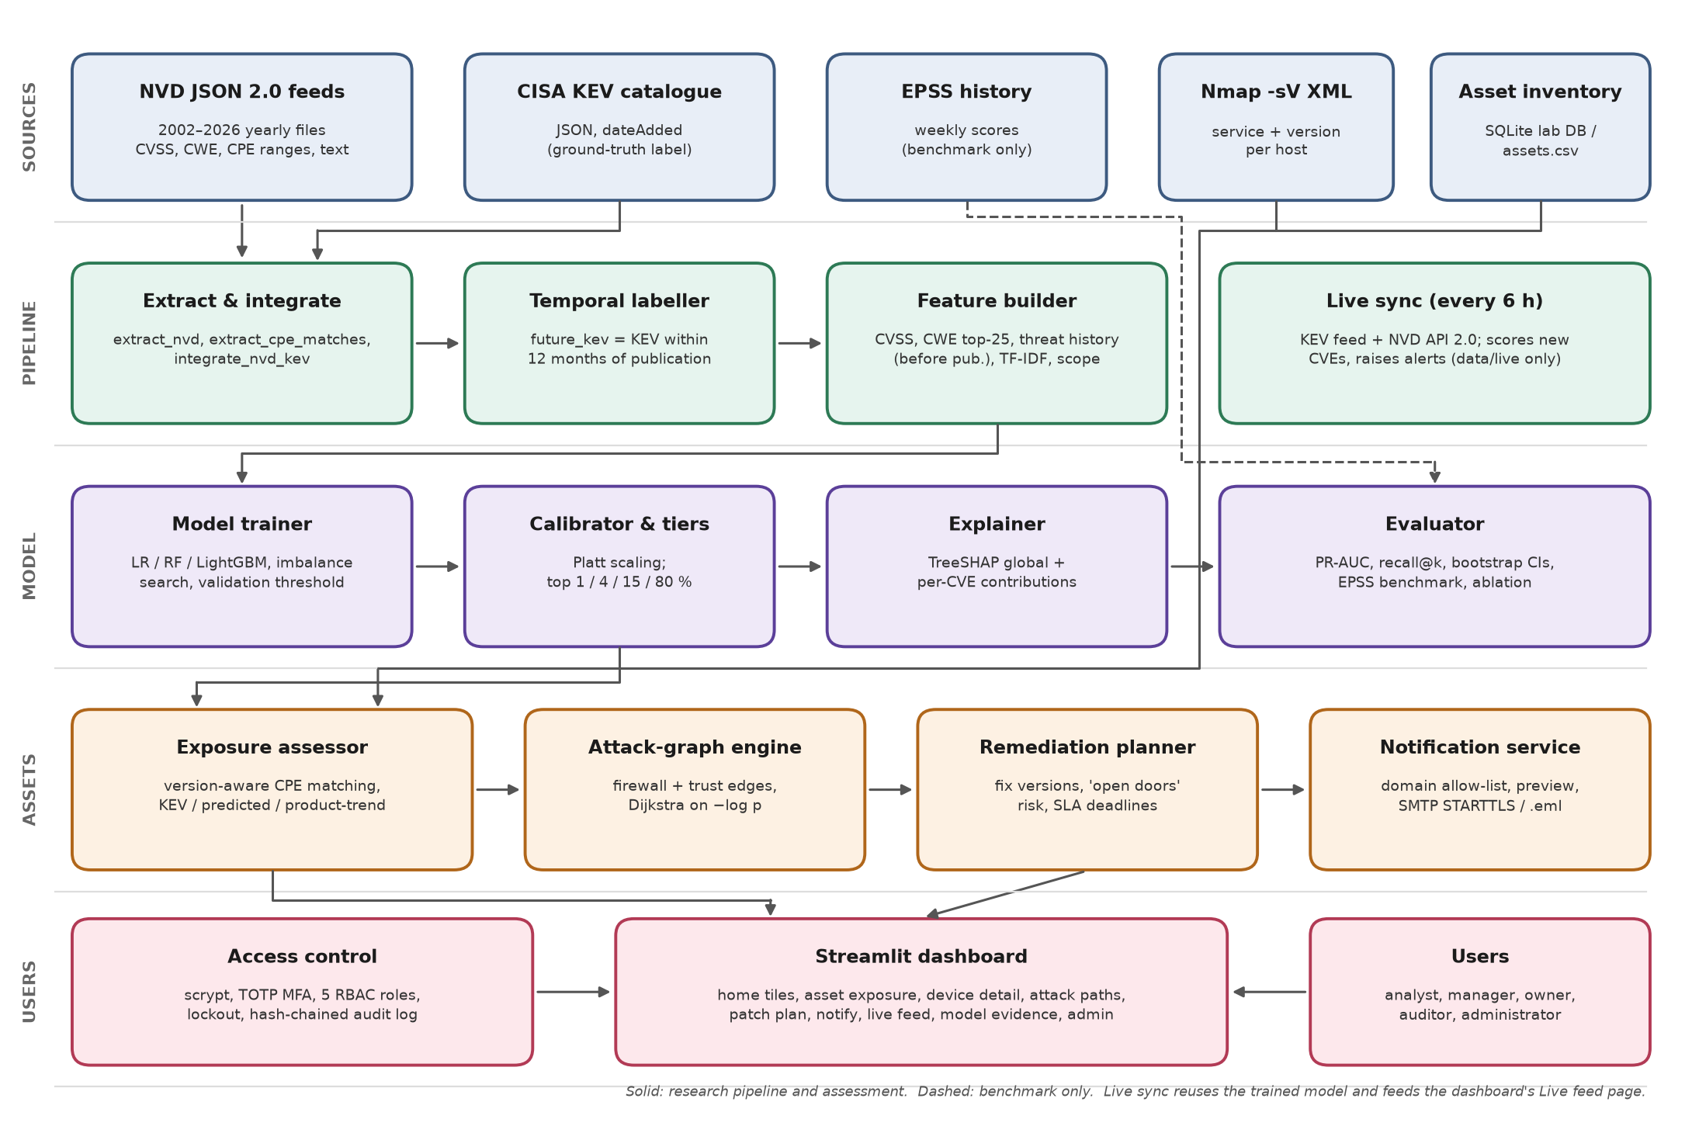
Figure 3.1. Component-level architecture and data flows.
There are three data flows. In the research flow (components 1 to 7), the raw feeds become a frozen evaluation dataset in data/processed. In the assessment flow (8 to 10), the calibrated model scores the CVEs found on each asset, and the attack graph and planner turn these scores into containment options and a ranked plan. In the operational flow, live sync writes only to data/live, so new data never changes the research results. The dashboard combines both stores, and every sign-in and action is recorded in a hash-chained audit log.

3.3 Testbed Specification
All results reported in this dissertation were produced on a single Windows 10 workstation, using Python 3.14 with scikit-learn 1.9.1, LightGBM 4.7.0, pandas 3.0.5 and Streamlit 1.65. The asset-level testbed is a synthetic organisation of 30 assets in four zones (DMZ, servers, workstations and management), stored in SQLite with two snapshots. Each asset follows a patch-hygiene profile of 30, 120, 270 or 540 days behind, and runs the real NVD fix versions for that date. Its firewall rules and trust links are stated design assumptions.
A VMware Workstation lab with the same subnets is specified for the final demonstration. It contains a pfSense firewall, Ubuntu Server 24.04 with Vulhub applications, Windows Server 2022 and Windows 11 evaluation editions, MySQL, and a Kali scanner running Nmap 7.95. Every lab subnet is on a host-only network with the host adapter disabled. Internet (NAT) access is used only during installation, before any vulnerable service runs. The authorisation boundary is the author’s own machine and the lab ranges 10.10.10.0/24 to 10.10.99.0/24. No scanning takes place outside this boundary. [Update after building the lab: exact image versions and build dates.]

3.4 Evaluation Protocol
The primary metric is PR-AUC, because exploitation is rare. Supporting metrics are ROC-AUC, recall within the top 1% and top 5% of the ranking (a review budget), the Brier score and expected calibration error for probability quality, and asset-level PR-AUC in the backtest.
The research question is answered positively if (1) on the 2025 test year the model’s PR-AUC and top-5% recall exceed those of CVSS ranking, with a paired bootstrap p-value below 0.05, and (2) the model is not significantly worse than EPSS. Ablation runs remove one feature group at a time to show which inputs matter.
The procedure for each run is fixed. All tuning (hyperparameters, imbalance handling, decision threshold and calibration) uses only the 2024 validation year. The 2025 test year (19,945 CVEs, 98 exploited) is then scored once. Training is deterministic with seed 42, so each configuration is run once. Uncertainty comes from 1,000 bootstrap resamples for confidence intervals and 2,000 paired resamples for significance tests.
Conditions are kept the same for every method: the model, CVSS, EPSS and the ablation variants rank the same CVEs against the same labels. EPSS receives its first weekly score after publication (1 to 7 days later), which, if anything, favours the baseline. The asset backtest assesses the organisation as of 27 August 2025 and compares the result with KEV additions up to 27 August 2026.

3.5 Data Plan
Vulnerability data comes from public sources: the NVD feeds and API, the CISA KEV catalogue and the EPSS history. It is downloaded by scripts and stored in the project folder (data/raw, data/processed, data/live) on the author’s computer, [backed up to: location]. These sources contain no personal data. The test organisation is synthetic. It was generated deterministically by a script from real NVD fix versions, and the sample Nmap file was written by hand. No AI-generated test data was used.
The only personal-style data is in the dashboard’s user database: demo usernames and email addresses on a fictional domain, scrypt password hashes, MFA secrets and the audit log. Test-mode emails are saved as .eml files. The user database, the outbox and any lab scan files will be deleted [date, e.g. when final marks are confirmed].

References
Allodi, L. and Massacci, F. (2014) ‘Comparing vulnerability severity and exploits using case-control studies’, ACM Transactions on Information and System Security, 17(1), pp. 1–20.
Arp, D., Quiring, E., Pendlebury, F., Warnecke, A., Pierazzi, F., Wressnegger, C., Cavallaro, L. and Rieck, K. (2022) ‘Dos and don’ts of machine learning in computer security’, in Proceedings of the 31st USENIX Security Symposium. Boston: USENIX Association.
Bozorgi, M., Saul, L.K., Savage, S. and Voelker, G.M. (2010) ‘Beyond heuristics: learning to classify vulnerabilities and predict exploits’, in Proceedings of the 16th ACM SIGKDD International Conference on Knowledge Discovery and Data Mining, pp. 105–114.
Cybersecurity and Infrastructure Security Agency (CISA) (2021) Binding Operational Directive 22-01: Reducing the significant risk of known exploited vulnerabilities. Washington, DC: CISA.
FIRST (2019) Common Vulnerability Scoring System version 3.1: specification document. Forum of Incident Response and Security Teams.
FIRST (2023) Common Vulnerability Scoring System version 4.0: specification document. Forum of Incident Response and Security Teams.
Hevner, A.R., March, S.T., Park, J. and Ram, S. (2004) ‘Design science in information systems research’, MIS Quarterly, 28(1), pp. 75–105.
Jacobs, J., Romanosky, S., Adjerid, I. and Baker, W. (2020) ‘Improving vulnerability remediation through better exploit prediction’, Journal of Cybersecurity, 6(1).
Jacobs, J., Romanosky, S., Edwards, B., Adjerid, I. and Roytman, M. (2021) ‘Exploit Prediction Scoring System (EPSS)’, Digital Threats: Research and Practice, 2(3).
Jacobs, J., Romanosky, S., Suciu, O., Edwards, B. and Sarabi, A. (2023) ‘Enhancing vulnerability prioritization: data-driven exploit predictions with community-driven insights’, in IEEE European Symposium on Security and Privacy Workshops (EuroS&PW), pp. 194–206.
Lundberg, S.M. and Lee, S.-I. (2017) ‘A unified approach to interpreting model predictions’, in Advances in Neural Information Processing Systems 30.
Lundberg, S.M., Erion, G., Chen, H., DeGrave, A., Prutkin, J.M., Nair, B., Katz, R., Himmelfarb, J., Bansal, N. and Lee, S.-I. (2020) ‘From local explanations to global understanding with explainable AI for trees’, Nature Machine Intelligence, 2(1), pp. 56–67.
Mell, P. and Spring, J. (2025) Likely Exploited Vulnerabilities: a proposed metric for vulnerability exploitation probability. NIST Cybersecurity White Paper (CSWP) 41. Gaithersburg, MD: National Institute of Standards and Technology.
Ou, X., Govindavajhala, S. and Appel, A.W. (2005) ‘MulVAL: a logic-based network security analyzer’, in Proceedings of the 14th USENIX Security Symposium, pp. 113–128.
Peffers, K., Tuunanen, T., Rothenberger, M.A. and Chatterjee, S. (2007) ‘A design science research methodology for information systems research’, Journal of Management Information Systems, 24(3), pp. 45–77.
Pendlebury, F., Pierazzi, F., Jordaney, R., Kinder, J. and Cavallaro, L. (2019) ‘TESSERACT: eliminating experimental bias in malware classification across space and time’, in Proceedings of the 28th USENIX Security Symposium, pp. 729–746.
Sabottke, C., Suciu, O. and Dumitras, T. (2015) ‘Vulnerability disclosure in the age of social media: exploiting Twitter for predicting real-world exploits’, in Proceedings of the 24th USENIX Security Symposium, pp. 1041–1056.
Saito, T. and Rehmsmeier, M. (2015) ‘The precision-recall plot is more informative than the ROC plot when evaluating binary classifiers on imbalanced datasets’, PLOS ONE, 10(3), e0118432.
Sheyner, O., Haines, J., Jha, S., Lippmann, R. and Wing, J.M. (2002) ‘Automated generation and analysis of attack graphs’, in Proceedings of the IEEE Symposium on Security and Privacy, pp. 273–284.
Spring, J., Hatleback, E., Householder, A., Manion, A. and Shick, D. (2021) Prioritizing vulnerability response: a stakeholder-specific vulnerability categorization (version 2.0). Pittsburgh, PA: Software Engineering Institute, Carnegie Mellon University.
Suciu, O., Nelson, C., Lyu, Z., Bao, T. and Dumitras, T. (2022) ‘Expected exploitability: predicting the development of functional vulnerability exploits’, in Proceedings of the 31st USENIX Security Symposium.

