

NATIONAL INSTITUTE OF BUSINESS MANAGEMENT SCHOOL OF COMPUTING & ENGINEERING
BSC (HONS) IN ETHICAL HACKING AND NETWORK SECURITY (EHNS)
BATCH - COBSCEHNS24.2P
NB6019CEM
RESEARCH PROJECT DELIVERY
Module Code | NB6019CEM
Module Title | Research Project Delivery
Submission | Dissertation
Project Title | Threat-Aware Digital Asset Exposure Prediction System Using Machine Learning
Student Full Name | Walpala Kankanamalage Isira Lakshan Kumanajan
Student ID | COBSCEHNS242P-013
Supervisor | Mr.Niranga Dharmarathna
Submission Date | 09 October 2026
Word Count | 2607

Chapter 1: Introduction

1.1 Problem Context
Every organization that runs software has more known vulnerabilities than it can fix. The National Vulnerability Database (NVD) publishes tens of thousands of CVEs a year, but only a small portion are ever used by attackers. In the data used here, 390 out of 127,580 analysed CVEs published between November 2021 and August 2025 were added to the CISA Known Exploited Vulnerabilities (KEV) database within a year, it’s about 0.3%. Most security teams still sort their scan results by CVSS score, and CVSS tells you how bad a flaw could be, not how likely it is to be used.
By the end, the problem looked narrower and harder than in the proposal. The decision has to be made on the day a CVE is published. A score is only useful once it is tied to a specific machine and its installed version. And public data contains traps that can make a model look far better than it really is.

1.2 Research Question
Can machine learning (ML), by using only information available on the day a vulnerability is published, predict which vulnerabilities, and so which organisational assets, will be actively exploited within 12 months, better than prioritising by CVSS score? This is a sharper form of the proposal’s question; the change is explained in Appendix B.

1.3 Aims and Objectives
Aim: to build and evaluate a machine learning (ML) system that predicts the future exploitation of vulnerabilities and uses it to rank an organization’s assets.
- Build a leakage-controlled dataset of NVD CVEs published from November 2021 to August 2025, labelled as exploited in KEV within 12 months. (Chapter 4)
- Train three model families and compare them with CVSS and EPSS on the 2025 test year by PR-AUC and top-5% recall, using paired bootstrap tests at the 5% level. (Chapter 5)
- Give calibrated probabilities and a SHAP explanation for every prediction. (Chapters 4 and 5)
- Map predictions to installed versions and backtest the asset ranking of a 30-asset organization over one year. (Chapter 5)

1.4 Scope and Structure of the Dissertation
The project covers CVE-level prediction from public data, with NVD and CISA KEV as inputs and EPSS used only as a benchmark. It then matches predictions to installed software versions, shows attack paths between subnets, builds a ranked patch plan and sends notices to the teams by email that own the affected assets. All of this sits behind a dashboard with multi-factor sign-in and five user roles. It does not cover exploit development, checking that fixes were applied (that job belongs to the owning team), zero-day vulnerabilities, private threat feeds, misconfigurations without a CVE, or use on a production network.
Chapter 2 reviews the literature and states the gap. Chapter 3 explains the approach, the design as built, the testbed, the evaluation protocol and the data plan. Chapter 4 describes how the system was implemented. Chapter 5 reports the evaluation results. Chapter 6 discusses those results against the research question and the gap and concludes.

Chapter 2: Literature Review

2.1 State of the Art
Severity scoring. CVSS v3.1 (FIRST, 2019) is still the usual way to rank vulnerabilities. Version 4.0 (FIRST, 2023) added threat metrics, but the user has to supply the threat information. Allodi and Massacci (2014) showed that a high CVSS score says little about real exploitation, and later work has not changed that view.
Predicting exploitation. Bozorgi et al. (2010) predicted proof-of-concept exploits from vulnerability text, and Sabottke, Suciu and Dumitras (2015) added Twitter data. Jacobs et al. (2020) showed that a model could cover more exploited vulnerabilities than CVSS rules for the same patching effort, and this line of work became EPSS (Jacobs et al., 2021). Its third version uses gradient boosting over more than a thousand features, some from commercial partners (Jacobs et al., 2023). Suciu et al. (2022) showed that exploitability changes over time. Most of this work treats the task as binary classification on heavily imbalanced data, and tree ensembles have become the usual choice of model.
Ground truth and decision support. The CISA KEV catalogue, started in 2021, lists vulnerabilities with confirmed exploitation and the date each was added. Because every entry is dated, KEV can serve as a time-stamped label, which older exploit databases could not offer. SSVC (Spring et al., 2021) uses decision trees instead of scores, and NIST’s Likely Exploited Vulnerabilities metric (Mell and Spring, 2025) uses EPSS history to estimate whether a CVE has already been exploited.
Method and context. Pendlebury et al. (2019) and Arp et al. (2022) showed how random splits and data snooping inflate results in security machine learning, and Saito and Rehmsmeier (2015) argued for precision-recall analysis when positives are rare. Attack graphs (Sheyner et al., 2002; Ou, Govindavajhala and Appel, 2005) model how an attacker moves through a network, and SHAP (Lundberg and Lee, 2017) explains individual model outputs.

2.2 Critical Evaluation
CVSS is free, quick and understood everywhere, but it is fixed at publication and measures impact rather than likelihood of compromise. The threat metrics in version 4.0 hand the hard part back to the user. EPSS( Exploit Prediction Scoring System) is the best public predictor and covers every CVE, but it has three practical weaknesses for an organisation.

Part of its data is private, so nobody outside can reproduce it. It gives a number without a reason. And its 30-day horizon suits daily triage better than patch planning over months. Because its scores change every day, it is also hard to check later why a decision was made.
Much of the academic work probably reports results that are better. Random cross-validation lets a model learn from the future, and some studies predict proof-of-concept code, which is not the same as real attacks. Social media features can be gamed, which turns the predictor itself into a target. While building this project I found another leak: vendors add lines such as “may have been exploited” to descriptions after the fact. These lines appeared in 11% of exploited descriptions and 0.4% of the rest.
KEV has its own issues. It lags behind real attacks, is incomplete and leans towards US government sector, and any model trained on it Obtains those Inclinations. SSVC(Stakeholder-Specific Vulnerability Categorization) needs a human decision for each vulnerability and does not scale. Attack-graph tools need detailed configuration and grow quickly on large networks. Most importantly, the CVE-level predictors all stop at the CVE. None of them tells an operator which machine to fix first.

2.3 Identified Gap
The project proposal identified a missing piece: a transparent, leakage-controlled method, built only on public data, that predicts future exploitation and links each prediction to an organisation’s own digital assets. The updated review confirms this gap and makes it sharper. EPSS v3 and NIST LEV(Likely Exploited Vulnerabilities) metric have improved how likelihood is estimated, but both still working at the level of single CVEs, and LEV looks backwards rather than forwards. The review also made it clear that a new model has to be compared with EPSS, not only with CVSS, before it can be called useful.
The delivered project addresses this with a time-validated model built on publicly available data, calibrated risk tiers and an explanation for every risk score. The scores are then carried down to installed versions, attack paths and a ranked patch plan. Chapter ‘6’ returns to this gap and judges how much of it was closed.

Chapter 3: Methodology and Design

3.1 Research Approach
The project follows design science research, where the contribution is a working artefact built to solve a stated problem and then evaluated against it. Chapters 1 and 2 identify the problem and set the objectives. This chapter and Chapter 4 cover design and build. The evaluation in Chapter 5 is experimental: an offline test on a year of data the model never saw, plus an asset-level backtest. Chapter 6 reports what was learned. The process was not linear. Findings from early evaluation, such as the description leak, went back into the design before the final test was run.

3.2 Detailed Design
The system consists of a Python pipeline of thirteen components. Table 3.1 lists each component’s and their responsibility, interfaces, settings and other details, and Figure 3.1 shows how they collaborate with each other. Components pass data through files with fixed names as ‘CSV’ files for datasets, ‘joblib’ files for trained models, and the SQLite databases for asset inventories with user accounts and audit logs. One command, run_pipeline.py, rebuilds the whole research pipeline from the raw feeds.
The research flow runs from components 1 to 7. And also the NVD data records are joined to KEV information, and each CVE is labelled future KEV if it was added to KEV within 12 months (one year) after publication. Five feature groups are built using only data from before that date. Three model types are trained int the system. The selected model, LightGBM with text features, is calibrated with Platt scaling, and its scores are split into four types of risk levels. The top one is 1%, then next 4%, third one as 15% and the rest. The output is frozen in data/processed, so later runs can’t change already reported results.
The assessment flow starts from components 8 and continues to 10. Services from an Nmap scan or the asset database are matched to CVEs by installed version, using 2.5 million NVD version ranges. Each asset’s priority combines this threat with its business criticality, impact and whether it is connected to the internet. The attack graph uses firewall rules and trusted links to find which assets an attacker could reach if one asset got compromised, and the planner ranks upgrades by how much risk they remove and reduce.

The operational flow is kept separately. Live sync checks the KEV feed and the NVD API in every six hours and scores new CVEs with the same model and writes only to data/live. The notification service sends remediation notices with mitigations steps to the asset-owning team of the organization. The web-based dashboard shows all of this behind multi-factor sign-in, and every action is recorded in a audit log by hash-chained.
Component | Responsibility | Interfaces (in → out) | Configuration
1. Extractor and integrator | Parse NVD records, drop rejected CVEs, join KEV by CVE ID | NVD JSON 2.0 yearly feeds, KEV JSON → integrated CSV, CPE version ranges | All feeds 2002–2026
2. Temporal labeller | Create future_kev; exclude CVEs already in KEV at publication | Integrated CSV → prediction dataset (127,580 CVEs) | 12-month window; study period 3 Nov 2021 to 27 Aug 2025
3. Feature builder | Build CVSS, CWE, threat-history, text and scope features; remove exploitation sentences | Prediction dataset → training and scoring feature files | Top 25 CWEs and TF-IDF (2,000 terms, 1–2 words) fitted on training years only; history strictly before publication
4. Model trainer | Train logistic regression, random forest and LightGBM; choose imbalance option and threshold | Features → models, metrics | Selected: LightGBM with text, 200 trees, 31 leaves, minimum 100 per leaf, 10:1 undersampling, seed 42
5. Calibrator | Convert scores to probabilities; assign risk tiers | Model → risk_model.joblib | Platt scaling fitted on 2024; tiers = top 1%, next 4%, next 15%, rest
6. Explainer | Global and per-CVE feature contributions | Model, features → SHAP values | TreeSHAP (LightGBM pred_contrib)
7. Evaluator | Metrics, EPSS benchmark, ablation, significance tests | Predictions, EPSS history → benchmark tables | 1,000 bootstrap samples for intervals; 2,000 paired samples for tests
8. Exposure assessor | Match services to CVEs by installed version; score each asset | Nmap XML or SQLite inventory → asset exposure | About 2.5 million NVD version ranges; criticality and internet-exposure weights
9. Attack-graph engine | Find reachable assets and the most likely path | Subnets, firewall rules, trust links → paths, containment options | Edge weight −log p; Dijkstra shortest path
10. Remediation planner | Rank upgrades by risk removed; set deadlines | Exposure, version ranges → patch plan, CSV | KEV due dates, otherwise deadlines by risk tier
11. Live sync | Fetch new or changed KEV and NVD records; score them; raise alerts | KEV feed, NVD API 2.0 → data/live | Every 6 hours; incremental bookmark
12. Notification service | Send remediation notices to owning teams | Plan → email (SMTP STARTTLS) or .eml file | Allowed recipient domains; preview before send
13. Access control and dashboard | Sign-in, roles, audit; user interface | auth.db (SQLite) → Streamlit pages | 5 roles; TOTP MFA; scrypt; lockout after 5 failures for 15 min; 30 min idle timeout
Table 3.1. Components of the artefact.
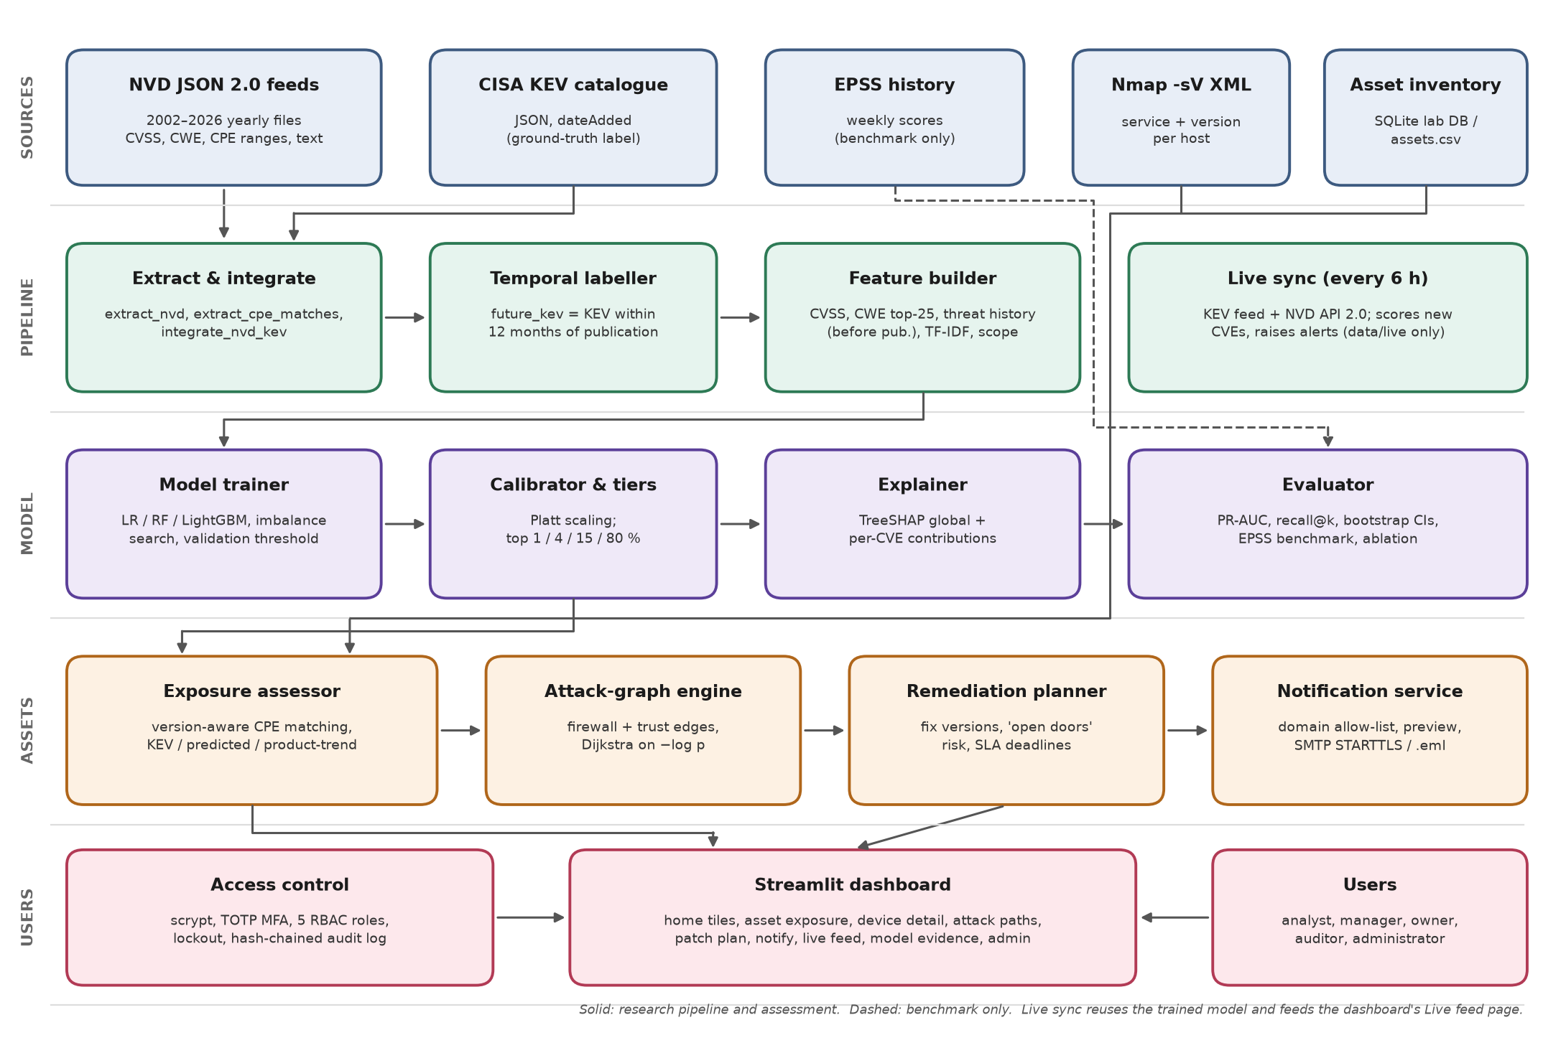
Figure 3.1. Component-level architecture and data flows.

3.3 Testbed Specification
All results in this Monograph were produced on one Windows 10 workstation by running Python 3.14, scikit-learn 1.9.1, LightGBM 4.7.0, pandas 3.0.5 and Streamlit 1.65. The asset testbed is a synthetic organization LAN network consists of 30 machines in four sub zones (DMZ, servers, workstations and management), held in SQLite. Each machine is 30, 120, 270 or 540 days behind on patches and runs the real NVD fixed versions for that date. The firewall rules and trust links are design assumptions.
A VMware Workstation lab with the same subnets has been designed for the virtual lan network for final demonstration. It has a pfSense firewall, Ubuntu Server 24.04, Windows Server 2022 and Windows 11 evaluation editions, MySQL, and a Kali scanner with Nmap 7.95. Each and every subnet is a host-only network with the host adapter turned off, and internet access is used only while software is installed. The authorization boundary is the author’s own pc and the 10.10.x.0/24 lab ranges, and no scanning is done within the outside.
3.4 Evaluation Protocol
The main metric is PR-AUC(Precision-Recall Area Under the Curve), because exploited CVEs are rare and accuracy would be meaningless: a model that always answers “no” would score 99.7%. Supporting measures are ROC-AUC(Receiver Operating Characteristic - Area Under the Curve), recall within the top 1% and 5% of the ranking (a realistic review budget), the Brier score and expected calibration error, and asset-level PR-AUC in the backtest.
The research question is answered “yes” if, on the 2025 test year, the model beats CVSS ranking in PR-AUC(AP) and top-5% recall with a paired bootstrap p-value below 0.05, and is not significantly worse than EPSS, without a drop.
Every tuning choice (hyperparameters, class imbalance handling, threshold and model calibration) was made on the 2024 validation year. The 2025 test year, 19,945 CVEs of which 98 were exploited, was then scored once. Training is deterministic with seed 42, so each setup was run once. Uncertainty comes from 1,000 bootstrap resamples for confidence intervals, alongside 2,000 paired resamples for significance tests.
To keep all conditions were equal: the model, CVSS (Common Vulnerability Scoring System), EPSS( Exploit Prediction Scoring System) and each ablation ranked exactly the same CVEs against the same labels. EPSS was given its first weekly score after publication, up to a week later, which if anything favours EPSS. The back test assessed the organisation as of 27 August 2025 and checked it against KEV additions up to 27 August 2026.

3.5 Data Plan
All vulnerability information comes from public sources: NVD, CISA KEV and EPSS history. The scripts are downloaded into the project folder on the author’s computer (data/raw, data/processed and data/live). The test organisation network is synthetic, generated by a script from real NVD fix versions, and the sample Nmap file was written by own. No AI-generated test data was used. The system dashboard’s user database holds demo accounts on a fictional domain, hashed passwords, MFA secrets and an audit log to achieve CIA (Confidentiality, Integrity, Availability) and AAA (Authentication, Authorization, Accounting).

