|  |  |
| --- | --- |
| **Logo_Baru-Rasmi_UUM_02** | STIA1123: Programming 2 Semester 191School of Computing, CAS, UUM |
| Lab 1 | |
| 3/10/2019  Submission  7/10/2019 | |

Instruction:

1. Write a java program that can read your name and output your name with the following
   1. to upper case
   2. to lower case
   3. divide your name into half
   4. get the length of your name
   5. print how many characters ‘a’ in the names
   6. Print your lucky number between 1-100.

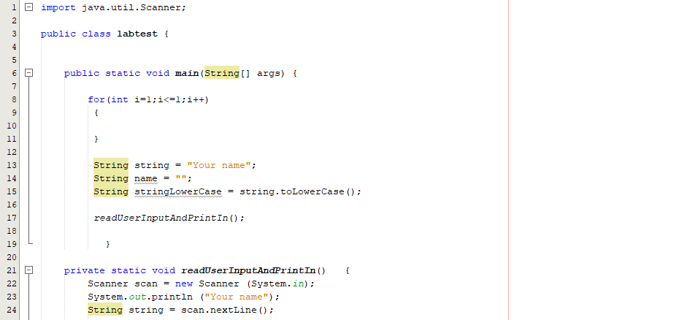

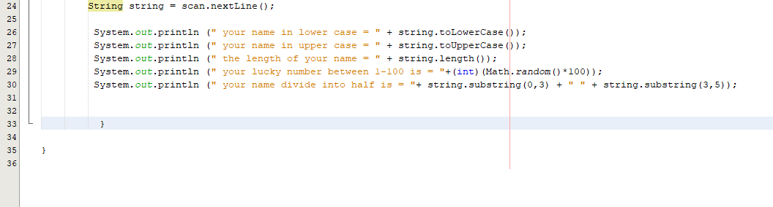

Output

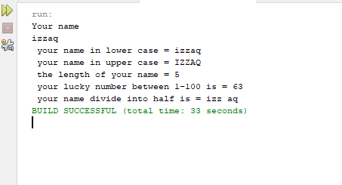

1. Identify a café in UUM and draw **3** **classes** in UML diagram with their variables. **Don’t define** any method just yet in this example. Only **classes** and **variables**.

|  |
| --- |
| Café |
| Menu  Place  Order |

1. From (question no 2) write a program to create **3** **objects** each from classes identified for the café using user input.

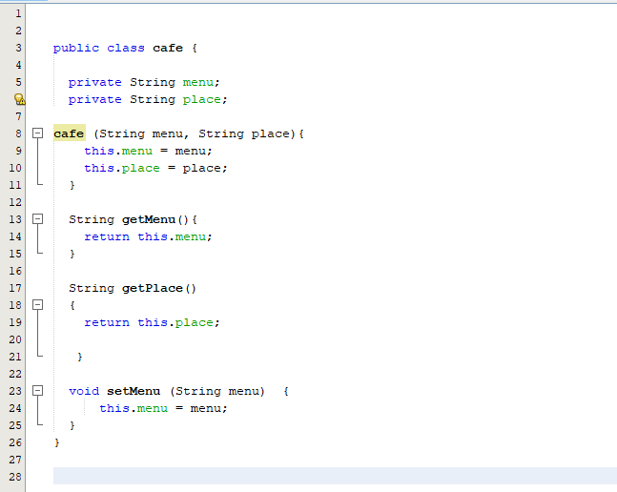

Save the following into word document

* + Java classes.
  + At least 3 print screen terminal application interface screenshot that describe input-process-output.
  + Github lab link.

Make sure the source code is readable and the interface screenshot is clear.

Then upload to:

* UUM Learning &
* <http://slumberjer.com/teaching/a191/stia1123/upload>

**Late submission will be not accepted and tolerated and will be given 0.**