AI Usage and Impact on Students and Professionals
Data Analysis Portfolio Project
Prepared by: Nor Izzati Mohd Zahir
Date: October 2026
Dataset Source: Kaggle Survey Dataset

Executive Summary
This project explores how students and professionals use AI tools and the impact these tools have on productivity and daily tasks. Using Microsoft Excel, the dataset was cleaned, analyzed, and visualized through an interactive dashboard featuring KPI metrics, pivot tables, charts, and slicers.
Key findings reveal that ChatGPT is the dominant AI platform among respondents, while coding, writing, studying, and research are the primary use cases. Survey results also show that most respondents would recommend AI tools to others, reflecting positive sentiment toward AI adoption. The analysis further highlights participation from multiple countries, demonstrating the global reach of AI technologies.
The project showcases practical skills in data cleaning, exploratory data analysis (EDA), dashboard development, data visualization, and insight generation using Excel.

Introduction
This project analyzes the usage and impact of Artificial Intelligence (AI) tools among students and professionals. The objective is to understand how AI tools are used, their effect on productivity, user satisfaction levels, and recommendation behavior.
The dataset was sourced from Kaggle and cleaned using Microsoft Excel to improve consistency and data quality. The cleaned dataset was then analyzed using pivot tables, charts, and dashboards to uncover patterns in AI adoption, user behavior, and perceived impact.

Skills Demonstrated
- Microsoft Excel
- Data Cleaning
- Exploratory Data Analysis (EDA)
- Pivot Tables
- Pivot Charts
- Data Visualization
- Dashboard Design

Dataset Profile
The cleaned dataset contains 298 records and 19 variables. It includes information on demographic characteristics, AI tool preferences, usage patterns, productivity impact, satisfaction levels, and recommendation behavior among students and professionals.

Dataset Summary
- Total Records: 298
- Total Variables: 19
- Data Source: Kaggle Survey Dataset
- Data Status: Cleaned and prepared for analysis

Purpose of Data Cleaning
Data cleaning was performed to improve data accuracy, consistency, and reliability. Activities included standardizing text values, handling missing data, correcting inconsistencies, and preparing the dataset for analysis and visualization.

Analysis Questions
- Which AI tool is used most frequently?
- What is the distribution of students and professionals?
- Would respondents recommend AI tools to others?
- What are the primary purposes of AI usage?
- Which countries have the highest number of AI users?

Analysis 1

Key Finding
ChatGPT is the most widely used AI tool, with 122 users. Google Gemini (39) and Microsoft Copilot (36) rank second and third, indicating that conversational AI tools dominate user preferences.

Analysis 2

Key Finding
Students represent 53% of respondents, while professionals account for 47%. The near-even distribution suggests that AI tools are widely adopted across both educational and workplace settings.

Analysis 3

Key Finding
Most respondents (60%) indicated that they would recommend AI tools to others, while 24% would not and 16% remained unsure. This suggests generally positive user perceptions and satisfaction with AI usage.

Analysis 4

Key Finding
Coding is the most common use of AI tools (70 responses), followed by Writing (48), Studying (41), and Research (40). These findings indicate that users primarily rely on AI to support learning, content creation, research, and technical productivity tasks.

Analysis 5

Key Finding

India recorded the highest number of respondents (45), followed by the United States and Canada (34 each). The distribution of respondents across multiple countries suggests that AI adoption is widespread and not limited to a single region.

Key Findings
- ChatGPT was the most popular AI tool, with 122 respondents reporting usage.
- Students represented 53% of respondents, while professionals accounted for 47%.
- 60% of respondents indicated that they would recommend AI tools to others.
- Coding was the most common AI use case, followed by writing, studying, and research activities.
- India had the highest number of respondents (45), demonstrating strong representation within the dataset.
- AI adoption was observed across multiple countries and user groups, highlighting the widespread use of AI technologies.

Dashboard

Interactive Excel Dashboard

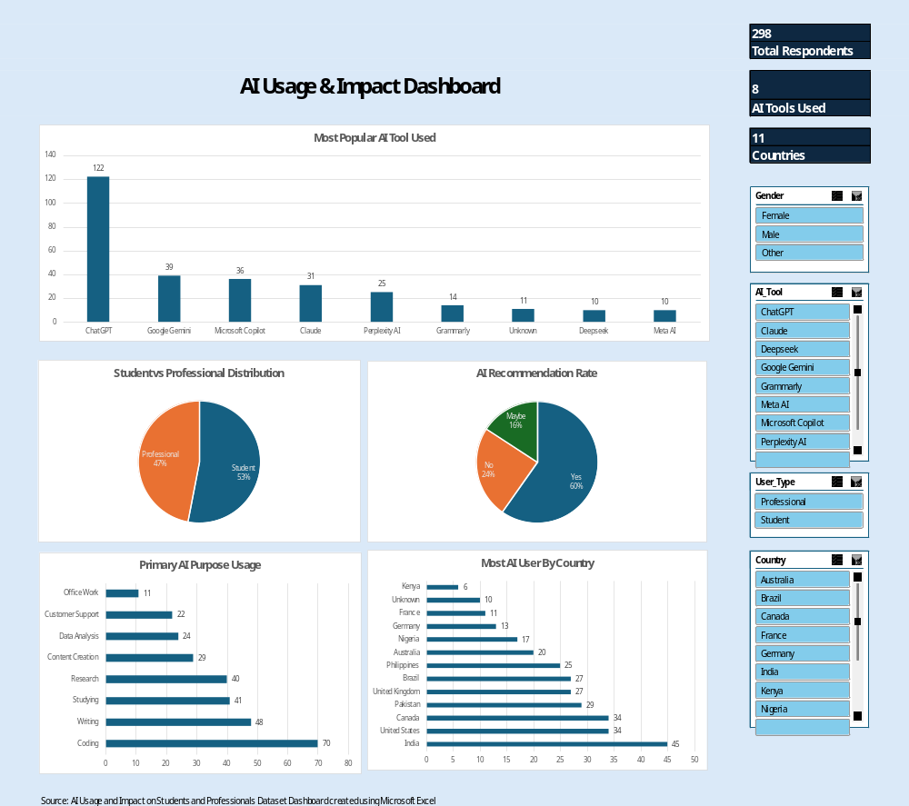

The dashboard provides an interactive view of AI usage patterns among students and professionals. Users can filter results using slicers for Gender, AI Tool, User Type, and Country. Key performance indicators (KPIs) and visualizations allow quick exploration of AI adoption trends, recommendation rates, primary use cases, and geographic distribution.

Conclusion

This project analyzed AI usage patterns among students and professionals using a survey dataset from Kaggle. After cleaning and preparing the data in Microsoft Excel, the dataset was explored through pivot tables, charts, and an interactive dashboard.

The analysis revealed that ChatGPT is the most widely used AI tool, while coding, writing, studying, and research are the primary purposes for AI usage. Most respondents indicated they would recommend AI tools, reflecting positive perceptions of AI adoption and productivity benefits. The findings also show broad participation across multiple countries and user groups.

This project demonstrates practical skills in data cleaning, exploratory data analysis (EDA), dashboard development, and data visualization using Microsoft Excel.

