Tutorial: Normalization

Objective:
- Describe why redundant data can cause update anomalies.
- Define functional dependency and apply it in normalization.

- Refer to the following StaffBranch table, answer following questions:
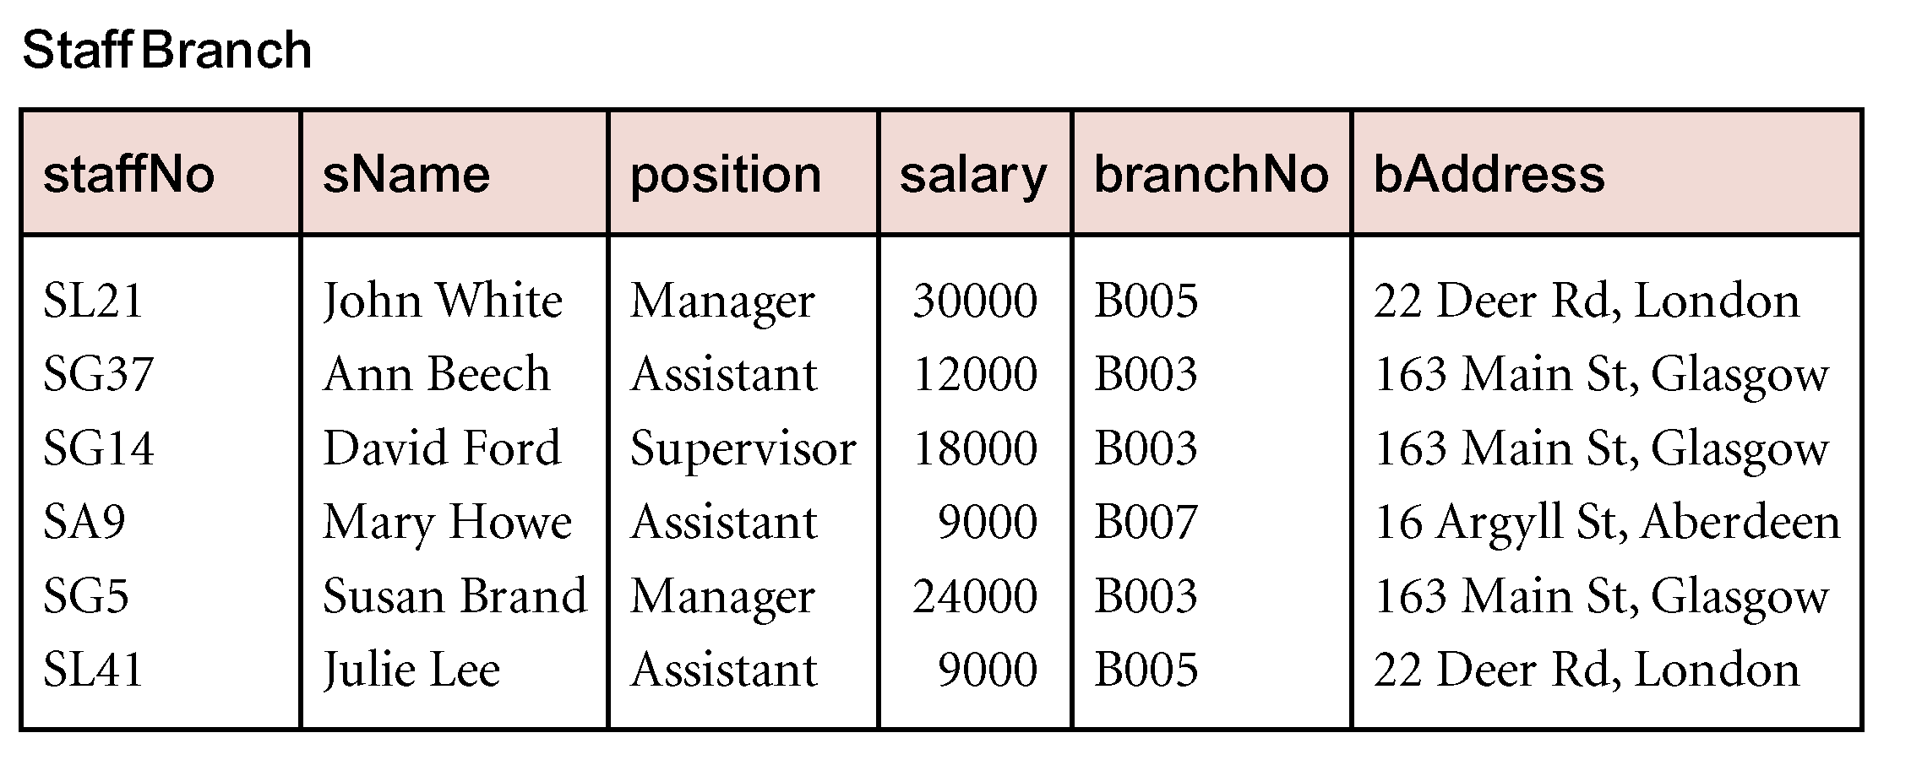
- What is the primary key of this table?
- staffNo
- Is there any redundant data? Give examples.
- Row 2, 3 & Row 5 branchNo and bAddress
- Describe how can one add a new branch with branchNo B008, and address at 12 Orchard Road, Singapore.
- To add a new branch, we must add a new staff too (because the table’s primary key is staffNo). We cannot add branchNo B008 without adding a new staff [Insertion Anomaly]
- What happen to branch B007 if staff Mary Howe’s record are to be deleted?
- If staff Mary Howes is deleted, branch B007 data’s will be deleted as well. [Deletion Anomaly]
- If we need to change the address of B003 to “8 Woodlands Road, Glasgow”, how many records need to be change?
- We need to update all three rows in staffBranch table in order to ensrure data consistency [Modifcation Anomaly]

- Given the following relational schema and its functional dependencies:

RentalInfo
custNo propertyNo custName pAddress rentStart ownerNo OName
fd1
fd2
fd3
fd5

fd4

- Specify candidate keys and state the primary key.
- Candidate keys: (custNo, propertyNo, ( custNo, rentStart)

- Assuming that the relation is in first normal form (1NF), describe and illustrate the process of normalising the relational schema to second (2NF) and third (3NF) normal forms. Identify the primary and foreign keys in your third normal forms.

- Table in 1NF
  - RentalInfo (..)
- 1NF → 2NF (Remove partial depency): fd3 and fd4 are Partial Dependencies
  - Property (propertyNo, pAddress, ownerNo, oName )
  - Customer (custNo , custName)
  - RentalInfo (custNo {FK}, propertyNo {FK}, rentStart)
- 2NF → 3NF (Remove Transitive Dependcy) :fd5 is Transitive Depency
  - Owner (ownerNo, oName)
  - Property (propertyNo, pAddress, ownerNo {FK})
  - Customer ( custNo, custName)
  - RentalInfo (custNo {FK}, propertyNo {FK}, rentStart)

Examine the table shown below.

brancNoNo | branchAddress | telNos | managerID | managerName
B001 | 8 Jefferson Way, Portland, OR 97201 | 503-555-3618,  503-555-2727,  503-555-6534 | 101 | Mary Lim
B002 | City Center Plaza, Seattle, WA 98122 | 206-555-6756,  206-555-8836 | 110 | John Tan
B003 | 14 – 8th Avenue, New York, NY 10012 | 212-371-3000 | 124 | Jason Wang
B004 | 16 – 14th Avenue, Seattle, WA 98128 | 206-555-3131,  206-555-4112 | 203 | Linda Yeo

- What normal form is this table in?
- 2NF
- Normalize this table to third normal form (3NF). Identify the primary and foreign keys in your 3NF relations.
- UNF → 1NF (identify PK, remove repeating group)
  - Branch
  - Telephone
- 1NF → 2NF (remove partial dependency)
  - There is no compsosite key ➔no partial depency, Tables are already in 2NF
- 2NF → 3NF (remove transitive dependencies)
Transitve Dependency : managerID → managerName
  - Manager
  - Branch
  - Telephone

