PENTECOST UNIVERSITY
FESAC

Secure Login Authentication System with Two-Factor Authentication and Role-Based Access
Assignment Report

Name: Addo Eric
Student ID: PUIT24210065
Programme: Information Technology
Date: October 2026

Table of Contents
1. Introduction and objectives
2. Technologies used
3. System architecture
4. Database design
5. User identification and registration
6. Two-factor authentication
7. Sessions
8. Role-based authorization
9. Salt and pepper password protection
10. Other protections
11. Implementation details
12. Testing
13. Limitations and future improvements
14. Conclusion
15. Instructions for running the application

1. Introduction and objectives
Almost every application that stores personal information needs to answer two questions: who is this user? and what are they allowed to do? This project builds a small but realistic authentication system that answers both questions and protects the passwords it stores.
The objectives, taken from the assignment brief, were to implement:
- User identification and registration: users create an account and later prove who they are.
- Two-factor authentication (2FA): a password alone is not enough; a one-time code is also required.
- Role-based authorization: what a user may do depends on a role (admin or user) that the server enforces.
- Salt and pepper: passwords are stored using a salted hash combined with a secret server-side pepper.
The system has a mobile and web interface built with Expo, and a PHP and MySQL backend that runs locally on XAMPP or Laragon. The same code is also deployed online at https://puit24210065.vercel.app, so that it can be tried from a public link.

2. Technologies used
Layer | Technology | Why it was chosen
Interface | Expo, React Native, TypeScript | One code base for Android, iOS and the browser, as required by the brief.
Navigation | Expo Router | File-based routing; the same routes work on phone and web.
Token storage (phone) | Expo SecureStore | Uses the iOS Keychain and Android Keystore.
API | PHP 8.1+ (no framework, no Composer) | Runs on any XAMPP or Laragon installation without extra downloads.
Database | MySQL / MariaDB with PDO | Prepared statements, foreign keys, unique indexes.
Password hashing | password_hash()  /  password_verify()  , Argon2id (bcrypt fallback) | Built into PHP, adaptive and salted.
Email | A small SMTP client written for the project | Sends the one-time code; no external library needed.
Online hosting | Vercel (static site +  vercel-php  functions) | Serves the Expo web build and runs the same PHP API under  /api  , over HTTPS.
Online database | Aiven MySQL 8.4 | Managed MySQL reachable from Vercel, with an encrypted (TLS) connection.
Online email | Gmail SMTP with an App Password | Delivers the one-time codes on the public site.

3. System architecture
Phone (Expo Go) ─┐ ┌─ users ├── HTTPS/JSON ──► PHP REST API ──►├─ otp_challenges (MySQL) Browser (Expo web)┘ (Bearer token public/index.php├─ sessions or HttpOnly └ Kernel └─ rate_limits cookie) └ AuthService
- Client. The Expo app has three signed-out screens (sign in, register, verify code) and three signed-in screens (dashboard, profile, administration). A route guard sends signed-out users to the sign-in screen, but this is only for convenience; the real checks are made by the server.
- API.public/index.php is the only entry point. The Kernel class handles routing, CORS, CSRF checks, session lookup and role checks, and returns response objects, which makes the whole API testable without a web server. AuthService contains the business logic (registration, password check, one-time code, sessions). Other small classes handle passwords, tokens, rate limiting, validation and email.
- Database. All access uses PDO prepared statements. Timestamps are generated by the application in UTC so behaviour does not depend on the database server's time zone.
- Configuration. Secrets (pepper, database password, SMTP password) live only in backend/.env on the server. The server refuses to start if the configuration is unsafe, for example if the pepper is missing, CORS is a wildcard, or the development one-time-code mode is enabled in production.
- Online version. On Vercel, api/index.php simply includes backend/public/index.php, so the public site runs the same PHP code. The website and the API share one domain, so the session cookie stays first-party. Settings come from Vercel's encrypted environment variables instead of .env, the database is Aiven MySQL (TLS verified against Aiven's CA certificate), and codes are emailed through Gmail.

4. Database design
Table | Purpose | Important columns and constraints
users | One row per account | email  (unique),  password_hash  ,  role  (  ENUM('user','admin')  , default  user  ),  created_at  ,  last_login_at
otp_challenges | A pending or used second-factor challenge | challenge_hash  (unique),  otp_hash  ,  attempts  ,  expires_at  ,  used_at  ; foreign key to  users  with  ON DELETE CASCADE
sessions | Login sessions | token_hash  (unique),  expires_at  ,  revoked_at  ; foreign key to  users
rate_limits | Counters for abuse prevention | bucket  (primary key, a hash),  hits  ,  window_start

Design decisions:
- The email column is unique, so the database itself rejects duplicates even if two requests race.
- Neither the one-time code, the challenge identifier, nor the session token is stored in readable form. Only hashes are stored (see sections 6 and 7).
- Indexes exist on foreign keys and on expiry columns, which are used when looking up sessions and cleaning old rows.
- The complete script is backend/database/schema.sql.

5. User identification and registration
Registration (POST /api/register). The client validates the form first (name length, email format, password rules, matching confirmation) to give instant feedback. The server then validates the same rules again, because client checks can be bypassed. The password must be 12 to 128 characters long, contain at least one letter and one digit, must not be a very common password, and must not equal the email address. The email is converted to lower case; if an account with that email already exists the server answers 409. The role of a new account is always user; the request body cannot choose a role.
Sign-in, step 1 (POST /api/login). The server looks up the account by email and verifies the password. For an unknown email it still performs a hashing operation, so that response time does not reveal whether an account exists. A wrong password and an unknown email produce exactly the same response (401, "Invalid email or password."). At this point the user is not signed in: no session exists until the second factor is verified.

6. Two-factor authentication
After a correct password the server:
- generates a six-digit code with random_int(), PHP's cryptographically secure generator;
- creates a random 256-bit challenge identifier and returns it to the app;
- stores only a keyed hash of the code (HMAC-SHA256, keyed with a secret derived from the pepper) and a hash of the challenge identifier;
- delivers the code by email through the SMTP server configured in .env.
Sign-in, step 2 (POST /api/verify-otp). The app sends the challenge identifier and the code. The server enforces:
- Expiry: a code is valid for five minutes.
- Attempt limit: five wrong guesses lock the code. The attempt counter is increased with a single atomic SQL statement before the comparison, so parallel requests cannot gain extra guesses.
- Single use: the code is marked as used with UPDATE ... WHERE used_at IS NULL; only the request that changes the row succeeds, so a code cannot be replayed.
- Replacement: asking for a new code, or signing in again, invalidates the previous code.
- Account-level limit: wrong guesses are also counted per account across challenges, so repeatedly starting a new sign-in does not reset the guess budget.
Development mode. To demonstrate the system without an email server, OTP_DELIVERY=dev makes the API return the code in its response, and the app shows it in a clearly labelled "Development mode" box. The server refuses to start with this setting when APP_ENV=production, so the code can never be exposed by a production deployment. The setting is off unless it is written into .env.

7. Sessions
When the code is correct the server creates a random 256-bit session token and stores its SHA-256 hash, together with an expiry time (8 hours by default). If the database were leaked, the stored values could not be used as sessions.
- Native app: the token is returned once and kept in Expo SecureStore (Keychain / Keystore). It is sent as a Bearer header.
- Web: the token is never given to JavaScript. It is sent as an HttpOnly cookie (Secure when configured, with SameSite). localStorage is deliberately not used, because any script on the page could read it. Because browsers attach cookies automatically, the server also protects cookie-based state-changing requests against cross-site request forgery: logout requires an allowed Origin header and a custom X-Client-Type header.
- Logout sets revoked_at in the database, so the token stops working immediately, even if someone copied it.

8. Role-based authorization
There are two roles, user and admin. For every protected request the server finds the session, loads the user from the database and checks the role. The interface hides the Admin menu link from ordinary users, but that is only for usability: the endpoint GET /api/admin/users returns 403 Forbidden to a normal user and 401 to a visitor without a session, whatever the client code or request contains. Changing a role in the database takes effect on the next request.
Public registration cannot create administrators. The first administrator is created on the server by registering normally and then running php bin/set-role.php you@example.com admin; only someone with access to the server can do this. Alternatively, the server setting ADMIN_EMAILS lists administrator email addresses. A listed account is promoted only after a successful login with both the password and the emailed code, which proves the person controls that inbox. The name a user types and the act of registering never grant the admin role. The online version uses this setting.

9. Salt and pepper password protection
- Salt.password_hash() generates a unique random salt for every password and stores it inside the hash string. Two users with the same password therefore get different hashes, and precomputed (rainbow) tables are useless.
- Pepper. A secret value, at least 32 characters, is kept in the server configuration, never in the database or the app. Before hashing, the password is passed through HMAC-SHA256 keyed with the pepper, and the result is given to password_hash(). An attacker who steals only the database cannot even start guessing passwords offline without the pepper. This pre-hashing step also avoids bcrypt's 72-byte limit.
- Algorithm. Argon2id is used when PHP supports it, otherwise bcrypt with cost 12. password_needs_rehash() upgrades old hashes at the next successful login.
- Plaintext passwords are never stored, logged or returned by the API.
The cost of the pepper is that it cannot be rotated without forcing password resets, because it is part of every hash. This is listed under limitations.

10. Other protections
- Rate limiting (stored in MySQL): 8 failed sign-ins per email and 30 requests per IP per 15 minutes; 30 code attempts per IP; at most 10 registrations per hour per IP; a 30-second cooldown between code requests. Responses are 429 with a Retry-After header.
- Prepared statements everywhere, so input cannot change the meaning of a query.
- CORS allows only the exact origins listed in .env, never *, because cookies are involved.
- Safe errors. Authentication failures are generic. Unexpected errors return a generic message while details go to the server log. Misconfiguration returns 500/503 without naming settings or values.
- Response headers: Cache-Control: no-store, X-Content-Type-Options, a restrictive Content-Security-Policy, and Strict-Transport-Security in production.

11. Implementation details
Area | Where
Entry point and routing, CORS, CSRF, role guard | backend/src/Http/Kernel.php  ,  backend/public/index.php
Registration, login, OTP, sessions | backend/src/Services/AuthService.php
Salt and pepper | backend/src/Security/Passwords.php
Secure random values | backend/src/Security/Tokens.php
Rate limiting | backend/src/Security/RateLimiter.php
Email (SMTP) and development delivery | backend/src/Mail/
Validation | backend/src/Validation/Validator.php  ,  mobile/src/lib/validation.ts
Configuration safety checks | backend/src/Config.php
Database schema | backend/database/schema.sql
Command-line tools | backend/bin/setup-db.php  ,  set-role.php  ,  generate-secret.php
App screens | mobile/app/
API client, session state, secure storage | mobile/src/lib/api.ts  ,  auth.tsx  ,  storage.ts

The interface is deliberately simple: a header bar with the application name and (when logged in) the menu links Dashboard, Profile, Admin (administrators only) and Logout, with the page content below it. Forms are a single column with a maximum width, so the same layout works on a phone and in a desktop browser. The admin user list is a plain table that scrolls sideways on narrow screens. Forms show a loading state on the button, field-level errors and readable messages.

12. Testing

12.1 Automated backend tests (PHP)
backend/tests/run.php contains 63 tests that call the API kernel directly against a separate test database (login_auth_test). They cover every item required by the brief:
Requirement | Test file
Registration succeeds; duplicates (including different letter case) are rejected; validation; SQL-injection input | registration.php
Passwords are stored as salted, peppered hashes (plaintext absent, wrong pepper fails, same password gives different hashes) | registration.php
Correct and incorrect password; identical generic errors for unknown email | login_and_otp.php
OTP success, wrong code, attempt limit, expiry (exactly 300 s), reuse, replacement, resend, delivery failure; hashes only in the database | login_and_otp.php
Session creation, invalid and expired sessions, logout and revocation, web cookie flow and CSRF checks | login_and_otp.php
Admin can list users; normal user gets 403; anonymous gets 401; role comes from the database; no hashes in output | authorization.php
CORS (allowed origin, rejected origin, never  *  ), 404/405/400/413/415, security headers, rate limits (account, IP, registration, OTP guessing) | http_and_abuse.php
Configuration errors handled safely (missing/short/placeholder pepper, dev OTP in production, wildcard CORS, insecure cookies, bad SMTP, database down) and no dev OTP in production responses | configuration.php

How the tests were run. On the development computer, Windows Smart App Control blocked php.exe, and no MySQL server could be started. The suite was therefore run with tools/wasm-runner (npm test): PHP 8.3 compiled to WebAssembly, running inside Node.js, with an in-memory SQLite database instead of MySQL. A small translation layer (tools/wasm-runner/compat.php) rewrites the few MySQL-only statements (ON DUPLICATE KEY UPDATE, TRUNCATE, SET FOREIGN_KEY_CHECKS, one DATE_ADD in a test). The application code itself is not changed. Because this PHP build has no Argon2 support, the bcrypt fallback was the algorithm exercised.
Result:
63 passed, 0 failed (894 assertions)
To check that the tests really detect faults, three bugs were deliberately introduced in a copy of the code, one at a time. Each was caught: removing the admin role check failed 2 authorization tests; making codes valid for 99,999 seconds failed the five-minute expiry test; and no longer marking codes as used failed 4 OTP tests (including "a code can be used only once").
Not yet verified against MySQL. The MySQL schema (database/schema.sql), the MySQL form of the rate-limit query and the duplicate-key error code (1062) were not exercised by this run. The schema and the rate-limit query were later used on the online MySQL database (section 12.4), but the test suite itself has not run against MySQL. On a computer where XAMPP or Laragon works, run:
cd backend php tests/run.php
and add the output here:
(paste the output of php tests/run.php here, including the final "N passed, M failed" line)

12.2 Client checks that were actually run
Check | Command | Result
TypeScript type check (strict mode) | npm run typecheck  in  mobile/ | Completed with no errors
Client validation unit tests | npm test  in  mobile/ | 6 tests, 6 passed, 0 failed
Production web build | npx expo export --platform web | Succeeded; output in  mobile/dist  (one JavaScript bundle, about 1.1 MB, and  index.html  )
Secrets in build output | search of the built JavaScript for  DB_PASS  ,  APP_PEPPER  ,  SMTP_PASS | None found

12.3 End-to-end tests over HTTP and in a browser
The unit tests above call the API classes directly, so they skip the code that reads real HTTP requests and writes real responses (headers, cookies, public/index.php). Two further checks covered that path, using the real PHP API served by tools/wasm-runner (npm run api), again with SQLite instead of MySQL:
- HTTP checks (26 passed, 0 failed): register, duplicate and invalid registration, wrong password, login with code, wrong code with attempts remaining, correct code, code reuse refused, bearer-token session, normal user refused on the admin route (403), anonymous refused (401), logout and revocation, CORS for allowed and unknown origins, a browser sign-in from a disallowed origin refused, the HttpOnly; SameSite=Lax session cookie, promotion with the real bin/set-role.php, the admin user list without password hashes, and cookie logout refused without the CSRF headers.
- Browser test (60 passed, 0 failed): the web build was opened in a headless Edge browser and driven through a script in three sessions (desktop standard user, phone-sized administrator, desktop administrator) against the real PHP API.
While these were being set up, a database-locking error appeared. It was caused by the test environment (SQLite file locks on a mounted Windows folder), not by the application, and was fixed in the runner. Some early runs also failed one step each because the script checked the page before the server had finished hashing the password; the script was changed to wait for each result. No bugs were found in the PHP application code.
Earlier, before the backend could be run, the same browser script was used against a small mock API to develop the interface. The browser checks were: redirect to sign-in when signed out; empty and weak inputs rejected on the client; registration; generic error for a wrong password; moving to the code screen; wrong then correct code; dashboard and role display; session survives a reload through the cookie; no token in localStorage or sessionStorage; the session cookie is not readable from JavaScript; profile page; the administration page listing users for an administrator and showing "Access denied (403)" for a normal user; sign-out and redirect. Two bugs found by this process (a confusing error when the API address was wrong, and a spurious "session ended" message at start-up) were fixed.

12.4 Tests of the online version (real MySQL and real email)
The deployed site at https://puit24210065.vercel.app was tested on 11 October 2026.
- Database setup:backend/database/schema.sql was run unchanged on Aiven MySQL 8.4.11 over a verified TLS connection and created the four tables. This is the first run of the project against real MySQL.
- Automated live checks (17 passed, 0 failed): health check reaching the database; Strict-Transport-Security and no-store headers; registration (new account gets the user role); duplicate email in different letter case refused (409); invalid input refused (422); wrong password refused with the generic message (this also exercises the MySQL form of the rate-limit query); correct password sends the code by email, and the response does not contain the code; masked email hint; a wrong code is refused with 4 attempts left; no session without the code (401); the admin route refused without a session (401); CORS allows only the site's own origin; finishing a sign-in from another origin is refused (403).
- Manual check: an account was registered on the public site with a personal Gmail address, the emailed code arrived and was entered, and the account was signed in. That account was then made an administrator directly in the database (the online equivalent of bin/set-role.php).
- Problem found and fixed: the first live run failed to send email (SMTP error 535, "username and password not accepted") because the App Password had been created in a different Google account from the sender address. The application handled it safely: it answered 503 and kept no code. Using the matching account fixed it.

12.5 Screenshots
Figures 1–10 were captured from the web version of the app running against the real PHP API on the local computer (tools/wasm-runner, development mode, so the code is shown on screen instead of being emailed). Figure 11 is from the online MySQL database.
Figure 1. Login screen.
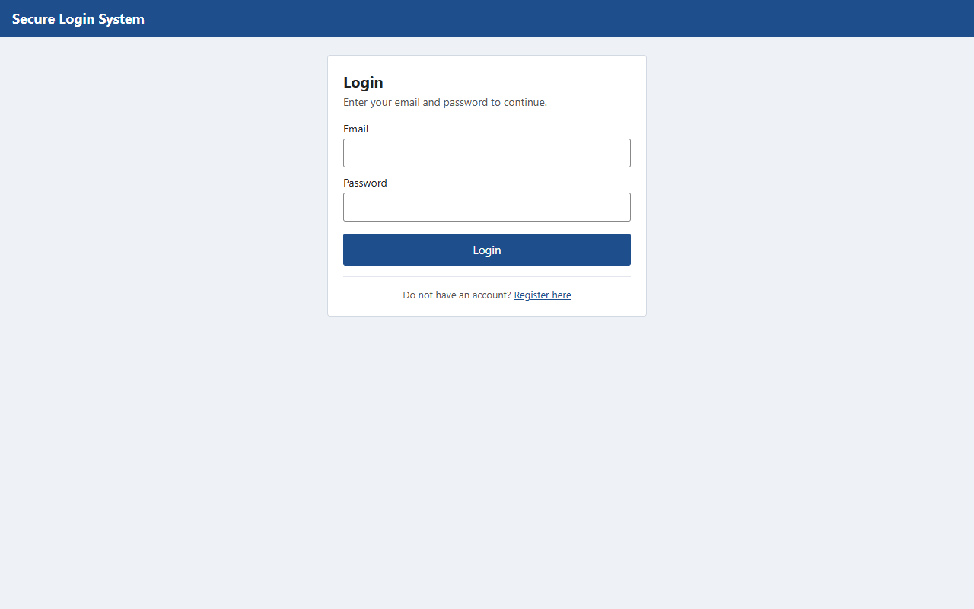
Figure 2. Registration with client-side validation errors.
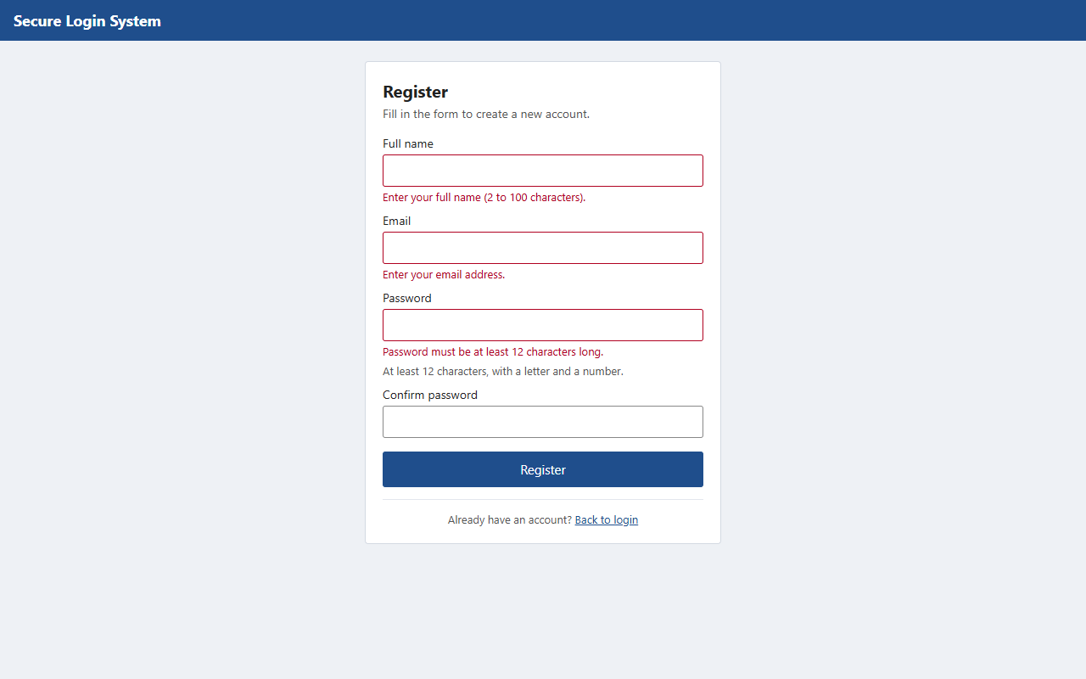
Figure 3. After a successful registration the user is returned to the login screen with a message.
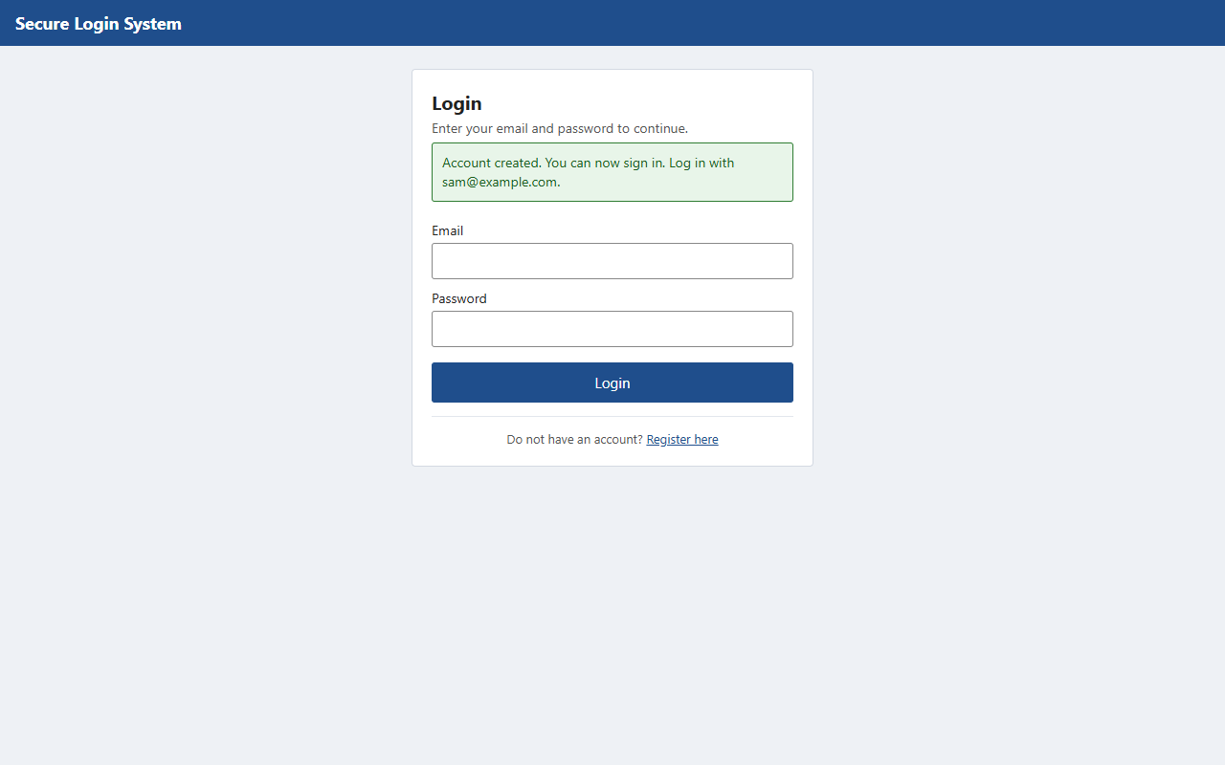
Figure 4. Two-factor step after the correct password. In development mode the code is shown in the yellow box; online it is emailed.
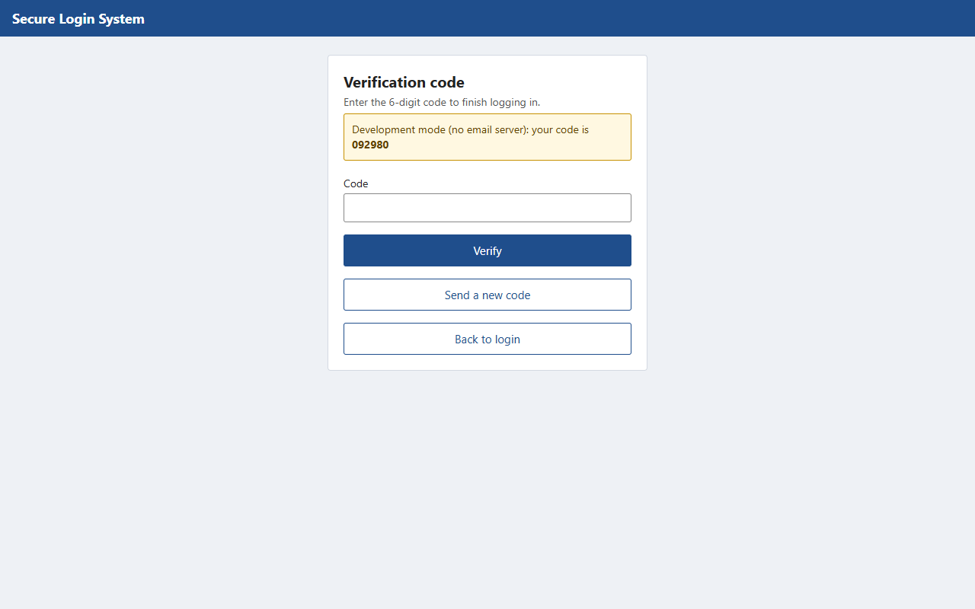
Figure 5. A wrong code is refused (the server also counts the attempt).
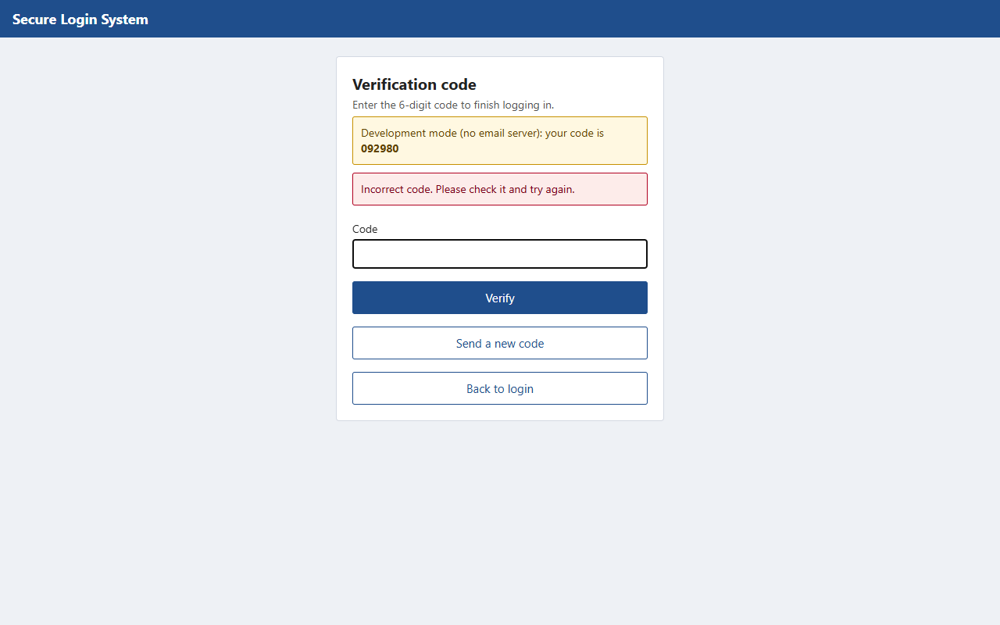
Figure 6. Dashboard of a standard user after password + code.
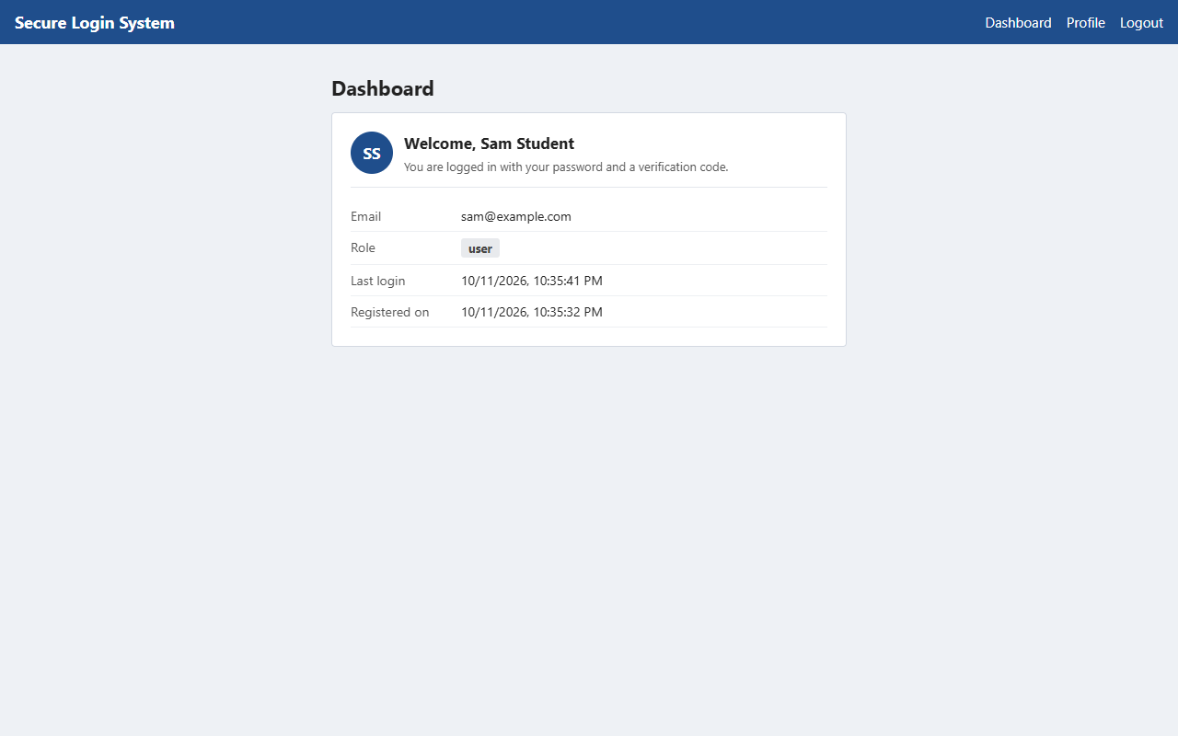
Figure 7. Profile page showing the role.
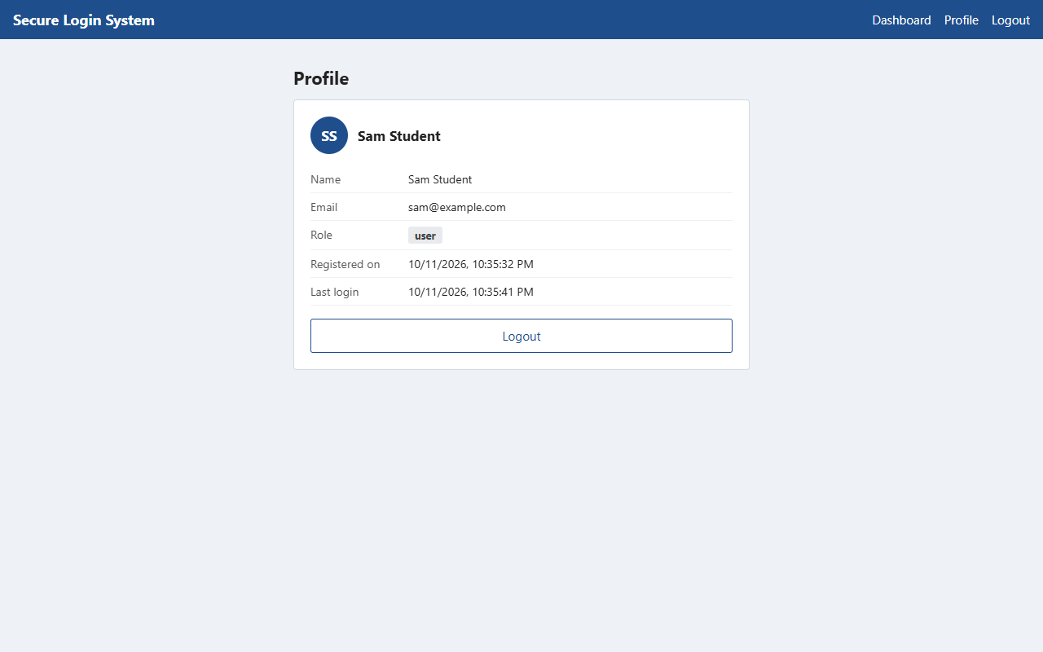
Figure 8. A standard user who opens the admin page by typing its address is refused by the server (403).
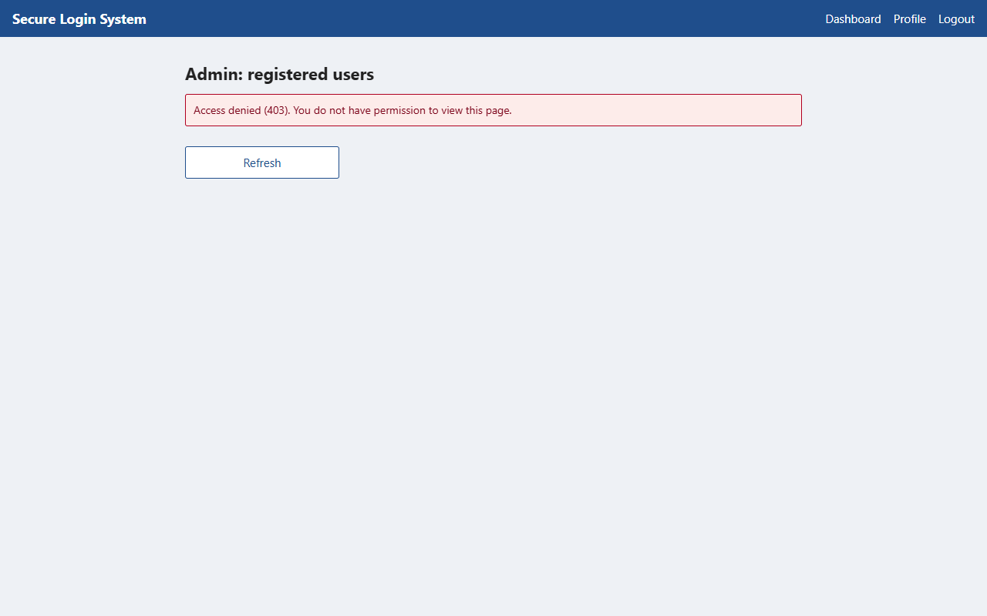
Figure 9. The admin page for an administrator, listing registered users (no password data is sent).
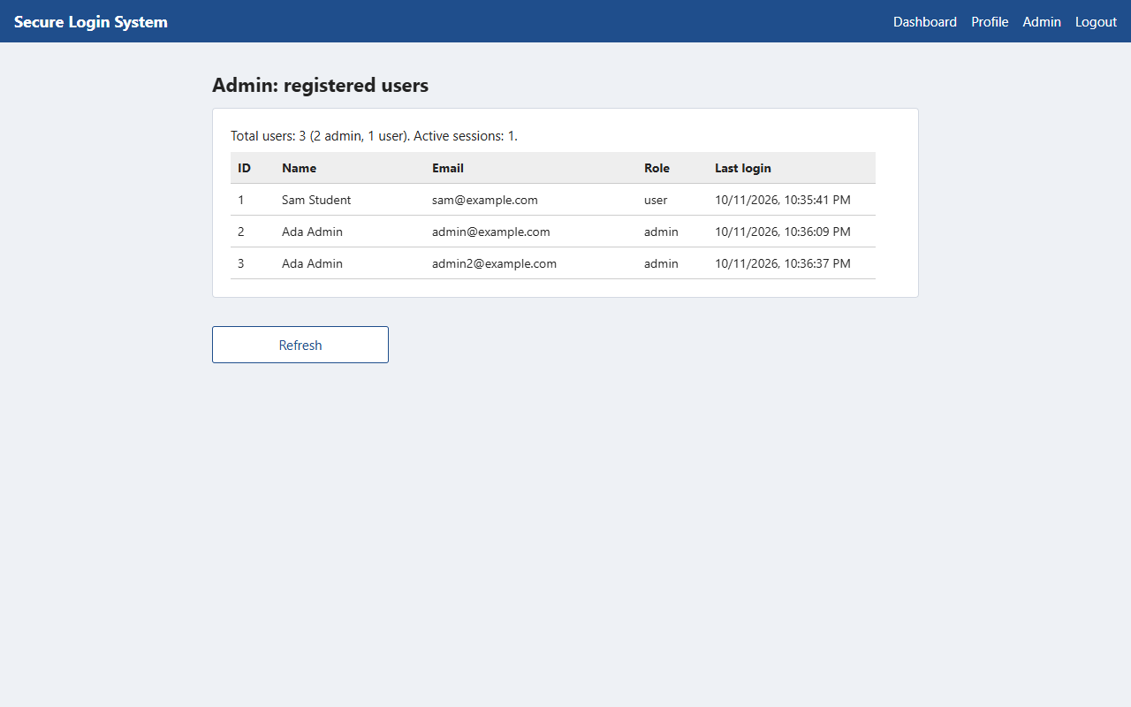
Figure 10. The dashboard at phone width.
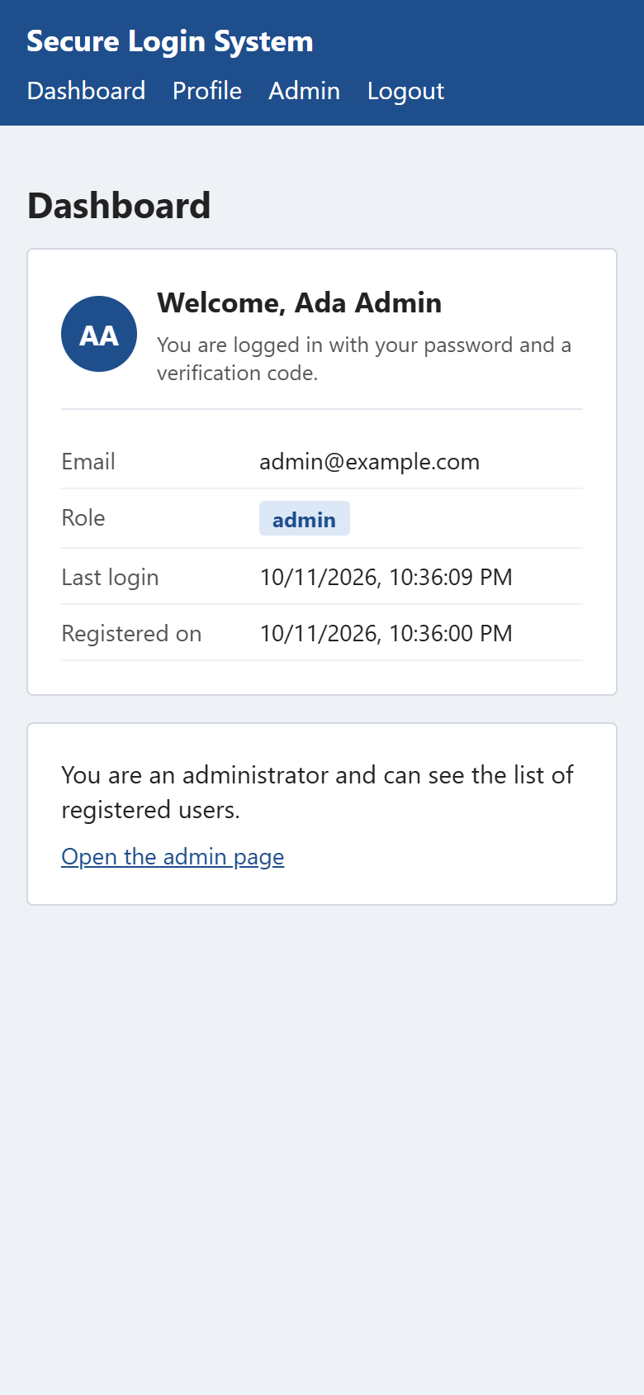
Figure 11. The users table in the online MySQL database. The password column contains only the Argon2id hash produced by password_hash(); the salt is inside the hash and the pepper is not stored.
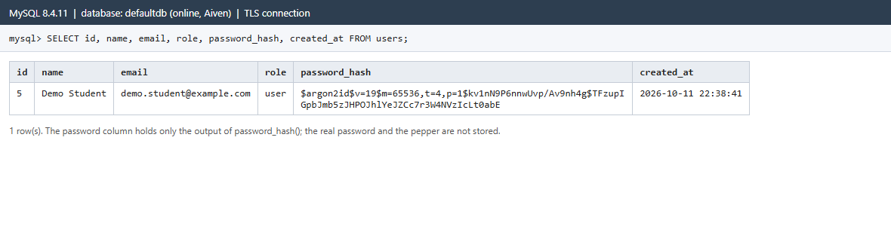
Still to add from a local XAMPP or Laragon run: the terminal output of php tests/run.php, and the app running in Expo Go on a phone.

13. Limitations and future improvements
- The backend tests were run with PHP in WebAssembly against SQLite, not yet against MySQL (section 12.1).
- Email delivery through SMTP is implemented but has not been tested against a live mail server.
- The pepper is a single secret; rotating it would require a re-hash migration (for example storing a pepper version with each hash) or forced password resets.
- Account lockout is per email, so an attacker can temporarily lock a victim's login by sending wrong passwords. A CAPTCHA or progressive delays would reduce this.
- Registration reveals whether an email is already registered (needed for a clear error message). Email verification would avoid this.
- No password reset, email verification or "remember this device" feature; sessions are fixed-length.
- Roles are changed only from the command line; there is no administrator interface for changing roles.
- The second factor is an emailed code, which is only as secure as the mailbox. Authenticator apps (TOTP) or WebAuthn passkeys are stronger.
- Rate limits are stored in MySQL and keyed by IP address, which can be inaccurate behind shared networks or proxies.
- The online version depends on three free or trial services (Vercel, Aiven, Gmail). Gmail limits sending to about 500 emails a day, codes can land in spam folders, and the first request after a quiet period can be slow while Vercel starts the PHP function.

14. Conclusion
The project implements the four required elements: users are identified through validated registration and a password check; a second factor (a single-use, expiring, attempt-limited one-time code) is required before a session is created; authorization depends on a role that the server reads from the database on every protected request; and passwords are protected with a per-password salt plus a server-side pepper. Sessions are random, stored only as hashes, expire and can be revoked, and the web version avoids storing tokens where scripts can read them.
The interface was built, type-checked, unit-tested and compiled for the web. The backend's 63 tests pass, and the whole system was tested end to end over HTTP and in a browser with the real PHP code, using SQLite in place of MySQL. The online version was then tested against real MySQL with real emailed codes, and sign-in works there. The full test suite has still to be run against a local XAMPP or Laragon MySQL.

15. Instructions for running the application
See README.md for the full step-by-step guide. In short, on Windows with XAMPP and Node.js installed:
# 1. start MySQL in the XAMPP Control Panel cd backend copy .env.example .env # then put the output of php bin/generate-secret.php after APP_PEPPER= php bin/setup-db.php php tests/run.php # backend tests php -S localhost:8000 -t public public/index.php # in a second terminal cd mobile npm install npm test npx expo start # press w for the browser
To make an administrator: register in the app, then php bin/set-role.php you@example.com admin. The online version is at https://puit24210065.vercel.app. How it is set up (Vercel, Aiven MySQL, Gmail) is described in docs/DEPLOYMENT.md, section 0.

