

SYSTEM REQUIREMENTS SPECIFICATION (SRS)

POLICY AND CIRCULAR MANAGEMENT

KCDIO | MANAGEMENT SERVICES DIVISION
MODULE | PC-19: POLICY AND CIRCULAR SYSTEM
DATE | -
VERSION | 1.0

EXECUTIVE SUMMARY

This document describes business and user requirements for the development of a new Hurman Resources Information System The content includes detailed information on business scope, system overview, stakeholders involved, business management requirements, business operation requirements and business process requirements. This document will be an input to the preparation of System Requirements Specifications to be developed.

DOCUMENT APPROVAL

Prepared by
NAME | POSITION | SIGNATURE / DATE
Tengku Zemy Azmira binti T Aziz | Team Lead Human Resources & Admin Services  Senior Information Technology Officer  Human Resources and Admin Services

Reviewed by Technical Team Member
NAME | POSITION | SIGNATURE / DATE
Abu Hurairah bin Abd. Manaf | Technical Project Manager  Deputy Director  Information Technology Division

Approved by Functional Team Member
NAME | POSITION | SIGNATURE / DATE

REVISION HISTORY

Version | Date | Prepared / Revised by | Summary of revision | Distribution list
1.0 | 30 May 2026 | Ahmad Izzuddin Bin Ahmad Sakri | New submission of SRS | ITG, Functional Team, Technical Team
 |  | Tengku Zemy Azmira T Aziz

TABLE OF CONTENTS

1.0 INTRODUCTION 5
1.1 Objective 5
1.2 Scope 5
1.3 Actor of the System 5
2.0 SYSTEM ARCHITECTURE 6
2.1 Information Architecture 6
2.2 System Environment 6
2.3 Integration 7
3.0 SYSTEM FUNCTION MODELLING 7
3.1 Modelling Notation 7
3.2 System Functional Hierarchy 7
3.3 Table of Actor Matching to System Function 8
4.0 USE CASE MODELLING 9
4.1 Organizational Hierarchy Module 9
4.2 List of Values (LOV) Module 10
4.3 Reporting Module 11

INTRODUCTION

Objective

The primary objective of a Software Requirements Specification (SRS) document is to define the functional and non-functional requirements of the Project Policy and Circular System. It serves as a crucial communication tool between various stakeholders, including clients, project managers, software developers, and quality assurance teams. The SRS outlines the software's functionality, performance, design, and constraints, providing a comprehensive understanding of the project's requirements

Scope
This module will cover:
- Management of Policy Circular
- Management of Access Role

Actor of the System

Table 1 : Actor of the System
ACTOR | DESCRIPTION
MSD Administor and KCDIOM Liason | Responsible for managing policy circulars, uploading documents, activating circulars and managing system access roles.
Staff/User | View and download policies and circulars
System | Handles automated processes such as storage, version control and archival activities.

SYSTEM ARCHITECTURE

Information Architecture
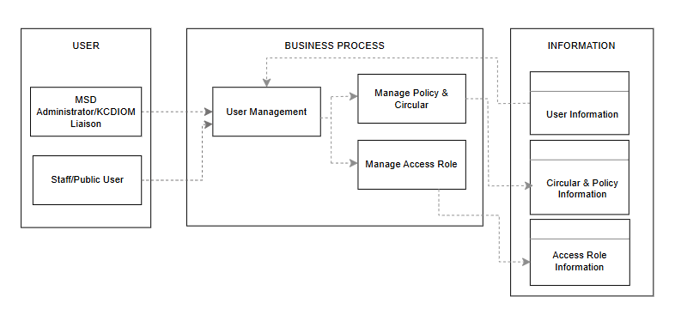
- Update add data of staff from CAS – User and HURIS – KCDIOM Info
Figure 1 : Information Architecture

System Environment

- PostgreSQL
The system will be developed using PostgreSQL database. There shall be an integration with current Oracle Database since many information are still available in the Oracle Database.

- PHP Laravel
Laravel provides a variety of tools and features for developing web applications, including routing, middleware, controllers, models, views, and authentication. It follows the Model-View-Controller (MVC) architectural pattern and emphasizes convention over configuration, which means that developers can get up and running quickly without having to spend a lot of time configuring the framework.

- Visual Studio

Visual Studio serves as the primary integrated development environment (IDE). It supports PHP and Laravel development workflows, including debugging, testing, and source control integration, ensuring high developer productivity.

Integration

The Policy and Circular System shall be integrated with Central Authentication System (CAS) for authentication method and HURIS for KCDIOM information.

SYSTEM FUNCTION MODELLING

Modelling Notation

Refer to System Function Modelling Notation as in Appendix A.

System Functional Hierarchy

Figure below illustrate the functional hierarchy of the IIUM Promotion System produced from the activity of modelling system functions on the Business Process Requirements (BPR) documented in the Functional User Requirements (FRS).

Figure 2 : Functional Hierarchy for Policy and Circular Structure
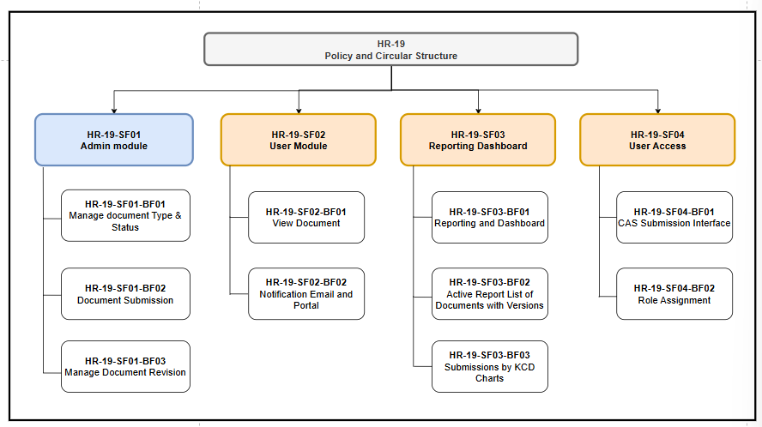
- Besarkan font
- User Module – Combine Notification box into 1 process only
- Reporting – Jadi 1 je generate report and dashboard

Table of Actor Matching to System Function

Table 2 : Actor Matching to System for Admin Module

Module Name: Admin Module
Business Function ID: HR-19-SF01
No | Business Process ID | Activity Descriptions | System Actor
1 | HR-19-SF01-BP01 | Manage document type & status | MSD Admin
2 | HR-19-SF01-BP02 | Document Submission | MSD Admin
3 | HR-19-SF01-BP03 | Manage Document Revision | MSD Admin

Table 3 : Actor Matching to System for List of Values (LOV) Module
Module Name: User Module
Business Function ID: HR-19-SF02
No | Business Process ID | Activity Descriptions | System Actor
1 | HR-19-SF02-BP01 | View Document | Staff / User
2 | HR-19-SF02-BP02 | Notification Email | System
3 | HR-19-SF02-BP03 | Notification Portal | System / Staff

Table 4 : Actor Matching to System for Reporting Module
Module Name: Reporting Dashboard
Business Function ID: HR-19-SF03
No | Business Process ID | Activity Descriptions | System Actor
1 | HR-19-SF03-BP01 | Reporting and Dashboard | MSD Admin
2 | HR-19-SF03-BP02 | Active Report List of Documents with Versions | MSD Admin
3 | HR-19-SF02-BP03 | Submissions by KCD Charts | MSD Admin
Table 5: Actor Matching to System for User Access Module
Module Name: User Access
Business Function ID: HR-19-SF04
No | Business Process ID | Activity Descriptions | System Actor
1 | HR-19-SF03-BP01 | CAS submission | Staff / User
2 | HR-19-SF03-BP02 | Role Assignment | MSD Admin

USE CASE MODELLING

Admin Module

- Use Case Diagram
Figure 3 : Use Case Diagram for admin Module
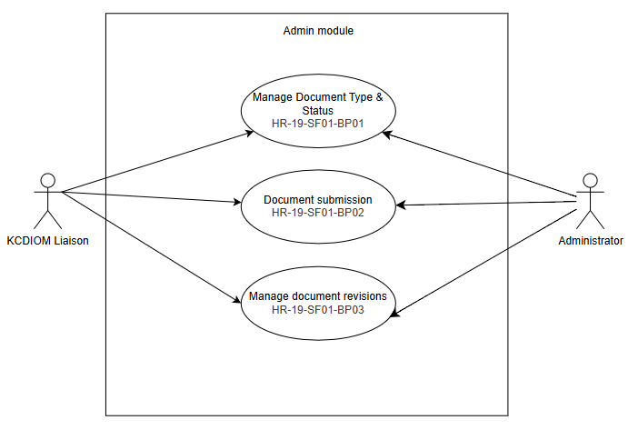
- Plus actor KCDIOM Liaison
- Use Case Descriptions

Table 5 : Use Case Descriptions for Admin Module
No | Use Case ID | Use Case Name |  | Descriptions
1 | HR-19-SF01-BP01 |  | Manage Document Type & Status | Enables the MSD Admin to configure document rules and status values.
2 | HR-19-SF01-BP02 |  | Document submission | Manage the formal intake newly approved files into the digital ecosystem repository.
3 | HR-19-SF01-BP03 |  | Manage document revisions | Manage the system's underlying version control recognise historical audit tracking when old policies get replaced.

User Module

- Use Case Diagram

Figure 4 : Use Case Diagram for User Module
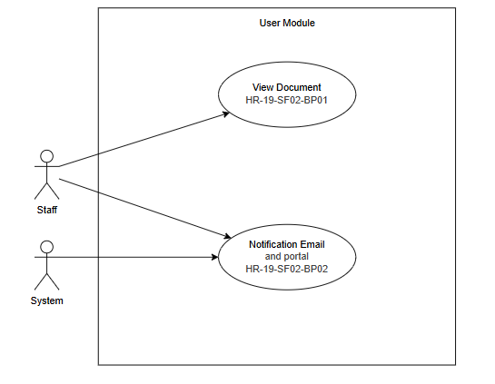
- Link dr notification system to ke staff juga
No | Use Case ID | Use Case Name |  | Descriptions
1 | HR-19-SF02-BP01 |  | View Document | The system allows users to browse and read live published policies and circulars.
2 | HR-19-SF02-BP02 |  | Notification Email | The system fires automated alert emails to target users when a new circular is published.
3 | HR-19-SF02-BP03 |  | Notification Portal | The system displays localized push notifications and alert banners on the web dashboard.

- Use Case Description
Table 6 : Use Case Description for User Module

Reporting Dashboard Module

- Use Case Diagram

Figure 4 : Use Case Diagram for reporting Module
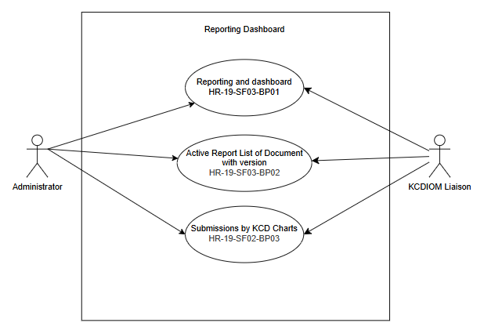
- Use Case Description
Table 6 : Use Case Description for reporting Module
No | Use Case ID | Use Case Name |  | Descriptions
1 | HR-19-SF03-BP01 |  | CAS Submission | Displays high-level KPI dashboard counter cards tracking total documents.
2 | HR-19-SF03-BP02 |  | Role Assignment | Generates a master list showing active items alongside their version history.
3 | HR-19-SF03-BP03 |  | Submissions by KCD Charts | Renders visual analytics charts of submissions filtered by Kulliyyah/Centre/Division.

User Access Module

- Use Case Diagram
Figure 4 : Use Case Diagram for User Access Module
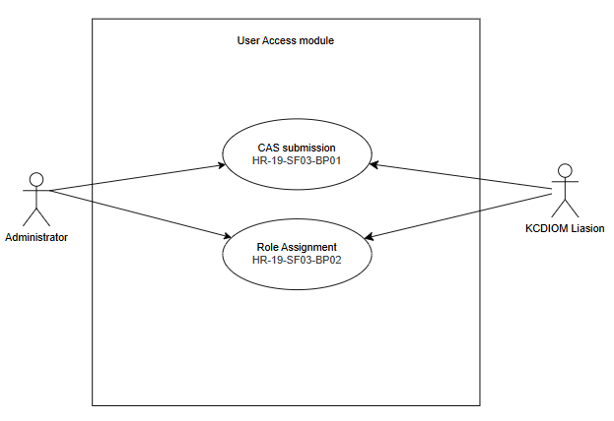
- Use Case Description
Table 6 : Use Case Description for User Access Module
No | ID | Use Case Name |  | Descriptions
1 | HR-19-SF04-BP01 |  | CAS Submission | Processes user login credentials and session verification via the Central Authentication Service.
2 | HR-19-SF04-BP02 |  | Role Assignment | Allows the master administrator to map accounts to structural system roles and permissions.

------------------------------------------------ END OF DOCUMENT ----------------------------------------------

