INDUSTRIAL TRAINING REPORT
INTERNATIONAL ISLAMIC UNIVERSITY MALAYSIA
(IIUM)

AHMAD IZZUDDIN BIN AHMAD SAKRI

REPORT SUBMITTED IN PARTIAL FULFILMENT FOR
THE BACHELOR IN SOFTWARE ENGINEERING
(INFORMATION TECHNOLOGY)

MALAYSIAN INSTITUTE OF INFORMATION TECHNOLOGY KUALA LUMPUR
2026
This report was read and verified by:

………………………………………. …………………...
ASNILI MARNIWATI BT AHMAD Date
Company Supervisor

……………………………………….. …………………..
SUZANA BINTI KASSIM Date
University Supervisor

Contents
DECLARATION iv
ACKNOWLEDGEMENT v
ABSTRACT vi
CHAPTER I 1
INTRODUCTION 1
1.1 Introduction 1
1.2 Background of Industrial Training 2
1.3 Objectives of Industrial Training 2
1.4 Scope of Industrial Training 3
CHAPTER ll 4
COMPANY INFORMATION 4
2.1 Introduction 4
2.2 Company Background 4
2.3 Company Profile 5
2.4 Organizational Structure 5
2.5 Nature of Business / Activities 6
2.6 Products and Services 6
2.7 Information Technology Division (ITD) 7
2.8 Internship Placement 8
2.9 Summary 8
CHAPTER lll 8
TECHNICAL SECTION 8
3.1 Introduction 8
3.2 Objective of the Project 9
3.5 System Analysis 17
3.6 Trainee Involvement 18
3.7 Technical Documentation 18
CHAPTER IV 19
CONCLUSION AND RECOMMENDATIONS 19
4.1 Introduction 19
4.2 Knowledge and Experience Gained 19
4.4 Solutions Implemented 20
4.5 Recommendations for the Organization 21
4.6 Personal reflections 22
4.7 Conclusion 22

DECLARATION

I declare that this Industrial Training Report titled "Development of the Circular and Policy Management System at the Management Services Department (MSD), International Islamic University Malaysia (IIUM)" is my own original work, except for the parts that are referenced. I have not submitted this report before, in whole or in part, for any other academic award or qualification at this or any other institution.
I confirm that I have properly acknowledged and cited all information, data, figures, and materials obtained from books, journals, websites, company documents, and other sources according to academic writing standards.
The work in this report was completed during my industrial training at the Management Services Department (MSD), International Islamic University Malaysia (IIUM) under the supervision of my assigned company supervisor and university supervisor.

ACKNOWLEDGEMENT

In the name of Allah, the Most Gracious, the Most Merciful. Alhamdulillah, all praise is due to Allah SWT for His blessings, guidance, and strength that enabled me to successfully complete my industrial training and this Industrial Training Report.
First and foremost, I would like to express my sincere gratitude to Universiti Kuala Lumpur Malaysian Institute of Information Technology (UniKL MIIT) for providing me with the opportunity to undergo industrial training as part of the Bachelor of Software Engineering programme. The internship has allowed me to gain valuable practical experience and exposure to a professional working environment.
I would like to express my deepest appreciation to my university supervisor, Madam Suzana Binti Kassim, for her continuous guidance, encouragement, constructive comments, and valuable advice throughout my internship and during the preparation of this report.
My sincere appreciation also goes to my company supervisor, Madam Asnili Marniwati Binti Ahmad, and all staff members of the Management Services Department (MSD), International Islamic University Malaysia (IIUM) for their guidance, support, patience, and willingness to share their knowledge and experience during my internship.
I would also like to thank the officers and staff of the Information Technology Division (ITD), IIUM, especially those who provided valuable feedback, technical guidance, and recommendations regarding the development of the Circular and Policy Management System. Their professional advice helped me better understand enterprise software development practices and organizational standards.
Finally, I would like to express my heartfelt gratitude to my parents, family members, and friends for their continuous encouragement, understanding, and moral support throughout my industrial training period. Their support has been a great source of motivation in completing both my internship and this report successfully.
I sincerely appreciate everyone who has directly or indirectly contributed to the successful completion of my industrial training and this report.
Thank you.

ABSTRACT

Industrial training is an essential component of the Bachelor of Software Engineering programme at Universiti Kuala Lumpur Malaysian Institute of Information Technology (UniKL MIIT). It provides students with the opportunity to apply theoretical knowledge in a professional working environment while developing technical and interpersonal skills relevant to the software engineering industry.
This report presents the activities and experiences gained during the industrial training conducted at the Management Services Department (MSD), International Islamic University Malaysia (IIUM) from 14 April 2026 to 17 August 2026. During the internship, the primary project assigned was the development of a Circular and Policy Management System, which aims to improve the management of university policies and circulars through a centralized web-based application. The project involved collaboration between MSD, as the system owner, and the Information Technology Division (ITD), which provided technical guidance and ensured compliance with the university's software development standards.
The internship focused on various software engineering activities, including requirement gathering, business process analysis, software documentation, database design, prototype development, and stakeholder presentations. An initial prototype was developed using PHP and MySQL, while Laravel was studied as the preferred framework for future implementation based on ITD's recommendations. Throughout the project, comprehensive documentation such as the Software Requirements Specification (SRS), functional requirements, use case diagrams, and database designs was prepared to support system development.
Overall, the industrial training provided valuable exposure to enterprise software engineering practices and strengthened my understanding of the Software Development Life Cycle (SDLC). It enhanced both my technical competencies and professional skills, particularly in requirement analysis, documentation, stakeholder communication, and system design. The knowledge and experience gained throughout the internship have prepared me for future challenges and responsibilities in the software engineering profession.

CHAPTER I

INTRODUCTION

1.1 Introduction
Industrial Training (INTRA) is an essential component of the Bachelor of Software Engineering programme at Universiti Kuala Lumpur (UniKL). The programme provides students with the opportunity to gain practical experience in a real working environment while applying the knowledge and technical skills acquired throughout their academic studies.
The internship exposes students to professional working practices, enhances communication and teamwork skills, and enables them to understand the complete Software Development Life Cycle (SDLC). Students are also given the opportunity to solve real-world problems, interact with stakeholders, and develop professional ethics required in the software engineering industry.
During this industrial training, I was attached to the Management Services Department (MSD) at the International Islamic University Malaysia (IIUM), Gombak Campus, from 14 April 2026 until 17 August 2026. Throughout the internship period, I was assigned to participate in the development of a Circular and Policy Management System.
Although the project belongs to MSD, the technical guidance and development standards were supervised by the Information Technology Division (ITD). Therefore, the project required continuous collaboration between both departments to ensure that the proposed system complied with organizational requirements and software development standards.
Unlike many software development projects that begin directly with coding, this project emphasized requirement analysis, stakeholder discussions, and comprehensive documentation before system implementation. These activities were essential because the system involves official university policies and circulars, which require structured approval workflows, role-based access control, and compliance with institutional governance procedures.
This internship provided valuable exposure to enterprise software engineering practices, enabling me to understand that successful software development depends not only on programming skills but also on effective communication, documentation, system analysis, and stakeholder collaboration.
On a personal note, I chose to undertake this internship placement because I wanted to gain a deeper, hands-on understanding of software development processes within a real professional environment, having had limited prior exposure to industry practice. As this placement is directly related to my university course, Software Engineering, it presented itself as a natural and valuable extension of my academic studies. From the outset, I was entrusted to work on the project largely independently, despite having no prior working experience, under the supervision of the ITD team. This required me to quickly familiarize myself with a range of procedural guidelines that had to be understood and adhered to throughout the internship. My weekly schedule also reflected the collaborative nature of the project: I was based at the ITD office for four days a week, and at the MSD office every Friday, which allowed me to experience both the technical and business perspectives of the project firsthand.

1.2 Background of Industrial Training
Industrial Training is designed to bridge the gap between academic learning and professional practice. It allows students to experience workplace culture while applying theoretical concepts to practical situations.
The internship expected to enhance their technical competency, improve professional communication, develop problem-solving skills, and gain exposure to organizational management and software development methodologies.
For software engineering students, industrial training provides practical experience in areas such as:
- Requirement gathering and analysis
- Software design and documentation
- Database development
- System implementation
These experiences help understand the challenges and expectations of software development within a professional environment.

1.3 Objectives of Industrial Training
The objectives of this industrial training are:
General Objectives
- To gain practical experience in a professional working environment.
- To bridge the gap between academic knowledge and industrial practices.
- To understand organizational workflows and software development processes.
Specific Objectives
- To participate in the development of the Circular and Policy Management System.
- To prepare software documentation according to organizational standards.
- To enhance technical skills in PHP, Laravel, and MySQL database development.
- To improve communication, teamwork, and presentation skills through interactions with MSD and ITD officers.
- To understand enterprise software development standards and governance practices.

1.4 Scope of Industrial Training
Throughout the internship, several activities were carried out to support the development of the Circular and Policy Management System.
The scope of work included:
Requirement Analysis
- Gathering requirements from MSD officers.
- Identifying user requirements.
- Analysing the existing manual process.
Documentation
- Preparing the Software Requirements Specification (SRS), Functional Requirement Software (FRS) and Software Database Document.
- Creating business process documentation.
- Designing use case diagrams and workflow diagrams.
System Development
- Developing an initial prototype using PHP and MySQL.
- Designing database structures.
- Testing database connectivity using XAMPP.
- Learning Laravel framework according to ITD development standards.
Meetings and Presentations
- Participating in meetings with MSD officers.
- Presenting the system prototype to MSD and ITD.
- Receiving technical feedback from ITD officers.
- Revising documentation based on stakeholder comments.

CHAPTER ll

COMPANY INFORMATION

2.1 Introduction
This chapter provides an overview of the organization where the industrial training was conducted. It describes the background of the International Islamic University Malaysia (IIUM), the Management Services Department (MSD), its organizational structure and the services provided. Understanding the organization is important as it provides the context in which the internship project was carried out.

2.2 Company Background
The International Islamic University Malaysia (IIUM) was established on 23 May 1983 as a public university with the mission of integrating Islamic values with modern knowledge. IIUM aims to become a leading international centre of educational excellence that promotes academic quality, ethical values, and research innovation.
The university operates several campuses throughout Malaysia, with its main campus located in Gombak, Selangor. IIUM offers undergraduate and postgraduate programmes across various disciplines, including Engineering, Information Technology, Medicine, Business, Law, Education, and Islamic Revealed Knowledge.
To support its academic and administrative operations, IIUM consists of various departments and divisions responsible for managing different organizational functions.

2.3 Company Profile

Figure 2.3.1: The official corporate logo of the International Islamic University Malaysia (IIUM).
Item | Description
Organization Name | International Islamic University Malaysia (IIUM)
Main Campus | Gombak, Selangor
Industry | Higher Education
Type of Organization | Public University
Internship Department | Management Services Department (MSD)
Technical Collaboration | Information Technology Division (ITD)
Figure 2.3.2: Institutional profile summary of the International Islamic University Malaysia (IIUM).

2.4 Organizational Structure
During my internship, I was assigned to the Management Services Department (MSD). MSD is one of the administrative departments responsible for managing university governance, official policies, and administrative circulars.
The department collaborates closely with other administrative divisions to ensure that university regulations, policies, and official communications are properly managed and distributed.
During my time at the organization, I observed that staff members within a single department are often responsible for a wide range of tasks rather than a single narrow function. For example, MSD encompasses various functional areas such as payment processing and promotions, in addition to policy and circular management. Similarly, ITD staff cover multiple roles, including database management, among other responsibilities. This gave me a clearer appreciation of how administrative and technical departments in a large organization such as IIUM operate with overlapping, multi-functional responsibilities.
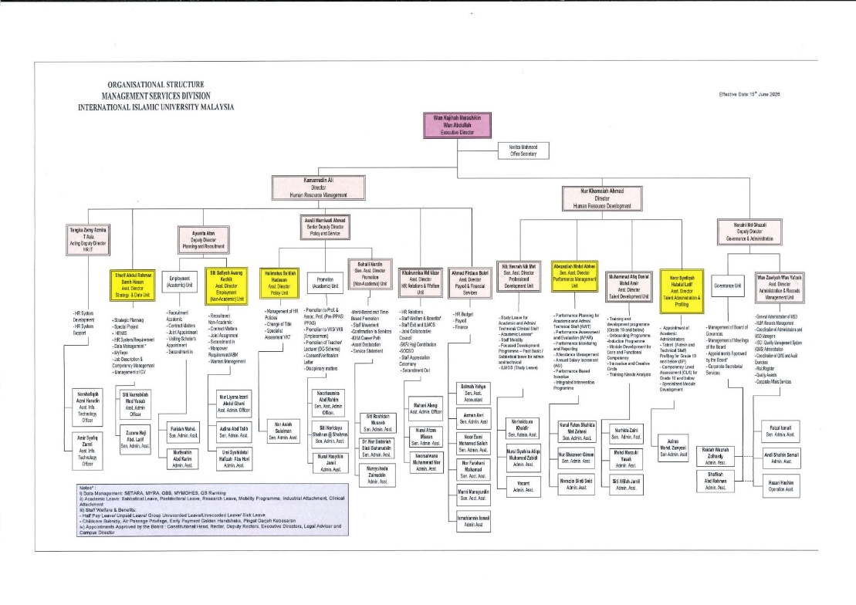
Figure 2.4.1: Organizational Structure of Management Services Department (MSD)

2.5 Nature of Business / Activities
The primary responsibilities of the Management Services Department include:
- Managing university policies and official circulars.
- Coordinating administrative governance.
- Supporting university management in administrative operations.
The department ensures that all policies and circulars are managed systematically

2.6 Products and Services
Unlike commercial organizations, MSD provides administrative services to the university community rather than physical products.
The major services provided include:
Policy Management
- Preparation of university policies.
- Policy review and revision.
- Policy publication.
Circular Management
- Creation of official circulars.
- Distribution of circulars.
- Circular record management.
- Archive management.

2.7 Information Technology Division (ITD)
Although my internship placement was under MSD, the software development activities were carried out with guidance from the Information Technology Division (ITD).
ITD is responsible for planning, developing, implementing, and maintaining the university's information systems and ICT infrastructure. The division ensures that all internally developed systems follow standardized software engineering practices and comply with IIUM's technology standards.
During my internship, ITD provided technical guidance regarding:
- Software development standards
- System architecture
- Laravel framework implementation
- Database design
- Documentation standards
- Requirement validation
Following the presentation of my initial prototype, ITD recommended that the system be redeveloped using the Laravel framework and aligned with their software development guidelines.

2.8 Internship Placement
Throughout my industrial training, I was assigned to the Management Services Department (MSD). My primary responsibility was to assist in the development of a Circular and Policy Management System, a web-based application designed to improve the management of university policies and circulars.
My work involved collaboration between MSD and ITD. MSD acted as the business owner by providing system requirements and business processes, while ITD served as the technical authority responsible for reviewing the proposed system architecture, documentation, and implementation standards.
This collaborative environment allowed me to gain practical experience in requirement analysis, stakeholder communication, software documentation, prototype development, and enterprise software engineering practices.

2.9 Summary
This chapter presented an overview of the International Islamic University Malaysia (IIUM) and the Management Services Department (MSD), where the industrial training was conducted. It described the department's background, organizational structure, core responsibilities, and the services it provides. Additionally, the role of the Information Technology Division (ITD) was discussed, highlighting its responsibility in providing technical guidance and ensuring that the proposed Circular and Policy Management System complies with the university's software development standards.

CHAPTER lll

TECHNICAL SECTION

3.1 Introduction
This chapter describes the technical work carried out during the industrial training period. It focuses on the development of the Circular and Policy Management System, including the project objectives, development schedule, system analysis, trainee involvement, and technical documentation prepared throughout the internship.
The project was assigned by the Management Services Department (MSD) to improve the management of university policies and circulars through a centralized web-based system. Although the project owner was MSD, the technical implementation followed the standards established by the Information Technology Division (ITD). Therefore, the project involved close collaboration between both departments to ensure that the system complied with organizational requirements and software engineering best practices.

3.2 Objective of the Project
The Circular and Policy Management System was proposed to improve the existing manual process used by the Management Services Department for handling university policies and circulars.
The objectives of the project are as follows:
- To develop official a centralized web-based system for managing university policies and circulars.
- To improve the efficiency of document creation, distribution, and storage.
- To establish a systematic workflow for official documents.
- To improve document retrieval through an organized digital repository.
- To ensure compliance with IIUM administrative procedures and governance standards.
3.3 Schedule of the project
The industrial training tenure spanned a total of 18 weeks, commencing on April 14, 2026, and concluding on August 17, 2026. To ensure systematic project execution, the development lifecycle was divided into five distinct timeline phases.
Phase | Calendar Dates | SDLC Stage / Activity | Specific Deliverables & Milestones
Phase 1 | 14 April 2026 – 11 May 2026 | Requirement Gathering | Stakeholder interviews with MSD officers; Analysis of legacy manual workflows.
Phase 2 | 12 May 2026 – 8 June 2026 | System Analysis & Architectural Design | Creation of Use Case and Swimlane diagrams
Phase 3 | 9 June 2026 – 29 June 2026 | Technical Documentation & Prototyping | Reviewing of SRS, FRS, and SDD; Development of the initial native PHP/MySQL prototype;
Phase 4 | 30 June 2026 – 23 July 2026 | Technical Review & Framework Pivot | Finalising SRS, FRS and SDD Transitioning and re-architecting the system core using the Laravel MVC Framework.
Phase 5 | 24 July 2026 – 17 August 2026 | Advanced Database Integration | Technical presentation to ITD board; Architecture review. Execution of database migrations.

Figure 3.3.1 illustrates the timeline-based project development schedule, mapping out key deliverables across each phase.
3.4 Description of the Project
Prior to the development of the Circular and Policy Management System, MSD relied on a temporary website built using Canva, shown in Figures 3.4.1 and 3.4.2, to publish staff service circulars. The page grouped circulars under six static categories: Service Matters (SM), Service Scheme & Employment (SS), Human Resource Development (HRD), Compensation & Benefits (CB), Organisational Administration (OA), and Retirement Benefits (RB). Each category contained fixed sub-codes, such as SM.1 Appointment and SM.7 Code of Conduct & Disciplinary Management, that were hard-coded into the page layout. Because Canva is a design tool rather than a content management platform, the site had no backend database, no server-side logic, and no way to filter, tag, or version documents; every new circular had to be added by manually editing the page itself. Locating a specific circular therefore depended entirely on the browser's native Ctrl+F search, as instructed on the homepage, with no access control to restrict who could view sensitive HR documents. These limitations formed the basis for MSD's request to develop a proper centralised, database-driven system.
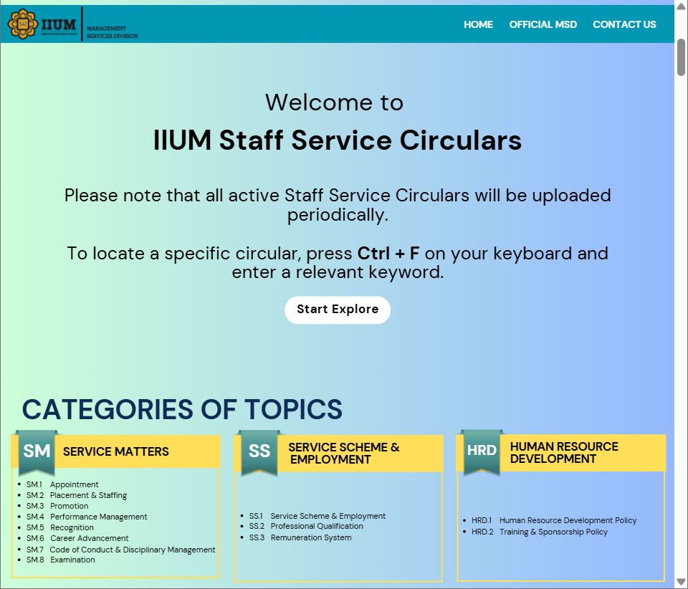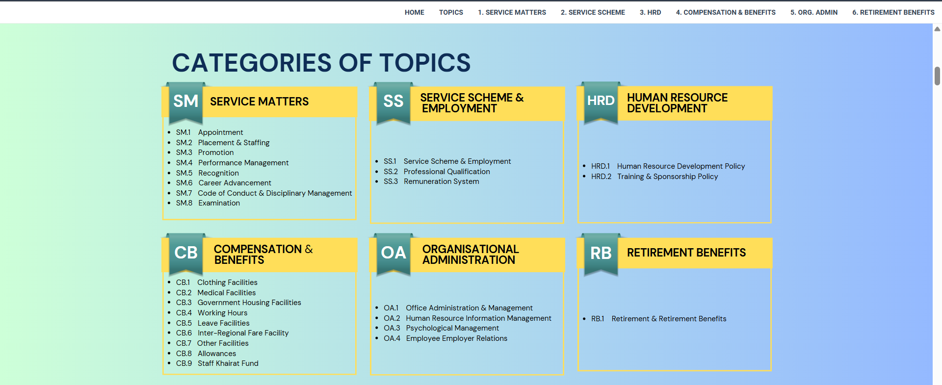
Figure 3.4.1 and 3.4.2: The user interface of the existing Canva website for Policy and Circular Management.
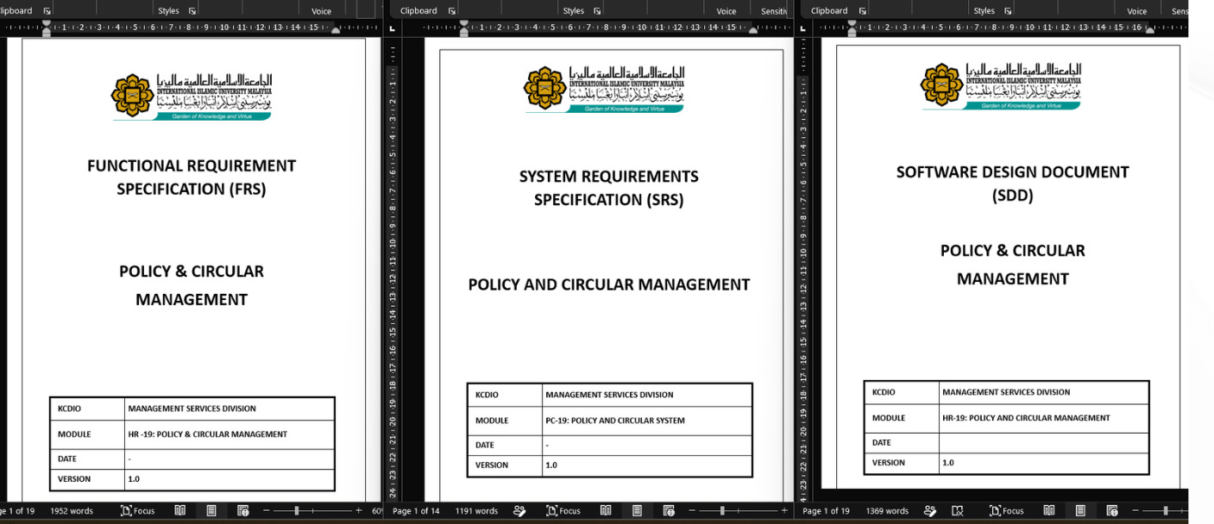
Figure 3.4.3: Technical documentation including SRS, FRS, and SDD documents.

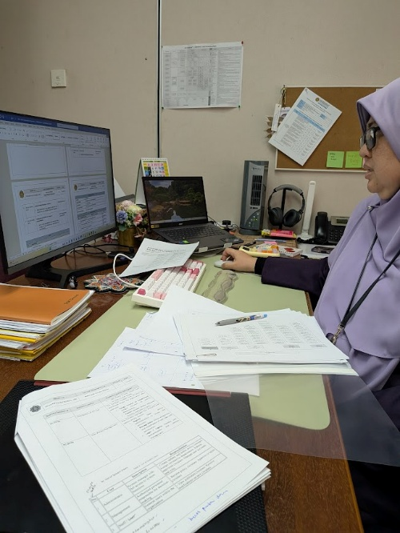
Figure 3.4.4: Senior ITD officer reviewing the system documentation.
Following the requirement-gathering phase, three core documents were prepared: the System Requirements Specification (SRS), Functional Requirement Specification (FRS), and Software Design Document (SDD), as shown in Figure 3.4.2. All three were issued under the KCDIO Management Services Division and registered against the same module code, HR-19: Policy & Circular Management (referred to as PC-19 in the SRS), at version 1.0, so that requirements, functional behaviour, and design could be cross-referenced by a single traceability code throughout the project. The SRS captured the system-level requirements and scope; the FRS translated these into specific functional behaviours, business rules; and the SDD documented the corresponding database and module design. As shown in Figure 3.4.3, each document underwent a formal review by senior ITD staff before it could be approved for use, a standard practice within the division to ensure that all technical documentation complied with IIUM's enterprise development standards prior to implementation.

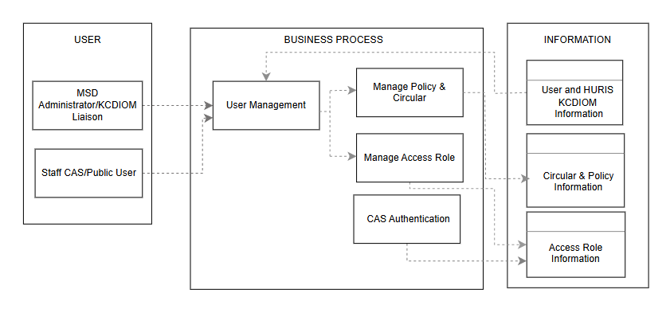
Figure 3.4.5: Proposed Circular & Policy Management System Architecture
Figure 3.4.4 illustrates the proposed system architecture, organised into three layers: the User layer, the Business Process layer, and the Information layer. The User layer distinguishes between two actor types, the MSD Administrator/KCDIOM Liaison and the Staff/CAS/Public user, each routed into the Business Process layer through separate access paths. The Business Process layer defines four core functions: User Management, which validates and provisions accounts; Manage Policy & Circular, which handles document creation and publishing; Manage Access Role, which governs permission assignment; and CAS Authentication, which verifies login credentials against IIUM's Central Authentication Service. Each of these functions reads from and writes to a corresponding store in the Information layer, namely User and HURIS KCDIOM Information, Circular & Policy Information, and Access Role Information, with the dashed connectors in the diagram representing these data-flow dependencies rather than direct user access. This layered architecture ensured a clear separation of concerns between authentication, business logic, and data storage, so that changes to one layer, such as swapping the authentication mechanism, would not require redesigning the others.
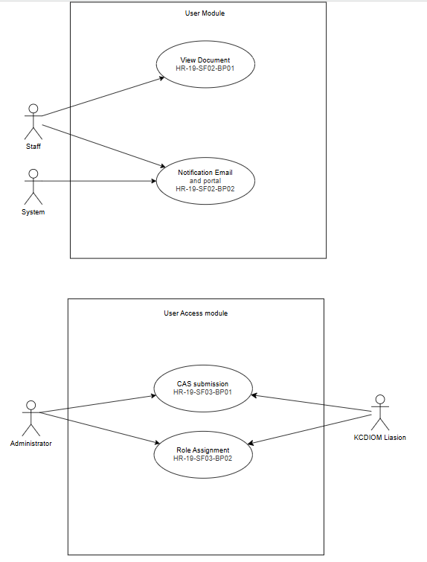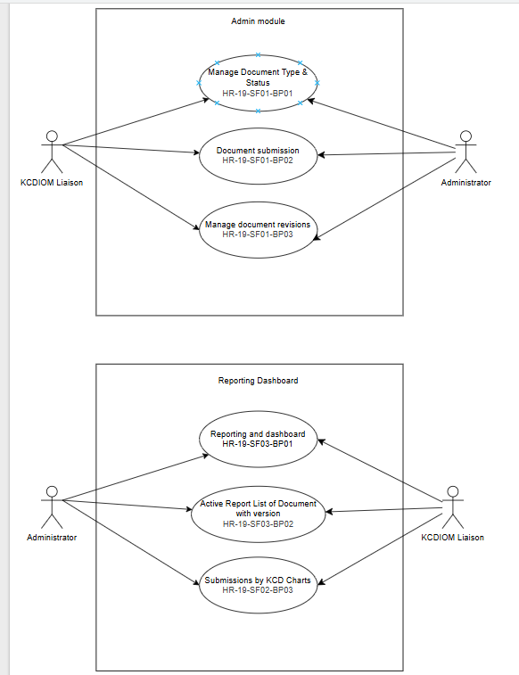
Figure 3.4.6: Use case diagram illustrating actor interactions with the system.

The use case diagrams in Figure 3.4.5 map out the functional scope of the system across four modules, each traced back to a specific sub-function (SF) and business process (BP) code from the SRS. In the User Module, the Staff actor triggers View Document (HR-19-SF02-BP01), while the System actor automatically triggers Notification Email and Portal (HR-19-SF02-BP02) once a document is published. The User Access Module links the Administrator and KCDIOM Liaison to CAS Submission (HR-19-SF03-BP01) and Role Assignment (HR-19-SF03-BP02), governing how new accounts are registered and granted permissions. The Admin Module covers three functions shared between the KCDIOM Liaison and Administrator: Manage Document Type & Status (HR-19-SF01-BP01), Document Submission (HR-19-SF01-BP02), and Manage Document Revisions (HR-19-SF01-BP03). The Reporting Dashboard, also shared between the Administrator and KCDIOM Liaison, groups Reporting and Dashboard (HR-19-SF03-BP01), Active Report List of Document with Version (HR-19-SF03-BP02), and Submissions by KCD Charts (HR-19-SF02-BP03). Numbering each use case against its originating requirement in this way kept the design directly traceable back to the SRS and FRS throughout development.
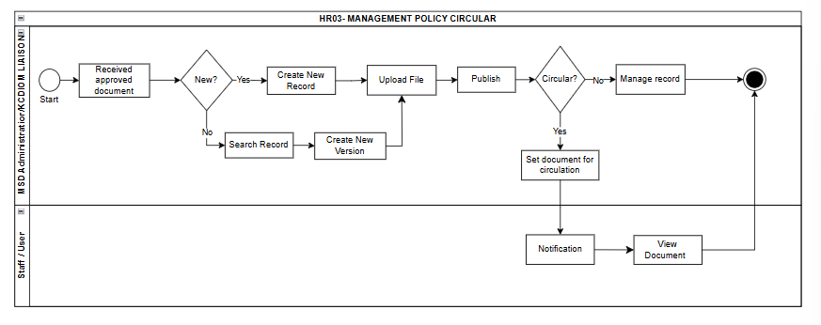
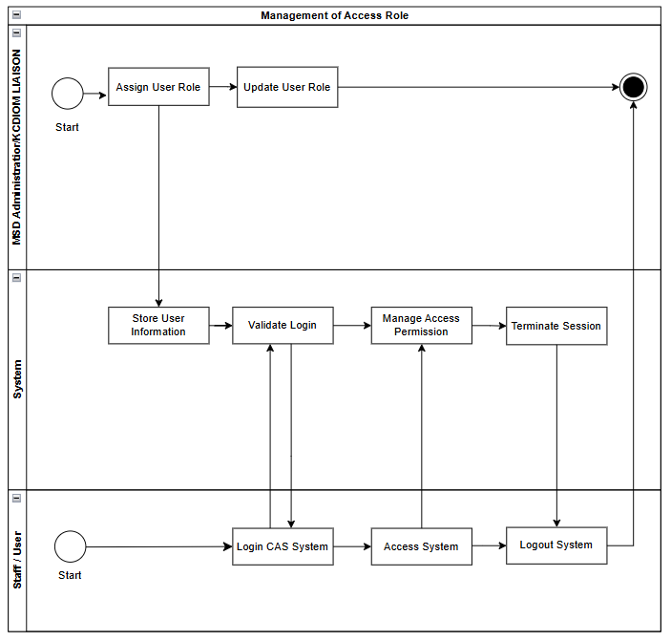
Figure 3.4.7: Swimlane diagram of the system processes and responsible actors.
Figure 3.4.6 presents two swimlane diagrams covering the system's main workflows. The first, HR03 - Management Policy Circular, is split between the MSD Administrator/KCDIOM Liaison and the Staff/User. After receiving an approved document, the administrator passes through a New? decision gate: a genuinely new item goes through Create New Record and Upload File, while an existing item is located via Search Record and advanced through Create New Version instead, so that both paths converge back at Publish. A second decision gate, Circular?, then determines whether the published item is routed to Manage Record for internal reference only, or Set for Circulation, which raises a Notification consumed by the Staff/User lane and resolved through View Document. The second diagram, Management of Access Role, adds a third lane, System, between the human actors: the MSD Administrator/KCDIOM Liaison assigns and updates a user role, which the System lane stores as user information; the Staff/User lane then authenticates through Login CAS System, and the System lane validates the login against the stored role before allowing Access System and, ultimately, Manage Access Permission through to Logout System and Terminate Session. Together, the two diagrams ensured that both document handling and access control followed a consistent, auditable sequence of steps before reaching the end user.
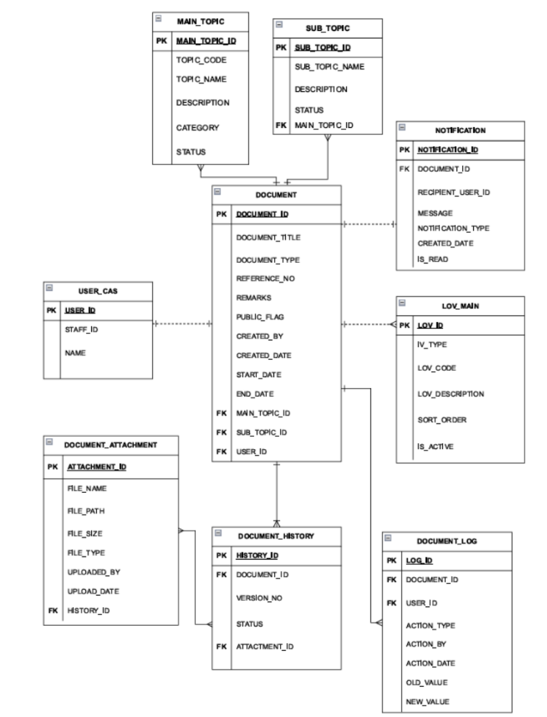
Figure 3.4.8: Entity Relationship Diagram (ERD) illustrating the data architecture.
The Entity Relationship Diagram in Figure 3.4.8 outlines the database structure supporting the system, consisting of nine entities: MAIN_TOPIC, SUB_TOPIC, DOCUMENT, DOCUMENT_ATTACHMENT, DOCUMENT_HISTORY, DOCUMENT_LOG, NOTIFICATION, LOV_MAIN, and USER_CAS. The DOCUMENT table sits at the centre of the schema, holding fields such as DOCUMENT_TITLE, DOCUMENT_TYPE, REFERENCE_NO, PUBLIC_FLAG, START_DATE, and END_DATE, alongside foreign keys MAIN_TOPIC_ID, SUB_TOPIC_ID, and USER_ID. MAIN_TOPIC and SUB_TOPIC form a one-to-many hierarchy, allowing each circular to be classified under a category and sub-category consistent with the topic structure used on the legacy Canva site. DOCUMENT_HISTORY and DOCUMENT_LOG each maintain a one-to-many relationship back to DOCUMENT, recording, respectively, version numbers with status and a full change log of ACTION_TYPE, ACTION_BY, OLD_VALUE, and NEW_VALUE for every action performed. DOCUMENT_ATTACHMENT stores uploaded files by FILE_NAME, FILE_PATH, FILE_SIZE, and FILE_TYPE, linked to DOCUMENT_HISTORY so that each file is tied to a specific version, while NOTIFICATION references both DOCUMENT and the recipient's USER_ID to drive the alerts described in Figure 3.4.6, and LOV_MAIN supplies shared list-of-values reference data such as document type codes. USER_CAS stores only the STAFF_ID and NAME retrieved from IIUM's CAS system, avoiding duplication of credential data outside the university's central authentication service. This design was intended to support the audit trail and version-control requirements identified during the system analysis phase.
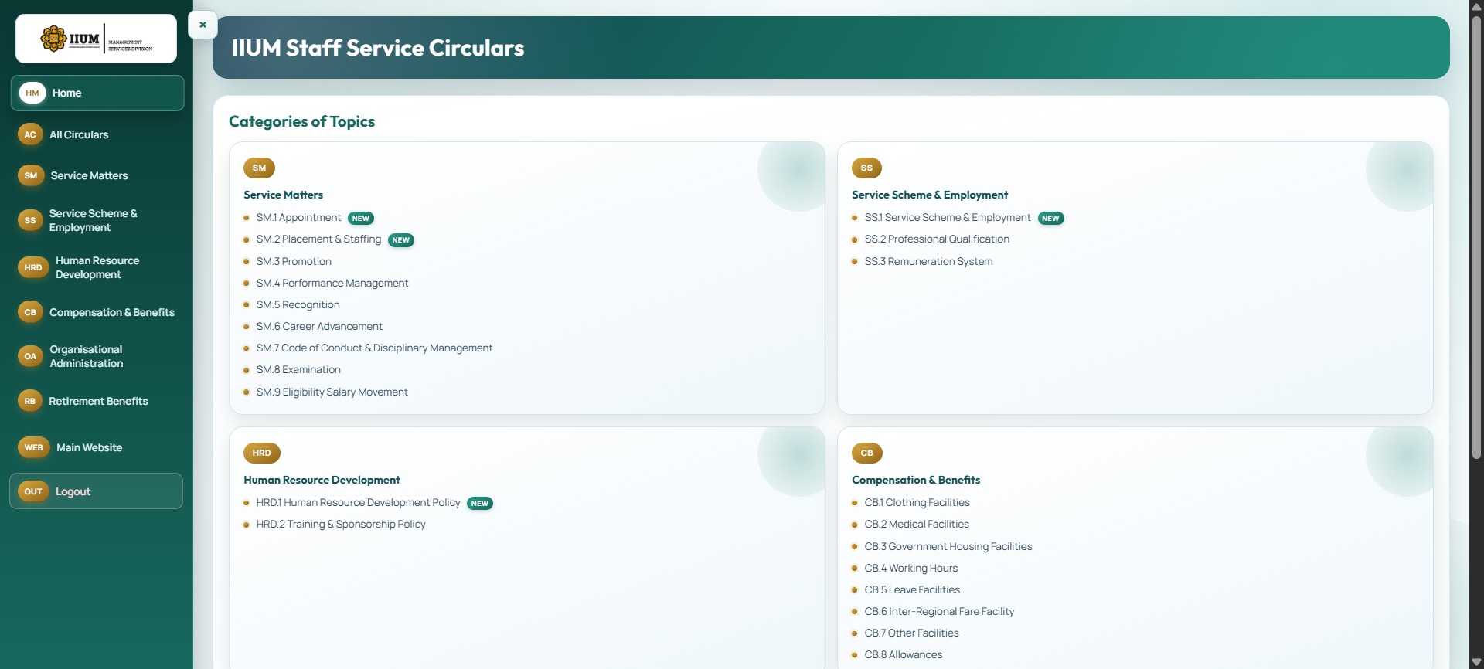
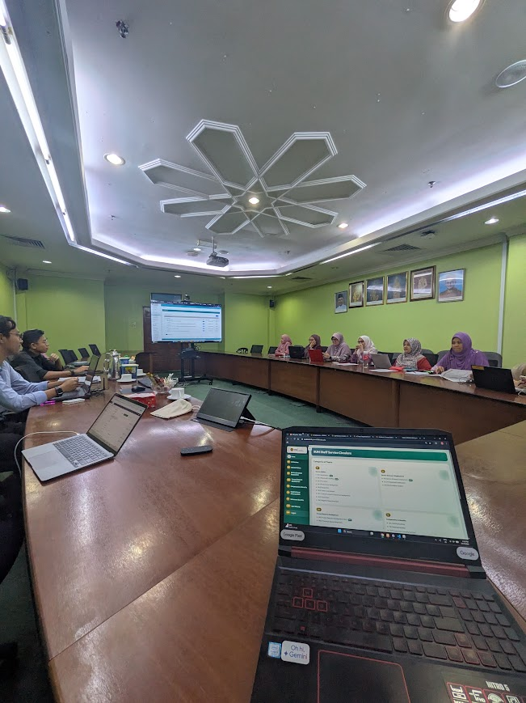:
Figure 3.4.9 and 3.4.10: Prototype demonstration and feedback sessions conducted with MSD and ITD representatives.
Figures 3.4.9 and 3.4.10 show the initial PHP/MySQL prototype being presented on-screen to representatives of both MSD and ITD during the Phase 3 review. This session served as a checkpoint for validating the proposed design, including the proposed document workflow and database structure, against departmental requirements and ITD's enterprise development standards before proceeding to the Phase 4 framework pivot, in which the prototype was re-architected using the Laravel MVC framework.

3.5 System Analysis
The system analysis involved understanding the current manual process for managing policies and circulars at IIUM. The existing process was characterized by:
- Lack of centralized search functionality
- Difficulty in tracking document versions and revisions
- Time-consuming distribution processes
- Limited access control mechanisms
- Use unauthorized website to publish circular and policy information
The proposed system addresses these limitations by providing:
- Digital document storage with metadata tagging
- Automated workflow routing based on document type and urgency
- Full-text search capabilities across all documents
- Version control with change tracking
- Use authorizes by IIUM portal itself
On a personal level, one of the most significant learning experiences during this project was working with Laravel, a framework I had not previously used. Prior to attending meetings with ITD, I had limited knowledge of the specific workflows and guidelines governing system development within the organization. It was only after presenting my initial prototype to ITD that I truly understood the complexity involved in enterprise system development and the importance of strictly following their established guidelines.

3.6 Trainee Involvement
Throughout the industrial training period, my involvement in the project included:
- Do interviews with MSD officers to understand requirements
- Documenting business processes and workflows
- Developing the initial system prototype using PHP and MySQL
- Creating database schemas and testing connectivity
- Preparing comprehensive documentation including SRS
- Presenting the prototype to both MSD and ITD
- Incorporating feedback from technical reviews
- Beginning Laravel framework implementation following ITD standards
Another notable aspect of my involvement was building the project's database from scratch. Every table I designed had to be reviewed and formally approved by senior staff before implementation, which taught me the importance of rigor, documentation, and accountability when designing systems intended for institutional use.

3.7 Technical Documentation
The following technical documents were prepared during the internship:
- Software Requirements Specification (SRS)
- Functional Requirements Specification (FRS)
- Software Database Documentation (SDD)
- Functional and non-functional requirements documentation
- Use case diagrams for different user roles
- User interface mock-ups
- Workflow diagrams for approval processes

CHAPTER IV

CONCLUSION AND RECOMMENDATIONS

4.1 Introduction
This chapter presents the overall conclusion of the industrial training, the knowledge and experience gained throughout the internship, challenges encountered during the project, recommendations for future improvements, and reflections on the learning outcomes. The internship provided valuable exposure to real-world software engineering practices, allowing theoretical knowledge gained at university to be applied in a professional working environment.

4.2 Knowledge and Experience Gained
The industrial training has significantly contributed to both my technical competencies and professional development.
From a technical perspective, I gained practical experience in software requirement analysis, business process modelling, software documentation, database design, and web application development. Throughout the development of the Circular and Policy Management System, I learned that software engineering extends beyond writing code. Activities such as requirement gathering, stakeholder communication, documentation, and system planning are equally important in ensuring project success.
One of the most valuable experiences was participating in meetings with officers from the Management Services Department (MSD) and the Information Technology Division (ITD). These discussions provided insight into how organizational requirements are collected, analysed, and translated into software specifications.
In addition, I improved my understanding of web application development using PHP and MySQL while gaining exposure to the Laravel framework, which is the preferred development framework used by ITD. Learning Laravel introduced me to modern software development concepts such as the Model-View-Controller (MVC) architecture, routing, migrations and controllers.
Furthermore, preparing Software Requirements Specification (SRS) documents, business process documentation, and database designs enhanced my ability to produce technical documents that comply with organizational standards.
4.3 Challenges Encountered
Several challenges were encountered throughout the internship, particularly during the development of the Circular and Policy Management System.
The first challenge was understanding the complex business processes involved in managing university policies and circulars. The approval workflow involved multiple stakeholders and authorization levels, requiring detailed analysis before system design could begin.
Another significant challenge was preparing project documentation according to ITD's standards. Unlike academic assignments, the documentation required detailed functional specifications, business process descriptions, database design, and workflow analysis before any implementation could proceed. The strict review process required several revisions to ensure that the documentation complied with organizational requirements.
A further challenge arose during the prototype presentation. Although the prototype successfully demonstrated the intended system functionality, ITD concluded that it did not fully satisfy their development standards. Consequently, the project required redesign and redevelopment using the Laravel framework and ITD's software development guidelines.
Additionally, adapting to Laravel was initially challenging because the prototype had been developed using native PHP. Learning a new framework while simultaneously refining the project documentation required continuous self-learning and independent research.

4.4 Solutions Implemented
Several approaches were taken to overcome the challenges encountered during the internship.
To improve understanding of the business processes, regular discussions were conducted with MSD officers to clarify system requirements and document approval workflows. Feedback obtained from these meetings was incorporated into the Software Requirements Specification and system design documentation.
To address the documentation requirements, previous system documentation and organizational guidelines were reviewed to understand ITD's documentation standards. Continuous revisions were made based on comments received from supervisors and technical reviewers.
Following the prototype presentation, the feedback provided by ITD was carefully analysed. The proposed system architecture, workflow, and documentation were revised according to their recommendations. In addition, self-learning activities were carried out through Laravel tutorials, official documentation, and practical exercises to prepare for future system redevelopment.
These solutions improved both the quality of the project documentation and my understanding of enterprise software development practices.

4.5 Recommendations for the Organization
Based on the experience gained during the internship, several recommendations can be proposed for future improvements.
Recommendations for MSD
- Continue digitizing administrative processes to reduce dependence on manual document management.
- Standardize business processes before initiating software development projects.
- Encourage regular collaboration with ITD during the requirement analysis stage to minimize requirement changes during development.
Recommendations for ITD
- Provide a standard documentation template and development guideline for student interns at the beginning of the internship.
- Conduct technical briefing sessions on organizational software development standards and preferred technologies such as Laravel.
- Provide sample projects to assist interns in understanding the expected system architecture.
Recommendations for Future Interns
- Strengthen knowledge of software documentation and requirement engineering before starting the internship.
- Learn modern web development frameworks such as Laravel in advance.
- Develop effective communication skills, as interaction with stakeholders is an important part of software engineering.

4.6 Personal reflections
The industrial training has been one of the most valuable learning experiences throughout my academic journey.
Initially, I believed that software development primarily focused on programming and system implementation. However, this internship demonstrated that successful software engineering requires comprehensive planning, effective communication, detailed documentation, and continuous collaboration with stakeholders.
Working on the Circular and Policy Management System exposed me to the complete software development process, beginning with requirement gathering and continuing through documentation, prototype development, stakeholder presentations, and project evaluation.
Although the prototype required further improvement after review by ITD, the experience taught me the importance of accepting constructive feedback and continuously improving software solutions according to organizational standards.
Overall, this internship has strengthened my technical knowledge, improved my professional communication skills, and increased my confidence in participating in real-world software engineering projects.

4.7 Conclusion
In conclusion, the industrial training at the Management Services Department (MSD), International Islamic University Malaysia, has successfully achieved its intended objectives. The internship provided practical exposure to enterprise software engineering practices while allowing the application of academic knowledge in a professional environment.
Through participation in the Circular and Policy Management System project, I developed valuable competencies in requirement analysis, software documentation, business process modelling, prototype development, and stakeholder communication. Furthermore, exposure to ITD's development standards and Laravel framework enhanced my understanding of modern enterprise software development.
The experience gained throughout the internship has prepared me for future employment as a software engineer by strengthening both my technical capabilities and professional skills. The lessons learned during this internship will serve as a strong foundation for my future career in the software engineering industry.

