activity_actual_chapter_profile.xml

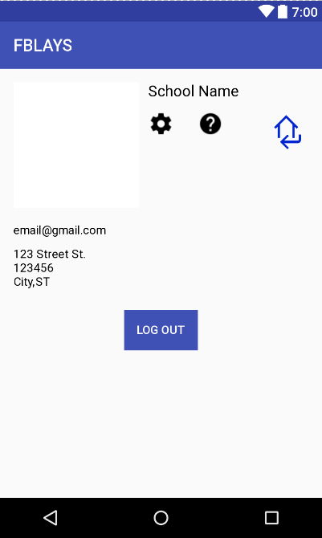

*<?***xml version="1.0" encoding="utf-8"***?>*

<**RelativeLayout xmlns:android="http://schemas.android.com/apk/res/android"**

**xmlns:app="http://schemas.android.com/apk/res-auto"**

**xmlns:tools="http://schemas.android.com/tools"**

**android:id="@+id/activity_chapter_profile"**

**android:layout_width="match_parent"**

**android:layout_height="match_parent"**

**android:paddingBottom="@dimen/activity_vertical_margin"**

**android:paddingLeft="@dimen/activity_horizontal_margin"**

**android:paddingRight="@dimen/activity_horizontal_margin"**

**android:paddingTop="@dimen/activity_vertical_margin"**

**tools:context="com.example.izzy.fblays2.ChapterProfile"**>

<**ImageView**

**android:layout_width="150dp"**

**android:layout_height="150dp"**

**app:srcCompat="@android:color/background_light"**

**android:id="@+id/profilePicIV"**

**android:layout_alignParentTop="true"**

**android:layout_toEndOf="@+id/purchaseInfo"** />

<**TextView**

**android:text="email@gmail.com"**

**android:layout_width="wrap_content"**

**android:layout_height="wrap_content"**

**android:id="@+id/emailTV"**

**android:textSize="14sp"**

**android:textColor="@android:color/black"**

**android:layout_below="@+id/profilePicIV"**

**android:layout_alignParentStart="true"**

**android:layout_marginTop="18dp"** />

<**Button**

**android:id="@+id/btnLogOut"**

**android:layout_marginTop="250dp"**

**android:layout_width="wrap_content"**

**android:layout_height="wrap_content"**

**android:layout_below="@+id/nameTV"**

**android:layout_centerHorizontal="true"**

**android:background="@color/colorPrimary"**

**android:text="Log Out"**

**android:textColor="@android:color/white"** />

<**TextView**

**android:text="School Name"**

**android:layout_width="wrap_content"**

**android:layout_height="wrap_content"**

**android:id="@+id/nameTV"**

**android:textSize="18sp"**

**android:textColor="@android:color/black"**

**android:layout_alignParentTop="true"**

**android:layout_alignStart="@+id/helpBtn"** />

<**TextView**

**android:text="ST"**

**android:layout_width="wrap_content"**

**android:layout_height="wrap_content"**

**android:id="@+id/schoolStateTV"**

**android:textColor="@android:color/black"**

**android:layout_toEndOf="@+id/cityTV"**

**android:layout_alignBaseline="@+id/cityTV"**

**android:layout_alignBottom="@+id/cityTV"**

/>

<**TextView**

**android:text="123 Street St."**

**android:layout_width="wrap_content"**

**android:layout_height="wrap_content"**

**android:layout_marginTop="12dp"**

**android:id="@+id/schoolAddressTV"**

**android:textSize="14sp"**

**android:textColor="@android:color/black"**

**android:layout_below="@+id/emailTV"**

**android:layout_alignStart="@+id/zipcodeTV"** />

<**TextView**

**android:text="123456"**

**android:layout_width="wrap_content"**

**android:layout_height="wrap_content"**

**android:id="@+id/zipcodeTV"**

**android:textColor="@android:color/black"**

**android:layout_below="@+id/schoolAddressTV"**

**android:layout_alignStart="@+id/cityTV"** />

<**TextView**

**android:text="City,"**

**android:layout_width="wrap_content"**

**android:layout_height="wrap_content"**

**android:id="@+id/cityTV"**

**android:textColor="@android:color/black"**

**android:layout_below="@+id/zipcodeTV"**

**android:layout_toEndOf="@+id/purchaseInfo"** />

<**ImageButton**

**android:id="@+id/btnReturn"**

**android:layout_width="50dp"**

**android:layout_height="50dp"**

**android:background="@android:color/transparent"**

**android:scaleType="fitXY"**

**android:src="@drawable/returnhome2"**

**android:layout_alignTop="@+id/settingsBtn"**

**android:layout_alignParentEnd="true"** />

<**TextView**

**android:text=""**

**android:layout_width="wrap_content"**

**android:layout_height="wrap_content"**

**android:id="@+id/purchaseInfo"**

**android:textAlignment="center"**

**android:textColor="@android:color/black"**

**android:layout_below="@+id/settingsBtn"**

**android:layout_alignParentStart="true"**

**android:layout_marginTop="17dp"** />

<**ImageButton**

**android:id="@+id/helpBtn"**

**android:src="@drawable/ic_settings"**

**android:background="@android:color/transparent"**

**android:scaleType="fitXY"**

**android:layout_width="30dp"**

**android:layout_height="30dp"**

**android:layout_below="@+id/nameTV"**

**android:layout_centerHorizontal="true"**

**android:layout_marginTop="13dp"** />

<**ImageButton**

**android:id="@+id/settingsBtn"**

**android:src="@drawable/help"**

**android:background="@android:color/transparent"**

**android:scaleType="fitXY"**

**android:layout_width="30dp"**

**android:layout_height="30dp"**

**android:layout_alignTop="@+id/helpBtn"**

**android:layout_toEndOf="@+id/btnLogOut"** />

</**RelativeLayout**>

activity_chapter_help.xml

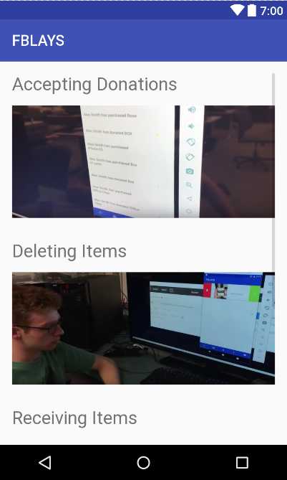

*<?***xml version="1.0" encoding="utf-8"***?>*

<**RelativeLayout xmlns:android="http://schemas.android.com/apk/res/android"**

**xmlns:tools="http://schemas.android.com/tools"**

**android:id="@+id/activity_chapter_help"**

**android:layout_width="match_parent"**

**android:layout_height="match_parent"**

**android:paddingBottom="@dimen/activity_vertical_margin"**

**android:paddingLeft="@dimen/activity_horizontal_margin"**

**android:paddingRight="@dimen/activity_horizontal_margin"**

**android:paddingTop="@dimen/activity_vertical_margin"**

**tools:context="com.example.izzy.fblays2.ChapterHelp"**>

<**ScrollView**

**android:layout_width="wrap_content"**

**android:layout_height="wrap_content"**>

<**RelativeLayout**

**android:layout_width="wrap_content"**

**android:layout_height="wrap_content"**>

<**TextView**

**android:text="Accepting Donations"**

**android:layout_width="wrap_content"**

**android:layout_height="wrap_content"**

**android:layout_alignParentTop="true"**

**android:layout_alignParentStart="true"**

**android:textSize="24sp"**

**android:id="@+id/acceptDonationTV"** />

<**RelativeLayout**

**android:layout_width="wrap_content"**

**android:layout_height="wrap_content"**

**android:id="@+id/videoLayoutAccept"**

**android:layout_marginTop="14dp"**

**android:layout_below="@+id/acceptDonationTV"**

>

<**ImageButton**

**android:id="@+id/btnPlayAccept"**

**android:layout_width="match_parent"**

**android:layout_height="150dp"**

**android:src="@drawable/acceptingdonation"**

**android:scaleType="fitXY"**

**android:background="@android:color/transparent"** />

</**RelativeLayout**>

<**TextView**

**android:text="Deleting Items"**

**android:layout_width="wrap_content"**

**android:layout_height="wrap_content"**

**android:layout_below="@id/videoLayoutAccept"**

**android:textSize="24sp"**

**android:layout_marginTop="30dp"**

**android:id="@+id/deleteSaleTV"** />

<**RelativeLayout**

**android:layout_width="wrap_content"**

**android:layout_height="wrap_content"**

**android:id="@+id/videoLayoutDelete"**

**android:layout_marginTop="14dp"**

**android:layout_below="@+id/deleteSaleTV"**

>

<**ImageButton**

**android:layout_width="match_parent"**

**android:layout_height="150dp"**

**android:id="@+id/btnPlayDelete"**

**android:src="@drawable/deletingdonation"**

**android:scaleType="fitXY"**

**android:background="@android:color/transparent"** />

</**RelativeLayout**>

<**TextView**

**android:text="Receiving Items"**

**android:layout_width="wrap_content"**

**android:layout_height="wrap_content"**

**android:layout_below="@id/videoLayoutDelete"**

**android:textSize="24sp"**

**android:layout_marginTop="30dp"**

**android:id="@+id/receiveSaleTV"** />

<**RelativeLayout**

**android:layout_width="wrap_content"**

**android:layout_height="wrap_content"**

**android:id="@+id/videoLayoutReceive"**

**android:layout_marginTop="14dp"**

**android:layout_below="@+id/receiveSaleTV"**

>

<**ImageButton**

**android:layout_width="match_parent"**

**android:layout_height="150dp"**

**android:id="@+id/btnPlayReceive"**

**android:src="@drawable/receivingdonation"**

**android:scaleType="fitXY"**

**android:background="@android:color/transparent"** />

</**RelativeLayout**>

<**ImageButton**

**android:layout_width="80dp"**

**android:layout_height="80dp"**

**android:layout_below="@id/videoLayoutReceive"**

**android:layout_marginTop="20dp"**

**android:scaleType="fitXY"**

**android:layout_centerHorizontal="true"**

**android:background="@android:color/transparent"**

**android:text="Return"**

**android:src="@drawable/returnhome2"**

**android:id="@+id/btnReturn"**

/>

</**RelativeLayout**>

</**ScrollView**>

</**RelativeLayout**>

activity_chapter_login.xml

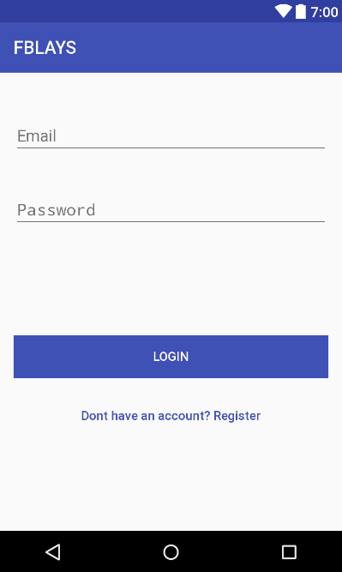

*<?***xml version="1.0" encoding="utf-8"***?>*

<**RelativeLayout xmlns:android="http://schemas.android.com/apk/res/android"**

**xmlns:tools="http://schemas.android.com/tools"**

**android:id="@+id/activity_main"**

**android:layout_width="match_parent"**

**android:layout_height="match_parent"**

**android:paddingBottom="@dimen/activity_vertical_margin"**

**android:paddingLeft="@dimen/activity_horizontal_margin"**

**android:paddingRight="@dimen/activity_horizontal_margin"**

**android:paddingTop="@dimen/activity_vertical_margin"**

**tools:context="com.example.izzy.fblays2.ChapterLogin"**>

<**EditText**

**android:layout_width="wrap_content"**

**android:layout_height="wrap_content"**

**android:inputType="textPersonName"**

**android:ems="10"**

**android:layout_marginTop="34dp"**

**android:id="@+id/input_email"**

**android:layout_alignParentTop="true"**

**android:layout_alignParentEnd="true"**

**android:layout_alignParentStart="true"**

**android:hint="Email"** />

<**EditText**

**android:layout_width="wrap_content"**

**android:layout_height="wrap_content"**

**android:ems="10"**

**android:layout_below="@+id/input_email"**

**android:layout_alignParentStart="true"**

**android:layout_marginTop="40dp"**

**android:id="@+id/input_Password"**

**android:layout_alignParentEnd="true"**

**android:hint="Password"**

**android:inputType="textPassword"** />

<**Button**

**android:text="Login"**

**android:layout_width="match_parent"**

**android:layout_height="wrap_content"**

**android:layout_marginTop="118dp"**

**android:id="@+id/bn_Login"**

**android:background="@color/colorPrimary"**

**android:textColor="@android:color/background_light"**

**android:layout_below="@+id/input_Password"**

**android:layout_alignParentStart="true"** />

<**Button**

**android:text="Dont have an account? Register"**

**android:layout_width="wrap_content"**

**android:layout_height="wrap_content"**

**android:layout_below="@+id/bn_Login"**

**android:layout_marginTop="18dp"**

**android:id="@+id/bn_toRegistration"**

**android:layout_alignParentStart="true"**

**android:layout_alignParentEnd="true"**

**android:backgroundTint="@android:color/transparent"**

**android:background="@android:color/transparent"**

**style="@style/Widget.AppCompat.Button.Borderless.Colored"**

**android:textColor="@color/colorPrimary"**

**android:textAllCaps="false"** />

</**RelativeLayout**>

activity_chapter_main_page.xml

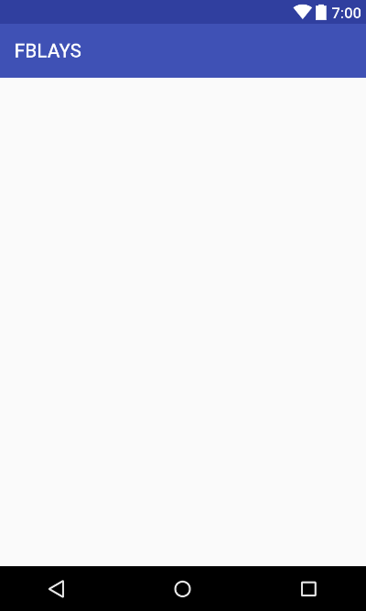

*<?***xml version="1.0" encoding="utf-8"***?>*

<**LinearLayout xmlns:android="http://schemas.android.com/apk/res/android"**

**xmlns:app="http://schemas.android.com/apk/res-auto"**

**android:orientation="vertical"**

**android:layout_width="match_parent"**

**android:layout_height="match_parent"** >

<**ScrollView**

**android:layout_width="match_parent"**

**android:layout_height="wrap_content"**

**android:paddingBottom="100dp"**>

<**LinearLayout**

**android:layout_width="match_parent"**

**android:layout_height="wrap_content"**

**android:orientation="vertical"**>

<**android.support.v4.view.ViewPager**

**android:id="@+id/viewpager"**

**android:layout_width="match_parent"**

**android:layout_height="wrap_content"**

**app:layout_behavior="@string/appbar_scrolling_view_behavior"** />

<**FrameLayout**

**android:layout_width="match_parent"**

**android:layout_height="wrap_content"**

**android:layout_weight="1"**

**android:layout_marginBottom="-48dp"**/>

<**android.support.design.widget.AppBarLayout**

**android:layout_width="match_parent"**

**android:layout_height="wrap_content"**

**android:theme="@style/ThemeOverlay.AppCompat.Dark.ActionBar"**

**android:layout_weight="0"**>

<**android.support.design.widget.TabLayout**

**android:id="@+id/tabs"**

**android:layout_width="match_parent"**

**android:layout_height="wrap_content"**

**app:tabMode="fixed"**

**app:tabGravity="fill"**

/>

</**android.support.design.widget.AppBarLayout**>

</**LinearLayout**>

</**ScrollView**>

</**LinearLayout**>

activity_chapter_profile.xml

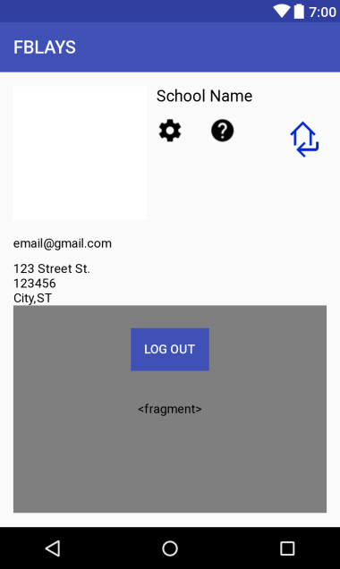

*<?***xml version="1.0" encoding="utf-8"***?>*

<**RelativeLayout xmlns:android="http://schemas.android.com/apk/res/android"**

**xmlns:app="http://schemas.android.com/apk/res-auto"**

**xmlns:tools="http://schemas.android.com/tools"**

**android:id="@+id/activity_chapter_profile"**

**android:layout_width="match_parent"**

**android:layout_height="match_parent"**

**android:paddingBottom="@dimen/activity_vertical_margin"**

**android:paddingLeft="@dimen/activity_horizontal_margin"**

**android:paddingRight="@dimen/activity_horizontal_margin"**

**android:paddingTop="@dimen/activity_vertical_margin"**

**tools:context="com.example.izzy.fblays2.ChapterProfile"**>

<**ImageView**

**android:layout_width="150dp"**

**android:layout_height="150dp"**

**app:srcCompat="@android:color/background_light"**

**android:id="@+id/profilePicIV"**

**android:layout_alignParentTop="true"**

**android:layout_toEndOf="@+id/purchaseInfo"** />

<**TextView**

**android:text="email@gmail.com"**

**android:layout_width="wrap_content"**

**android:layout_height="wrap_content"**

**android:id="@+id/emailTV"**

**android:textSize="14sp"**

**android:textColor="@android:color/black"**

**android:layout_below="@+id/profilePicIV"**

**android:layout_alignParentStart="true"**

**android:layout_marginTop="18dp"** />

<**Button**

**android:id="@+id/btnLogOut"**

**android:layout_marginTop="250dp"**

**android:layout_width="wrap_content"**

**android:layout_height="wrap_content"**

**android:layout_below="@+id/nameTV"**

**android:layout_centerHorizontal="true"**

**android:background="@color/colorPrimary"**

**android:text="Log Out"**

**android:textColor="@android:color/white"** />

<**TextView**

**android:text="School Name"**

**android:layout_width="wrap_content"**

**android:layout_height="wrap_content"**

**android:id="@+id/nameTV"**

**android:textSize="18sp"**

**android:textColor="@android:color/black"**

**android:layout_alignParentTop="true"**

**android:layout_alignStart="@+id/helpBtn"** />

<**TextView**

**android:text="ST"**

**android:layout_width="wrap_content"**

**android:layout_height="wrap_content"**

**android:id="@+id/schoolStateTV"**

**android:textColor="@android:color/black"**

**android:layout_toEndOf="@+id/cityTV"**

**android:layout_alignBaseline="@+id/cityTV"**

**android:layout_alignBottom="@+id/cityTV"**

/>

<**TextView**

**android:text="123 Street St."**

**android:layout_width="wrap_content"**

**android:layout_height="wrap_content"**

**android:layout_marginTop="12dp"**

**android:id="@+id/schoolAddressTV"**

**android:textSize="14sp"**

**android:textColor="@android:color/black"**

**android:layout_below="@+id/emailTV"**

**android:layout_alignStart="@+id/zipcodeTV"** />

<**TextView**

**android:text="123456"**

**android:layout_width="wrap_content"**

**android:layout_height="wrap_content"**

**android:id="@+id/zipcodeTV"**

**android:textColor="@android:color/black"**

**android:layout_below="@+id/schoolAddressTV"**

**android:layout_alignStart="@+id/cityTV"** />

<**TextView**

**android:text="City,"**

**android:layout_width="wrap_content"**

**android:layout_height="wrap_content"**

**android:id="@+id/cityTV"**

**android:textColor="@android:color/black"**

**android:layout_below="@+id/zipcodeTV"**

**android:layout_toEndOf="@+id/purchaseInfo"** />

<**ImageButton**

**android:id="@+id/btnReturn"**

**android:layout_width="50dp"**

**android:layout_height="50dp"**

**android:background="@android:color/transparent"**

**android:scaleType="fitXY"**

**android:src="@drawable/returnhome2"**

**android:text="Ok!"**

**android:textColor="@android:color/white"**

**android:layout_alignTop="@+id/settingsBtn"**

**android:layout_alignParentEnd="true"** />

<**fragment xmlns:android="http://schemas.android.com/apk/res/android"**

**xmlns:tools="http://schemas.android.com/tools"**

**android:id="@+id/map"**

**android:name="com.google.android.gms.maps.SupportMapFragment"**

**android:layout_width="match_parent"**

**android:layout_height="match_parent"**

**tools:context="com.example.izzy.fblays2.ChapterProfile"**

**android:layout_below="@+id/cityTV"** />

<**TextView**

**android:text=""**

**android:layout_width="wrap_content"**

**android:layout_height="wrap_content"**

**android:id="@+id/purchaseInfo"**

**android:textAlignment="center"**

**android:textColor="@android:color/black"**

**android:layout_below="@+id/settingsBtn"**

**android:layout_alignParentStart="true"**

**android:layout_marginTop="17dp"** />

<**ImageButton**

**android:id="@+id/helpBtn"**

**android:src="@drawable/ic_settings"**

**android:background="@android:color/transparent"**

**android:scaleType="fitXY"**

**android:layout_width="30dp"**

**android:layout_height="30dp"**

**android:layout_below="@+id/nameTV"**

**android:layout_centerHorizontal="true"**

**android:layout_marginTop="13dp"** />

<**ImageButton**

**android:id="@+id/settingsBtn"**

**android:src="@drawable/help"**

**android:background="@android:color/transparent"**

**android:scaleType="fitXY"**

**android:layout_width="30dp"**

**android:layout_height="30dp"**

**android:layout_alignTop="@+id/helpBtn"**

**android:layout_toEndOf="@+id/btnLogOut"** />

</**RelativeLayout**>

activity_chapter_registration.xml

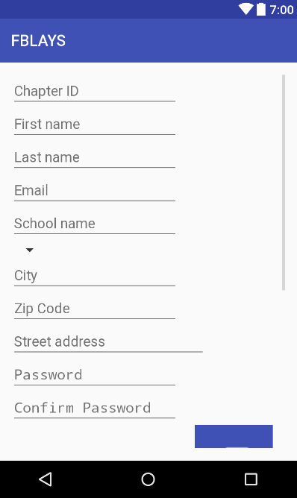

*<?***xml version="1.0" encoding="utf-8"***?>*

<**RelativeLayout xmlns:android="http://schemas.android.com/apk/res/android"**

**xmlns:app="http://schemas.android.com/apk/res-auto"**

**xmlns:tools="http://schemas.android.com/tools"**

**android:id="@+id/activity_chapter_registration"**

**android:layout_width="match_parent"**

**android:layout_height="match_parent"**

**android:paddingBottom="@dimen/activity_vertical_margin"**

**android:paddingLeft="@dimen/activity_horizontal_margin"**

**android:paddingRight="@dimen/activity_horizontal_margin"**

**android:paddingTop="@dimen/activity_vertical_margin"**

**tools:context="com.example.izzy.fblays2.ChapterRegistration"**>

<**ScrollView**

**android:layout_width="match_parent"**

**android:layout_height="match_parent"**

**android:layout_alignParentTop="true"**

**android:layout_alignParentStart="true"**>

<**LinearLayout**

**android:layout_width="match_parent"**

**android:layout_height="match_parent"**

**android:layout_alignParentTop="true"**

**android:layout_alignParentLeft="true"**

**android:layout_alignParentStart="true"**

**android:orientation="vertical"**

**android:weightSum="1"**>

<**EditText**

**android:layout_width="wrap_content"**

**android:layout_height="wrap_content"**

**android:ems="10"**

**android:id="@+id/reg_ChapterID"**

**android:hint="Chapter ID"**

**android:layout_alignParentTop="true"**

**android:layout_alignParentStart="true"**

**android:layout_alignParentEnd="true"**

**android:inputType="number"** />

<**Space**

**android:layout_width="0dp"**

**android:layout_height="0dp"**

**android:layout_centerHorizontal="true"**

**android:layout_below="@+id/reg_email"**

**android:layout_marginTop="0dp"**

**android:id="@+id/firstLast"**/>

<**EditText**

**android:layout_width="wrap_content"**

**android:layout_height="wrap_content"**

**android:inputType="textPersonName"**

**android:ems="10"**

**android:id="@+id/reg_firstName"**

**android:hint="First name"**

**android:layout_marginTop="0dp"**

**android:layout_below="@+id/firstLast"**

**android:layout_alignParentStart="true"**

**android:layout_alignEnd="@+id/firstLast"** />

<**EditText**

**android:layout_width="wrap_content"**

**android:layout_height="wrap_content"**

**android:inputType="textPersonName"**

**android:ems="10"**

**android:id="@+id/reg_lastName"**

**android:hint="Last name"**

**android:layout_alignBaseline="@+id/reg_firstName"**

**android:layout_alignBottom="@+id/reg_firstName"**

**android:layout_alignParentEnd="true"**

**android:layout_toEndOf="@+id/reg_firstName"** />

<**EditText**

**android:layout_width="wrap_content"**

**android:layout_height="wrap_content"**

**android:inputType="textEmailAddress"**

**android:ems="10"**

**android:id="@+id/reg_email"**

**android:hint="Email"**

**android:layout_below="@+id/reg_ChapterID"**

**android:layout_alignParentStart="true"**

**android:layout_marginTop="0dp"**

**android:layout_alignParentEnd="true"** />

<**EditText**

**android:layout_width="wrap_content"**

**android:layout_height="wrap_content"**

**android:inputType="textPersonName"**

**android:ems="10"**

**android:layout_marginTop="0dp"**

**android:id="@+id/reg_schoolName"**

**android:layout_below="@+id/reg_firstName"**

**android:layout_alignParentStart="true"**

**android:hint="School name"**

**android:layout_alignParentEnd="true"** />

<**Spinner**

**android:layout_width="wrap_content"**

**android:layout_height="wrap_content"**

**android:id="@+id/spinner"**

**android:layout_alignBottom="@+id/reg_streetAddress"**

**android:layout_alignParentEnd="true"**

**android:layout_below="@+id/reg_zipCode"**

**android:layout_toEndOf="@+id/reg_streetAddress"**

**android:spinnerMode="dialog"** />

<**Space**

**android:layout_width="wrap_content"**

**android:layout_height="wrap_content"**

**android:layout_below="@+id/reg_schoolName"**

**android:layout_centerHorizontal="true"**

**android:layout_marginTop="0dp"**

**android:id = "@+id/cityZip"** />

<**EditText**

**android:layout_width="wrap_content"**

**android:layout_height="wrap_content"**

**android:inputType="textPersonName"**

**android:ems="10"**

**android:layout_below="@+id/cityZip"**

**android:layout_toStartOf="@+id/cityZip"**

**android:layout_alignParentStart="true"**

**android:id="@+id/reg_city"**

**android:hint="City"** />

<**EditText**

**android:layout_width="wrap_content"**

**android:layout_height="wrap_content"**

**android:ems="10"**

**android:layout_below="@+id/cityZip"**

**android:layout_toEndOf="@+id/cityZip"**

**android:layout_alignParentEnd="true"**

**android:id="@+id/reg_zipCode"**

**android:inputType="number"**

**android:hint="Zip Code"** />

<**EditText**

**android:layout_height="wrap_content"**

**android:inputType="textPostalAddress"**

**android:ems="10"**

**android:id="@+id/reg_streetAddress"**

**android:hint="Street address"**

**android:layout_below="@+id/reg_city"**

**android:layout_alignParentStart="true"**

**android:layout_width="250dp"** />

<**EditText**

**android:layout_width="wrap_content"**

**android:layout_height="wrap_content"**

**android:inputType="textPassword"**

**android:ems="10"**

**android:layout_below="@+id/reg_streetAddress"**

**android:layout_alignParentStart="true"**

**android:id="@+id/reg_password"**

**android:layout_alignParentEnd="true"**

**android:hint="Password"** />

<**EditText**

**android:layout_width="wrap_content"**

**android:layout_height="wrap_content"**

**android:inputType="textPassword"**

**android:ems="10"**

**android:layout_below="@+id/reg_password"**

**android:layout_alignParentStart="true"**

**android:id="@+id/reg_confirmPassword"**

**android:layout_alignParentEnd="true"**

**android:hint="Confirm Password"** />

<**LinearLayout**

**android:layout_width="match_parent"**

**android:layout_height="match_parent"**

**android:orientation="horizontal"**>

<**ImageView**

**android:layout_width="220dp"**

**android:layout_height="220dp"**

**app:srcCompat="@android:color/transparent"**

**android:scaleType="fitXY"**

**android:id="@+id/chapterPic"** />

<**LinearLayout**

**android:layout_width="match_parent"**

**android:layout_height="match_parent"**

**android:orientation="vertical"**>

<**ImageButton**

**android:id="@+id/btnGallery"**

**android:layout_width="100dp"**

**android:layout_height="0dp"**

**android:layout_weight=".5"**

**android:padding="25dp"**

**android:scaleType="fitXY"**

**android:background="@color/colorPrimary"**

**android:onClick="onGalleryClicked"**

**android:layout_gravity="center"**

**android:src="@drawable/ic_piclibrary"**

**android:textSize="12sp"** />

<**LinearLayout**

**android:layout_width="wrap_content"**

**android:layout_height="0dp"**

**android:layout_weight=".1"** />

<**ImageButton**

**android:id="@+id/btnCamera"**

**android:layout_width="100dp"**

**android:layout_gravity="center"**

**android:layout_height="0dp"**

**android:layout_weight=".5"**

**android:padding="25dp"**

**android:scaleType="fitXY"**

**android:background="@color/colorPrimary"**

**android:onClick="onCameraClicked"**

**android:src="@drawable/ic_camera"**

**android:textColor="@android:color/background_light"**

**android:textSize="12sp"** />

</**LinearLayout**>

</**LinearLayout**>

<**Button**

**android:text="Register"**

**android:layout_width="match_parent"**

**android:layout_height="wrap_content"**

**android:layout_alignParentBottom="true"**

**android:layout_marginBottom="20dp"**

**android:layout_marginTop="20dp"**

**android:id="@+id/bn_Register"**

**android:layout_alignParentStart="true"**

**android:layout_alignParentEnd="true"**

**android:layout_weight="0.13"**

**android:background="@color/colorPrimary"**

**android:textColor="@android:color/background_light"**/>

<**Button**

**android:id="@+id/bn_toLogin"**

**android:layout_width="match_parent"**

**android:layout_height="wrap_content"**

**android:background="@android:color/transparent"**

**android:backgroundTint="@android:color/transparent"**

**android:text="Already have an account? Log in"**

**android:textAllCaps="false"**

**android:layout_marginBottom="25dp"**

**android:textColor="@color/colorPrimary"** />

</**LinearLayout**></**ScrollView**>

</**RelativeLayout**>

activity_confirm_donation.xml

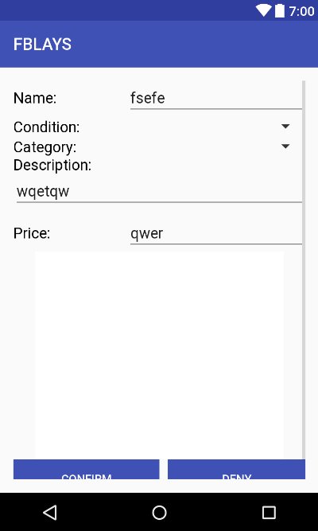

*<?***xml version="1.0" encoding="utf-8"***?>*

<**RelativeLayout xmlns:android="http://schemas.android.com/apk/res/android"**

**xmlns:app="http://schemas.android.com/apk/res-auto"**

**xmlns:tools="http://schemas.android.com/tools"**

**android:id="@+id/activity_confirm_donation"**

**android:layout_width="match_parent"**

**android:layout_height="match_parent"**

**android:paddingBottom="@dimen/activity_vertical_margin"**

**android:paddingLeft="@dimen/activity_horizontal_margin"**

**android:paddingRight="@dimen/activity_horizontal_margin"**

**android:paddingTop="@dimen/activity_vertical_margin"**

**tools:context="com.example.izzy.fblays2.ConfirmDonation"**>

<**ScrollView**

**android:layout_width="match_parent"**

**android:layout_height="match_parent"**

**android:layout_alignParentTop="true"**

**android:layout_alignParentStart="true"**>

<**RelativeLayout**

**android:layout_width="match_parent"**

**android:layout_height="match_parent"**

**android:orientation="vertical"**

**android:layout_alignParentTop="true"**

**android:layout_alignParentLeft="true"**

**android:layout_alignParentStart="true"**

**android:weightSum="1"**>

<**TextView**

**android:text="Name:"**

**android:layout_width="wrap_content"**

**android:layout_height="wrap_content"**

**android:id="@+id/textView12"**

**android:textSize="18sp"**

**android:layout_alignBaseline="@+id/nameET"**

**android:layout_alignBottom="@+id/nameET"**

**android:layout_alignParentStart="true"**

**android:textColor="@android:color/black"** />

<**EditText**

**android:layout_width="wrap_content"**

**android:layout_height="wrap_content"**

**android:inputType="textPersonName"**

**android:ems="10"**

**android:id="@+id/nameET"**

**android:layout_alignParentTop="true"**

**android:layout_alignParentEnd="true"**

**android:text="fsefe"** />

<**TextView**

**android:text="Price:"**

**android:layout_width="wrap_content"**

**android:layout_height="wrap_content"**

**android:id="@+id/textView4"**

**android:textSize="18sp"**

**android:textColor="@android:color/black"**

**android:layout_below="@+id/descriptionET"**

**android:layout_alignParentStart="true"**

**android:layout_marginTop="18dp"** />

<**EditText**

**android:layout_width="wrap_content"**

**android:layout_height="wrap_content"**

**android:inputType="numberDecimal"**

**android:ems="10"**

**android:id="@+id/priceET"**

**android:text="qwer"**

**android:layout_alignBaseline="@+id/textView4"**

**android:layout_alignBottom="@+id/textView4"**

**android:layout_alignParentEnd="true"** />

<**TextView**

**android:text="Condition:"**

**android:layout_width="wrap_content"**

**android:layout_height="wrap_content"**

**android:id="@+id/textView11"**

**android:textSize="18sp"**

**android:textColor="@android:color/black"**

**android:layout_alignBaseline="@+id/condition1ET"**

**android:layout_alignBottom="@+id/condition1ET"**

**android:layout_alignParentStart="true"** />

<**Spinner**

**android:id="@+id/categoryET"**

**android:layout_width="wrap_content"**

**android:layout_height="wrap_content"**

**android:layout_below="@+id/condition1ET"**

**android:layout_alignParentEnd="true"**

**android:spinnerMode="dialog"** />

<**TextView**

**android:text="Category:"**

**android:layout_width="wrap_content"**

**android:layout_height="wrap_content"**

**android:id="@+id/nameTV"**

**android:textSize="18sp"**

**android:textColor="@android:color/black"**

**android:layout_alignBaseline="@+id/categoryET"**

**android:layout_alignBottom="@+id/categoryET"**

**android:layout_alignParentStart="true"** />

<**Spinner**

**android:id="@+id/condition1ET"**

**android:layout_width="wrap_content"**

**android:layout_height="wrap_content"**

**android:layout_below="@+id/nameET"**

**android:layout_alignParentEnd="true"**

**android:spinnerMode="dialog"** />

<**ImageView**

**android:layout_width="300dp"**

**android:layout_height="250dp"**

**app:srcCompat="@android:color/background_light"**

**android:id="@+id/objectIV"**

**android:layout_below="@+id/priceET"**

**android:layout_centerHorizontal="true"** />

<**TextView**

**android:text="Description:"**

**android:layout_width="wrap_content"**

**android:layout_height="wrap_content"**

**android:id="@+id/textView5"**

**android:textSize="18sp"**

**android:textColor="@android:color/black"**

**android:layout_below="@id/categoryET"**

**android:layout_alignParentStart="true"** />

<**EditText**

**android:layout_width="wrap_content"**

**android:layout_height="wrap_content"**

**android:inputType="textMultiLine"**

**android:ems="10"**

**android:id="@+id/descriptionET"**

**android:text="wqetqw"**

**android:layout_below="@+id/textView5"**

**android:layout_alignParentStart="true"**

**android:layout_alignParentEnd="true"** />

<**Button**

**android:text="Deny"**

**android:layout_width="wrap_content"**

**android:layout_height="wrap_content"**

**android:id="@+id/btnDeny"**

**android:layout_below="@id/objectIV"**

**android:layout_alignParentBottom="true"**

**android:layout_alignParentEnd="true"**

**android:layout_alignLeft="@+id/space"**

**android:layout_marginLeft="10dp"**

**android:textColor="@android:color/background_light"**

**android:background="@color/colorPrimary"** />

<**Button**

**android:text="Confirm"**

**android:layout_width="wrap_content"**

**android:layout_height="wrap_content"**

**android:id="@+id/btnConfirm"**

**android:layout_alignParentBottom="true"**

**android:layout_alignParentStart="true"**

**android:layout_alignRight="@+id/space"**

**android:background="@color/colorPrimary"**

**android:textColor="@android:color/background_light"** />

<**Space**

**android:layout_width="wrap_content"**

**android:layout_height="wrap_content"**

**android:layout_alignParentTop="true"**

**android:layout_centerHorizontal="true"**

**android:layout_marginTop="447dp"**

**android:id="@+id/space"**/>

</**RelativeLayout**>

</**ScrollView**>

</**RelativeLayout**>

activity_donate.xml

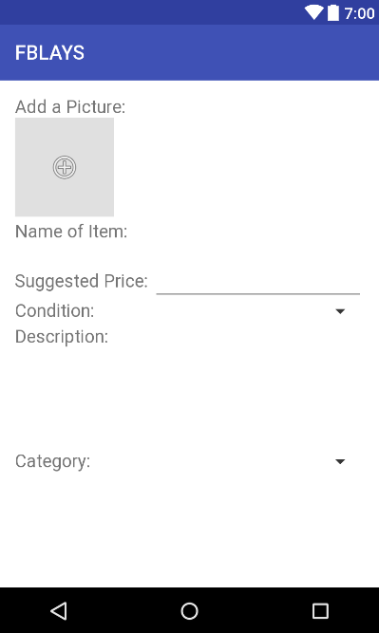

*<?***xml version="1.0" encoding="utf-8"***?>*

<**RelativeLayout xmlns:android="http://schemas.android.com/apk/res/android"**

**xmlns:app="http://schemas.android.com/apk/res-auto"**

**xmlns:tools="http://schemas.android.com/tools"**

**android:id="@+id/mainpage_layout"**

**android:layout_width="match_parent"**

**android:layout_height="match_parent"**

**tools:context=".DonateFragment"**

**android:background="@android:color/background_light"**>

<**ScrollView**

**android:layout_height="match_parent"**

**android:layout_width="match_parent"**

**android:layout_marginBottom="50dp"**>

<**LinearLayout**

**android:orientation="vertical" android:layout_width="match_parent"**

**android:layout_height="match_parent"**

**android:paddingBottom="@dimen/activity_vertical_margin"**

**android:paddingLeft="@dimen/activity_horizontal_margin"**

**android:paddingRight="@dimen/activity_horizontal_margin"**

**android:paddingTop="@dimen/activity_vertical_margin"**

**android:weightSum="1"**

**android:layout_alignParentTop="true"**

**android:layout_alignParentLeft="true"**

**android:layout_alignParentStart="true"**>

<**TextView**

**android:layout_width="wrap_content"**

**android:layout_height="wrap_content"**

**android:text="Add a Picture:"**

**android:textSize="18sp"**

**android:textColor="?android:attr/textColorTertiary"** />

<**LinearLayout**

**android:layout_width="match_parent"**

**android:layout_height="100dp"**

**android:orientation="horizontal"**>

<**ImageButton**

**app:srcCompat="@android:drawable/ic_menu_add"**

**android:background="?attr/colorControlHighlight"**

**android:id="@+id/buttonPic"**

**android:layout_width="100dp"**

**android:layout_height="100dp"** />

<**ImageView**

**android:layout_marginLeft="10dp"**

**android:layout_width="100dp"**

**android:layout_height="100dp"**

**app:srcCompat="@mipmap/ic_launcher"**

**android:scaleType="fitXY"**

**android:id="@+id/imageViewPic"**

**android:visibility="invisible"**

/>

</**LinearLayout**>

<**LinearLayout**

**android:layout_width="match_parent"**

**android:layout_height="30dp"**

**android:orientation="horizontal"**>

<**TextView**

**android:layout_width="wrap_content"**

**android:layout_height="match_parent"**

**android:text="Name of Item: "**

**android:textSize="18sp"**

**android:textColor="?android:attr/textColorTertiary"**

**android:paddingTop="4dp"**

**android:id="@+id/textView"** />

<**EditText**

**android:layout_width="match_parent"**

**android:layout_height="wrap_content"**

**android:layout_alignParentRight="true"**

**android:background="@android:color/background_light"**

**android:id="@+id/nameET"** />

</**LinearLayout**>

<**LinearLayout**

**android:layout_width="match_parent"**

**android:layout_height="50dp"**

**android:orientation="horizontal"**>

<**TextView**

**android:layout_width="wrap_content"**

**android:layout_height="match_parent"**

**android:text="Suggested Price: "**

**android:textSize="18sp"**

**android:textColor="?android:attr/textColorTertiary"**

**android:paddingTop="24dp"**

**android:id="@+id/priceTV"** />

<**EditText**

**android:layout_width="wrap_content"**

**android:layout_height="wrap_content"**

**android:inputType="numberDecimal"**

**android:ems="10"**

**android:id="@+id/priceET"**

**android:layout_weight="1"** />

</**LinearLayout**>

<**LinearLayout**

**android:layout_width="match_parent"**

**android:layout_height="30dp"**

**android:orientation="horizontal"**>

<**TextView**

**android:layout_width="wrap_content"**

**android:layout_height="match_parent"**

**android:text="Condition: "**

**android:textSize="18sp"**

**android:textColor="?android:attr/textColorTertiary"**

**android:paddingTop="4dp"**/>

<**Spinner**

**android:layout_width="match_parent"**

**android:layout_height="match_parent"**

**android:id="@+id/conditionSpinner"**

/>

</**LinearLayout**>

<**TextView**

**android:layout_width="wrap_content"**

**android:layout_height="wrap_content"**

**android:text="Description:"**

**android:textSize="18sp"**

**android:textColor="?android:attr/textColorTertiary"** />

<**EditText**

**android:layout_width="match_parent"**

**android:layout_height="100dp"**

**android:background="@android:color/background_light"**

**android:id="@+id/descriptionET"** />

<**LinearLayout**

**android:layout_width="match_parent"**

**android:layout_height="30dp"**

**android:orientation="horizontal"**>

<**TextView**

**android:layout_width="wrap_content"**

**android:layout_height="match_parent"**

**android:text="Category: "**

**android:textSize="18sp"**

**android:textColor="?android:attr/textColorTertiary"**

**android:paddingTop="4dp"**/>

<**Spinner**

**android:layout_width="match_parent"**

**android:layout_height="match_parent"**

**android:id="@+id/catSpinner"** />

</**LinearLayout**>

<**Button**

**android:layout_width="match_parent"**

**android:layout_height="wrap_content"**

**android:text="Submit"**

**android:layout_gravity="center"**

**android:layout_marginTop="15dp"**

**android:id="@+id/donateBtn"**

**android:visibility="gone"**

**android:background="@color/colorPrimary"**

**android:textColor="?android:attr/textColorPrimaryInverse"**/>

</**LinearLayout**>

</**ScrollView**>

</**RelativeLayout**>

activity_edit_chapter_info.xml

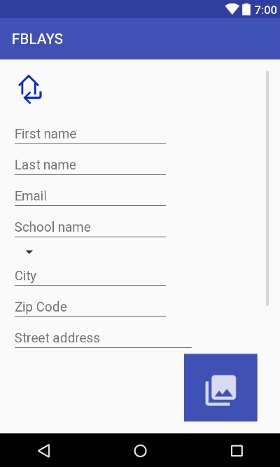

*<?***xml version="1.0" encoding="utf-8"***?>*

<**RelativeLayout xmlns:android="http://schemas.android.com/apk/res/android"**

**xmlns:app="http://schemas.android.com/apk/res-auto"**

**xmlns:tools="http://schemas.android.com/tools"**

**android:id="@+id/activity_chapter_registration"**

**android:layout_width="match_parent"**

**android:layout_height="match_parent"**

**android:paddingBottom="@dimen/activity_vertical_margin"**

**android:paddingLeft="@dimen/activity_horizontal_margin"**

**android:paddingRight="@dimen/activity_horizontal_margin"**

**android:paddingTop="@dimen/activity_vertical_margin"**

**tools:context="com.example.izzy.fblays2.EditChapterInfo"**>

<**ScrollView**

**android:layout_width="match_parent"**

**android:layout_height="match_parent"**

**android:layout_alignParentTop="true"**

**android:layout_alignParentStart="true"**>

<**LinearLayout**

**android:layout_width="match_parent"**

**android:layout_height="match_parent"**

**android:layout_alignParentTop="true"**

**android:layout_alignParentLeft="true"**

**android:layout_alignParentStart="true"**

**android:orientation="vertical"**

**android:weightSum="1"**>

<**Space**

**android:layout_width="0dp"**

**android:layout_height="0dp"**

**android:layout_centerHorizontal="true"**

**android:layout_below="@+id/reg_email"**

**android:layout_marginTop="0dp"**

**android:id="@+id/firstLast"**/>

<**ImageButton**

**android:id="@+id/btnReturn"**

**android:layout_width="50dp"**

**android:layout_height="50dp"**

**android:layout_marginBottom="15dp"**

**android:scaleType="fitXY"**

**android:background="@android:color/transparent"**

**android:src="@drawable/returnhome2"**/>

<**EditText**

**android:layout_width="wrap_content"**

**android:layout_height="wrap_content"**

**android:inputType="textPersonName"**

**android:ems="10"**

**android:id="@+id/reg_firstName"**

**android:hint="First name"**

**android:layout_marginTop="0dp"**

**android:layout_below="@+id/firstLast"**

**android:layout_alignParentStart="true"**

**android:layout_alignEnd="@+id/firstLast"** />

<**EditText**

**android:layout_width="wrap_content"**

**android:layout_height="wrap_content"**

**android:inputType="textPersonName"**

**android:ems="10"**

**android:id="@+id/reg_lastName"**

**android:hint="Last name"**

**android:layout_alignBaseline="@+id/reg_firstName"**

**android:layout_alignBottom="@+id/reg_firstName"**

**android:layout_alignParentEnd="true"**

**android:layout_toEndOf="@+id/reg_firstName"** />

<**EditText**

**android:layout_width="wrap_content"**

**android:layout_height="wrap_content"**

**android:inputType="textEmailAddress"**

**android:ems="10"**

**android:id="@+id/reg_email"**

**android:hint="Email"**

**android:layout_below="@+id/reg_ChapterID"**

**android:layout_alignParentStart="true"**

**android:layout_marginTop="0dp"**

**android:layout_alignParentEnd="true"** />

<**EditText**

**android:layout_width="wrap_content"**

**android:layout_height="wrap_content"**

**android:inputType="textPersonName"**

**android:ems="10"**

**android:layout_marginTop="0dp"**

**android:id="@+id/reg_schoolName"**

**android:layout_below="@+id/reg_firstName"**

**android:layout_alignParentStart="true"**

**android:hint="School name"**

**android:layout_alignParentEnd="true"** />

<**Spinner**

**android:layout_width="wrap_content"**

**android:layout_height="wrap_content"**

**android:id="@+id/spinner"**

**android:layout_alignBottom="@+id/reg_streetAddress"**

**android:layout_alignParentEnd="true"**

**android:layout_below="@+id/reg_zipCode"**

**android:layout_toEndOf="@+id/reg_streetAddress"**

**android:spinnerMode="dialog"** />

<**Space**

**android:layout_width="wrap_content"**

**android:layout_height="wrap_content"**

**android:layout_below="@+id/reg_schoolName"**

**android:layout_centerHorizontal="true"**

**android:layout_marginTop="0dp"**

**android:id = "@+id/cityZip"** />

<**EditText**

**android:layout_width="wrap_content"**

**android:layout_height="wrap_content"**

**android:inputType="textPersonName"**

**android:ems="10"**

**android:layout_below="@+id/cityZip"**

**android:layout_toStartOf="@+id/cityZip"**

**android:layout_alignParentStart="true"**

**android:id="@+id/reg_city"**

**android:hint="City"** />

<**EditText**

**android:layout_width="wrap_content"**

**android:layout_height="wrap_content"**

**android:ems="10"**

**android:layout_below="@+id/cityZip"**

**android:layout_toEndOf="@+id/cityZip"**

**android:layout_alignParentEnd="true"**

**android:id="@+id/reg_zipCode"**

**android:inputType="number"**

**android:hint="Zip Code"** />

<**EditText**

**android:layout_height="wrap_content"**

**android:inputType="textPostalAddress"**

**android:ems="10"**

**android:id="@+id/reg_streetAddress"**

**android:hint="Street address"**

**android:layout_below="@+id/reg_city"**

**android:layout_alignParentStart="true"**

**android:layout_width="250dp"** />

<**LinearLayout**

**android:layout_width="match_parent"**

**android:layout_height="match_parent"**

**android:orientation="horizontal"**>

<**ImageView**

**android:layout_width="220dp"**

**android:layout_height="220dp"**

**app:srcCompat="@android:color/transparent"**

**android:id="@+id/chapterPic"** />

<**LinearLayout**

**android:layout_width="match_parent"**

**android:layout_height="match_parent"**

**android:orientation="vertical"**>

<**ImageButton**

**android:id="@+id/btnGallery"**

**android:layout_width="100dp"**

**android:layout_height="0dp"**

**android:layout_weight=".5"**

**android:padding="25dp"**

**android:scaleType="fitXY"**

**android:background="@color/colorPrimary"**

**android:onClick="onGalleryClicked"**

**android:layout_gravity="center"**

**android:src="@drawable/ic_piclibrary"**

**android:textSize="12sp"** />

<**LinearLayout**

**android:layout_width="wrap_content"**

**android:layout_height="0dp"**

**android:layout_weight=".1"** />

<**ImageButton**

**android:id="@+id/btnCamera"**

**android:layout_width="100dp"**

**android:layout_gravity="center"**

**android:layout_height="0dp"**

**android:layout_weight=".5"**

**android:padding="25dp"**

**android:scaleType="fitXY"**

**android:background="@color/colorPrimary"**

**android:onClick="onCameraClicked"**

**android:src="@drawable/ic_camera"**

**android:textColor="@android:color/background_light"**

**android:textSize="12sp"** />

</**LinearLayout**>

</**LinearLayout**>

<**Button**

**android:text="Update"**

**android:layout_width="match_parent"**

**android:layout_height="wrap_content"**

**android:layout_alignParentBottom="true"**

**android:layout_marginBottom="20dp"**

**android:layout_marginTop="40dp"**

**android:id="@+id/btnUpdate"**

**android:layout_alignParentStart="true"**

**android:layout_alignParentEnd="true"**

**android:layout_weight="0.13"**

**android:background="@color/colorPrimary"**

**android:textColor="@android:color/background_light"** />

</**LinearLayout**></**ScrollView**>

</**RelativeLayout**>

activity_edit_sale_info.xml

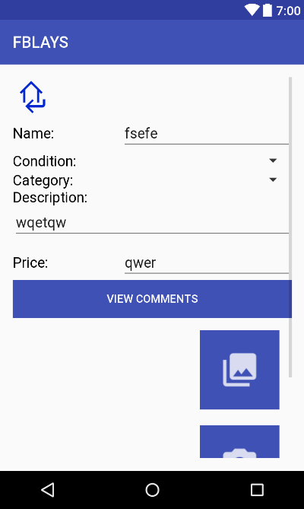

*<?***xml version="1.0" encoding="utf-8"***?>*

<**RelativeLayout xmlns:android="http://schemas.android.com/apk/res/android"**

**xmlns:tools="http://schemas.android.com/tools"**

**xmlns:app="http://schemas.android.com/apk/res-auto"**

**android:id="@+id/activity_edit_sale_info"**

**android:layout_width="match_parent"**

**android:layout_height="match_parent"**

**android:paddingBottom="@dimen/activity_vertical_margin"**

**android:paddingLeft="@dimen/activity_horizontal_margin"**

**android:paddingRight="@dimen/activity_horizontal_margin"**

**android:paddingTop="@dimen/activity_vertical_margin"**

**tools:context="com.example.izzy.fblays2.EditSaleInfo"**>

<**ScrollView**

**android:layout_width="match_parent"**

**android:layout_height="match_parent"**

**android:layout_alignParentTop="true"**

**android:layout_alignParentStart="true"**>

<**RelativeLayout**

**android:layout_width="match_parent"**

**android:layout_height="match_parent"**

**android:orientation="vertical"**

**android:layout_alignParentTop="true"**

**android:layout_alignParentLeft="true"**

**android:layout_alignParentStart="true"**

**android:weightSum="1"**>

<**TextView**

**android:text="Name:"**

**android:layout_width="wrap_content"**

**android:layout_height="wrap_content"**

**android:id="@+id/textView12"**

**android:textSize="18sp"**

**android:layout_alignBaseline="@+id/nameET"**

**android:layout_alignBottom="@+id/nameET"**

**android:layout_alignParentStart="true"**

**android:textColor="@android:color/black"** />

<**EditText**

**android:layout_width="wrap_content"**

**android:layout_height="wrap_content"**

**android:inputType="textPersonName"**

**android:ems="10"**

**android:id="@+id/nameET"**

**android:layout_below="@id/btnReturn"**

**android:layout_alignParentEnd="true"**

**android:text="fsefe"** />

<**TextView**

**android:text="Price:"**

**android:layout_width="wrap_content"**

**android:layout_height="wrap_content"**

**android:id="@+id/textView4"**

**android:textSize="18sp"**

**android:textColor="@android:color/black"**

**android:layout_below="@+id/descriptionET"**

**android:layout_alignParentStart="true"**

**android:layout_marginTop="18dp"** />

<**EditText**

**android:layout_width="wrap_content"**

**android:layout_height="wrap_content"**

**android:inputType="numberDecimal"**

**android:ems="10"**

**android:id="@+id/priceET"**

**android:text="qwer"**

**android:layout_alignBaseline="@+id/textView4"**

**android:layout_alignBottom="@+id/textView4"**

**android:layout_alignParentEnd="true"** />

<**TextView**

**android:text="Condition:"**

**android:layout_width="wrap_content"**

**android:layout_height="wrap_content"**

**android:id="@+id/textView11"**

**android:textSize="18sp"**

**android:textColor="@android:color/black"**

**android:layout_alignBaseline="@+id/condition1ET"**

**android:layout_alignBottom="@+id/condition1ET"**

**android:layout_alignParentStart="true"** />

<**Spinner**

**android:layout_width="200dp"**

**android:layout_height="wrap_content"**

**android:inputType="textPersonName"**

**android:ems="10"**

**android:id="@+id/categoryET"**

**android:text="sdfggs"**

**android:layout_below="@+id/condition1ET"**

**android:layout_alignParentEnd="true"** />

<**TextView**

**android:text="Category:"**

**android:layout_width="wrap_content"**

**android:layout_height="wrap_content"**

**android:id="@+id/nameTV"**

**android:textSize="18sp"**

**android:textColor="@android:color/black"**

**android:layout_alignBaseline="@+id/categoryET"**

**android:layout_alignBottom="@+id/categoryET"**

**android:layout_alignParentStart="true"** />

<**TextView**

**android:text="Description:"**

**android:layout_width="wrap_content"**

**android:layout_height="wrap_content"**

**android:id="@+id/textView5"**

**android:textSize="18sp"**

**android:textColor="@android:color/black"**

**android:layout_below="@id/categoryET"**

**android:layout_alignParentStart="true"** />

<**EditText**

**android:layout_width="wrap_content"**

**android:layout_height="wrap_content"**

**android:inputType="textMultiLine"**

**android:ems="10"**

**android:id="@+id/descriptionET"**

**android:text="wqetqw"**

**android:layout_below="@+id/textView5"**

**android:layout_alignParentStart="true"**

**android:layout_alignParentEnd="true"** />

<**Button**

**android:text="Edit"**

**android:layout_width="wrap_content"**

**android:layout_height="wrap_content"**

**android:id="@+id/btnEdit"**

**android:layout_alignParentBottom="true"**

**android:layout_alignParentStart="true"**

**android:layout_below="@id/btnEdit"**

**android:layout_alignParentEnd="true"**

**android:textColor="@android:color/background_light"**

**android:background="@color/colorPrimary"** />

<**Space**

**android:layout_width="wrap_content"**

**android:layout_height="wrap_content"**

**android:layout_alignParentTop="true"**

**android:layout_centerHorizontal="true"**

**android:layout_marginTop="447dp"**

**android:id="@+id/space"**/>

<**ImageButton**

**android:src="@drawable/returnhome2"**

**android:scaleType="fitXY"**

**android:layout_width="50dp"**

**android:layout_height="50dp"**

**android:id="@+id/btnReturn"**

**android:background="@android:color/transparent"**

**android:layout_alignParentTop="true"**

**android:layout_alignParentStart="true"** />

<**Button**

**android:layout_width="match_parent"**

**android:layout_height="wrap_content"**

**android:id="@+id/commentBtn"**

**android:text="View Comments"**

**android:textColor="@android:color/background_light"**

**android:background="@color/colorPrimary"**

**android:layout_marginBottom="15dp"**

**android:layout_below="@id/priceET"**/>

<**LinearLayout**

**android:layout_width="match_parent"**

**android:layout_height="match_parent"**

**android:orientation="horizontal"**

**android:id="@+id/newpiclayout"**

**android:layout_below="@+id/commentBtn"**

**android:layout_marginBottom="70dp"**

**android:layout_alignParentStart="true"**>

<**ImageView**

**android:layout_width="220dp"**

**android:layout_height="220dp"**

**android:scaleType="fitXY"**

**app:srcCompat="@android:color/transparent"**

**android:id="@+id/objectIV"** />

<**LinearLayout**

**android:layout_width="match_parent"**

**android:layout_height="match_parent"**

**android:orientation="vertical"**>

<**ImageButton**

**android:id="@+id/choosePic"**

**android:layout_width="100dp"**

**android:layout_height="0dp"**

**android:layout_weight=".5"**

**android:padding="25dp"**

**android:scaleType="fitXY"**

**android:background="@color/colorPrimary"**

**android:onClick="onGalleryClicked"**

**android:layout_gravity="center"**

**android:src="@drawable/ic_piclibrary"**

**android:textSize="12sp"** />

<**LinearLayout**

**android:layout_width="wrap_content"**

**android:layout_height="0dp"**

**android:layout_weight=".1"** />

<**ImageButton**

**android:id="@+id/takePic"**

**android:layout_width="100dp"**

**android:layout_height="0dp"**

**android:layout_gravity="center"**

**android:layout_weight=".5"**

**android:background="@color/colorPrimary"**

**android:onClick="onCameraClicked"**

**android:padding="25dp"**

**android:scaleType="fitXY"**

**android:src="@drawable/ic_camera"**

**android:textColor="@android:color/background_light"**

**android:textSize="12sp"** />

</**LinearLayout**>

</**LinearLayout**>

<**Spinner**

**android:layout_width="200dp"**

**android:layout_height="wrap_content"**

**android:inputType="textPersonName"**

**android:ems="10"**

**android:id="@+id/condition1ET"**

**android:text="sdfgs"**

**android:layout_below="@+id/nameET"**

**android:layout_alignParentEnd="true"** />

</**RelativeLayout**>

</**ScrollView**>

</**RelativeLayout**>

activity_feed.xml

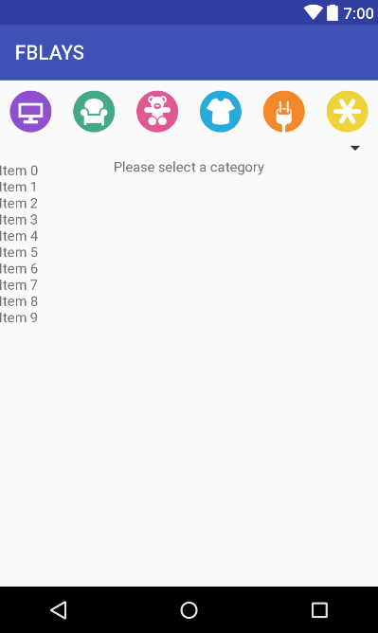

*<?***xml version="1.0" encoding="utf-8"***?>*

<**RelativeLayout xmlns:android="http://schemas.android.com/apk/res/android"**

**xmlns:app="http://schemas.android.com/apk/res-auto"**

**xmlns:tools="http://schemas.android.com/tools"**

**android:id="@+id/activity_feed"**

**android:layout_width="match_parent"**

**android:layout_height="match_parent"**

**tools:context="com.example.izzy.fblays2.FeedFragment"**>

<**android.support.v7.widget.RecyclerView**

**android:layout_width="match_parent"**

**android:layout_height="wrap_content"**

**android:id="@+id/recyclerViewFeed"**

**android:layout_alignParentTop="true"**

**android:layout_alignParentStart="true"**

**android:layout_marginTop="83dp"**

**android:layout_marginBottom="50dp"**>

</**android.support.v7.widget.RecyclerView**>

<**TextView**

**android:layout_width="match_parent"**

**android:layout_height="50dp"**

**android:text="Please select a category"**

**android:gravity="center"**

**android:layout_below="@+id/buttonLinLayout"**

**android:id="@+id/noneTXT"**/>

<**LinearLayout**

**android:layout_width="match_parent"**

**android:layout_height="63dp"**

**android:orientation="horizontal"**

**android:layout_alignParentTop="true"**

**android:layout_alignParentStart="true"**

**android:id="@+id/buttonLinLayout"**>

<**ImageButton**

**android:layout_width="63dp"**

**android:layout_height="63dp"**

**app:srcCompat="@mipmap/ic_electronic"**

**android:id="@+id/electronicsBtn"**

**android:layout_weight="1"**

**android:background="@android:color/transparent"**

**android:elevation="0dp"**

**android:adjustViewBounds="false"**

**style="?android:attr/borderlessButtonStyle"**

**tools:theme="@style/Widget.AppCompat.Button.Borderless"** />

<**ImageButton**

**android:layout_width="63dp"**

**android:layout_height="63dp"**

**app:srcCompat="@mipmap/ic_furniture"**

**android:id="@+id/furnitureBtn"**

**android:layout_weight="1"**

**android:background="@android:color/transparent"** />

<**ImageButton**

**android:layout_width="63dp"**

**android:layout_height="63dp"**

**app:srcCompat="@mipmap/ic_toy"**

**android:id="@+id/toysBtn"**

**android:layout_weight="1"**

**android:background="@android:color/transparent"** />

<**ImageButton**

**android:layout_width="63dp"**

**android:layout_height="63dp"**

**app:srcCompat="@mipmap/ic_clothing"**

**android:id="@+id/ClothingBtn"**

**android:layout_weight="1"**

**android:background="@android:color/transparent"** />

<**ImageButton**

**android:layout_width="63dp"**

**android:layout_height="63dp"**

**app:srcCompat="@mipmap/ic_appliance"**

**android:id="@+id/appliancesBtn"**

**android:layout_weight="1"**

**android:background="@android:color/transparent"** />

<**ImageButton**

**android:layout_width="63dp"**

**android:layout_height="63dp"**

**app:srcCompat="@mipmap/ic_misc"**

**android:id="@+id/miscBtn"**

**android:layout_weight="1"**

**android:background="@android:color/transparent"**

**style="@android:style/Widget.ImageButton"** />

</**LinearLayout**>

<**Spinner**

**android:layout_width="match_parent"**

**android:layout_height="wrap_content"**

**android:layout_alignBottom="@+id/noneTXT"**

**android:layout_alignParentStart="true"**

**android:layout_marginBottom="33dp"**

**android:id="@+id/filterSpinner"** />

</**RelativeLayout**>

activity_join_chapter.xml

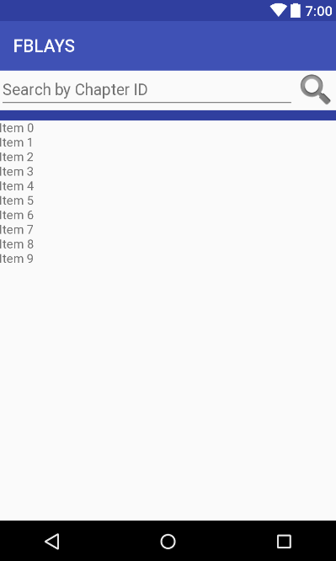

*<?***xml version="1.0" encoding="utf-8"***?>*

<**LinearLayout xmlns:android="http://schemas.android.com/apk/res/android"**

**xmlns:app="http://schemas.android.com/apk/res-auto"**

**xmlns:tools="http://schemas.android.com/tools"**

**android:orientation="vertical"**

**android:layout_width="match_parent"**

**android:layout_height="match_parent"**

**tools:context="com.example.izzy.fblays2.JoinChapter"**>

<**LinearLayout**

**android:layout_width="match_parent"**

**android:layout_height="wrap_content"**

**android:orientation="vertical"**>

<**RelativeLayout**

**android:layout_width="match_parent"**

**android:layout_height="45dp"**>

<**ImageButton**

**android:layout_width="wrap_content"**

**android:layout_height="match_parent"**

**android:background="@android:color/transparent"**

**android:layout_alignParentTop="true"**

**android:layout_alignParentRight="true"**

**android:layout_alignParentEnd="true"**

**android:id="@+id/searchBtn"**

**app:srcCompat="@android:drawable/ic_search_category_default"** />

<**EditText**

**android:id="@+id/searchET"**

**android:layout_width="wrap_content"**

**android:layout_height="match_parent"**

**android:layout_alignParentBottom="true"**

**android:layout_alignParentLeft="true"**

**android:layout_alignParentStart="true"**

**android:layout_toLeftOf="@+id/searchBtn"**

**android:layout_toStartOf="@+id/searchBtn"**

**android:ems="10"**

**android:hint="Search by Chapter ID"**

**android:inputType="number"**

**android:textColor="?android:attr/textColorTertiary"**

**android:textSize="18sp"** />

</**RelativeLayout**>

<**LinearLayout**

**android:layout_width="match_parent"**

**android:layout_height="12dp"**

**android:background="@color/colorPrimaryDark"**></**LinearLayout**>

</**LinearLayout**>

<**android.support.v7.widget.RecyclerView**

**android:layout_width="match_parent"**

**android:layout_height="wrap_content"**

**android:id="@+id/recyclerView"**

**android:layout_alignParentTop="true"**

**android:layout_alignParentStart="true"**

**android:layout_marginTop="0dp"**>

</**android.support.v7.widget.RecyclerView**>

<**LinearLayout**

**android:layout_width="match_parent"**

**android:layout_height="match_parent"**

**android:orientation="vertical"**>

<**RelativeLayout**

**android:layout_width="match_parent"**

**android:layout_height="wrap_content"**>

<**ImageView**

**android:layout_width="150dp"**

**android:layout_height="150dp"**

**app:srcCompat="@android:color/background_light"**

**android:layout_alignParentTop="true"**

**android:layout_alignParentStart="true"**

**android:id="@+id/profilePicIV"**

**android:visibility="invisible"**/>

<**TextView**

**android:text="email@gmail.com"**

**android:layout_width="wrap_content"**

**android:layout_height="wrap_content"**

**android:layout_below="@+id/nameTV"**

**android:layout_alignStart="@+id/nameTV"**

**android:layout_marginTop="12dp"**

**android:id="@+id/emailTV"**

**android:textSize="14sp"**

**android:textColor="@android:color/black"**

**android:visibility="invisible"**/>

<**TextView**

**android:text="School Name"**

**android:layout_width="wrap_content"**

**android:layout_height="wrap_content"**

**android:layout_marginStart="14dp"**

**android:id="@+id/nameTV"**

**android:textSize="18sp"**

**android:textColor="@android:color/black"**

**android:layout_alignParentTop="true"**

**android:layout_toEndOf="@+id/profilePicIV"**

**android:visibility="invisible"**/>

<**TextView**

**android:text="ST"**

**android:layout_width="40dp"**

**android:layout_height="wrap_content"**

**android:id="@+id/schoolStateTV"**

**android:textColor="@android:color/black"**

**android:layout_toEndOf="@+id/cityTV"**

**android:layout_alignBaseline="@+id/cityTV"**

**android:layout_alignBottom="@+id/cityTV"**

**android:visibility="invisible"**/>

<**TextView**

**android:text="123 Street St."**

**android:layout_width="wrap_content"**

**android:layout_height="wrap_content"**

**android:layout_marginTop="12dp"**

**android:id="@+id/schoolAddressTV"**

**android:textSize="14sp"**

**android:textColor="@android:color/black"**

**android:layout_below="@+id/emailTV"**

**android:layout_alignStart="@+id/zipcodeTV"**

**android:visibility="invisible"**/>

<**TextView**

**android:text="123456"**

**android:layout_width="wrap_content"**

**android:layout_height="wrap_content"**

**android:id="@+id/zipcodeTV"**

**android:textColor="@android:color/black"**

**android:layout_below="@+id/schoolAddressTV"**

**android:layout_alignStart="@+id/cityTV"**

**android:visibility="invisible"**/>

<**TextView**

**android:text="City,"**

**android:layout_width="wrap_content"**

**android:layout_height="wrap_content"**

**android:id="@+id/cityTV"**

**android:textColor="@android:color/black"**

**android:layout_below="@+id/zipcodeTV"**

**android:layout_alignStart="@+id/emailTV"**

**android:visibility="invisible"**/>

</**RelativeLayout**>

<**Button**

**android:text="Join Chapter"**

**android:layout_width="match_parent"**

**android:layout_height="wrap_content"**

**android:id="@+id/joinBtn"**

**android:visibility="invisible"**/>

</**LinearLayout**>

</**LinearLayout**>

activity_launcher_screen.xml

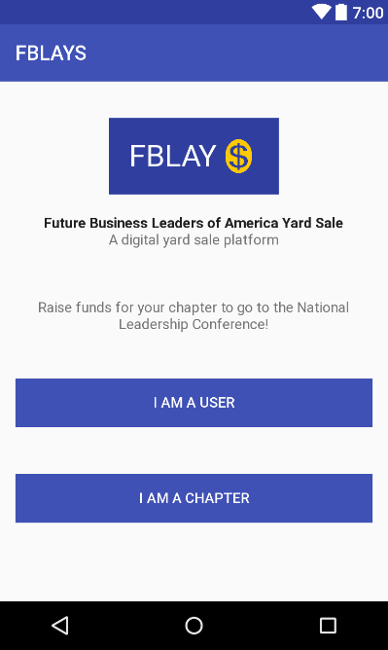

*<?***xml version="1.0" encoding="utf-8"***?>*

<**LinearLayout xmlns:android="http://schemas.android.com/apk/res/android"**

**xmlns:tools="http://schemas.android.com/tools"**

**android:id="@+id/activity_launcher_screen"**

**android:layout_width="match_parent"**

**android:layout_height="match_parent"**

**android:paddingBottom="@dimen/activity_vertical_margin"**

**android:paddingLeft="@dimen/activity_horizontal_margin"**

**android:paddingRight="@dimen/activity_horizontal_margin"**

**android:paddingTop="@dimen/activity_vertical_margin"**

**tools:context="com.example.izzy.fblays2.LauncherScreen"**

**android:orientation="vertical"**>

<**LinearLayout**

**android:layout_width="wrap_content"**

**android:layout_height="wrap_content"**

**android:orientation="horizontal"**

**android:background="@color/colorPrimaryDark"**

**android:paddingLeft="20dp"**

**android:paddingRight="20dp"**

**android:layout_gravity="center"**

**android:layout_marginTop="20dp"**>

<**TextView**

**android:layout_width="wrap_content"**

**android:layout_height="75dp"**

**android:text="FBLAY"**

**android:textSize="30sp"**

**android:gravity="center"**

**android:textColor="@android:color/background_light"** />

<**ImageView**

**android:layout_width="39dp"**

**android:layout_height="75dp"**

**android:src="@drawable/moneysign"**/>

</**LinearLayout**>

<**TextView**

**android:layout_width="wrap_content"**

**android:layout_height="wrap_content"**

**android:text="Future Business Leaders of America Yard Sale"**

**android:layout_gravity="center"**

**android:layout_marginTop="20dp"**

**android:textSize="14sp"**

**android:textStyle="normal|bold"**

**android:textColor="?android:attr/textColorPrimary"** />

<**TextView**

**android:layout_width="wrap_content"**

**android:layout_height="wrap_content"**

**android:text="A digital yard sale platform"**

**android:layout_gravity="center"**/>

<**TextView**

**android:layout_width="wrap_content"**

**android:layout_height="wrap_content"**

**android:text="Raise funds for your chapter to go to the National Leadership Conference!"**

**android:layout_gravity="center"**

**android:gravity="center"**

**android:layout_marginTop="50dp"**/>

<**RelativeLayout**

**android:layout_width="match_parent"**

**android:layout_height="wrap_content"**>

<**Button**

**android:id="@+id/btnUser"**

**android:layout_width="wrap_content"**

**android:layout_height="wrap_content"**

**android:layout_alignParentEnd="true"**

**android:layout_alignParentStart="true"**

**android:layout_alignParentTop="true"**

**android:layout_marginTop="45dp"**

**android:background="@color/colorPrimary"**

**android:text="I am a user"**

**android:textColor="?android:attr/textColorPrimaryInverse"**

**android:textSize="14sp"** />

<**Button**

**android:id="@+id/btnChapter"**

**android:layout_width="wrap_content"**

**android:layout_height="wrap_content"**

**android:layout_alignParentEnd="true"**

**android:layout_alignStart="@+id/btnUser"**

**android:layout_below="@+id/btnUser"**

**android:layout_marginTop="46dp"**

**android:background="@color/colorPrimary"**

**android:text="I am a chapter"**

**android:textColor="?android:attr/textColorPrimaryInverse"**

**android:textSize="14sp"** />

</**RelativeLayout**>

</**LinearLayout**>

activity_login.xml

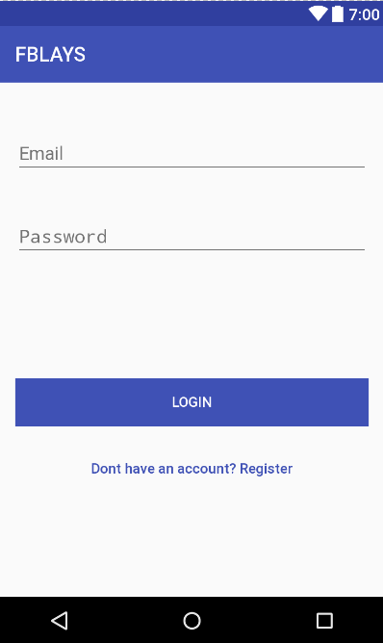

*<?***xml version="1.0" encoding="utf-8"***?>*

<**RelativeLayout xmlns:android="http://schemas.android.com/apk/res/android"**

**xmlns:tools="http://schemas.android.com/tools"**

**android:id="@+id/activity_login"**

**android:layout_width="match_parent"**

**android:layout_height="match_parent"**

**android:paddingBottom="@dimen/activity_vertical_margin"**

**android:paddingLeft="@dimen/activity_horizontal_margin"**

**android:paddingRight="@dimen/activity_horizontal_margin"**

**android:paddingTop="@dimen/activity_vertical_margin"**

**tools:context="com.example.izzy.fblays2.LoginActivity"**>

<**EditText**

**android:layout_width="wrap_content"**

**android:layout_height="wrap_content"**

**android:inputType="textEmailAddress"**

**android:ems="10"**

**android:layout_below="@+id/textView"**

**android:layout_alignParentTop="true"**

**android:layout_alignParentEnd="true"**

**android:layout_alignParentStart="true"**

**android:layout_marginTop="34dp"**

**android:id="@+id/emailETLogin"**

**android:hint="Email"** />

<**EditText**

**android:layout_width="wrap_content"**

**android:layout_height="wrap_content"**

**android:inputType="textPassword"**

**android:ems="10"**

**android:layout_below="@+id/emailETLogin"**

**android:layout_alignParentStart="true"**

**android:layout_alignParentEnd="true"**

**android:layout_marginTop="40dp"**

**android:id="@+id/passwordETLogin"**

**android:hint="Password"** />

<**Button**

**android:text="Login"**

**android:layout_width="wrap_content"**

**android:layout_height="wrap_content"**

**android:layout_below="@+id/passwordETLogin"**

**android:layout_alignParentEnd="true"**

**android:layout_alignParentStart="true"**

**android:layout_marginTop="119dp"**

**android:id="@+id/loginBtn"**

**android:background="@color/colorPrimary"**

**android:textColor="?android:attr/textColorPrimaryInverse"**

**android:textSize="14sp"**/>

<**Button**

**android:text="Dont have an account? Register"**

**android:layout_width="wrap_content"**

**android:layout_height="wrap_content"**

**android:id="@+id/noLoginBtn"**

**android:background="@android:color/transparent"**

**android:textSize="14sp"**

**android:textColor="@color/colorPrimary"**

**android:layout_marginTop="18dp"**

**android:textAllCaps="false"**

**android:layout_below="@+id/loginBtn"**

**android:layout_alignParentStart="true"**

**android:layout_alignParentEnd="true"** />

</**RelativeLayout**>

activity_main_page.xml

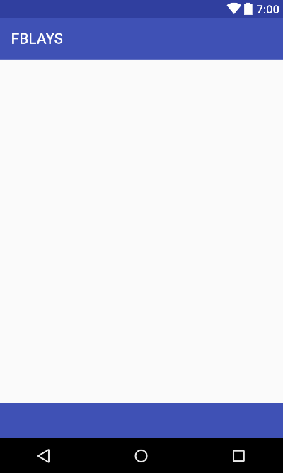

*<?***xml version="1.0" encoding="utf-8"***?>*

<**LinearLayout xmlns:android="http://schemas.android.com/apk/res/android"**

**xmlns:app="http://schemas.android.com/apk/res-auto"**

**android:orientation="vertical"**

**android:layout_width="match_parent"**

**android:layout_height="match_parent"** >

<**android.support.v4.view.ViewPager**

**android:id="@+id/viewpager"**

**android:layout_width="match_parent"**

**android:layout_height="wrap_content"**

**app:layout_behavior="@string/appbar_scrolling_view_behavior"** />

<**FrameLayout**

**android:layout_width="match_parent"**

**android:layout_height="wrap_content"**

**android:layout_weight="1"**

**android:layout_marginBottom="-48dp"**/>

<**android.support.design.widget.AppBarLayout**

**android:layout_width="match_parent"**

**android:layout_height="wrap_content"**

**android:theme="@style/ThemeOverlay.AppCompat.Dark.ActionBar"**

**android:layout_weight="0"**>

<**android.support.design.widget.TabLayout**

**android:id="@+id/tabs"**

**android:layout_width="match_parent"**

**android:layout_height="wrap_content"**

**app:tabMode="fixed"**

**app:tabGravity="fill"**

/>

</**android.support.design.widget.AppBarLayout**>

</**LinearLayout**>

activity_notification_list2.xml

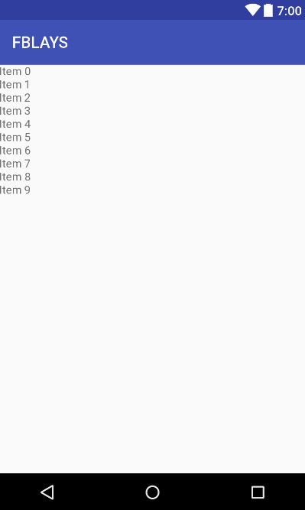

*<?***xml version="1.0" encoding="utf-8"***?>*

<**RelativeLayout xmlns:android="http://schemas.android.com/apk/res/android"**

**xmlns:tools="http://schemas.android.com/tools"**

**android:id="@+id/activity_notification_list2"**

**android:layout_width="match_parent"**

**android:layout_height="match_parent"**

**tools:context="com.example.izzy.fblays2.ChapterNotificationsFragment"**>

<**android.support.v7.widget.RecyclerView**

**android:layout_width="match_parent"**

**android:layout_height="wrap_content"**

**android:id="@+id/recyclerView"**

**android:layout_marginBottom="50dp"**>

</**android.support.v7.widget.RecyclerView**>

</**RelativeLayout**>

activity_profile.xml

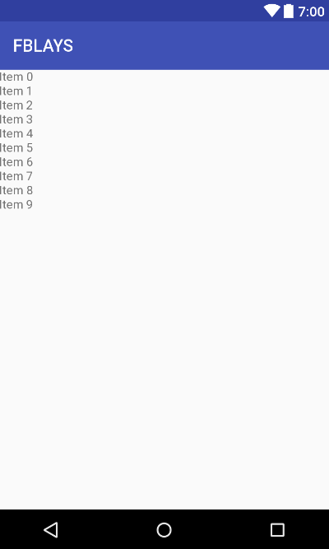

*<?***xml version="1.0" encoding="utf-8"***?>*

<**RelativeLayout xmlns:android="http://schemas.android.com/apk/res/android"**

**xmlns:tools="http://schemas.android.com/tools"**

**android:id="@+id/activity_profile"**

**android:layout_width="match_parent"**

**android:layout_height="match_parent"**

**tools:context="com.example.izzy.fblays2.Profile"**>

<**android.support.v7.widget.RecyclerView**

**android:layout_width="match_parent"**

**android:layout_height="wrap_content"**

**android:id="@+id/recyclerViewProf"**

**android:layout_marginBottom="50dp"**

>

</**android.support.v7.widget.RecyclerView**>

</**RelativeLayout**>

activity_purchase_item.xml

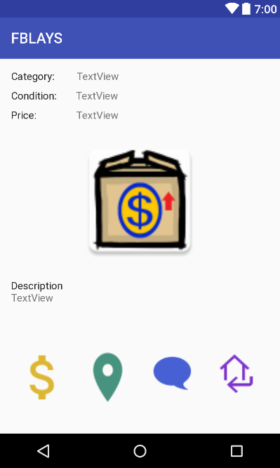

*<?***xml version="1.0" encoding="utf-8"***?>*

<**RelativeLayout xmlns:android="http://schemas.android.com/apk/res/android"**

**xmlns:app="http://schemas.android.com/apk/res-auto"**

**xmlns:tools="http://schemas.android.com/tools"**

**android:id="@+id/activity_purchase_item"**

**android:layout_width="match_parent"**

**android:layout_height="match_parent"**

**android:paddingLeft="@dimen/activity_horizontal_margin"**

**android:paddingRight="@dimen/activity_horizontal_margin"**

**android:paddingTop="@dimen/activity_vertical_margin"**

**tools:context="com.example.izzy.fblays2.PurchaseItem"**>

<**ScrollView**

**android:layout_width="match_parent"**

**android:layout_height="match_parent"**

**android:layout_alignParentTop="true"**

**android:layout_alignParentStart="true"**>

<**RelativeLayout**

**android:layout_width="match_parent"**

**android:layout_height="match_parent"**>

<**LinearLayout**

**android:id="@+id/linearLayout3"**

**android:layout_width="match_parent"**

**android:layout_height="wrap_content"**

**android:layout_alignParentStart="true"**

**android:layout_below="@+id/linearLayout2"**

**android:layout_marginTop="10dp"**>

<**TextView**

**android:id="@+id/textView25"**

**android:layout_width="wrap_content"**

**android:layout_height="wrap_content"**

**android:text="Price:"**

**android:textColor="?android:attr/textColorPrimary"**/>

<**TextView**

**android:id="@+id/txtPrice"**

**android:layout_width="wrap_content"**

**android:layout_height="wrap_content"**

**android:layout_marginStart="54dp"**

**android:text="TextView"** />

</**LinearLayout**>

<**LinearLayout**

**android:id="@+id/linearLayout2"**

**android:layout_width="match_parent"**

**android:layout_height="wrap_content"**

**android:layout_alignParentStart="true"**

**android:layout_below="@+id/linearLayout"**

**android:layout_marginTop="10dp"**>

<**TextView**

**android:id="@+id/textView23"**

**android:layout_width="wrap_content"**

**android:layout_height="wrap_content"**

**android:text="Condition:"**

**android:textColor="?android:attr/textColorPrimary"**/>

<**TextView**

**android:id="@+id/txtCondition1"**

**android:layout_width="wrap_content"**

**android:layout_height="wrap_content"**

**android:layout_marginStart="26dp"**

**android:text="TextView"** />

</**LinearLayout**>

<**ImageView**

**android:id="@+id/purchaseImage"**

**android:layout_width="300dp"**

**android:layout_height="175dp"**

**android:layout_below="@+id/linearLayout3"**

**android:layout_centerHorizontal="true"**

**android:layout_marginTop="21dp"**

**app:srcCompat="@mipmap/ic_launcher"** />

<**LinearLayout**

**android:id="@+id/linearLayout4"**

**android:layout_width="match_parent"**

**android:layout_height="wrap_content"**

**android:layout_alignParentStart="true"**

**android:layout_below="@+id/purchaseImage"**

**android:orientation="vertical"**

**android:layout_marginTop="20dp"**>

<**TextView**

**android:id="@+id/textView27"**

**android:layout_width="wrap_content"**

**android:layout_height="wrap_content"**

**android:layout_alignParentStart="true"**

**android:layout_below="@+id/linearLayout3"**

**android:text="Description"**

**android:textColor="?android:attr/textColorPrimary"**/>

<**TextView**

**android:id="@+id/txtDescription"**

**android:layout_width="wrap_content"**

**android:layout_height="wrap_content"**

**android:layout_alignParentStart="true"**

**android:layout_below="@+id/textView27"**

**android:text="TextView"** />

</**LinearLayout**>

<**LinearLayout**

**android:id="@+id/linearLayout"**

**android:layout_width="match_parent"**

**android:layout_height="wrap_content"**

**android:layout_alignParentTop="true"**

**android:layout_alignParentStart="true"**>

<**TextView**

**android:id="@+id/textView21"**

**android:layout_width="wrap_content"**

**android:layout_height="wrap_content"**

**android:text="Category:"**

**android:textColor="?android:attr/textColorPrimary"** />

<**TextView**

**android:id="@+id/txtCategory"**

**android:layout_width="wrap_content"**

**android:layout_height="wrap_content"**

**android:layout_marginStart="30dp"**

**android:text="TextView"** />

</**LinearLayout**>

<**LinearLayout**

**android:layout_width="match_parent"**

**android:layout_height="wrap_content"**

**android:orientation="horizontal"**

**android:layout_below="@id/linearLayout4"**

**android:layout_marginTop="55dp"**>

<**ImageButton**

**android:id="@+id/purchase"**

**android:layout_width="00dp"**

**android:layout_height="80dp"**

**android:layout_margin="5dp"**

**android:layout_weight=".25"**

**android:background="@android:color/transparent"**

**android:scaleType="fitXY"**

**android:src="@drawable/ic_action_name"** />

<**ImageButton**

**android:src="@drawable/map_btn"**

**android:layout_weight=".25"**

**android:layout_width="00dp"**

**android:scaleType="fitXY"**

**android:paddingLeft="5dp"**

**android:paddingRight="5dp"**

**android:layout_margin="5dp"**

**android:background="@android:color/transparent"**

**android:layout_height="80dp"**

**android:id="@+id/btnMap"** />

<**ImageButton**

**android:src="@drawable/comment"**

**android:layout_weight=".25"**

**android:layout_width="00dp"**

**android:scaleType="fitXY"**

**android:paddingLeft="5dp"**

**android:paddingRight="5dp"**

**android:layout_margin="5dp"**

**android:background="@android:color/transparent"**

**android:layout_height="70dp"**

**android:id="@+id/commentBtn"**

/>

<**ImageButton**

**android:src="@drawable/returnhome"**

**android:layout_weight=".25"**

**android:layout_width="00dp"**

**android:scaleType="fitXY"**

**android:layout_gravity="top"**

**android:layout_margin="5dp"**

**android:background="@android:color/transparent"**

**android:layout_height="70dp"**

**android:id="@+id/btnReturn"** />

</**LinearLayout**>

</**RelativeLayout**>

</**ScrollView**>

</**RelativeLayout**>

activity_purchase_item_complete.xml

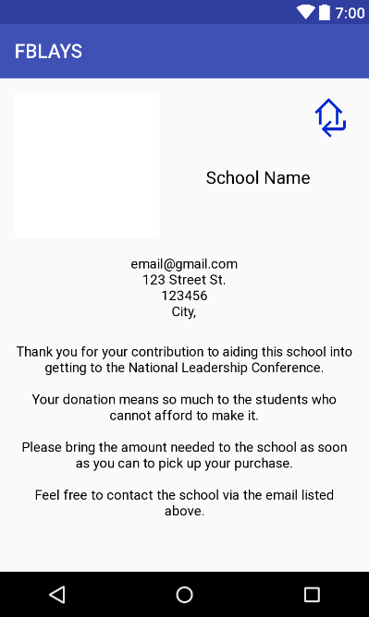

*<?***xml version="1.0" encoding="utf-8"***?>*

<**RelativeLayout xmlns:android="http://schemas.android.com/apk/res/android"**

**xmlns:app="http://schemas.android.com/apk/res-auto"**

**xmlns:tools="http://schemas.android.com/tools"**

**android:id="@+id/activity_purchase_item_complete"**

**android:layout_width="match_parent"**

**android:layout_height="match_parent"**

**android:paddingBottom="@dimen/activity_vertical_margin"**

**android:paddingLeft="@dimen/activity_horizontal_margin"**

**android:paddingRight="@dimen/activity_horizontal_margin"**

**android:paddingTop="@dimen/activity_vertical_margin"**

**tools:context="com.example.izzy.fblays2.PurchaseItemComplete"**>

<**ImageView**

**android:layout_width="150dp"**

**android:layout_height="150dp"**

**app:srcCompat="@android:color/background_light"**

**android:layout_alignParentTop="true"**

**android:layout_alignParentStart="true"**

**android:id="@+id/profilePicIV"** /> <**TextView**

**android:text="School Name"**

**android:layout_width="wrap_content"**

**android:layout_height="wrap_content"**

**android:id="@+id/nameTV"**

**android:textSize="18sp"**

**android:textAlignment="center"**

**android:textColor="@android:color/black"**

**android:layout_marginLeft="10dp"**

**android:layout_marginEnd="46dp"**

**android:layout_above="@+id/relativeLayout2"**

**android:layout_alignParentEnd="true"**

**android:layout_marginBottom="52dp"** />

<**RelativeLayout**

**android:layout_width="match_parent"**

**android:layout_height="wrap_content"**

**android:layout_marginTop="18dp"**

**android:layout_below="@+id/profilePicIV"**

**android:layout_alignParentStart="true"**

**android:id="@+id/relativeLayout2"**>

<**TextView**

**android:text="email@gmail.com"**

**android:layout_width="wrap_content"**

**android:gravity="center"**

**android:layout_height="wrap_content"**

**android:id="@+id/emailTV"**

**android:textSize="14sp"**

**android:textColor="@android:color/black"**

**android:layout_centerHorizontal="true"** />

<**TextView**

**android:text="123 Street St."**

**android:layout_centerHorizontal="true"**

**android:layout_width="wrap_content"**

**android:layout_height="wrap_content"**

**android:id="@+id/schoolAddressTV"**

**android:textSize="14sp"**

**android:textColor="@android:color/black"**

**android:layout_below="@+id/emailTV"** />

<**TextView**

**android:text="123456"**

**android:layout_width="wrap_content"**

**android:layout_centerHorizontal="true"**

**android:layout_height="wrap_content"**

**android:id="@+id/zipcodeTV"**

**android:textColor="@android:color/black"**

**android:layout_below="@+id/schoolAddressTV"** />

<**TextView**

**android:text="City,"**

**android:layout_width="wrap_content"**

**android:layout_centerHorizontal="true"**

**android:layout_height="wrap_content"**

**android:id="@+id/cityTV"**

**android:textColor="@android:color/black"**

**android:layout_below="@+id/zipcodeTV"** />

<**TextView**

**android:text="Thank you for your contribution to aiding this school into getting to the National Leadership Conference.\n\nYour donation means so much to the students who cannot afford to make it.\n\nPlease bring the amount needed to the school as soon as you can to pick up your purchase.**

**\nFeel free to contact the school via the email listed above."**

**android:layout_width="wrap_content"**

**android:layout_height="wrap_content"**

**android:id="@+id/purchaseInfo"**

**android:textAlignment="center"**

**android:layout_below="@id/cityTV"**

**android:layout_marginTop="25dp"**

**android:layout_centerHorizontal="true"**

**android:textColor="@android:color/black"** />

</**RelativeLayout**>

<**ImageButton**

**android:id="@+id/btnReturn"**

**android:layout_width="50dp"**

**android:layout_height="50dp"**

**android:scaleType="fitXY"**

**android:background="@android:color/transparent"**

**android:src="@drawable/returnhome2"**

**android:layout_alignParentTop="true"**

**android:layout_alignParentEnd="true"** />

</**RelativeLayout**>

activity_register.xml

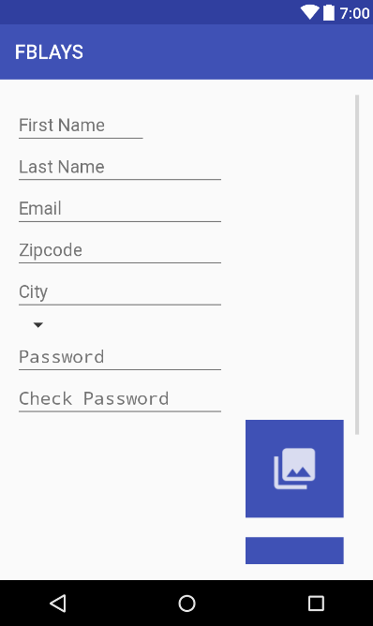

*<?***xml version="1.0" encoding="utf-8"***?>*

<**RelativeLayout xmlns:android="http://schemas.android.com/apk/res/android"**

**xmlns:app="http://schemas.android.com/apk/res-auto"**

**xmlns:tools="http://schemas.android.com/tools"**

**android:id="@+id/activity_register"**

**android:layout_width="match_parent"**

**android:layout_height="match_parent"**

**android:paddingBottom="@dimen/activity_vertical_margin"**

**android:paddingLeft="@dimen/activity_horizontal_margin"**

**android:paddingRight="@dimen/activity_horizontal_margin"**

**android:paddingTop="@dimen/activity_vertical_margin"**

**tools:context="com.example.izzy.fblays2.RegisterActivity"**>

<**ScrollView**

**android:layout_width="match_parent"**

**android:layout_height="match_parent"**

**android:layout_alignParentBottom="true"**

**android:layout_alignParentStart="true"**>

<**LinearLayout**

**android:layout_width="match_parent"**

**android:layout_height="match_parent"**

**android:layout_alignParentLeft="true"**

**android:layout_alignParentStart="true"**

**android:layout_alignParentTop="true"**

**android:orientation="vertical"**

**android:weightSum="1"**>

<**EditText**

**android:id="@+id/firstNameET"**

**android:layout_width="wrap_content"**

**android:layout_height="wrap_content"**

**android:layout_alignParentEnd="true"**

**android:layout_alignParentRight="true"**

**android:layout_alignParentTop="true"**

**android:layout_marginEnd="217dp"**

**android:layout_marginRight="217dp"**

**android:layout_marginTop="10dp"**

**android:ems="10"**

**android:hint="First Name"**

**android:inputType="textPersonName"** />

<**EditText**

**android:id="@+id/lastNameET"**

**android:layout_width="wrap_content"**

**android:layout_height="wrap_content"**

**android:layout_alignParentLeft="true"**

**android:layout_alignParentStart="true"**

**android:layout_alignTop="@+id/firstNameET"**

**android:ems="10"**

**android:hint="Last Name"**

**android:inputType="textPersonName"** />

<**EditText**

**android:id="@+id/emailETLogin"**

**android:layout_width="wrap_content"**

**android:layout_height="wrap_content"**

**android:layout_alignParentLeft="true"**

**android:layout_alignParentStart="true"**

**android:layout_below="@+id/firstNameET"**

**android:ems="10"**

**android:hint="Email"**

**android:inputType="textEmailAddress"** />

<**EditText**

**android:id="@+id/zipcodeEt"**

**android:layout_width="wrap_content"**

**android:layout_height="wrap_content"**

**android:layout_alignEnd="@+id/cityET"**

**android:layout_alignRight="@+id/cityET"**

**android:layout_centerVertical="true"**

**android:ems="10"**

**android:hint="Zipcode"**

**android:inputType="number"** />

<**EditText**

**android:id="@+id/cityET"**

**android:layout_width="wrap_content"**

**android:layout_height="wrap_content"**

**android:layout_above="@+id/zipcodeEt"**

**android:layout_alignParentLeft="true"**

**android:layout_alignParentStart="true"**

**android:ems="10"**

**android:hint="City"**

**android:inputType="textPersonName"** />

<**Spinner**

**android:id="@+id/spinner"**

**android:layout_width="wrap_content"**

**android:layout_height="wrap_content"**

**android:layout_alignBottom="@+id/reg_streetAddress"**

**android:layout_alignParentEnd="true"**

**android:layout_below="@+id/cityET"**

**android:layout_toEndOf="@+id/reg_streetAddress"**

**android:spinnerMode="dialog"** />

<**EditText**

**android:id="@+id/passwordET"**

**android:layout_width="wrap_content"**

**android:layout_height="wrap_content"**

**android:layout_alignParentLeft="true"**

**android:layout_alignParentStart="true"**

**android:layout_below="@+id/emailETLogin"**

**android:ems="10"**

**android:hint="Password"**

**android:inputType="textPassword"** />

<**EditText**

**android:id="@+id/passwordCheckET"**

**android:layout_width="wrap_content"**

**android:layout_height="wrap_content"**

**android:layout_below="@+id/emailETLogin"**

**android:layout_toEndOf="@+id/emailETLogin"**

**android:ems="10"**

**android:hint="Check Password"**

**android:inputType="textPassword"** />

<**LinearLayout**

**android:layout_width="match_parent"**

**android:layout_height="match_parent"**

**android:orientation="horizontal"**>

<**ImageView**

**android:layout_width="220dp"**

**android:layout_height="220dp"**

**app:srcCompat="@android:color/transparent"**

**android:scaleType="fitXY"**

**android:id="@+id/profilePic"** />

<**LinearLayout**

**android:layout_width="match_parent"**

**android:layout_height="match_parent"**

**android:orientation="vertical"**>

<**ImageButton**

**android:id="@+id/buttonPic"**

**android:layout_width="100dp"**

**android:layout_height="0dp"**

**android:layout_weight=".5"**

**android:padding="25dp"**

**android:scaleType="fitXY"**

**android:background="@color/colorPrimary"**

**android:onClick="onGalleryClicked"**

**android:layout_gravity="center"**

**android:src="@drawable/ic_piclibrary"**

**android:textSize="12sp"** />

<**LinearLayout**

**android:layout_width="wrap_content"**

**android:layout_height="0dp"**

**android:layout_weight=".1"** />

<**ImageButton**

**android:id="@+id/buttonPic2"**

**android:layout_width="100dp"**

**android:layout_gravity="center"**

**android:layout_height="0dp"**

**android:layout_weight=".5"**

**android:padding="25dp"**

**android:scaleType="fitXY"**

**android:background="@color/colorPrimary"**

**android:onClick="onCameraClicked"**

**android:src="@drawable/ic_camera"**

**android:textColor="@android:color/background_light"**

**android:textSize="12sp"** />

</**LinearLayout**>

</**LinearLayout**>

<**Button**

**android:id="@+id/RegBtn"**

**android:layout_width="match_parent"**

**android:layout_height="wrap_content"**

**android:layout_alignParentBottom="true"**

**android:layout_centerHorizontal="true"**

**android:layout_marginBottom="43dp"**

**android:layout_marginTop="20dp"**

**android:layout_weight="0.32"**

**android:background="@color/colorPrimary"**

**android:onClick="onRegisterClicked"**

**android:text="Register"**

**android:textColor="?android:attr/textColorPrimaryInverse"**

**android:textSize="14sp"** />

</**LinearLayout**>

</**ScrollView**>

</**RelativeLayout**>

activity_update_user_info.xml

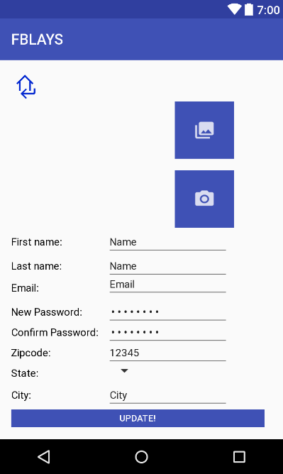

*<?***xml version="1.0" encoding="utf-8"***?>*

<**LinearLayout xmlns:android="http://schemas.android.com/apk/res/android"**

**xmlns:app="http://schemas.android.com/apk/res-auto"**

**xmlns:tools="http://schemas.android.com/tools"**

**android:id="@+id/activity_update_user_info"**

**android:layout_width="match_parent"**

**android:layout_height="match_parent"**

**android:orientation="vertical"**

**android:paddingBottom="@dimen/activity_vertical_margin"**

**android:paddingLeft="@dimen/activity_horizontal_margin"**

**android:paddingRight="@dimen/activity_horizontal_margin"**

**android:paddingTop="@dimen/activity_vertical_margin"**

**tools:context="com.example.izzy.fblays2.UpdateUserInfo"**>

<**ImageButton**

**android:id="@+id/btnReturn"**

**style="@style/Widget.AppCompat.Button.Small"**

**android:layout_width="40dp"**

**android:layout_height="40dp"**

**android:scaleType="fitXY"**

**android:background="@android:color/transparent"**

**android:onClick="onUpdateClicked"**

**android:src="@drawable/returnhome2"**

**android:textColor="?android:attr/textColorPrimaryInverse"**

**android:layout_alignParentTop="true"**

**android:layout_alignEnd="@+id/lastNameTV"** />

<**LinearLayout**

**android:layout_width="match_parent"**

**android:layout_height="wrap_content"**

**android:orientation="horizontal"**>

<**ImageView**

**android:layout_width="170dp"**

**android:layout_height="170dp"**

**app:srcCompat="@android:color/transparent"**

**android:id="@+id/profilePicIV"** />

<**LinearLayout**

**android:layout_width="match_parent"**

**android:layout_height="match_parent"**

**android:orientation="vertical"**>

<**ImageButton**

**android:id="@+id/button2"**

**android:layout_width="80dp"**

**android:layout_height="0dp"**

**android:layout_weight=".5"**

**android:padding="25dp"**

**android:scaleType="fitXY"**

**android:background="@color/colorPrimary"**

**android:onClick="onGalleryClicked"**

**android:layout_gravity="center"**

**android:src="@drawable/ic_piclibrary"**

**android:textSize="12sp"** />

<**LinearLayout**

**android:layout_width="wrap_content"**

**android:layout_height="0dp"**

**android:layout_weight=".1"** />

<**ImageButton**

**android:id="@+id/newPicBtn"**

**android:layout_width="80dp"**

**android:layout_gravity="center"**

**android:layout_height="0dp"**

**android:layout_weight=".5"**

**android:padding="25dp"**

**android:scaleType="fitXY"**

**android:background="@color/colorPrimary"**

**android:onClick="onCameraClicked"**

**android:src="@drawable/ic_camera"**

**android:textColor="@android:color/background_light"**

**android:textSize="12sp"** />

</**LinearLayout**>

</**LinearLayout**>

<**RelativeLayout**

**android:layout_width="match_parent"**

**android:layout_height="wrap_content"**>

<**EditText**

**android:id="@+id/lastNameET"**

**android:layout_width="wrap_content"**

**android:layout_height="wrap_content"**

**android:layout_alignBaseline="@+id/lastNameTV"**

**android:layout_alignBottom="@+id/lastNameTV"**

**android:layout_alignStart="@+id/firstNameET"**

**android:ems="10"**

**android:inputType="textPersonName"**

**android:text="Name"**

**android:textSize="14sp"** />

<**TextView**

**android:id="@+id/firstNameTV"**

**android:layout_width="wrap_content"**

**android:layout_height="wrap_content"**

**android:layout_alignParentStart="true"**

**android:layout_alignParentTop="true"**

**android:layout_marginTop="11dp"**

**android:text="First name:"**

**android:textColor="@android:color/black"**

**android:textSize="14sp"** />

<**TextView**

**android:id="@+id/lastNameTV"**

**android:layout_width="wrap_content"**

**android:layout_height="wrap_content"**

**android:layout_alignParentStart="true"**

**android:layout_below="@+id/firstNameTV"**

**android:layout_marginTop="16dp"**

**android:text="Last name:"**

**android:textColor="@android:color/black"**

**android:textSize="14sp"** />

<**TextView**

**android:id="@+id/emailTV"**

**android:layout_width="wrap_content"**

**android:layout_height="wrap_content"**

**android:layout_alignParentStart="true"**

**android:layout_below="@+id/lastNameTV"**

**android:layout_marginTop="13dp"**

**android:text="Email:"**

**android:textColor="@android:color/black"**

**android:textSize="14sp"** />

<**TextView**

**android:id="@+id/textView17"**

**android:layout_width="wrap_content"**

**android:layout_height="wrap_content"**

**android:layout_alignParentStart="true"**

**android:layout_below="@+id/emailTV"**

**android:layout_marginTop="16dp"**

**android:text="New Password:"**

**android:textColor="@android:color/black"**

**android:textSize="14sp"** />

<**TextView**

**android:id="@+id/confirmPasswordTV"**

**android:layout_width="wrap_content"**

**android:layout_height="wrap_content"**

**android:layout_alignParentStart="true"**

**android:layout_below="@+id/textView17"**

**android:layout_marginTop="11dp"**

**android:text="Confirm Password:"**

**android:textColor="@android:color/black"**

**android:textSize="14sp"** />

<**TextView**

**android:id="@+id/textView19"**

**android:layout_width="wrap_content"**

**android:layout_height="wrap_content"**

**android:layout_alignParentStart="true"**

**android:layout_below="@+id/confirmPasswordTV"**

**android:layout_marginTop="11dp"**

**android:text="Zipcode:"**

**android:textColor="@android:color/black"**

**android:textSize="14sp"** />

<**TextView**

**android:id="@+id/stateTV"**

**android:layout_width="wrap_content"**

**android:layout_height="wrap_content"**

**android:layout_alignParentStart="true"**

**android:layout_below="@+id/textView19"**

**android:layout_marginTop="11dp"**

**android:text="State:"**

**android:textColor="@android:color/black"**

**android:textSize="14sp"** />

<**TextView**

**android:id="@+id/textView22"**

**android:layout_width="wrap_content"**

**android:layout_height="wrap_content"**

**android:layout_alignParentStart="true"**

**android:layout_below="@+id/stateTV"**

**android:layout_marginTop="13dp"**

**android:text="City:"**

**android:textColor="@android:color/black"**

**android:textSize="14sp"** />

<**EditText**

**android:id="@+id/emailET"**

**android:layout_width="wrap_content"**

**android:layout_height="wrap_content"**

**android:ems="10"**

**android:inputType="textEmailAddress"**

**android:text="Email"**

**android:textSize="14sp"**

**android:layout_above="@+id/passET"**

**android:layout_alignStart="@+id/lastNameET"** />

<**EditText**

**android:id="@+id/firstNameET"**

**android:layout_width="wrap_content"**

**android:layout_height="wrap_content"**

**android:ems="10"**

**android:inputType="textPersonName"**

**android:text="Name"**

**android:textSize="14sp"**

**android:layout_alignBaseline="@+id/firstNameTV"**

**android:layout_alignBottom="@+id/firstNameTV"**

**android:layout_alignStart="@+id/conPassET"** />

<**EditText**

**android:id="@+id/zipcodeET"**

**android:layout_width="wrap_content"**

**android:layout_height="wrap_content"**

**android:ems="10"**

**android:inputType="number"**

**android:text="12345"**

**android:textSize="14sp"**

**android:layout_alignBaseline="@+id/textView19"**

**android:layout_alignBottom="@+id/textView19"**

**android:layout_alignStart="@+id/conPassET"** />

<**Spinner**

**android:id="@+id/stateSpinner"**

**android:layout_width="wrap_content"**

**android:layout_height="wrap_content"**

**android:spinnerMode="dialog"**

**android:layout_alignBottom="@+id/stateTV"**

**android:layout_alignStart="@+id/zipcodeET"** />

<**EditText**

**android:id="@+id/cityET"**

**android:layout_width="wrap_content"**

**android:layout_height="wrap_content"**

**android:ems="10"**

**android:inputType="textPersonName"**

**android:text="City"**

**android:textSize="14sp"**

**android:layout_alignBaseline="@+id/textView22"**

**android:layout_alignBottom="@+id/textView22"**

**android:layout_alignStart="@+id/stateSpinner"** />

<**EditText**

**android:id="@+id/passET"**

**android:layout_width="wrap_content"**

**android:layout_height="wrap_content"**

**android:ems="10"**

**android:inputType="textPassword"**

**android:text="password"**

**android:textSize="14sp"**

**android:layout_alignBaseline="@+id/textView17"**

**android:layout_alignBottom="@+id/textView17"**

**android:layout_alignStart="@+id/emailET"** />

<**EditText**

**android:id="@+id/conPassET"**

**android:layout_width="wrap_content"**

**android:layout_height="wrap_content"**

**android:layout_alignBaseline="@+id/confirmPasswordTV"**

**android:layout_alignBottom="@+id/confirmPasswordTV"**

**android:layout_marginStart="11dp"**

**android:layout_toEndOf="@+id/confirmPasswordTV"**

**android:ems="10"**

**android:inputType="textPassword"**

**android:text="password"**

**android:textSize="14sp"** />

<**LinearLayout**

**android:layout_width="match_parent"**

**android:layout_height="wrap_content"**

**android:orientation="horizontal"**

**android:layout_below="@+id/cityET"**>

<**Button**

**android:id="@+id/updateBtn"**

**style="@style/Widget.AppCompat.Button.Small"**

**android:layout_width="match_parent"**

**android:layout_height="wrap_content"**

**android:background="@color/colorPrimary"**

**android:onClick="onUpdateClicked"**

**android:text="Update!"**

**android:textColor="?android:attr/textColorPrimaryInverse"**

**android:textSize="12sp"**

**android:layout_weight="1"**

**android:layout_marginRight="10dp"**

**android:layout_alignParentBottom="true"**

**android:layout_alignParentStart="true"** />

</**LinearLayout**>

</**RelativeLayout**>

</**LinearLayout**>

activity_user_help.xml

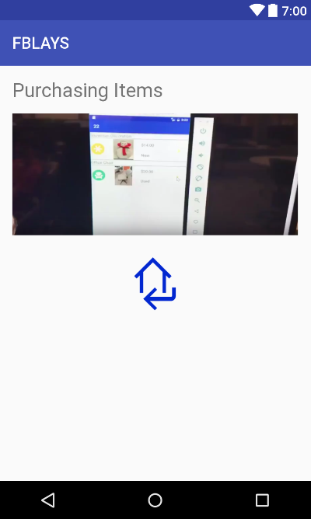

*<?***xml version="1.0" encoding="utf-8"***?>*

<**RelativeLayout xmlns:android="http://schemas.android.com/apk/res/android"**

**xmlns:tools="http://schemas.android.com/tools"**

**android:id="@+id/activity_user_help"**

**android:layout_width="match_parent"**

**android:layout_height="match_parent"**

**android:paddingBottom="@dimen/activity_vertical_margin"**

**android:paddingLeft="@dimen/activity_horizontal_margin"**

**android:paddingRight="@dimen/activity_horizontal_margin"**

**android:paddingTop="@dimen/activity_vertical_margin"**

**tools:context="com.example.izzy.fblays2.UserHelp"**>

<**TextView**

**android:text="Purchasing Items"**

**android:layout_width="wrap_content"**

**android:layout_height="wrap_content"**

**android:layout_alignParentTop="true"**

**android:layout_alignParentStart="true"**

**android:textSize="24sp"**

**android:id="@+id/purchasingItemsTV"** />

<**RelativeLayout**

**android:layout_width="wrap_content"**

**android:layout_height="wrap_content"**

**android:id="@+id/videoLayout"**

**android:layout_marginTop="14dp"**

**android:layout_below="@+id/purchasingItemsTV"**

>

<**ImageButton**

**android:id="@+id/btnPlay"**

**android:layout_width="match_parent"**

**android:layout_height="150dp"**

**android:background="@android:color/transparent"**

**android:scaleType="fitXY"**

**android:src="@drawable/purchasepic"** />

</**RelativeLayout**>

<**ImageButton**

**android:layout_width="80dp"**

**android:layout_height="80dp"**

**android:layout_below="@id/videoLayout"**

**android:layout_marginTop="20dp"**

**android:scaleType="fitXY"**

**android:layout_centerHorizontal="true"**

**android:background="@android:color/transparent"**

**android:text="Return"**

**android:src="@drawable/returnhome2"**

**android:id="@+id/btnReturn"**

/>

</**RelativeLayout**>

activity_user_home.xml

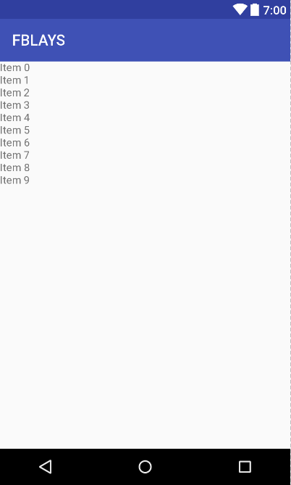

*<?***xml version="1.0" encoding="utf-8"***?>*

<**RelativeLayout xmlns:android="http://schemas.android.com/apk/res/android"**

**xmlns:tools="http://schemas.android.com/tools"**

**android:id="@+id/activity_user_home"**

**android:layout_width="match_parent"**

**android:layout_height="match_parent"**

**tools:context="com.example.izzy.fblays2.UserHomeFragment"**>

<**android.support.v7.widget.RecyclerView**

**android:layout_width="match_parent"**

**android:layout_height="wrap_content"**

**android:id="@+id/recyclerViewUserHome"**

**android:layout_alignParentTop="true"**

**android:layout_alignParentStart="true"**

**android:layout_marginBottom="50dp"**>

</**android.support.v7.widget.RecyclerView**>

</**RelativeLayout**>

activity_user_lixt.xml

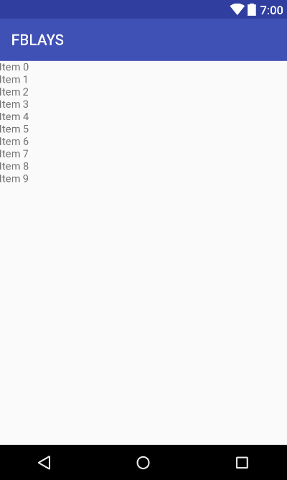

*<?***xml version="1.0" encoding="utf-8"***?>*

<**RelativeLayout xmlns:android="http://schemas.android.com/apk/res/android"**

**xmlns:tools="http://schemas.android.com/tools"**

**android:id="@+id/activity_user_notification_list"**

**android:layout_width="match_parent"**

**android:layout_height="match_parent"**

**tools:context="com.example.izzy.fblays2.UserNotificationList"**>

<**android.support.v7.widget.RecyclerView**

**android:layout_width="match_parent"**

**android:layout_height="wrap_content"**

**android:id="@+id/recyclerView"**

**android:layout_marginBottom="50dp"**>

</**android.support.v7.widget.RecyclerView**>

</**RelativeLayout**>

activity_user_notification_list.xml

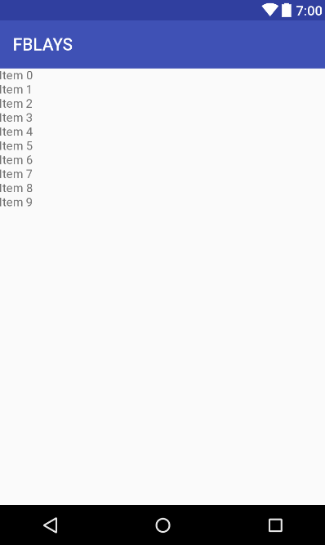

*<?***xml version="1.0" encoding="utf-8"***?>*

<**RelativeLayout xmlns:android="http://schemas.android.com/apk/res/android"**

**xmlns:tools="http://schemas.android.com/tools"**

**android:id="@+id/activity_user_notification_list"**

**android:layout_width="match_parent"**

**android:layout_height="match_parent"**

**tools:context="com.example.izzy.fblays2.UserNotificationList"**>

<**android.support.v7.widget.RecyclerView**

**android:layout_width="match_parent"**

**android:layout_height="wrap_content"**

**android:id="@+id/recyclerView"**

**android:layout_marginBottom="50dp"**>

</**android.support.v7.widget.RecyclerView**>

</**RelativeLayout**>

activity_user_profile.xml

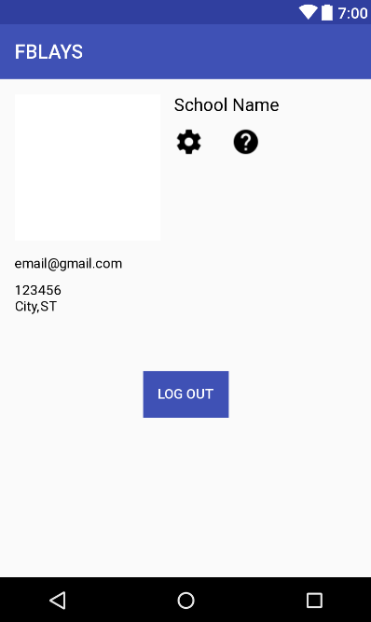

*<?***xml version="1.0" encoding="utf-8"***?>*

<**RelativeLayout xmlns:android="http://schemas.android.com/apk/res/android"**

**xmlns:app="http://schemas.android.com/apk/res-auto"**

**xmlns:tools="http://schemas.android.com/tools"**

**android:id="@+id/activity_chapter_profile"**

**android:layout_width="match_parent"**

**android:layout_height="match_parent"**

**android:paddingBottom="@dimen/activity_vertical_margin"**

**android:paddingLeft="@dimen/activity_horizontal_margin"**

**android:paddingRight="@dimen/activity_horizontal_margin"**

**android:paddingTop="@dimen/activity_vertical_margin"**

**tools:context="com.example.izzy.fblays2.UserProfileFragment"**>

<**ImageView**

**android:id="@+id/profilePicIV"**

**android:layout_width="150dp"**

**android:layout_height="150dp"**

**android:layout_alignParentStart="true"**

**android:layout_alignParentTop="true"**

**app:srcCompat="@android:color/background_light"** />

<**TextView**

**android:id="@+id/emailTV"**

**android:layout_width="wrap_content"**

**android:layout_height="wrap_content"**

**android:layout_marginTop="15dp"**

**android:text="email@gmail.com"**

**android:textColor="@android:color/black"**

**android:textSize="14sp"**

**android:layout_below="@+id/profilePicIV"**

**android:layout_alignParentStart="true"** />

<**TextView**

**android:id="@+id/nameTV"**

**android:layout_width="wrap_content"**

**android:layout_height="wrap_content"**

**android:layout_marginStart="14dp"**

**android:text="School Name"**

**android:textColor="@android:color/black"**

**android:textSize="18sp"**

**android:layout_alignParentTop="true"**

**android:layout_toEndOf="@+id/profilePicIV"** />

<**TextView**

**android:id="@+id/stateTV"**

**android:layout_width="wrap_content"**

**android:layout_height="wrap_content"**

**android:layout_alignBaseline="@+id/cityTV"**

**android:layout_alignBottom="@+id/cityTV"**

**android:layout_toEndOf="@+id/cityTV"**

**android:text="ST"**

**android:textColor="@android:color/black"** />

<**TextView**

**android:id="@+id/cityTV"**

**android:layout_width="wrap_content"**

**android:layout_height="wrap_content"**

**android:layout_alignStart="@+id/emailTV"**

**android:layout_below="@+id/zipcodeTV"**

**android:text="City,"**

**android:textColor="@android:color/black"** />

<**TextView**

**android:id="@+id/zipcodeTV"**

**android:layout_width="wrap_content"**

**android:layout_height="wrap_content"**

**android:layout_alignStart="@+id/emailTV"**

**android:layout_below="@+id/emailTV"**

**android:layout_marginTop="11dp"**

**android:text="123456"**

**android:textColor="@android:color/black"** />

<**Button**

**android:id="@+id/joinBtn"**

**android:layout_width="150dp"**

**android:layout_height="wrap_content"**

**android:text="Join Chapter"**

**android:layout_below="@+id/btnHelp"**

**android:layout_marginTop="5dp"**

**android:layout_marginLeft="10dp"**

**android:layout_toEndOf="@+id/profilePicIV"**

**android:background="@color/colorPrimary"**

**android:textColor="@android:color/white"**

**android:visibility="gone"**/>

<**Button**

**android:id="@+id/leaveBtn"**

**android:layout_width="150dp"**

**android:layout_height="wrap_content"**

**android:layout_marginTop="5dp"**

**android:layout_marginLeft="10dp"**

**android:layout_toEndOf="@+id/profilePicIV"**

**android:background="@color/colorPrimary"**

**android:textColor="@android:color/white"**

**android:text="Leave Chapter"**

**android:layout_below="@+id/btnHelp"**

**android:visibility="gone"**/>

<**ImageButton**

**android:id="@+id/btnHelp"**

**android:layout_width="30dp"**

**android:layout_height="30dp"**

**android:background="@android:color/transparent"**

**android:src="@drawable/help"**

**android:scaleType="fitXY"**

**android:layout_marginEnd="19dp"**

**android:layout_alignTop="@+id/btnSettings"**

**android:layout_alignEnd="@+id/nameTV"** />

<**ImageButton**

**android:id="@+id/btnSettings"**

**android:layout_width="30dp"**

**android:layout_height="30dp"**

**android:background="@android:color/transparent"**

**android:src="@drawable/ic_settings"**

**android:scaleType="fitXY"**

**android:layout_marginTop="12dp"**

**android:layout_below="@+id/nameTV"**

**android:layout_alignStart="@+id/nameTV"** />

<**Button**

**android:id="@+id/btnLogOut"**

**android:layout_width="wrap_content"**

**android:layout_height="wrap_content"**

**android:background="@color/colorPrimary"**

**android:text="Log Out"**

**android:textColor="@android:color/white"**

**android:layout_marginTop="58dp"**

**android:layout_below="@+id/stateTV"**

**android:layout_centerHorizontal="true"** />

</**RelativeLayout**>

activity_view_comments.xml

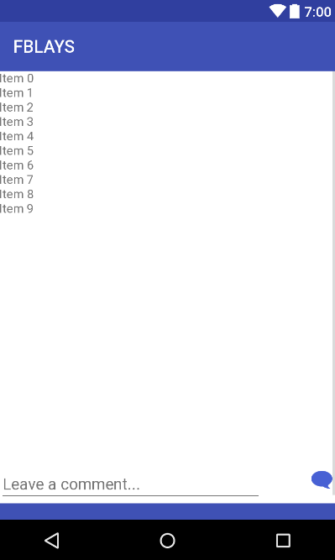

*<?***xml version="1.0" encoding="utf-8"***?>*

<**RelativeLayout xmlns:android="http://schemas.android.com/apk/res/android"**

**xmlns:app="http://schemas.android.com/apk/res-auto"**

**xmlns:tools="http://schemas.android.com/tools"**

**android:id="@+id/activity_view_comments"**

**android:layout_width="match_parent"**

**android:layout_height="match_parent"**

**tools:context="com.example.izzy.fblays2.ViewComments"**

**android:background="@android:color/background_light"**>

<**ScrollView**

**android:layout_width="match_parent"**

**android:layout_height="match_parent"**><**RelativeLayout**

**android:layout_width="match_parent"**

**android:layout_height="match_parent"**>

<**android.support.v7.widget.RecyclerView**

**android:layout_width="match_parent"**

**android:layout_height="450dp"**

**android:id="@+id/recyclerView"**

**android:layout_centerHorizontal="true"**

/>

<**EditText**

**android:layout_height="wrap_content"**

**android:inputType="textPersonName"**

**android:ems="10"**

**android:id="@+id/commentET"**

**android:hint="Leave a comment..."**

**android:layout_below="@+id/recyclerView"**

**android:layout_alignParentStart="true"**

**android:layout_width="300dp"** />

<**ImageButton**

**android:layout_width="wrap_content"**

**android:layout_height="wrap_content"**

**app:srcCompat="@drawable/comment"**

**android:id="@+id/commentBtn"**

**android:background="@android:color/transparent"**

**android:layout_below="@+id/recyclerView"**

**android:layout_alignParentEnd="true"** />

<**Button**

**android:layout_width="match_parent"**

**android:layout_height="wrap_content"**

**android:text="Return"**

**android:id="@+id/btnReturn"**

**android:layout_below="@id/commentET"**

**android:background="@color/colorPrimary"**

**android:textColor="?android:attr/textColorPrimaryInverse"**/>

</**RelativeLayout**></**ScrollView**>

</**RelativeLayout**>

activity_view_user.xml

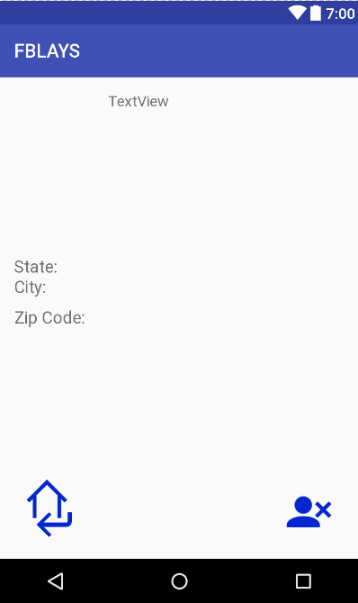

*<?***xml version="1.0" encoding="utf-8"***?>*

<**RelativeLayout xmlns:android="http://schemas.android.com/apk/res/android"**

**xmlns:app="http://schemas.android.com/apk/res-auto"**

**xmlns:tools="http://schemas.android.com/tools"**

**android:id="@+id/activity_view_user"**

**android:layout_width="match_parent"**

**android:layout_height="match_parent"**

**android:paddingBottom="@dimen/activity_vertical_margin"**

**android:paddingLeft="@dimen/activity_horizontal_margin"**

**android:paddingRight="@dimen/activity_horizontal_margin"**

**android:paddingTop="@dimen/activity_vertical_margin"**

**tools:context="com.example.izzy.fblays2.ViewUser"**>

<**TextView**

**android:text="TextView"**

**android:layout_width="wrap_content"**

**android:layout_height="wrap_content"**

**android:id="@+id/txtEmail"**

**android:layout_alignParentTop="true"**

**android:layout_alignParentEnd="true"**

**android:layout_toEndOf="@+id/profilePic"**

**android:textSize="16sp"**

**android:textAllCaps="false"** />

<**ImageButton**

**android:id="@+id/btnReturn"**

**android:layout_width="75dp"**

**android:scaleType="fitXY"**

**android:layout_height="75dp"**

**android:background="@android:color/transparent"**

**android:src="@drawable/returnhome2"**

**android:text="Return"**

**android:layout_alignParentBottom="true"**

**android:layout_alignParentStart="true"** />

<**ImageButton**

**android:text="Kick"**

**android:layout_width="75dp"**

**android:scaleType="fitXY"**

**android:src="@drawable/removemember2"**

**android:layout_height="75dp"**

**android:background="@android:color/transparent"**

**android:id="@+id/btnKick"**

**android:layout_alignParentBottom="true"**

**android:layout_alignParentEnd="true"** />

<**ImageView**

**android:layout_width="100dp"**

**app:srcCompat="@android:color/transparent"**

**android:id="@+id/profilePic"**

**android:layout_height="100dp"**

**android:layout_alignParentTop="true"**

**android:layout_alignParentStart="true"** />

<**TextView**

**android:text="State: "**

**android:layout_width="wrap_content"**

**android:layout_height="wrap_content"**

**android:id="@+id/txtState"**

**android:textSize="18sp"**

**android:layout_above="@+id/txtCity"**

**android:layout_alignParentStart="true"** />

<**TextView**

**android:text="City: "**

**android:layout_width="wrap_content"**

**android:layout_height="wrap_content"**

**android:id="@+id/txtCity"**

**android:textSize="18sp"**

**android:layout_above="@+id/txtZip"**

**android:layout_alignParentStart="true"**

**android:layout_marginBottom="11dp"** />

<**TextView**

**android:text="Zip Code: "**

**android:layout_width="wrap_content"**

**android:layout_height="wrap_content"**

**android:id="@+id/txtZip"**

**android:textSize="18sp"**

**android:layout_centerVertical="true"**

**android:layout_alignParentStart="true"** />

</**RelativeLayout**>

chapter_layout.xml

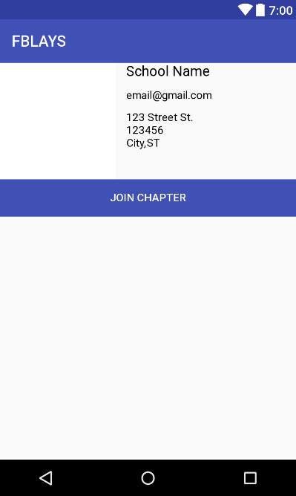

*<?***xml version="1.0" encoding="utf-8"***?>*

<**LinearLayout xmlns:android="http://schemas.android.com/apk/res/android"**

**android:orientation="vertical" android:layout_width="match_parent"**

**xmlns:app="http://schemas.android.com/apk/res-auto"**

**android:layout_height="wrap_content"**>

<**LinearLayout**

**android:layout_width="match_parent"**

**android:layout_height="match_parent"**

**android:orientation="vertical"**>

<**RelativeLayout**

**android:layout_width="match_parent"**

**android:layout_height="wrap_content"**>

<**ImageView**

**android:layout_width="150dp"**

**android:layout_height="150dp"**

**app:srcCompat="@android:color/background_light"**

**android:layout_alignParentTop="true"**

**android:layout_alignParentStart="true"**

**android:id="@+id/profilePicIV"**

/>

<**TextView**

**android:text="email@gmail.com"**

**android:layout_width="wrap_content"**

**android:layout_height="wrap_content"**

**android:layout_below="@+id/nameTV"**

**android:layout_alignStart="@+id/nameTV"**

**android:layout_marginTop="12dp"**

**android:id="@+id/emailTV"**

**android:textSize="14sp"**

**android:textColor="@android:color/black"**

/>

<**TextView**

**android:text="School Name"**

**android:layout_width="wrap_content"**

**android:layout_height="wrap_content"**

**android:layout_marginStart="14dp"**

**android:id="@+id/nameTV"**

**android:textSize="18sp"**

**android:textColor="@android:color/black"**

**android:layout_alignParentTop="true"**

**android:layout_toEndOf="@+id/profilePicIV"**

/>

<**TextView**

**android:text="ST"**

**android:layout_width="40dp"**

**android:layout_height="wrap_content"**

**android:id="@+id/schoolStateTV"**

**android:textColor="@android:color/black"**

**android:layout_toEndOf="@+id/cityTV"**

**android:layout_alignBaseline="@+id/cityTV"**

**android:layout_alignBottom="@+id/cityTV"**

/>

<**TextView**

**android:text="123 Street St."**

**android:layout_width="wrap_content"**

**android:layout_height="wrap_content"**

**android:layout_marginTop="12dp"**

**android:id="@+id/schoolAddressTV"**

**android:textSize="14sp"**

**android:textColor="@android:color/black"**

**android:layout_below="@+id/emailTV"**

**android:layout_alignStart="@+id/zipcodeTV"**

/>

<**TextView**

**android:text="123456"**

**android:layout_width="wrap_content"**

**android:layout_height="wrap_content"**

**android:id="@+id/zipcodeTV"**

**android:textColor="@android:color/black"**

**android:layout_below="@+id/schoolAddressTV"**

**android:layout_alignStart="@+id/cityTV"**

/>

<**TextView**

**android:text="City,"**

**android:layout_width="wrap_content"**

**android:layout_height="wrap_content"**

**android:id="@+id/cityTV"**

**android:textColor="@android:color/black"**

**android:layout_below="@+id/zipcodeTV"**

**android:layout_alignStart="@+id/emailTV"**

/>

</**RelativeLayout**>

<**Button**

**android:text="Join Chapter"**

**android:layout_width="match_parent"**

**android:layout_height="wrap_content"**

**android:id="@+id/joinBtn"**

**android:textColor="@android:color/white"**

**android:background="@color/colorPrimary"**

/>

</**LinearLayout**>

</**LinearLayout**>

comment_layout.xml

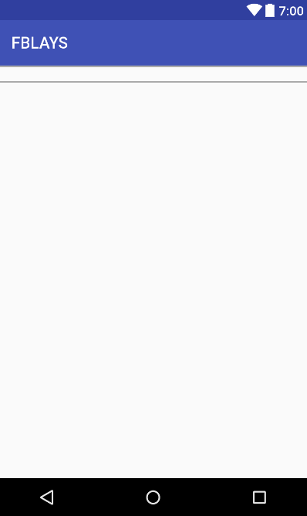

*<?***xml version="1.0" encoding="utf-8"***?>*

<**LinearLayout xmlns:android="http://schemas.android.com/apk/res/android"**

**android:orientation="horizontal" android:layout_width="match_parent"**

**android:layout_height="wrap_content"**

**android:background="@drawable/item_border"**

>

<**TextView**

**android:layout_width="100dp"**

**android:layout_height="wrap_content"**

**android:textSize="18sp"**

**android:layout_gravity="center_vertical"**

**android:id="@+id/nameTV"**

**android:textColor="@android:color/black"**

/>

<**TextView**

**android:layout_width="275dp"**

**android:layout_height="wrap_content"**

**android:id="@+id/commentTV"**

**android:textSize="18sp"**

/>

</**LinearLayout**>

donatepage_layout.xml

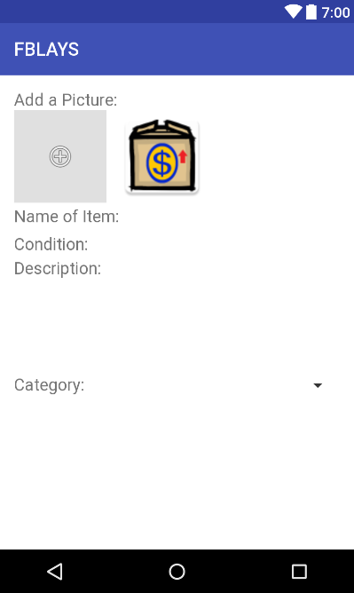

*<?***xml version="1.0" encoding="utf-8"***?>*

<**RelativeLayout xmlns:android="http://schemas.android.com/apk/res/android"**

**xmlns:app="http://schemas.android.com/apk/res-auto"**

**xmlns:tools="http://schemas.android.com/tools"**

**android:id="@+id/mainpage_layout"**

**android:layout_width="match_parent"**

**android:layout_height="match_parent"**

**tools:context="com.example.izzy.fblays2.MainPage"**

**android:background="@android:color/background_light"**>

<**LinearLayout**

**android:orientation="vertical" android:layout_width="match_parent"**

**android:layout_height="match_parent"**

**android:paddingBottom="@dimen/activity_vertical_margin"**

**android:paddingLeft="@dimen/activity_horizontal_margin"**

**android:paddingRight="@dimen/activity_horizontal_margin"**

**android:paddingTop="@dimen/activity_vertical_margin"**

**android:weightSum="1"**

**android:layout_alignParentTop="true"**

**android:layout_alignParentLeft="true"**

**android:layout_alignParentStart="true"**>

<**TextView**

**android:layout_width="wrap_content"**

**android:layout_height="wrap_content"**

**android:text="Add a Picture:"**

**android:textSize="18sp"**

**android:textColor="?android:attr/textColorTertiary"** />

<**LinearLayout**

**android:layout_width="match_parent"**

**android:layout_height="100dp"**

**android:orientation="horizontal"**>

<**ImageButton**

**app:srcCompat="@android:drawable/ic_menu_add"**

**android:background="?attr/colorControlHighlight"**

**android:id="@+id/buttonPic"**

**android:layout_width="100dp"**

**android:layout_height="100dp"** />

<**ImageView**

**android:layout_marginLeft="10dp"**

**android:layout_width="100dp"**

**android:layout_height="100dp"**

**app:srcCompat="@mipmap/ic_launcher"**

**android:id="@+id/imageViewPic"** />

</**LinearLayout**>

<**LinearLayout**

**android:layout_width="match_parent"**

**android:layout_height="30dp"**

**android:orientation="horizontal"**>

<**TextView**

**android:layout_width="wrap_content"**

**android:layout_height="match_parent"**

**android:text="Name of Item:"**

**android:textSize="18sp"**

**android:textColor="?android:attr/textColorTertiary"**

**android:paddingTop="4dp"**

**android:id="@+id/textView"** />

<**EditText**

**android:layout_width="match_parent"**

**android:layout_height="wrap_content"**

**android:layout_alignParentRight="true"**

**android:background="@android:color/background_light"**

**android:id="@+id/nameET"** />

</**LinearLayout**>

<**LinearLayout**

**android:layout_width="match_parent"**

**android:layout_height="30dp"**

**android:orientation="horizontal"**>

<**TextView**

**android:layout_width="wrap_content"**

**android:layout_height="match_parent"**

**android:text="Condition:"**

**android:textSize="18sp"**

**android:textColor="?android:attr/textColorTertiary"**

**android:paddingTop="4dp"**/>

<**EditText**

**android:layout_width="match_parent"**

**android:layout_height="wrap_content"**

**android:layout_alignParentRight="true"**

**android:background="@android:color/background_light"** />

</**LinearLayout**>

<**TextView**

**android:layout_width="wrap_content"**

**android:layout_height="wrap_content"**

**android:text="Description:"**

**android:textSize="18sp"**

**android:textColor="?android:attr/textColorTertiary"** />

<**EditText**

**android:layout_width="match_parent"**

**android:layout_height="100dp"**

**android:background="@android:color/background_light"**

**android:id="@+id/descriptionET"** />

<**LinearLayout**

**android:layout_width="match_parent"**

**android:layout_height="30dp"**

**android:orientation="horizontal"**>

<**TextView**

**android:layout_width="wrap_content"**

**android:layout_height="match_parent"**

**android:text="Category:"**

**android:textSize="18sp"**

**android:textColor="?android:attr/textColorTertiary"**

**android:paddingTop="4dp"**/>

<**Spinner**

**android:layout_width="match_parent"**

**android:layout_height="match_parent"**

**android:id="@+id/catSpinner"** />

</**LinearLayout**>

<**Button**

**android:layout_width="match_parent"**

**android:layout_height="wrap_content"**

**android:text="Submit"**

**android:layout_gravity="center"**

**android:layout_marginTop="15dp"**

**android:id="@+id/donateBtn"**

**android:visibility="gone"** />

</**LinearLayout**>

</**RelativeLayout**>

feed_item_layout.xml

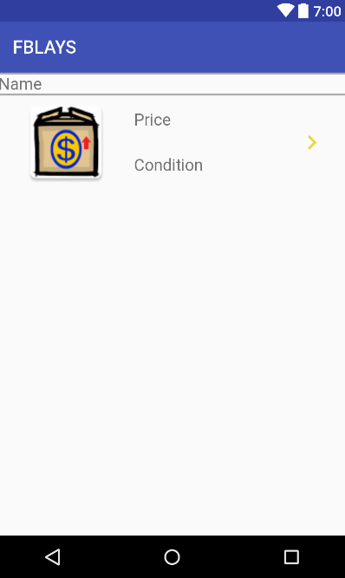

*<?***xml version="1.0" encoding="utf-8"***?>*

<**LinearLayout xmlns:android="http://schemas.android.com/apk/res/android"**

**xmlns:app="http://schemas.android.com/apk/res-auto"**

**android:orientation="vertical" android:layout_width="match_parent"**

**android:layout_height="wrap_content"**

**android:weightSum="1"**>

<**TextView**

**android:id="@+id/txtName"**

**android:layout_width="match_parent"**

**android:layout_height="wrap_content"**

**android:text="Name "**

**android:textSize="18sp"**

**android:background="@drawable/item_border"**

**android:paddingTop="2dp"**

**android:paddingBottom="2dp"**/>

<**RelativeLayout**

**android:id="@+id/viewItem"**

**android:layout_width="match_parent"**

**android:layout_height="100dp"**

**android:layout_alignParentStart="true"**

**android:layout_alignParentTop="true"**

**android:layout_marginBottom="2dp"**

**android:layout_marginTop="2dp"**>

<**ImageView**

**android:id="@+id/imageView2"**

**android:layout_width="50dp"**

**android:layout_height="50dp"**

**android:layout_marginEnd="10dp"** />

<**ImageView**

**android:id="@+id/imageView"**

**android:layout_width="150dp"**

**android:layout_height="match_parent"**

**android:layout_alignParentStart="true"**

**android:layout_alignParentTop="true"**

**app:srcCompat="@mipmap/ic_launcher"** />

<**RelativeLayout**

**android:id="@+id/relativeLayout"**

**android:layout_width="wrap_content"**

**android:layout_height="match_parent"**

**android:layout_alignParentTop="true"**

**android:layout_toEndOf="@+id/imageView"**

**android:orientation="vertical"**>

<**TextView**

**android:id="@+id/txtCondition1"**

**android:layout_width="wrap_content"**

**android:layout_height="50dp"**

**android:layout_alignParentBottom="true"**

**android:layout_alignParentStart="true"**

**android:gravity="center"**

**android:text="Condition"**

**android:textSize="18sp"** />

<**TextView**

**android:id="@+id/txtPrice"**

**android:layout_width="wrap_content"**

**android:layout_height="50dp"**

**android:layout_alignParentStart="true"**

**android:layout_alignParentTop="true"**

**android:gravity="center"**

**android:text="Price"**

**android:textSize="18sp"** />

</**RelativeLayout**>

<**RelativeLayout**

**android:layout_width="wrap_content"**

**android:layout_height="match_parent"**

**android:layout_alignParentTop="true"**

**android:layout_toStartOf="@+id/btnViewItem"**

**android:layout_marginRight="10dp"**>

<**LinearLayout**

**android:layout_width="wrap_content"**

**android:layout_height="wrap_content"**

**android:orientation="horizontal"**

**android:layout_marginTop="41dp"**>

<**TextView**

**android:layout_width="wrap_content"**

**android:layout_height="wrap_content"**

**android:text=""**

**android:id="@+id/distance"**

**android:layout_marginRight="5dp"**/>

<**TextView**

**android:layout_width="wrap_content"**

**android:layout_height="wrap_content"**

**android:layout_alignParentStart="true"**

**android:text=""**

**android:id="@+id/miles"**/>

</**LinearLayout**>

</**RelativeLayout**>

<**ImageButton**

**android:id="@+id/btnViewItem"**

**android:layout_width="75dp"**

**android:layout_height="match_parent"**

**android:layout_alignParentEnd="true"**

**android:layout_alignParentTop="true"**

**android:background="@android:color/transparent"**

**android:cropToPadding="false"**

**android:src="@drawable/ic_view_item"**

**android:text="View item"** />

</**RelativeLayout**>

</**LinearLayout**>

fragment_chapter_sales.xml



*<?***xml version="1.0" encoding="utf-8"***?>*

<**RelativeLayout xmlns:android="http://schemas.android.com/apk/res/android"**

**xmlns:tools="http://schemas.android.com/tools"**

**android:id="@+id/activity_user_home"**

**android:layout_width="match_parent"**

**android:layout_height="match_parent"**

**tools:context="com.example.izzy.fblays2.ChapterMainPage"**>

<**android.support.v7.widget.RecyclerView**

**android:layout_width="match_parent"**

**android:layout_height="wrap_content"**

**android:id="@+id/recyclerViewChapterSales"**

**android:layout_alignParentTop="true"**

**android:layout_alignParentStart="true"**

**android:layout_marginBottom="50dp"**

>

</**android.support.v7.widget.RecyclerView**>

</**RelativeLayout**>

header_layout.xml

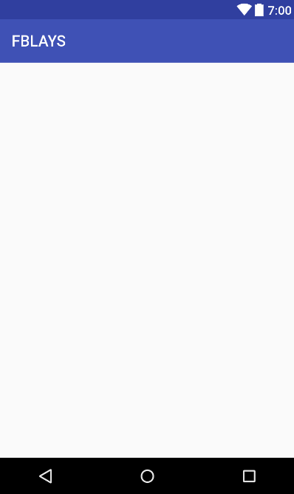

*<?***xml version="1.0" encoding="utf-8"***?>*

<**LinearLayout xmlns:android="http://schemas.android.com/apk/res/android"**

**android:orientation="horizontal" android:layout_width="match_parent"**

**android:layout_height="0dp"**

**android:background="?attr/colorPrimary"**>

<**TextView**

**android:layout_width="150dp"**

**android:layout_height="match_parent"**

**android:text="Chapter ID"**

**android:textSize="18dp"**

**android:textStyle="bold"**

**android:gravity="center_vertical"**

**android:layout_marginLeft="12dp"**

**android:id="@+id/chapterIDHeader"**

/>

<**TextView**

**android:layout_width="200dp"**

**android:layout_height="match_parent"**

**android:text="User ID"**

**android:textSize="18dp"**

**android:textStyle="bold"**

**android:gravity="center_vertical"**

**android:layout_marginLeft="12dp"**

**android:id="@+id/userIDHeader"**

**android:layout_toRightOf="@+id/chapterIDHeader"**

/>

</**LinearLayout**>

notification_layout.xml

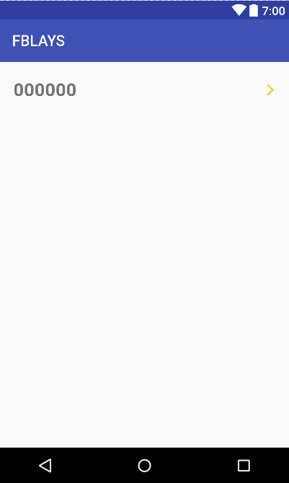

*<?***xml version="1.0" encoding="utf-8"***?>*

<**RelativeLayout xmlns:android="http://schemas.android.com/apk/res/android"**

**android:orientation="horizontal" android:layout_width="match_parent"**

**android:layout_height="75dp"**>

<**TextView**

**android:layout_width="wrap_content"**

**android:paddingEnd="60dp"**

**android:layout_height="match_parent"**

**android:text="000000"**

**android:textSize="24dp"**

**android:textStyle="bold"**

**android:gravity="center_vertical"**

**android:layout_marginLeft="18dp"**

**android:id="@+id/notifMessage"**

/>

<**ImageButton**

**android:layout_width="30dp"**

**android:layout_height="match_parent"**

**android:layout_alignParentRight="true"**

**android:layout_marginRight="10dp"**

**android:id="@+id/notifButton"**

**android:src="@drawable/ic_view_item"**

**android:background="@android:color/transparent"** />

<**Button**

**android:id="@+id/btnDelete"**

**android:layout_width="match_parent"**

**android:layout_height="wrap_content"**

**android:layout_alignBaseline="@+id/notifMessage"**

**android:layout_alignBottom="@+id/notifMessage"**

**android:layout_alignStart="@+id/notifMessage"**

**android:layout_marginRight="40dp"**

**android:background="@android:color/transparent"**

**android:backgroundTint="@android:color/transparent"** />

</**RelativeLayout**>

receive_layout.xml

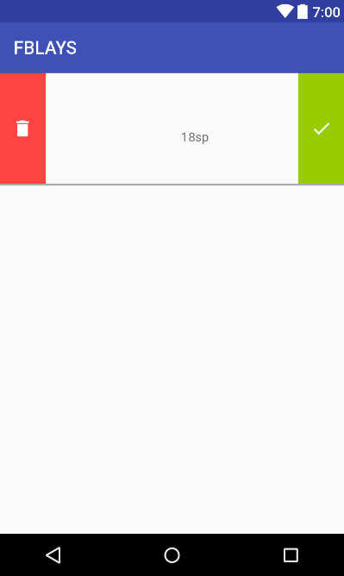

*<?***xml version="1.0" encoding="utf-8"***?>*

<**LinearLayout xmlns:android="http://schemas.android.com/apk/res/android"**

**android:orientation="horizontal" android:layout_width="match_parent"**

**android:layout_height="125dp"**

**android:weightSum="1"**

**android:background="@drawable/bottom_border"**

**android:paddingBottom="2dp"**>

<**ImageButton**

**android:layout_width="0dp"**

**android:layout_height="match_parent"**

**android:layout_gravity="center"**

**android:text="Delete"**

**android:id="@+id/btnDelete"**

**android:layout_weight=".5"**

**android:onClick="deleteItem"**

**android:src="@drawable/ic_delet"**

**android:background="@android:color/holo_red_light"** />

<**TextView**

**android:layout_width="match_parent"**

**android:layout_height="30dp"**

**android:layout_gravity="center"**

**android:visibility="gone"**

**android:textSize="24dp"**

**android:layout_marginLeft="5dp"**

**android:id = "@+id/txtMessage"**

/>

<**ImageView**

**android:layout_width="150dp"**

**android:layout_height="match_parent"**

**android:id="@+id/picIV"** />

<**TextView**

**android:layout_width="130dp"**

**android:layout_height="wrap_content"**

**android:layout_marginTop="63dp"**

**android:text="18sp"**

**android:id="@+id/nameTV"**/>

<**ImageButton**

**android:layout_width="0dp"**

**android:layout_height="match_parent"**

**android:layout_gravity="center"**

**android:text="Check"**

**android:id="@+id/btnReceived"**

**android:onClick="checkItem"**

**android:src="@drawable/check"**

**android:layout_weight=".5"**

**android:background="@android:color/holo_green_light"**/>

</**LinearLayout**>

row_notification.xml

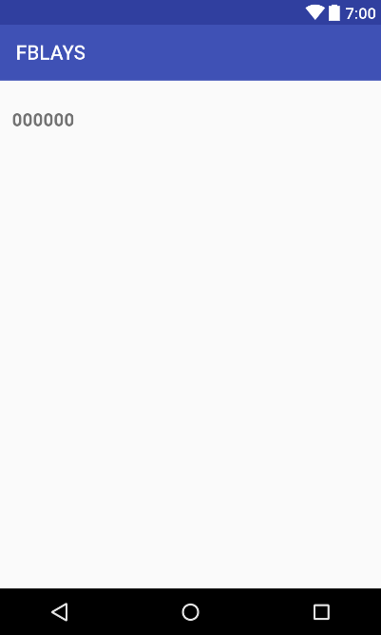

*<?***xml version="1.0" encoding="utf-8"***?>*

<**LinearLayout xmlns:android="http://schemas.android.com/apk/res/android"**

**android:orientation="vertical" android:layout_width="match_parent"**

**android:layout_height="80dp"**>

<**TextView**

**android:layout_width="150dp"**

**android:layout_height="match_parent"**

**android:text="000000"**

**android:textSize="18dp"**

**android:textStyle="bold"**

**android:gravity="center_vertical"**

**android:layout_marginLeft="12dp"**

**android:id="@+id/notifMessage"**

/>

<**TextView**

**android:layout_width="200dp"**

**android:layout_height="match_parent"**

**android:text="0"**

**android:textSize="18dp"**

**android:textStyle="bold"**

**android:gravity="center_vertical"**

**android:layout_marginLeft="12dp"**

**android:id="@+id/notifUserID"**

**android:layout_toRightOf="@+id/notifMessage"**

/>

</**LinearLayout**>

sale_layout.xml

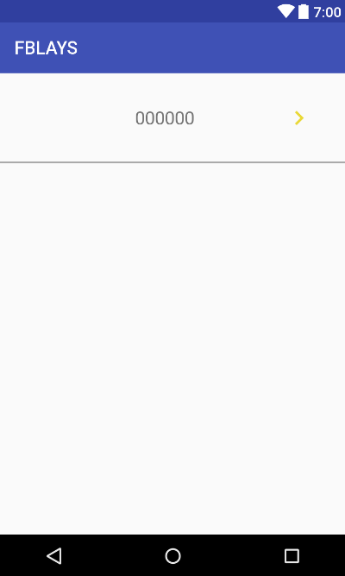

*<?***xml version="1.0" encoding="utf-8"***?>*

<**LinearLayout xmlns:android="http://schemas.android.com/apk/res/android"**

**android:orientation="horizontal" android:layout_width="match_parent"**

**android:layout_height="wrap_content"**

**android:background="@drawable/bottom_border"**

**android:weightSum="1"**>

<**ImageView**

**android:layout_width="50dp"**

**android:layout_height="50dp"**

**android:id="@+id/categoryIV"**

**android:layout_gravity="center"**/>

<**ImageView**

**android:layout_width="100dp"**

**android:layout_height="100dp"**

**android:id="@+id/picture"**/>

<**TextView**

**android:layout_height="100dp"**

**android:id="@+id/nameTV"**

**android:text="000000"**

**android:textSize="20sp"**

**android:gravity="center_vertical"**

**android:layout_width="130dp"** />

<**ImageButton**

**android:layout_width="100dp"**

**android:layout_height="match_parent"**

**android:id="@+id/btnSale"**

**android:text="View Sale"**

**android:gravity="center"**

**android:src="@drawable/ic_view_item"**

**android:background="@android:color/transparent"**

**android:layout_weight="1"**

/>

</**LinearLayout**>

spinner_condition.xml

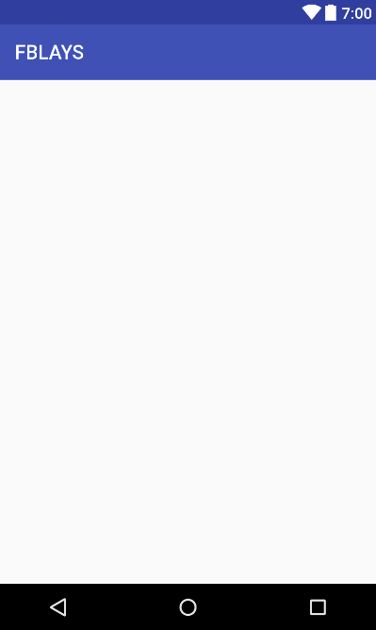

*<?***xml version="1.0" encoding="utf-8"***?>*

<**TextView**

**xmlns:android="http://schemas.android.com/apk/res/android"**

**android:layout_width="match_parent"**

**android:layout_height="wrap_content"**

**android:textSize="18sp"**

**android:gravity="left"**

**android:textColor="#000000"**

**android:paddingTop="1dp"**

/>

user_home_item_row.xml

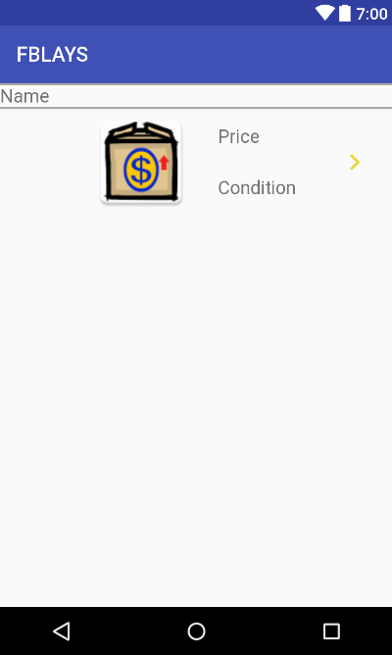

*<?***xml version="1.0" encoding="utf-8"***?>*

<**LinearLayout xmlns:android="http://schemas.android.com/apk/res/android"**

**xmlns:app="http://schemas.android.com/apk/res-auto"**

**android:orientation="vertical" android:layout_width="match_parent"**

**android:layout_height="wrap_content"**

**android:weightSum="1"**>

<**TextView**

**android:id="@+id/txtName"**

**android:layout_width="match_parent"**

**android:layout_height="wrap_content"**

**android:text="Name "**

**android:textSize="18sp"**

**android:background="@drawable/item_border"**

**android:paddingTop="2dp"**

**android:paddingBottom="2dp"**/>

<**RelativeLayout**

**android:id="@+id/viewItem"**

**android:layout_width="match_parent"**

**android:layout_height="100dp"**

**android:layout_alignParentStart="true"**

**android:layout_alignParentTop="true"**

**android:clickable="true"**

**android:layout_marginTop="2dp"**

**android:layout_marginBottom="2dp"**>

<**ImageView**

**android:id="@+id/categoryIV"**

**android:layout_marginTop="18dp"**

**android:layout_width="63dp"**

**android:layout_height="63dp"** />

<**ImageView**

**android:id="@+id/imageView"**

**android:layout_width="150dp"**

**android:layout_height="match_parent"**

**android:layout_alignParentTop="true"**

**android:layout_toRightOf="@+id/categoryIV"**

**app:srcCompat="@mipmap/ic_launcher"** />

<**RelativeLayout**

**android:id="@+id/relativeLayout"**

**android:layout_width="wrap_content"**

**android:layout_height="match_parent"**

**android:layout_alignParentTop="true"**

**android:layout_toEndOf="@+id/imageView"**

**android:orientation="vertical"**>

<**TextView**

**android:id="@+id/txtCondition1"**

**android:layout_width="wrap_content"**

**android:layout_height="50dp"**

**android:layout_alignParentBottom="true"**

**android:layout_alignParentStart="true"**

**android:gravity="center"**

**android:text="Condition"**

**android:textSize="18sp"** />

<**TextView**

**android:id="@+id/txtPrice"**

**android:layout_width="wrap_content"**

**android:layout_height="50dp"**

**android:layout_alignParentStart="true"**

**android:layout_alignParentTop="true"**

**android:gravity="center"**

**android:text="Price"**

**android:textSize="18sp"** />

</**RelativeLayout**>

<**ImageButton**

**android:id="@+id/btnViewItem"**

**android:layout_width="75dp"**

**android:layout_height="match_parent"**

**android:text="View item"**

**android:background="@android:color/transparent"**

**android:cropToPadding="false"**

**android:layout_alignParentTop="true"**

**android:layout_alignParentEnd="true"**

**android:src="@drawable/ic_view_item"**/>

</**RelativeLayout**>

</**LinearLayout**>

user_layout.xml

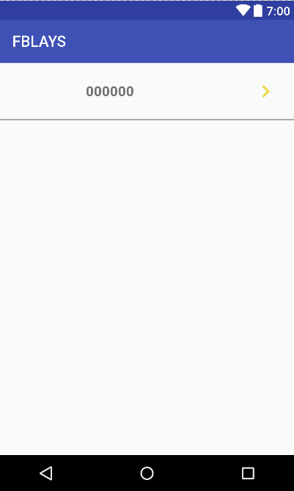

*<?***xml version="1.0" encoding="utf-8"***?>*

<**LinearLayout xmlns:android="http://schemas.android.com/apk/res/android"**

**android:orientation="horizontal" android:layout_width="match_parent"**

**android:layout_height="75dp"**

**android:background="@drawable/bottom_border"**>

<**ImageView**

**android:layout_width="100dp"**

**android:layout_height="match_parent"**

**android:id="@+id/profilePic"**/>

<**TextView**

**android:layout_width="140dp"**

**android:layout_height="match_parent"**

**android:text="000000"**

**android:textSize="18dp"**

**android:textStyle="bold"**

**android:gravity="center_vertical"**

**android:layout_marginLeft="12dp"**

**android:id="@+id/viewMessage"**

/>

<**ImageButton**

**android:layout_width="90dp"**

**android:layout_height="match_parent"**

**android:textStyle="bold"**

**android:gravity="center_vertical"**

**android:layout_marginLeft="50dp"**

**android:id="@+id/viewButton"**

**android:layout_toRightOf="@+id/notifMessage"**

**android:src="@drawable/ic_view_item"**

**android:background="@android:color/transparent"** />

</**LinearLayout**>