Overall Accuracy for each evaluation

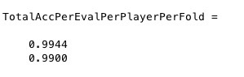

Overall Accuracy for each evaluation for each player mean class (n and not n, where n=player)

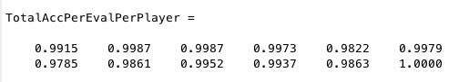

Confusion Matrix for Eval 1

(Output horizontal, Label verticla)

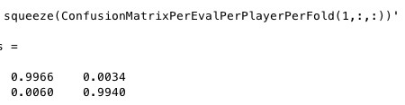

Confusion Matrix for Eval 2

(Output horizontal, Label vertical)

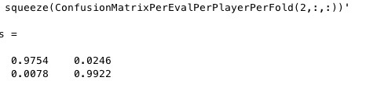

Accuracy for each SubGroup Eval 1

(TimedUntimed Vertical Take1Take2 Horizontal)

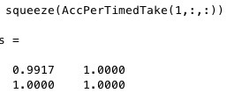

Accuracy for each SubGroup Eval 2

(TimedUntimed Vertical Take1Take2 Horizontal)

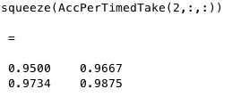

Mean Score Per Track for each Eval

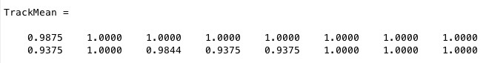

In the order of tracks

1: Hom (H)

2: Ban (R)

3: Coo (R)

4: Mai (R)

5: Bann (J)

6: Mor (J)

7: Wild 1

8: Wild 2

Mean Score for Track Types per eval: (R,J,H,W)

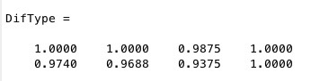

Notes!!

The Accuracy for the sub group mean, track means and track type means are only the percentage that should have been 1’s that are 1’s. It does not include the 0’s that have been wrongly classified as you cant tell what sub group, track or track type that the wrong 1 classified too!

Procedure Notes

CNN:

../../../Desktop/Screen%20Shot%202017-04-05%20at%2002.26.52.pdf

Adam optimizer

0.03 learning rate

100 minimum, stop if validation or train loss increases

250 mini-batch size

0.25 dropout val

zero padding conv layers

500 frame snippets (5 seconds)

Datasplit sizes:

4 folds. 2 tracks tested per fold (6/2 split) (1/2 test ½ val)

6 players

2 evaluations

48 CNN in total

Eval 1

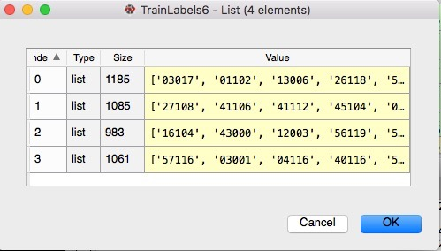1/6 of tracks are the classified player

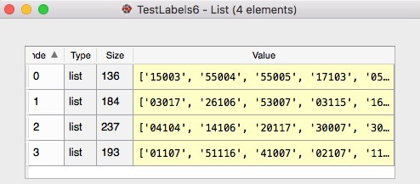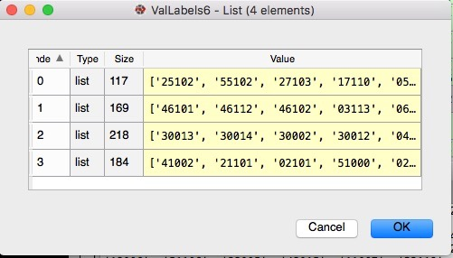

Eval 2

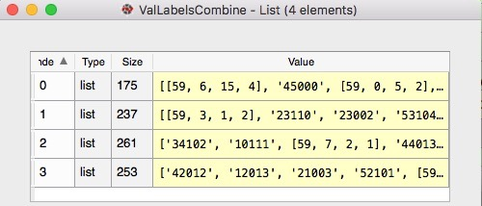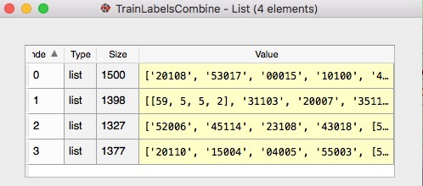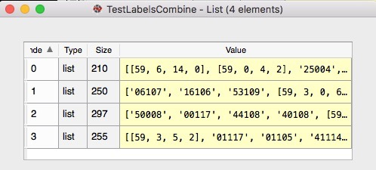1/7-1/8 (roughly) of tracks are the classified player

7 class results

Mean per Eval

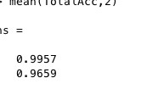

Confusion Matrix Eval 1

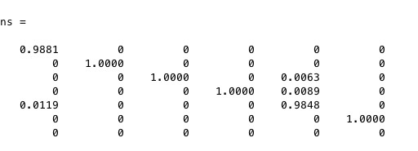

Confusion Matrix Eval 2

