diss

me

4/22/2019

# Load packages  
library(readr)  
library(tidyverse)  
library(rgdal)  
library(sp)  
library(raster)  
library(sf)  
library(rworldmap)  
library(grid)  
library(rworldxtra)  
library(stringr)  
library(maptools)  
library(tiff)  
library(dggridR)  
library(modeest)  
library(lme4)  
library(MuMIn)  
library(lmerTest)  
library(segmented)  
library(effects)  
library(scales)  
library(gridExtra)  
  
# Import base dataset   
lucas <- read_csv("data/2012_lucas.csv")  
  
# LATVIA BORDER and POLY ----  
  
# get data   
latvia <- raster::getData("GADM", country = "LVA", level = 0)  
  
# change projection  
latvia <- spTransform(latvia, "+proj=longlat +ellps=WGS84 +datum=WGS84 +init=epsg:3857")  
  
# create polygon  
data = data.frame(f=99.9)  
spdf = SpatialPolygonsDataFrame(latvia, data)  
shapefile(spdf, "data/latvia_poly", overwrite = TRUE)  
  
# format data  
map <- fortify(latvia)%>%  
 dplyr::select(long, lat)   
colnames(map)[colnames(map) == "lat"] <- "LAT"  
colnames(map)[colnames(map) == "long"] <- "LONG"  
  
# set CRS and transform  
coordinates(map) <- c("LONG", "LAT")  
proj4string(map) <- CRS("+proj=longlat +ellps=WGS84 +datum=WGS84 +init=epsg:3857")  
border_points <- spTransform(map, "+proj=longlat +ellps=WGS84 +datum=WGS84 +init=epsg:3857")  
r_border <- raster(border_points) # border as raster  
  
## ABANDONED LAND ----  
  
# filter for abandoned land  
U112_options <- c("10", "20") # stated that these were abandoned agricultural areas  
U410_options <- c("B", "C", "D", "E", "F") # classes that could be agriculture in U410 (natural terrestrial areas)  
  
lucas_filtered <- lucas %>%   
 separate(LC1, into = c('class', 'number'), sep = 1) %>%  
 filter(LU1 == "U410" & class %in% U410_options |  
 LU1 == "U112" & class == "D" & number %in% U112_options |  
 LU1 == "U420" & class == "E" & number == "30") %>%  
 dplyr::select(GPS_LAT, GPS_LONG) %>% # potentially need elevation here??  
 mutate(class = "1") %>%  
 mutate(name = "abandoned")  
  
# write to csv   
write.csv(lucas_filtered, file = "data/lucas_2012_filtered.csv")

# TOTAL AREA ----  
  
# import data 1989 ----  
data <- read_csv("~/Documents/Edinburgh Year 4/dissertation/data/classified_1989.csv")  
  
# format ----  
new <- data %>%  
 separate(groups, into = c('class0', 'number0',   
 'class1', 'number1',   
 'class2', 'number2',   
 'class3', 'number3',   
 'class4', 'number4',   
 'class5', 'number5',   
 'class6', 'number6'), sep = ",")   
  
new$class0 <- gsub("[^0-9.-]", "", new$class0)  
new$number0 <- gsub("[^0-9.-]", "", new$number0)  
new$class1 <- gsub("[^0-9.-]", "", new$class1)  
new$number1 <- gsub("[^0-9.-]", "", new$number1)  
new$class2 <- gsub("[^0-9.-]", "", new$class2)  
new$number2 <- gsub("[^0-9.-]", "", new$number2)  
new$class3 <- gsub("[^0-9.-]", "", new$class3)  
new$number3 <- gsub("[^0-9.-]", "", new$number3)  
new$class4 <- gsub("[^0-9.-]", "", new$class4)  
new$number4 <- gsub("[^0-9.-]", "", new$number4)  
new$class5 <- gsub("[^0-9.-]", "", new$class5)  
new$number5 <- gsub("[^0-9.-]", "", new$number5)  
new$class6 <- gsub("[^0-9.-]", "", new$class6)  
new$number6 <- gsub("[^0-9.-]", "", new$number6)  
  
new$number0 <- as.numeric(new$number0)  
new$number1 <- as.numeric(new$number1)  
new$number2 <- as.numeric(new$number2)  
new$number3 <- as.numeric(new$number3)  
new$number4 <- as.numeric(new$number4)  
new$number5 <- as.numeric(new$number5)  
new$number6 <- as.numeric(new$number6)  
  
delete89 <- new %>%  
 dplyr::select(-c(.geo, `system:index`))  
  
new_df89 <- bind_rows(  
 delete89 %>% dplyr::select(label, class = class0, pixels = number0),  
 delete89 %>% dplyr::select(label, class = class1, pixels = number1),  
 delete89 %>% dplyr::select(label, class = class2, pixels = number2),  
 delete89 %>% dplyr::select(label, class = class3, pixels = number3),  
 delete89 %>% dplyr::select(label, class = class4, pixels = number4),  
 delete89 %>% dplyr::select(label, class = class5, pixels = number5),  
 delete89 %>% dplyr::select(label, class = class6, pixels = number6)  
) %>%  
 mutate(area = pixels*30) %>%  
 mutate(year = 1989)  
   
  
# get sum of all regions for each class and input into excel -----  
sum(new$number0,na.rm=TRUE)  
sum(new$number1,na.rm=TRUE)  
sum(new$number2,na.rm=TRUE)  
sum(new$number3,na.rm=TRUE)  
sum(new$number4,na.rm=TRUE)  
sum(new$number5,na.rm=TRUE)  
sum(new$number6,na.rm=TRUE)

# TOTAL TRANSITION ----  
  
# import data 89 to 90 1 to 3 ----  
data <- read_csv("~/Documents/Edinburgh Year 4/dissertation/data/89_90_1to3.csv")  
  
# format ----  
new <- data %>%  
 separate(groups, into = c('class0', 'number0',   
 'class1', 'number1'), sep = ",")   
  
new$class0 <- gsub("[^0-9.-]", "", new$class0)  
new$number0 <- gsub("[^0-9.-]", "", new$number0)  
new$class1 <- gsub("[^0-9.-]", "", new$class1)  
new$number1 <- gsub("[^0-9.-]", "", new$number1)  
  
new$number0 <- as.numeric(new$number0)  
new$number1 <- as.numeric(new$number1)  
  
# get sum of all regions for transition and input into excel -----  
sum(new$number1,na.rm=TRUE)  
  
transition_8990_1 <- new %>%  
 dplyr::select(-c(.geo, `system:index`, class0, class1, number0)) %>%  
 mutate(area = number1*30) %>%  
 mutate(year = "1990") %>%  
 mutate(transition = "1") %>%  
 mutate(previous_class = "1") %>%  
 mutate(current_class = "3")

# load data ----  
detailed_area <- read_csv("data/detailed_area.csv") %>%  
 dplyr::select(-c("X1"))  
colnames(detailed_area)[colnames(detailed_area) == "label"] <- "cell"  
detailed_area$class <- factor(detailed_area$class)  
detailed_area$cell <- factor(detailed_area$cell)  
  
detailed_transition <- read_csv("data/detailed_transition.csv") %>%  
 dplyr::select(-c("X1"))  
colnames(detailed_transition)[colnames(detailed_transition) == "label"] <- "cell"  
detailed_transition$cell <- factor(detailed_transition$cell)  
detailed_transition$transition <- factor(detailed_transition$transition)  
  
# apply bigger grid  
detailedA <- detailed_area %>%  
 mutate(grid = if_else(cell == 8 | cell == 9 | cell == 10 | cell == 11 | cell == 23 |  
 cell == 24 | cell == 25 | cell == 26 | cell == 27 |  
 cell == 38 | cell == 39 | cell == 40 | cell == 41 |  
 cell == 42 | cell == 43 | cell == 53 | cell == 54 | cell == 55 | cell == 56, "NW",   
 if_else(cell == 3 | cell == 4 | cell == 5 | cell == 6 | cell == 7 |  
 cell == 19 | cell == 20 | cell == 21 | cell == 22 |  
 cell == 35 | cell == 36 | cell == 37 | cell == 49 |  
 cell == 50 | cell == 51 | cell == 52, "SW",   
 if_else(cell == 64 | cell == 65 | cell == 66 | cell == 67 | cell == 68 |  
 cell == 69 | cell == 79 | cell == 80 | cell == 81 |  
 cell == 82 | cell == 83 | cell == 84 | cell == 85 |  
 cell == 86 | cell == 87 | cell == 88 | cell == 89 | cell == 94 |   
 cell == 95 | cell == 96 | cell == 97 | cell == 98 | cell == 99 |  
 cell == 100 | cell == 101 | cell == 102 | cell == 103 | cell == 104, "C",  
 if_else(cell == 113 | cell == 114 | cell == 115 | cell == 116 | cell == 117 |  
 cell == 118 | cell == 119 | cell == 120 | cell == 128 |  
 cell == 129 | cell == 130 | cell == 131 | cell == 132 |  
 cell == 133 | cell == 134 | cell == 143 | cell == 144 | cell == 145 |   
 cell == 146 | cell == 147 | cell == 158 | cell == 159 | cell == 160 |  
 cell == 161 | cell == 162 | cell == 173 | cell == 174 | cell == 175 | cell == 176, "NE",  
 if_else(cell == 108 | cell == 109 | cell == 110 | cell == 111 | cell == 112 |  
 cell == 121 | cell == 122 | cell == 123 | cell == 124 |  
 cell == 125 | cell == 126 | cell == 127 | cell == 136 |  
 cell == 137 | cell == 138 | cell == 139 | cell == 140 | cell == 141 |   
 cell == 142 | cell == 151 | cell == 152 | cell == 153 | cell == 154 |  
 cell == 155 | cell == 156 | cell == 157 | cell == 166 | cell == 167 | cell == 168 |  
 cell == 169 | cell == 170 | cell == 171 | cell == 172 | cell == 183 | cell == 184 | cell == 185 |  
 cell == 186, "SE", "NA"))))))   
  
# apply bigger grid  
detailedT <- detailed_transition %>%  
 mutate(grid = if_else(cell == 8 | cell == 9 | cell == 10 | cell == 11 | cell == 23 |  
 cell == 24 | cell == 25 | cell == 26 | cell == 27 |  
 cell == 38 | cell == 39 | cell == 40 | cell == 41 |  
 cell == 42 | cell == 43 | cell == 53 | cell == 54 | cell == 55 | cell == 56, "NW",   
 if_else(cell == 3 | cell == 4 | cell == 5 | cell == 6 | cell == 7 |  
 cell == 19 | cell == 20 | cell == 21 | cell == 22 |  
 cell == 35 | cell == 36 | cell == 37 | cell == 49 |  
 cell == 50 | cell == 51 | cell == 52, "SW",   
 if_else(cell == 64 | cell == 65 | cell == 66 | cell == 67 | cell == 68 |  
 cell == 69 | cell == 79 | cell == 80 | cell == 81 |  
 cell == 82 | cell == 83 | cell == 84 | cell == 85 |  
 cell == 86 | cell == 87 | cell == 88 | cell == 89 | cell == 94 |   
 cell == 95 | cell == 96 | cell == 97 | cell == 98 | cell == 99 |  
 cell == 100 | cell == 101 | cell == 102 | cell == 103 | cell == 104, "C",  
 if_else(cell == 113 | cell == 114 | cell == 115 | cell == 116 | cell == 117 |  
 cell == 118 | cell == 119 | cell == 120 | cell == 128 |  
 cell == 129 | cell == 130 | cell == 131 | cell == 132 |  
 cell == 133 | cell == 134 | cell == 143 | cell == 144 | cell == 145 |   
 cell == 146 | cell == 147 | cell == 158 | cell == 159 | cell == 160 |  
 cell == 161 | cell == 162 | cell == 173 | cell == 174 | cell == 175 | cell == 176, "NE",  
 if_else(cell == 108 | cell == 109 | cell == 110 | cell == 111 | cell == 112 |  
 cell == 121 | cell == 122 | cell == 123 | cell == 124 |  
 cell == 125 | cell == 126 | cell == 127 | cell == 136 |  
 cell == 137 | cell == 138 | cell == 139 | cell == 140 | cell == 141 |   
 cell == 142 | cell == 151 | cell == 152 | cell == 153 | cell == 154 |  
 cell == 155 | cell == 156 | cell == 157 | cell == 166 | cell == 167 | cell == 168 |  
 cell == 169 | cell == 170 | cell == 171 | cell == 172 | cell == 183 | cell == 184 | cell == 185 |  
 cell == 186, "SE", "NA"))))))   
  
# DFs for Q1  
# before and after in km2 per cell   
questiononeSUC <- detailedA %>%  
 dplyr::filter(year == 1989 | year == 1990 | year == 1991 | year == 1992 | year == 1993 | year == 1994) %>%  
 dplyr::select(-c(pixels)) %>%  
 mutate(before_after = ifelse(year == 1989 | year == 1990 | year == 1991, "first", "second")) %>%  
 dplyr::select(-c(year)) %>%  
 group_by(before_after, grid, class, cell) %>%  
 summarise(area = mean(area)/1000)   
  
  
questiononeEUA <- detailedA %>%  
 dplyr::filter(year == 2001 | year == 2002 | year == 2003 | year == 2004 | year == 2005 | year == 2006) %>%  
 dplyr::select(-c(pixels)) %>%  
 mutate(before_after = ifelse(year == 2001 | year == 2002 | year == 2003, "first", "second")) %>%  
 dplyr::select(-c(year)) %>%  
 group_by(before_after, grid, class, cell) %>%  
 summarise(area = mean(area)/1000)   
  
# DFs for Q2  
# before and after   
questiontwoSUC <- detailedT %>%  
 dplyr::filter(year == 1990 | year == 1991 | year == 1992 | year == 1993 | year == 1994 | year == 1995) %>%  
 dplyr::select(-c(pixels)) %>%  
 mutate(before_after = ifelse(year == 1990 | year == 1991 | year == 1992, "first", "second")) %>%  
 dplyr::select(-c(year)) %>%  
 group_by(before_after, grid, transition, cell) %>%  
 summarise(area = mean(area)/1000)   
  
# for EUA  
questiontwoEUA <- detailedT %>%  
 dplyr::filter(year == 2002 | year == 2003 | year == 2004 | year == 2005 | year == 2006 | year == 2007) %>%  
 dplyr::select(-c(pixels)) %>%  
 mutate(before_after = ifelse(year == 2002| year == 2003 | year == 2004, "first", "second")) %>%  
 dplyr::select(-c(year) )%>%  
 group_by(before_after, grid, transition, cell) %>%  
 summarise(area = mean(area)/1000)   
  
  
# DFs for Q3 ----  
questionthreeASUC <- detailedA %>%  
 dplyr::filter(year == 1989 | year == 1990 | year == 1991 | year == 1995 | year == 1996 | year == 1997) %>%  
 dplyr::select(-c(pixels)) %>%  
 mutate(before_after = ifelse(year == 1989 | year == 1990 | year == 1991, "first", "second")) %>%  
 dplyr::select(-c(year)) %>%  
 group_by(before_after, grid, class, cell) %>%  
 summarise(area = mean(area)/1000)   
  
  
questionthreeAEUA <- detailedA %>%  
 dplyr::filter(year == 2001 | year == 2002 | year == 2003 | year == 2007 | year == 2008 | year == 2009) %>%  
 dplyr::select(-c(pixels)) %>%  
 mutate(before_after = ifelse(year == 2001 | year == 2002 | year == 2003, "first", "second")) %>%  
 dplyr::select(-c(year)) %>%  
 group_by(before_after, grid, class, cell) %>%  
 summarise(area = mean(area)/1000)   
  
questionthreeTSUC <- detailedT %>%  
 dplyr::filter(year == 1990 | year == 1991 | year == 1992 | year == 1996 | year == 1997 | year == 1998) %>%  
 dplyr::select(-c(pixels)) %>%  
 mutate(before_after = ifelse(year == 1990 | year == 1991 | year == 1992, "first", "second")) %>%  
 dplyr::select(-c(year)) %>%  
 group_by(before_after, grid, transition, cell) %>%  
 summarise(area = mean(area)/1000)   
  
questionthreeTEUA <- detailedT %>%  
 dplyr::filter(year == 2002 | year == 2003 | year == 2004 | year == 2008 | year == 2009 | year == 2010) %>%  
 dplyr::select(-c(pixels)) %>%  
 mutate(before_after = ifelse(year == 2002| year == 2003 | year == 2004, "first", "second")) %>%  
 dplyr::select(-c(year) )%>%  
 group_by(before_after, grid, transition, cell) %>%  
 summarise(area = mean(area)/1000)

# Abandoned SUC ----  
questiononeSUC1 <- questiononeSUC %>%  
 dplyr::filter(class == 1)   
  
questiononeSUC1$grid <- factor(questiononeSUC1$grid)  
questiononeSUC1$cell <- factor(questiononeSUC1$cell)  
questiononeSUC1$before_after <- factor(questiononeSUC1$before_after)  
  
# model  
abandonedSUC <- lmer(area ~ before_after + (1|grid), data = questiononeSUC1)  
summary(abandonedSUC)  
  
r.squaredGLMM(abandonedSUC)  
  
# check assumptions  
plot(abandonedSUC)

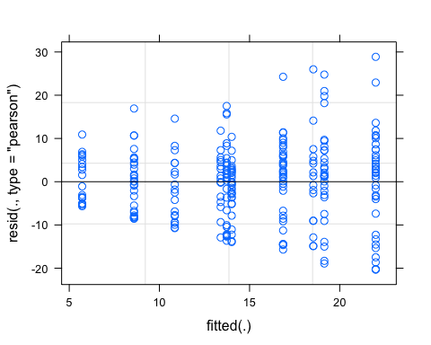

qqnorm(resid(abandonedSUC))   
qqline(resid(abandonedSUC))

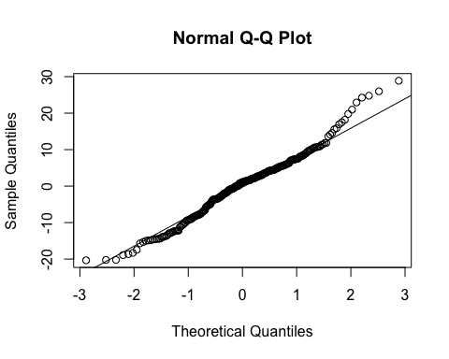

# Q2 A--I: EUA ----  
questiontwoEUA1 <- questiontwoEUA %>%  
 dplyr::filter(transition == 1)  
  
questiontwoEUA1$grid <- factor(questiontwoEUA1$grid)  
questiontwoEUA1$cell <- factor(questiontwoEUA1$cell)  
questiontwoEUA1$before_after <- factor(questiontwoEUA1$before_after)  
  
atoiEUA <- lmer(area ~ before_after + (1|grid), data = questiontwoEUA1)  
summary(atoiEUA)  
  
r.squaredGLMM(atoiEUA)  
  
plot(atoiEUA)

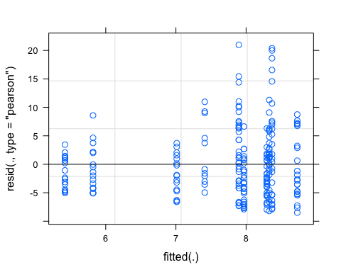

qqnorm(resid(atoiEUA))   
qqline(resid(atoiEUA))

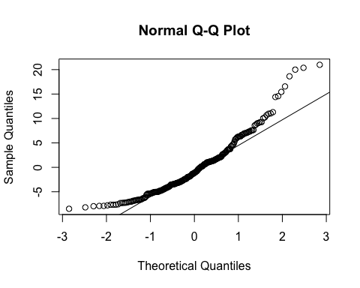

# Q3 lag Abandoned SUC ----  
questionthreeSUC1 <- questionthreeASUC %>%  
 dplyr::filter(class == 1)   
  
questionthreeSUC1$grid <- factor(questionthreeSUC1$grid)  
questionthreeSUC1$cell <- factor(questionthreeSUC1$cell)  
questionthreeSUC1$before_after <- factor(questionthreeSUC1$before_after)  
  
# model  
abandonedlagSUC <- lmer(area ~ before_after + (1|grid), data = questionthreeSUC1)  
summary(abandonedlagSUC)  
  
r.squaredGLMM(abandonedlagSUC)  
  
# check assumptions  
plot(abandonedlagSUC)

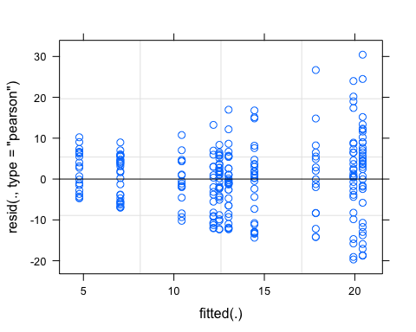

qqnorm(resid(abandonedlagSUC))   
qqline(resid(abandonedlagSUC))

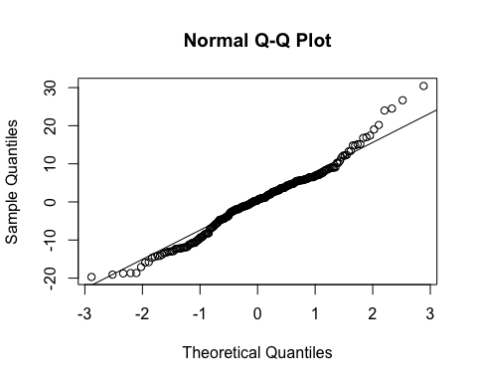

# Q3 part b ----  
abandonedseglag <- detailedA %>%  
 dplyr::select(-c(pixels)) %>%  
 filter(class == "1") %>%  
 group_by(year) %>%  
 summarise(year_total = sum(area)/1000)  
  
abandonedlm <- lm(year_total ~ year, data = abandonedseglag)   
summary(abandonedlm)  
  
abandonedmod <- segmented(abandonedlm, seg.Z = ~year, psi = list(year = c(1996,2004)))  
summary(abandonedmod)