**THE UNIVERSITY OF EDINBURGH**

**SCHOOL OF GEOSCIENCES**

**THE VISIBILITY OF SOCIO-POLITICO-ECONOMIC EVENTS ACROSS A LATVIAN LANDSCAPE**

*BY*

**Isabelle Rich**

in partial fulfilment of the requirement for the

Degree of BSc with Honours in

Ecological and Environmental Sciences

April 2019

**Abstract**

**Table of contents**

Abstract

Table of contents

Acknowledgements

List of abbreviations

1. Introduction……………………………………………………………… 1
   1. Objectives and rationale…………………………………... 2
   2. Research questions, hypotheses and predictions…….... 2
2. Methods
3. Results
   1. Q1
   2. Q2
   3. Q3
4. Discussion
   1. Key findings
   2. Q1
   3. Q2
   4. Q3
   5. Limitations
   6. Future research
5. Conclusion
6. Reference list
7. Appendices

**Acknowledgements**

I firstly would like to thank Dr Isla Myers-Smith, not only for her continuous support, wisdom and advice that kept me grounded during dissertation work, but for all the opportunities working with her has given me: I can safely say that assisting with her 2017 field season changed my life for the better. I am grateful for PhD student Gergana Daskalova for sharing code and resources, and her dedication, knowledge and encouragement throughout this process and always. Without her, I would have never found my love for data science. I would like to also thank the rest of the Team Shrub research group at the University of Edinburgh: my coursemate Cameron Cosgrove, Dr Sandra Algers-Blondin and Mariana Garcia Criadio for helping me plan and achieve the goals of my dissertation.

I would like to thank all the additional academics I reached out to that graciously provided advice: Sam Harrison (University of Edinburgh, PhD candidate), Keiko Nomura (University of Edinburgh, PhD candidate) and Dr Alemayehu Midekisa (Geospatial research specialist, University of California, San Francisco), thank you for solving some seemingly unsolvable problems. I am also grateful for the vast amount of resources on the internet for assisting me within seconds.

I must acknowledge my large and wonderful support network. Thank you to my coursemates for sharing their wisdom, time and company during our long days at the library. I am beyond grateful for my flatmates. Without these ladies, I would not have the confidence, strength and passion to complete this dissertation. A final thanks goes to my family: thank you for supporting my decision to travel across the pond for university. I can confidently say it was the best decision I’ve ever made.

**List of abbreviations**

EU – European Union

EUA – European Union Accession

GEE – Google Earth Engine

LUC – Land use change

LUCAS – Land Use and Coverage Area frame Survey

SAP – Single Area Payment

SPE – Socio-politico-economic

SUC – Soviet Union collapse

1. **Introduction** 
   1. **Objectives and rationale**

This study aims to investigate the importance of SPE events as drivers of agricultural LUC in Latvia through the use of satellite imagery. Although the importance of SPE events on LUC is acknowledged (Alexander V Prishchepov *et al.*, 2012; Vanwambeke *et al.*, 2012), it remains unclear whether a signature of agricultural LUC is left across a country. By using satellite imagery to determine the strength and direction of agricultural LUC and transitions, patterns of a changing landscape can be unraveled to unveil when the effect of SPE events is most visible. My findings will give insight into the homogeneity, or lack thereof, of the effects of SPE events across a Latvian landscape. Results will reveal the transition patterns between each agricultural land use type, including extensive, intensive and abandoned land, providing insight into the relationship between land uses. Ultimately, my study will uncover the importance of SPE events as drivers of LUC in Latvia, permitting predictions about land use under changing SPE conditions to be made.

* 1. **Research questions and hypotheses**

I have not included alternative hypotheses for the sake of brevity and the wide range of possible alternatives.

**RQ1: Across Latvia, is intensive, extensive and abandoned land use change visible within the three years following SPE events?**

**H1**: Directly following SUC, intensive agriculture will decrease (H1a), and abandoned land will increase across Latvia (H1b). Extensive cover change will be weakly positive (H1c). After EUA, intensive agriculture will increase (H1d), and abandoned land will decrease across Latvia (H1e). Extensive cover change will be weakly negative (H1f).

**H10**: Intensive, extensive and abandoned land use will not visibly increase or decrease in Latvia directly following SUC and EUA.

**RQ2**: **Do the strength and direction of land use transitions change within the three years following SPE events?**

**H2**: Following SUC, intensive land will transition to abandoned (H2a) and extensive land (H2b), with the transition to abandoned land being stronger. After EUA, abandoned (H2c) and extensive (H2d) and will transition to intensive land.

**H20**: Land use transitions between intensive, extensive and abandoned land will not significantly increase or decrease in Latvia following SUC and EUA.

**RQ3: Is there a time lag between SPE events and the visibility of LUC and transitions?**

**H3**: Following SUC, a weak lag relationship will be present for intensive cover decrease (H3a) and abandoned land increase (H3b). There will be a strong relationship between the new time window and extensive land cover increase (H3c). There will be a strong lag for the transition from intensive to extensive land (H3d) and a weak lag for the transition to abandoned land (H3e). After EUA, a strong lag will be present for the decrease of extensive agriculture (H3f). A weak lag relationship will be visible for abandoned land cover decrease (H3g), intensive land increase (H3h) and the transition from abandoned land to intensive land (H3i). A strong lag will be observed for the transition from extensive to intensive land (H3j).

**H30**: Time following SPE events will not have an effect on strength of LUC and land use transitions.

* 1. **Predictions**

**1.3.1 SUC**

I predict that abandoned land will increase visibly following SUC, due to the sharp decline of the agricultural sector (Alexander V Prishchepov *et al.*, 2012). I predict that intensive agriculture will be replaced by extensively farmed land due to a large scale shift from Soviet collective farms to small-scale subsistence farms (Vanwambeke *et al.*, 2012). However, I predict that uncertainty around land access during the post-Soviet transition period will cause a lag in the increase of transition to extensive land, resulting in a large increase in abandoned land within two years following SUC. I predict intensive agriculture decrease will be observed directly following SUC, representing the rapid decrease in government investment in agriculture (Vanwambeke *et al.*, 2012) contributing to the high levels of abandonment (Alexander V Prishchepov *et al.*, 2012).

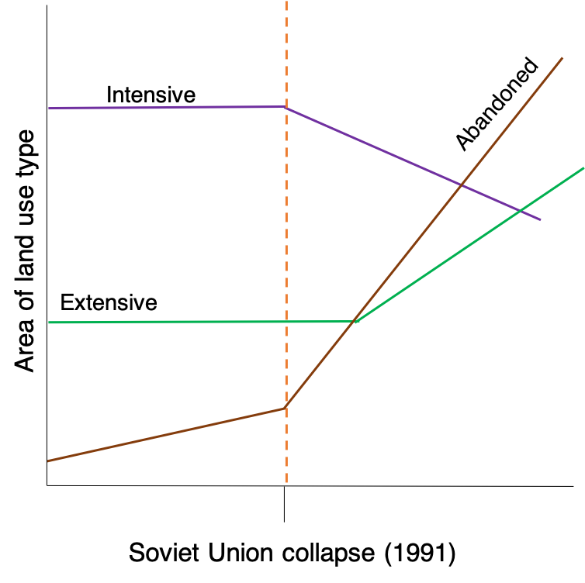

**Figure 1.1** – Prediction figures illustrating my hypotheses regarding LUC following SUC, creating in Microsoft PowerPoint. Specific transitions not depicted. Not drawn to scale.

**1.3.2 EUA**

I predict an increase in intensive land will be visible directly following EUA, as public support has facilitated the increase of agricultural production and income (Veveris and Kalis, 2016). In turn, I predict that abandoned land decreases within two years of EUA to facilitate forming large, intensive farms. I predict that although extensive land will decrease due to difficulty adapting to working within a single EU market, it will not happen directly following EUA. I predict instead that there will be a time lag on this decrease and transition, representing a desire to maintain traditional farming practices (Nikodemus *et al.*, 2010)

**Figure 1.2** – Prediction figures illustrating my hypotheses regarding LUC following EUA, creating in Microsoft PowerPoint. Specific transitions not depicted. Not drawn to scale.

**1.3.3 Implications of results**

If areas of a land use increase or decrease significantly directly following an SPE event, the SPE event can be seen as the main driver of LUC. Significant LUC also would indicate a homogeneous shift across the Latvian landscape. If no significant LUC is seen, it is likely that different regions experienced LUC with differing strengths and directions. Such heterogeneous effects would also signify that the SPE event was not the main driver of LUC or that it was coupled with other key drivers.

**2. Methods**

To answer my three main research questions, I constructed a classification of land use change in Latvia between 1989 to 2011 using GEE (Gorelick *et al.*, 2017). My workflow diagram, depicting the key steps to this process, is shown in Figure 1.

**Figure 2.1** – Workflow diagram, created on Microsoft PowerPoint.

**2.1 Study site**

Latvia (55º40’-58 º05’N and 20º58’-28º14’E) is on the Baltic coast, in North Eastern Europe (Prieditis, 1993). Latvia borders Estonia to the north, Lithuania to the south and both Russia and Belarus to the east. Latvia spans 64.6 thousand km2 and is largely flat, with the majority of terrain between 40-200 metres above sea level (Prieditis, 1993). Land is vegetated for 180-200 days annually (Prieditis, 1993). Latvia was a Soviet state during 1945-1990, where there were predominantly large, homogenously cultivated farms on favourable areas, with the rest of the land largely forested (Vanwambeke *et al.*, 2012). Following the SUC in 1991, land reform aimed to restore pre-Soviet farming culture when extensive, small farms were key to Latvia’s culture. Leading up to EUA, agricultural support schemes played a large role in promoting such extensive farming practices (Vanwambeke *et al.*, 2012).

**2.2 Image processing**

Landsat 5 Thematic Mapper satellite imagery (1985-2011) covers my study period well and is commonly used in similar classification studies (Alexander V Prishchepov *et al.*, 2012; Fonji and Taff, 2014; Sidhu *et al.*, 2018). I selected Landsat 5 Surface Reflectance imagery (30 metre resolution), which is atmospherically corrected, preventing the occurrence of clouds and shadows in the imagery (Zanter, 2018). For each study year (1989-2011), I employed an additional cloud mask to remove any remaining pixels containing clouds or shadows, as well as any edge pixels that do not contain all bands of interest. I chose summer images, depicting the growing season, to best characterise the spectral signatures of my different classes (Fonji and Taff, 2014). I took the median of each year’s image collection to an annual composite for each study year (Pimple *et al.*, 2018). I cropped each year’s image to the border of Latvia to increase the speed of my classification. Lastly, I selected blue, green, red, near-infrared and shortwave infrared bands, each with corresponding wavelengths, for my classification (Pimple *et al.*, 2018). My chosen bands will act as predictor variables for my classification.

**2.3 Classification background**

Classification approaches create categorical datasets, such as land use (Horning, 2010). Classifications aim to investigate the relationships within a group of objects to determine if the data can be summarised into classes (Gordon, 1999). There are three key steps to a classification: train, validate and test (Suthaharan, 2016).

In a supervised classification, relationships are discovered using data of known values, also called training points (Albalate and Minker, 2013). Training points train the classifier to infer prediction rules that form a decision tree (Albalate and Minker, 2013). Decision trees are composed of binary questions which group data by specific characteristics, such as bandwidth (Strobl *et al.*, 2009). With each step of the tree, the classifier asks whether a criterium of a specific class is met. After the classifier is trained, it can be applied across data of unknown classes. Test data of known values, normally obtained in the training phase, are then passed through the classifier to determine classifier accuracy and error (Suthaharan, 2016).

Random forest classifications are a supervised learning technique which is composed of numerous decision trees, creating a forest of trees (Horning, 2010). As multiple trees decide the class of each object, a voting process begins, where the final class assigned is the one that is predicted most (Horning, 2010). Using multiple trees increases classification accuracy (Suthaharan, 2016), as there is decreased overfitting, where noise is used to predict classes (Horning, 2010). A separate validation set, where overfitting is accounted for and parameters are pruned, is therefore not required (Suthaharan, 2016).

**Figure 2.2** – Random forest conceptual diagram, created with Microsoft PowerPoint.

**2.4 Training data**

My training data represent the known locations of each land use type in 2012. Field data results in high certainty in the training set (Millard and Richardson, 2015).

I used the LUCAS dataset (Eurostat, 2013), which contains GPS coordinates of both land use, as defined by the socioeconomic activities and land cover for European countries, for every three years since 2009. I chose to use 2012 data, as it is the earliest dataset that clearly separates fallow and abandoned agricultural land. Within R statistical software, version 3.5.3 (R Core Team, 2019), I filtered data to represent each of my land use classes: abandoned land and extensive and intensive agriculture. I also included four additional classes (artificial land, wetlands, water and forestry), as a larger training dataset improves classification stability and accuracy (Millard and Richardson, 2015). This collection of classes is supported by a similar study conducted by Fonji and Taff (2014).

To select which data would form each of my classes, I used the LUCAS 2012 Technical Reference Document (Eurostat, 2013), which contains descriptions of each land use and land cover category. Table 2.1 displays the criteria that define each of my key classes. The criteria to determine additional class can be found in Appendix X.

**Table 2.1 –** Criteria chosen to represent each key land use class.

|  |  |
| --- | --- |
| **Land use** | **Criteria** |
| **Abandoned** | 1. Abandoned agricultural land. 2. Abandoned land, filtered to include cropland, woodland, grassland and bare land. 3. Semi-natural and natural areas not in use. 4. Unused, spontaneously revegetated land. |
| **Extensive** | Heterogeneous crops planted mainly for own consumption produced in kitchen gardens or allotments, filtered to include cropland, woodland, grassland and bare land (natural areas). |
| **Intensive** | Industrial agriculture, filtered to include cropland, woodland, grassland and bare land. |

Following filtering, I had the coordinates of a total of 4013 data points, 1434 of which are from my three key classes (Table 2.2; Appendix X). I transformed these coordinates into a spatial file by setting the projection to that of GEE: Pseudo-Mercator WGS 84 (EPSG: 3857).

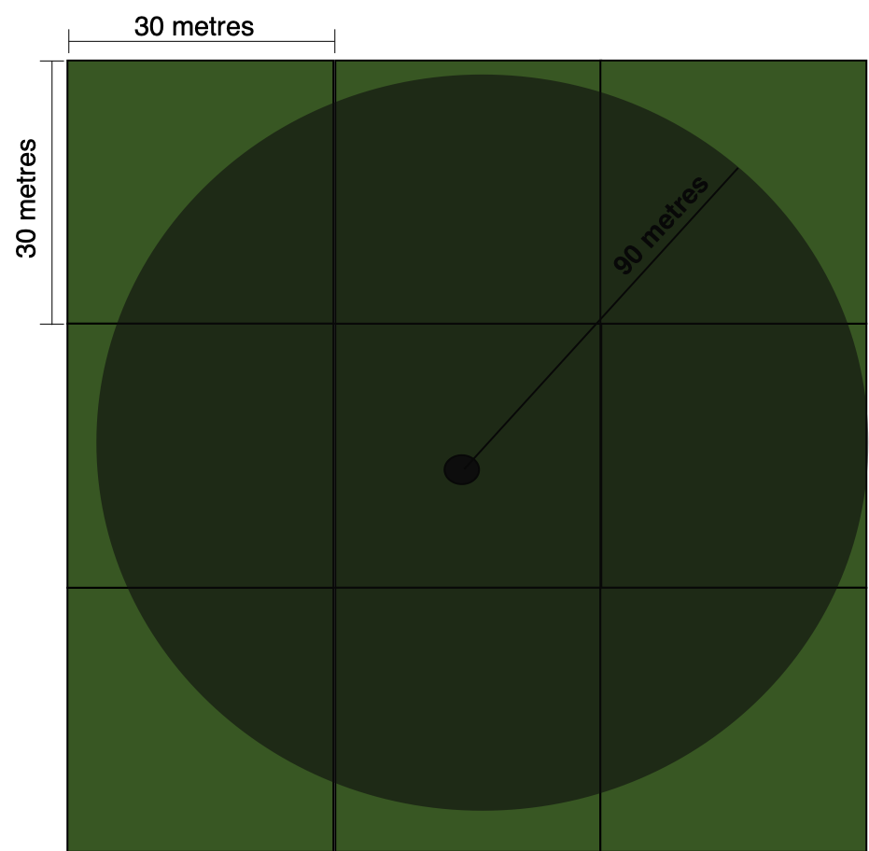

**Figure 2.3** – Circular buffer with 90 metre radius around data point, created with Microsoft PowerPoint. Square boxes represent pixels with 30 metre resolution.

Once imported into GEE, I created a 90-metre buffer around each point, turning point data into circular polygons (Figure 2.3). As each point represents an area or polygon of land, a buffer was necessary to compensate for GPS precision (Wulder *et al.*, 2005) and ensure the surrounding pixels were included. I chose a 90-metre buffer, creating a circular polygon with an area of 25446.9 square metres. This buffer size was used by Sader *et al.* (1995) for their land use classification. It is further supported by the average farm size in Latvia, with more than 91% of farms being this size or larger in 2003 (Zdanovskis and Pilvere, 2015).

To set up my training data for my classification, I divided my data randomly by class into two groups: training (80%) and testing (20%), also known as a hold-out approach (Suthaharan, 2016). The hold-out approach permits assessment of how the trained classifier works with unseen data (testing group).

**Table 2.2** – Total number of points obtained from LUCAS and the number used for training (80%) and testing (20%) for key classes. Total includes four additional classes.

|  |  |  |  |
| --- | --- | --- | --- |
| **Land type** | **Number of LUCAS points** | **Number of points in training sample** | **Number of points in testing sample** |
| **Abandoned** | 112 | 90 | 22 |
| **Extensive** | 27 | 18 | 9 |
| **Intensive** | 1295 | 1038 | 257 |
| **Total** | 4013 | 3223 | 817 |

I then sampled the imagery to collect the bandwidths across the locations of my training set. The bandwidths correspond to the unique spectral signature of each land type. As the training set refers to 2012 data, it would be most suitable to sample 2012 imagery. However, Landsat 5 only contains imagery until the beginning of 2012 and does not cover the summer months that my data corresponds to. Landsat 7 could have been used, however, 22% of images are missing due to instrument failure (Alexandridis *et al.*, 2013). When examining error, it was clear that this failure had an effect on images covering Latvia. I therefore chose to substitute 2012 images with 2011 images. Consequently, my training points will not precisely match up with the imagery. However, large-scale land use change is not expected to occur between 2011 and 2012, as this period was a stable time for Latvia’s economy and therefore, land use was kept constant (Skribane and Jekabsone, 2013). For instance, abandoned area coverage changed less than 0.1% between 2011 and 2012 (Arika and Mazure, 2017). Upon retrieving the unique bands, the classifier was ready to be constructed and trained.

**2.5 Random forest classification**

There are two main inputs when constructing a random forest classifier: the number of decision trees and number of predictor variables per node of each decision tree. I set the number of decision trees to 30 with consideration of the computational burden on GEE (Nomura and Mitchard, 2018). The default number of predictor variables used at each node to form the binary rules within the classifier is commonly set to the square root of the number of input variables (Gislason *et al.*, 2006). Here, the number of input variables is the number of bands (6) used to classify the image. Limiting the number of predictor variables reduces the computational complexity, as well as the correlation between decision trees (Gislason *et al.*, 2006).

I trained the classifier using the bandwidths gathered from sampling the input imagery and applied this classification across Latvia. For each year, I applied the trained classifier to the new imagery. Each classified image was exported as both an image and a GEE asset at 30 metre resolution. Exporting as an asset allows for data to be used in other scripts by the same user, which was important for preventing GEE exceeding memory capacity during data collection.

**2.6 Classification accuracy and error**

I tested classification accuracy and error in two ways: (1) the resubstitution method and (2) the hold-out method. Accuracy was obtained as the percent of pixels classified and error was given in the form of a confusion matrix. A confusion matrix compares the ground truthed data to the classification output on a class by class basis (Murayama and Thapa, 2011) and is an indication of the classifier’s performance (Dougherty, 2013). Table 2.3 represents a conceptual example of a confusion matrix, where the features that were classified correctly and incorrectly are reported.

**Table 2.3** – Conceptual output of confusion matrix.

|  |  |  |  |
| --- | --- | --- | --- |
|  | **Predicted Class A** | **Predicted Class B** | **Predicted Class C** |
| **Known Class A** | True A | False B | False C |
| **Known Class B** | False A | True B | False C |
| **Known Class C** | False A | False B | True C |

**2.6.1 Resubstitution accuracy and error**

The resubstitution method tests the classifier’s ability to resample bandwidths that were used to train the classifier originally (Verbyla and Litvaitis, 1989). Resubstitution is known to produce optimistically biased results on the overall accuracy of the classifier (Verbyla and Litvaitis, 1989), therefore, the results of the leave-out method should be considered more representative.

**2.6.2 Hold-out accuracy and error**

The hold-out method makes use of the test set left aside when forming the training sample. This process depicts the efficiency with which the trained model classifies unseen data (Suthaharan, 2016). I resampled the input imagery using my test set, ultimately reclassifying the image. From this, a test accuracy and error matrix can be obtained.

**2.7 Data collection and processing**

As my classification is computationally intensive, memory constraints prevented both the classification and the calculations to be completed in the same script. I imported each year’s classified image and applied a grid composed of 124 equally sized cells (689.5 km2) onto Latvia. Collecting data by cell prevented exceeding the memory capacity of GEE and improved the replication within my study. A larger grid of five blocks was also imposed manually using R statistical software to allow for regional examination.

**2.7.1 Area**

For each year, I collected the number of pixels per cell of each of my three key land use classes. I saved each file as a CSV and aggregated them using R statistical software, version 3.5.3 (R Core Team, 2019). I calculated area in square kilometres using the following formula:

$$Area=number of pixels* resolution \left(30 m\right)/100$$

**2.7.2 Transition**

To calculate the number of pixels undergoing a land use transition, I first outlined the transitions I needed to gather data for, shown in Table 2.4.

**Table 2.4** – Transitions to examine for each time step.

|  |  |
| --- | --- |
| **Start land use** | **End land use** |
| Abandoned | Intensive |
| Intensive | Abandoned |
| Extensive | Intensive |
| Intensive | Extensive |

The process will be explained using the abandoned to intensive transition as an example. First, taking the first year’s imagery, solely land that is abandoned is selected. Using the next year’s imagery, only intensive land is selected. I then overlaid the intensive land imagery atop the abandoned imagery. With the *and* command in GEE, I was able to select pixels that were both abandoned land in the first year *and* intensive land in the next year. This process was completed for all transitions for a yearly time step, meaning from one year to the following year, for each of my study years (1989-2011). I saved each file as a CSV and aggregated them using R statistical software, version 3.5.3 (R Core Team, 2019). I calculated area in square kilometres using the same formula in section 2.7.1.

**2.8 Statistical analyses**

All data analysis was performed using R statistical software, version 3.5.3 (R Core Team, 2019). Examples of key chunks of code used is available in Appendix X. Complete scripts of all code used to complete this project is available on GitHub (https://github.com/izzyrich/dissertation).

**2.8.1 Data setup**

To test my three questions, I aggregated yearly data into groups, representing the before and after period of each SPE event (Table 2.5). As SUC happened in December 1991, 1991 is grouped in the before category. EUA happened in May 2004, thus 2004 is in the after category as land cover was examined over summer months. Area was averaged for each cell in each time period to obtain one value for each cell. Although this lowers sample size, aggregation was necessary to help meet model assumptions.

**Table 2.5** – Time periods representing before and after each event.

|  |  |  |
| --- | --- | --- |
| **Event** | **Before period** | **After period** |
| **SUC** | 1989-1991 | 1992-1994 |
| **SUC lag** | 1989-1991 | 1995-1997 |
| **EUA** | 2001-2003 | 2004-2006 |
| **EUA lag** | 2001-2003 | 2007-2009 |

**2.8.2 Linear mixed models**

Linear mixed models (LMMs) were used due to the hierarchical nature of the data, with values grouped by location. LMMs help account for the lack of independence of each data point and consider what values are true replicates. In my data, smaller cells would be true replicates, but as all assumptions of a LMM were violated without data aggregation, cell was not used as a random effect. Deviations from normality and homoscedasticity were tested using visual assessment with Q-Q plots and histograms (Arnau *et al.*, 2013). No apparent violations were observed when data was averaged across cells. I used the R package *lme4* to run all LMMs (Bates *et al.*, 2015). All LMMs followed the same structure, with time period as the fixed effect and grid as the random effect:

Separate models for each time period combination were run for each land use type and transition.

To determine model fit, pseudo-R2 values were calculated to examine the amount of variation explained by the fixed effects, as well as the whole model (Nakagawa and Schielzeth, 2013). Using R2 values allows for between-model comparison, helping to assess the relative importance of time period as a predictor for each land use type and transition. Variables were considered significant when the error around the slope was low and when the *p*-value was under 0.05 (Zhu, 2012). Pseudo *P*-values were calculated using the *lmerTest* package (Kuznetsova *et al.*, 2017). Significance was further examined through effect size examination, where effect size is defined as the average group difference (Zhu, 2012).

**2.8.3 Breakpoint analysis**

Breakpoint analysis examines the location of tipping points, where properties in a dataset change dramatically (Toms and Villard, 2015). Breakpoints are determined by a change in the relationship between the response and explanatory variable, visible through a sharp change in the slope. It therefore can be equivalent to a piecewise linear regression. Breakpoints were determined using the *segmented* R package (Muggeo, 2017). Such analysis does not allow for a LMM design, so linear models were used. Data was thus summed by year to obtain a total yearly sum of area for each land use type and transition. A separate model was run for each land use type and transition using the following structure:

Breakpoints were examined visually to determine if they align with the SPE events.

**3. Results**

EXAMPLE MAP

**3.1 LUC visibility within three years following SPE events**

**3.1.1 Soviet Union Collapse**

|  |  |  |  |
| --- | --- | --- | --- |
| **Estimate** | | **± SE of estimate** |  |
| -5.14 | 1.13 | | |
| **t-value** | ***p*-value** | | |
| -4.56 | <0.0001 | | |
| **R2M** | **R2C** | | |
| 0.06 | 0.30 | | |

Within three years following SUC, abandoned land cover significantly decreased (Table 3.1; Figure 3.1), implying a rejection of H1b where abandoned land cover is predicted to visibly increase. Time period explained a very low proportion of the variation within the abandoned land cover data (R2M = 6%). By adding grid as a random effect, a greater proportion of variation observed was explained (R2C = 30%).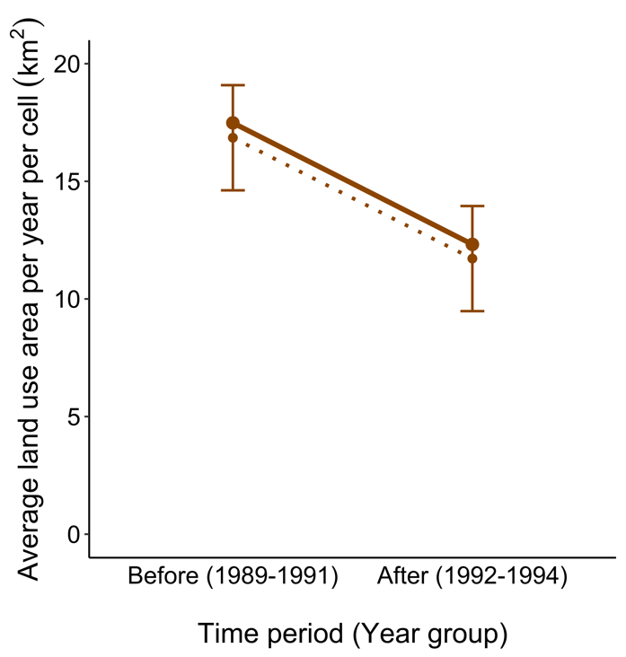

**Table 3.1** – Significant LMM ran between time period and abandoned land area.

**Figure 3.1 –** Effect size graph for abandoned land cover change following SUC. Dashed line represents effect size and error bar shows error around effect size, as determined by the model. Solid line represents actual data.

I found no significant relationship between time period and both intensive and extensive land (Appendix), implying an acceptance of the null hypothesis (H10).

**3.1.2 European Union Accession**

Within three years following EUA, abandoned land cover significantly decreased (Table 3.2; Figure 3.1a), causing an acceptance of H1e. Intensive land cover significantly increased within three years following EUA (Table 3.2; Figure 3.2b), allowing acceptance of H1d. The time period predictor explained little variation in both land use models, with a slight increase when grid was introduced as a random effect (Table 3.2).

**a.**

**b.**

**Figure 3.2 –** Effect size graph for (a) abandoned land cover change and (b) Intensive land cover change following EUA. Dashed line represents effect size and error bar shows error around effect size, as determined by the model. Solid line represents actual data. Scale of y-axis different for effective visualisation – two graphs should not be compared directly.

**Table 3.2** – Two significant LMMs ran for the relationship between time period and two land use types.

|  |  |  |  |  |  |  |  |  |  |
| --- | --- | --- | --- | --- | --- | --- | --- | --- | --- |
| **Land use** | **Estimate** | | **± SE of estimate** | **t-value** | | ***p*-value** | | **R2M** | **R2C** |
| **Abandoned** | -2.61 | 1.20 | | | -2.12 | | 0.03 | 0.01 | 0.10 |
| **Intensive** | 6179.11 | 1942.18 | | | 3.18 | | <0.01 | 0.04 | 0.09 |

There was no significant relationship between time period and extensive LUC (Appendix). This implies an acceptance of H10 for extensive land, indicating that extensive LUC is not visible directly following either SPE event.

**3.1.3 Other potential predictors of land use change: location**

When data is not aggregated, cell can be included as a nested random effect, which provides finer scale data. In all cases, this increased total model fit (R2C) and significance (decreased *p*-value) as compared to the models solely including the larger grid as a random effect (Appendix). However, the variation explained by the fixed, time period, effect (R2M) was only increased for the extensive LUC LMM for the EUA time period (Appendix). Assumptions were not met for models including cell as a random effect, with no transformation helping to mitigate normality and homoscedasticity issues. Results still may indicate the importance of location in determining LUC and LUC visibility (Figure 3.3a & Figure 3.3b).

**a.**

**b.**

**Figure 3.3 –** Figure depicting average abandoned land area per year per cell (a) aggregated by grid and (b) shown for all cells increasing in abandoned land cover. Scale of y-axis different for effective visualisation – two graphs should not be compared directly. Raw data solely for visualisation purposes.

**3.2 Land use transition visibility within three years following SPE events**

**3.2.1 Soviet Union Collapse**

|  |  |  |  |
| --- | --- | --- | --- |
| **Estimate** | | **± SE of estimate** |  |
| -3.02 | 0.70 | | |
| **t-value** | ***p*-value** | | |
| -3.76 | <0.001 | | |
| **R2M** | **R2C** | | |
| 0.04 | 0.24 | | |

Within three years following SUC, the amount of intensive land transitioning to abandoned land significantly decreased (Table 3.3; Figure 3.4). A negative relationship for this transition causes a rejection of H2a. Again, the fixed effect explains a very small proportion of variation in the data, with model fit considerably improved when considering grid as a random effect (Table 3.3).

**Table 3.3** – Significant LMM ran between time period and transition to abandoned land.

**Figure 3.4** – Effect size graph for transition from intensive to abandoned land abandoned following SUC. Dashed line represents effect size and error bar shows error around effect size, as determined by the model. Solid line represents actual data.

I found no significant relationship between SUC and the transition from intensive to extensive land (Appendix), causing null hypothesis acceptance (H20).

**3.2.2 EUA**

For both transitions to intensive land from extensive and abandoned land, no significant relationship was found (Appendix). By accepting the null hypothesis (H20), it is implied that neither transition is visible directly following EUA.

**3.3 Time lag on land use change visibility following SPE events**

**3.3.1 Soviet Union Collapse**

When examining the influence of a time lag following SUC on LUC and transitions, all LUC and transitions were significant (Table 3.4).

For abandoned land, land cover significantly decreased, with a steeper slope than that seen directly following SUC (Table 3.1 & 3.4), causing a rejection of H3b. For this model, a greater proportion of the data’s variation is explained by the fixed effect (R2M = 14%). By moving the time window, extensive land use has a weakly negative, significant relationship with time period, with the fixed effect being the sole explainer of variation in the model (Table 3.4), thus H3c is rejected. Intensive land use change also becomes significant, with a strong negative relationship indicating a loss of intensive land (Table 3.4), causing a rejection of H3a due to the strength of the relationship. A slightly weaker relationship is seen for the transition from intensive to abandoned land, as compared to the change observed directly following SUC (Table 3.3 & 3.4), causing H3e to be accepted. The transition to extensive from intensive land becomes significant with this new time window as a predictor (Table 3.4). A very weak relationship is seen, with slight less transitioning to extensive land following SUC. H3j is thus rejected due to the strength of the relationship.

**Table 3.4** – Significant LMMs ran for the new time period.

|  |  |  |  |  |  |  |  |  |  |
| --- | --- | --- | --- | --- | --- | --- | --- | --- | --- |
| **Land use/transition** | **Estimate** | | **± SE of estimate** | **t-value** | | ***p*-value** | | **R2M** | **R2C** |
| **Abandoned** | -7.41 | 1.08 | | | -6.90 | | <0.0001 | 0.14 | 0.27 |
| **Extensive** | -0.60 | 0.11 | | | -5.75 | | <0.0001 | 0.11 | 0.11 |
| **Intensive** | -4910.30 | 2416.93 | | | -2.03 | | 0.04 | 0.01 | 0.09 |
| **I 🡪 A** | -2.09 | 0.84 | | | -2.50 | | 0.01 | 0.04 | 0.24 |
| **I 🡪 E** | -0.13 | 0.03 | | | -3.70 | | <0.001 | 0.06 | 0.10 |

**3.3.2 European Union Accession**

When testing the influence of a time lag following EUA on LUC and transitions, time lag was a significant predictor for intensive LUC only. A steep positive relationship indicates a strong move towards intensive land use following EUA (Table 3.5). The slope (estimate) of this relationship is weaker than that seen directly following EUA (Table 3.2), causing H3h to be accepted.

**Table 3.5** – Significant LMM ran for the new time period on intensive land.

|  |  |  |  |  |  |  |  |  |  |
| --- | --- | --- | --- | --- | --- | --- | --- | --- | --- |
| **Land use** | **Estimate** | | **± SE of estimate** | **t-value** | | ***p*-value** | | **R2M** | **R2C** |
| **Intensive** | 4522.85 | 1904.92 | | | 2.37 | | 0.02 | 0.02 | 0.10 |

**3.4 Determining breakpoints**

For both the LUC and transitions, breakpoints did not line up with the two SPE events. Intensive land was the only land use type to have one breakpoint point precisely match an SPE event: EUA (Figure 3.5a). Abandoned land experienced two breakpoints directly following SUC: one signifying a sharp decrease in land cover, trailed by a sharp increase (Figure 3.5b). Extensive land experienced a breakpoint four year following SUC and three years following EUA (Figure 3.5c).

1. **b. c.**

**Figure 3.5** – Breakpoint graphs for (a) intensive land, (b) abandoned land and (c) extensive land. Coloured line shows total land use area per year. Dotted line represents the two SPE events (SUC and EUA). Dashed line indicates where model fit two breakpoints. Solid black line represents segmented regression as fit by model.

Transitions between both extensive and abandoned land to intensive land, and the reverse, followed roughly the same trajectory observed by the land use type transitioning into (Appendix).

**4. Discussion**

**4.1 Key findings**

**4.2 Is intensive, extensive and abandoned land use change visible within the three years following socio-politico-economic events?**

**4.2.1 Soviet Union Collapse**

My results demonstrate that out of intensive, extensive and abandoned LUC, only abandoned LUC is visible within three years of SUC. Rapid abandoned LUC is well documented in literature, with many citing dramatic levels of agricultural abandonment (Alexander V Prishchepov *et al.*, 2012; Vanwambeke *et al.*, 2012) directly following SUC (Bell *et al.*, 2009). An increase in agricultural abandonment is not supported by my results, where it was shown that abandoned land coverage decreased in the three years following SUC, as compared to the three years prior. Findings by Prischepov *et al.* (2012) suggest that agricultural abandonment reached its peak around the year 2000, with a sharp increase from 1990-1996, while Vanwambeke *et al.* (2012) state that this shift occurred prior to SUC, between 1988-1992. The lack of agreement on the timing of a move to agricultural abandonment implies an absence of a clear signature on Latvia’s landscape.

Agricultural abandonment is said to increase following SUC due to the collapse of the collective farming system (Ruskule *et al.*, 2012; Gradinaru *et al.*, 2015) and the breakup of larger farmers into smaller areas to restitute land to previous owners (Nikodemus *et al.*, 2005; Alexander V Prishchepov *et al.*, 2012; Fonji and Taff, 2014). Previous owners had limited interest to uptake farming practices on this newfound land. As land reform was not complete until roughly 2002, the transfer of land to individuals more suited to farming was prevented (Alexander V Prishchepov *et al.*, 2012).The slow transfer of land may explain why agricultural abandonment was not seen directly following SUC in my classification, with the potential for increase following this three year study period. Although it is not completely improbable that my results introduce a new pattern, it is likely that agricultural abandonment decrease is observed due to another factor.

Prishchepov *et al.* (2012b) uncovered the importance of imagery when determining areas of abandoned land, with the number of image dates used cited as the largest accuracy determiner. Specifically, the Landsat record was noted for such limited image-date availability, restricting the detection accuracy of agricultural land abandonment. Thus, my classification may have been more sensitive to agricultural land abandonment in the years following this three-year window. Additionally, as my training points were from 2012, it is likely that these points represented areas that had been abandoned for a long period of time, as most land abandonment occurred before 2000 (Vanwambeke *et al.*, 2012). Newly abandoned points may have a different spectral signature than long standing abandoned points (Lugo and Helmer, 2004; Ruskule *et al.*, 2012), causing an underestimation following SUC.

Intensive and extensive LUC were not found to be visible within three years of SUC. Intensive land was predicted to decrease following SUC, in line with the large scale abandonment noted and the collapse of the collective farming system (Nikodemus *et al.*, 2005; Alexander V Prishchepov *et al.*, 2012). It is not surprising that extensively farmed land did not statistically increase or decrease directly following SUC due to the slow returning of previously intensively used land. It is predicted that, upon completion of land reform, extensive land coverage would be significantly larger Latvia-wide as subsistence farming acts to replace Soviet collective farms (Vanwambeke *et al.*, 2012). It is likely that a time lag would better explain intensive and extensive LUC.

**4.2.2 European Union Accession**

My results suggest that within the three years following EUA, abandoned land decreased and intensive land cover increased. Intensive land use increase is well cited following EUA, as support schemes provided by the EU promoted agricultural restoration (Vanwambeke *et al.*, 2012). Directly following EUA, over 50% of agricultural land was cropped with the support of single area payments (SAPs) (Nikodemus *et al.*, 2010). SAPs are given at a fixed rate per hectare for maintained agricultural land. SAPs tend to encourage large, intensive fields, potentially causing the increase in intensive, homogeneous agriculture seen (Nikodemus *et al.*, 2010; Fonji and Taff, 2014). Csaki and Jambor (2010) found an 8% increase in large farms directly following EUA. Land reclamation was more common in areas that were previously intensively used, potentially having a part to play in the increase of intensively used land (Vanwambeke *et al.*, 2012). Following EUA, land salvation rates surpassed land abandonment, explaining the decrease in land abandonment (Vanwambeke *et al.*, 2012).

Following EUA, abandoned land is known to have decreased, owing to the rapid colonisation of woody species and transition into young forests (Nikodemus *et al.*, 2010; Ruskule *et al.*, 2012; Vanwambeke *et al.*, 2012). A transition to forest is not always even and can be delayed by a herbaceous vegetation for up to twenty years (Ruskule *et al.*, 2012), giving rise to a variety of landscapes following abandonment. Additionally, support schemes have also been successful in decreasing the level of agricultural abandonment seen (Abolina and Luzadis, 2015), owing to the attractiveness of land uptake as a source of income from EU payment schemes (Griffiths *et al.*, 2013). It is not unlikely that, following this three year period, abandoned land will increase again ascribed to outmigration from rural areas to cities (Fonji and Taff, 2014).

Extensive land use was not found to be significantly related to EUA. I predicted a weakly negative relationship, owing to the increase of intensive land. However, it is likely that an increase is also possible. SAPs supported farmers regardless of their level of production (Nikodemus *et al.*, 2010), aiming to promote diverse and traditional mosaic landscapes (Vanwambeke *et al.*, 2012). However, the increase in disparity between forests and agricultural area does not correspond to such mosaic landscapes, and instead, deters from small, extensive farms (Vanwambeke *et al.*, 2012). The strength of increasing agricultural production through intensive farms may annul the effects of traditional landscape promotion, thus causing no significant increase or decrease in extensive land cover.

**4.2.3 Other potential predictors of land use change: location**

It is not surprising that specific location characteristics can have a large stake in determining LUC and explaining LUC variation. Case studies examining north-eastern (Fonji and Taff, 2014) and central Latvia (Nikodemus *et al.*, 2005; Vanwambeke *et al.*, 2012) have shed light into the potential differences between regions. Most notably, the effect of varying environmental characteristics such as soil structure and altitude on the potential for agricultural success (Nikodemus *et al.*, 2010), as well as the varying cultural experiences of differing land use types (Bell *et al.*, 2009). Despite these clear differences, it is necessary to improve knowledge of the effects of large scale, continuous SPE change to discover patterns that can be applied across countries to help inform new land use policies (Alexander V Prishchepov *et al.*, 2012). As regional studies have been completed, I have focused my findings and discussion on a country scale, to help add to a discussion that is not yet refined.

**4.3 Do the strength and direction of land use transitions change within the three years following socio-politico-economic events?**

**4.3.1 Soviet Union Collapse**

My results indicate that there was a significant decrease in the amount of land transitioning from intensive agriculture to abandoned land directly following SUC. A decrease in this transition is emulated by the decline of abandoned land area explained in section 4.2.1. When coupled, it is evident that the interplay between abandoned and intensive land uses is significant: when abandoned land cover decreases, intensive land cover increases and visa versa. As described, I expected that the reverse would happen, with intensive land cover decreasing and abandoned land cover increasing. It is unlikely that intensive land cover would continue to increase, owing to the collapse of the intensive Soviet agricultural system (Fonji and Taff, 2014). It is probable that the transition between intensive to abandoned land will reverse in direction after this three-year period.

My results demonstrate the lack of a clear relationship between the transition from intensive to extensive land. On account of the slow reform where the once large, collective Soviet farms were divided and given to their previous land owners (Nikodemus *et al.*, 2005), it is plausible that a clear relationship is not evident within three years of SUC.

**4.3.2 European Union Accession**

The transition to intensive land from both abandoned and extensive land uses was not seen to significantly change directly following EUA. The lack of an increase of abandoned land transitioning to intensive agriculture may be attributed to the rapid succession of woody species on abandoned land (Nikodemus *et al.*, 2010; Vanwambeke *et al.*, 2012), rather than an uptake of abandoned land for new, intensive farms. Forests and tree cutting are an economic asset, owing to the speed at which income can be gained (Vanwambeke *et al.*, 2012). Following the EUA, forestry has gained size and professionalism and has become a large industry competitor to agriculture (Vanwambeke *et al.*, 2012). The importance of forestry to the Latvian economy and culture may be an indicator as to why land use did not always transition to intensive agriculture.

Abandoned land undergoing slow transition may also not be used for intensive agriculture, ascribed to the ability to gain EU SAPs for managing previously abandoned land (Nikodemus *et al.*, 2010). SAPs do not require land to be used for agricultural production, thus transitioning land may remain untouched with the aim of maintaining open landscapes. However, there is a higher uptake of SAPs on abandoned areas with better soils, most likely suggesting that the use of abandoned land for SAPs often occurs with the aim of reinstating agricultural practices (Nikodemus *et al.*, 2010). It is therefore likely that abandoned land was transitioning to intensive agriculture, but that this was not the overwhelmingly largest transition occurring. Instead, it is probable that the transition between abandoned land and forestry/forested areas is more significant.

The transition to intensive land from extensive land was not seen to be significantly different prior to EUA. The lack of a relationship may be attributed to the cultural significance of subsistence farming in Latvia. There is a strong divide between farmers that support EU payment schemes and those against them (Nikodemus *et al.*, 2010), which may shed light into the cultural importance of maintaining small-scale, subsistence farming without government aid. Without government assistance, many farmers do not have substantial income and thus, land abandonment may increase owing to subsistence farm failure. The interplay between intensive and extensive land here may not be as strong as I originally predicted. Instead, it is likely that extensive land has a stronger connection to abandoned land following EUA.

**4.4: Is there a time lag between socio-politico-economic events and the visibility of land use change and transitions?**

**4.3.1 Soviet Union Collapse**

Within six years of SUC, all LUC and transitions were significantly different to pre-SUC conditions. The effect size of abandoned land cover decrease is stronger with time lag as a predictor of LUC, as compared to the years directly following SUC. A sharp decrease in abandoned land over this period is not well cited in literature, as previously mentioned. With the peak of abandoned land cover likely to be around 2000 (Alexander V Prishchepov *et al.*, 2012; Vanwambeke *et al.*, 2012), it is probable that my classification did not pick up the steady increase that many papers discuss. More likely, however, is that the spectral signature of abandoned land has changed within my complete time series. A change in spectral signature would indicate that training points at the end of my time series (2012) do not accurately characterise abandoned land in the 1990s, thus, underestimating the amount of abandoned land observed following SUC (Alexander V. Prishchepov *et al.*, 2012).

The effect size of intensive LUC is significantly stronger when taking a potential time lag into account. Furthermore, the direction of change shifts from positive to negative. A shift to a negative relationship most likely signifies a time lag between intensive land cover decrease. My results are supported by the slow land reformation process, where large, Soviet collective farms were redistributed to their previous owners. Land restitution began in 1990, but only in 1994 was the law adopted, with the deadline to submit restitution claims at the end of 1996 (Hartvigsen, n.d.). It is not unlikely that a move away from intensive land would not have been visible until completion of land restitution, thus explaining the time lag in this relationship.

A weak, negative relationship was observed for extensive LUC six years following SUC. Despite the significance of this relationship, the direction is likely to be arbitrary, due to the large amount of error relative to the effect size. Consequently, according to my results, it is likely that extensive agricultural area did not significantly change following SUC. A neutral relationship is in accordance with land use history, in terms of the battle between maintaining a traditional landscape and shifting towards profitable, intensive agriculture (Vanwambeke *et al.*, 2012).

Both transitions from intensive agriculture to abandoned and extensive land showed a negative relationship, indicating that more land transitioned before SUC than after. The transition to extensive land, again, is significant but the direction is not likely to be precise, due to the relatively flat slope and relatively large error around the slope. The transition to abandoned land is steeper, though still negative, going against my original prediction. The aspects at play when determining abandoned land cover in my classification, such as lack of precise training points, are likely having an impact on the strength and direction of this transition.

**4.3.2 European Union Accession**

My results indicated a significant time lag effect for solely intensive LUC. All other LUC and transitions did not have an evident relationship. However, the strength of this relationship is less than that directly following EUA, indicating that perhaps, instead of there being a lag on the effects of the SPE, the main impact happened directly following EUA. Thus, the relationship has weakened and the move to intensive agriculture is less strong. Logically, farmers willing to accept and adopt the potential benefits of EU payments would have directly following EUA to aid in their income: 67% of farms produced no output for sale previous to EUA (Nikodemus *et al.*, 2010). Those wishing to stick to traditional farming are unlikely to be swayed by potential economic benefits, owing to the ingraining of small-scale agriculture in Latvian culture and landscape (Nikodemus *et al.*, 2005). It is likely that the other LUC and transitions either reached turning point directly following EUA (abandoned land), while others may hit a breakpoint after this six year lag, an idea that will be explored in the next section.

**4.3.3 Breakpoints**

**4.5 Future research**

**4.6 Limitations**

**5. Conclusion**

**6. References**

Abolina, E. & Luzadis, V.A. (2015) ‘Abandoned agricultural land and its potential for short rotation woody crops in Latvia’, *Land Use Policy*, 49, 435–445.

Albalate, A. & Minker, W. (2013) *Semi-Supervised and Unsupervised Machine Learning: Novel Strategies*, Hoboken, NJ, USA: John Wiley & Sons, Inc.

Alexandridis, T.K., Cherif, I., Kalogeropoulos, C., Monachou, S., Eskridge, K. & Silleos, N. (2013) ‘Rapid error assessment for quantitative estimations from Landsat 7 gap-filled images’, *Remote Sensing Letters*, 4, 920–928.

Arika, E. & Mazure, G. (2017) ‘Problems and Solutions for Abandonment of Utilised Agricultural Areas in Latvia’, *Economic Science for Rural Development*, 307–314.

Arnau, J., Bendayan, R., Blanca, M.J. & Bono, R. (2013) ‘The effect of skewness and kurtosis on the robustness of linear mixed models’, *Behavior Research Methods*, 45, 873–879.

Bates, D., Mächler, M., Bolker, B.M. & Walker, S.C. (2015) ‘Fitting Linear Mixed-Effects Models Using lme4’, *Journal of Statistical Software*, 67, 1–48.

Bell, S., Peneze, Z., Nikodemus, O. & Kruze, I. (2009) ‘Management of Cultural Landscapes: What Does this Mean in the Former Soviet Union? A Case Study from Latvia’, *Landscape Research*, 34, 425–455.

Csaki, C. & Jambor, A. (2010) ‘Five Years of Accession: Impacts on Agriculture in the NMS Les cinq années suivant l’adhésion: incidences sur l’agriculture des pays non membres Fünf Jahre Mitgliedschaft: Auswirkungen auf die Landwirtschaft in den neuen Mitgliedsstaaten’, *EuroChoices*, 9, 10–17.

Dougherty, G. (2013) *Pattern recognition and classification: an introduction*, New York: Springer.

Eurostat, E.C. (2013) ‘LUCAS 2012 (Land Use / Cover Area Frame Survey)Technical Reference Document: C-3 Land use and Land Cover Classification (revised)’.

Fonji, S. & Taff, G.N. (2014) ‘Using satellite data to monitor land-use land-cover change in North-eastern Latvia’, *SpringerPlus*, 3, 61.

Gislason, P.O., Benediktsson, J.A. & Sveinsson, J.R. (2006) ‘Random Forests for land cover classification’, *Pattern Recognition Letters*, 27, 294–300.

Gordon, A.D. (1999) *Classification*. 2nd ed., Chapman & Hall/CRC (Monographs on statistics and applied probability, 82).

Gorelick, N., Hancher, M., Ilyushchenko, S., Thau, D. & Moore, R. (2017) ‘Google Earth Engine: Planetary-scale geospatial analysis for everyone’, *Remote Sensing of Environment*, 202, 18–27.

Gradinaru, S.R., Ioja, C.I., Onose, D.A., Gavrilidis, A.A., Patru-Stupariu, I., Kienast, F. & Hersperger, A.M. (2015) ‘Land abandonment as a precursor of built-up development at the sprawling periphery of former socialist cities’, *Ecological Indicators*, 57, 305–313.

Griffiths, P., Müller, D., Kuemmerle, T. & Hostert, P. (2013) ‘Agricultural land change in the Carpathian ecoregion after the breakdown of socialism and expansion of the European Union’, *Environmental Research Letters*, 8, 045024.

Hartvigsen, M. (n.d.) ‘Land reform in Central and Eastern Europe after 1989 and its outcome in the form of farm structures and land fragmentation’, 61.

Horning, N. (2010) ‘Random Forests : An algorithm for image classification and generation of continuous fields data sets’, *International Conference on Geoinformatics for Spatial Infrastructure Development in Earth and Allied Sciences*.

Kuznetsova, A., Brockhoff, P.B. & Christensen, R.H.B. (2017) ‘**lmerTest** Package: Tests in Linear Mixed Effects Models’, *Journal of Statistical Software*, 82.

Lugo, A.E. & Helmer, E. (2004) ‘Emerging forests on abandoned land: Puerto Rico’s new forests’, *Forest Ecology and Management*, 190, 145–161.

Millard, K. & Richardson, M. (2015) ‘On the Importance of Training Data Sample Selection in Random Forest Image Classification: A Case Study in Peatland Ecosystem Mapping’, *Remote Sensing*, 8489–8515.

Muggeo, V.M.R. (2017) *Regression Models with Break-Points/Change-Points Estimation*.

Murayama, Y. & Thapa, R.B. (eds) (2011) *Spatial Analysis and Modeling in Geographical Transformation Process*, Dordrecht: Springer Netherlands (GeoJournal Library).

Nakagawa, S. & Schielzeth, H. (2013) ‘A general and simple method for obtaining R2 from generalized linear mixed-effects models’, *Methods in Ecology and Evolution*, 4, 133–142.

Nikodemus, O., Bell, S., Grı̄ne, I. & Liepiņš, I. (2005) ‘The impact of economic, social and political factors on the landscape structure of the Vidzeme Uplands in Latvia’, *Landscape and Urban Planning*, 70, 57–67.

Nikodemus, O., Bell, S., Penēze, Z. & Imants Krūze (2010) ‘The Influence of European Union Single Area Payments and Less Favoured Area Payments on the Latvian Landscape’, *European Countryside*, 1, 25–41.

Nomura, K. & Mitchard, E. (2018) ‘More Than Meets the Eye: Using Sentinel-2 to Map Small Plantations in Complex Forest Landscapes’, *Remote Sensing*, 10, 1693.

Pimple, U., Simonetti, D., Sitthi, A., Pungkul, S., Leadprathom, K., Skupek, H., Som-ard, J., Gond, V. & Towprayoon, S. (2018) ‘Google Earth Engine Based Three Decadal Landsat Imagery Analysis for Mapping of Mangrove Forests and Its Surroundings in the Trat Province of Thailand’, *Journal of Computer and Communications*, 06, 247–264.

Prieditis, N. (1993) ‘Black alder swamps on forested peatlands in Latvia’, *Folia Geobotanica et Phytotaxonomica*, 28, 261–277.

Prishchepov, Alexander V, Radeloff, V.C., Baumann, M., Kuemmerle, T. & Müller, D. (2012) ‘Effects of institutional changes on land use: agricultural land abandonment during the transition from state-command to market-driven economies in post-Soviet Eastern Europe’, *Environmental Research Letters*, 7, 024021.

Prishchepov, Alexander V., Radeloff, V.C., Dubinin, M. & Alcantara, C. (2012) ‘The effect of Landsat ETM/ETM+ image acquisition dates on the detection of agricultural land abandonment in Eastern Europe’, *Remote Sensing of Environment*, 126, 195–209.

R Core Team (2019) *R: A language and environment for statistical computing*, Vienna (R Foundation for Statistical Computing).

Ruskule, A., Nikodemus, O., Kasparinska, Z., Kasparinskis, R. & Brūmelis, G. (2012) ‘Patterns of afforestation on abandoned agriculture land in Latvia’, *Agroforestry Systems*, 85, 215–231.

Sader, S.A., Ahl, D. & Liou, W.-S. (1995) ‘Accuracy of Landsat-TM and GIS Rule-Based Methods for Forest Wetland Classification in Maine’, *Remote Sensing of Environment*, 53, 133–144.

Sidhu, N., Pebesma, E. & Câmara, G. (2018) ‘Using Google Earth Engine to detect land cover change: Singapore as a use case’, *European Journal of Remote Sensing*, 51, 486–500.

Skribane, I. & Jekabsone, S. (2013) ‘Structural Changes in the Economy of Latvia after it Joined the European Union’, *Intellectual Economics*, 7, 29–41.

Strobl, C., Malley, J. & Tutz, G. (2009) ‘An Introduction to Recursive Partitioning: Rationale, Application and Characteristics of Classification and Regression Trees, Bagging and Random Forests’, *Psychological methods*, 14, 323–348.

Suthaharan, S. (2016) *Machine Learning Models and Algorithms for Big Data Classification: Thinking with Examples for Effective Learning*, (Integrated Series in Information Systems).

Toms, J.D. & Villard, M.A. (2015) ‘Threshold detection: matching statistical methodology to ecological questions and conservation planning objectives’, *Avian Conservation & Ecology*, 10.

Vanwambeke, S.O., Meyfroidt, P. & Nikodemus, O. (2012) ‘From USSR to EU: 20 years of rural landscape changes in Vidzeme, Latvia’, *Landscape and Urban Planning*, 105, 241–249.

Verbyla, D.L. & Litvaitis, J.A. (1989) ‘Resampling methods for evaluating classification accuracy of wildlife habitat models’, *Environmental Management*, 13, 783–787.

Veveris, A. & Kalis, I. (2016) ‘The Impact of EU Agricultural Policy on the Competitiveness of the Farms in Latvia’, *Economics and Mangement*, 16, 452–458.

Wulder, M.A., Skakun, R.S., Dymond, C.C., Kurz, W.A. & White, J.C. (2005) ‘Characterization of the diminishing accuracy in detecting forest insect damage over time’, *Canadian Journal of Remote Sensing*, 31, 421–431.

Zanter, K. (2018) ‘Landsat 4-7 Surface Reflectance (LEDAPS) Product Guide’, US Geological Survey.

Zdanovskis, K. & Pilvere, I. (2015) ‘Agricultural Development after Joining the European Union’, *Research for Rural Development*, 2, 161–168.

Zhu, W. (2012) ‘Sadly, the earth is still round (p < 0.05)’, *Journal of Sport and Health Science*, 1, 9–11.