**Words Can be Things**

*IFC Instruction Manual - Communicator A*

READ THIS BEFORE STARTING THE GAME

**Foreword:**

Hello, Agent. You are fortunately not the infiltrator from ‘Joker P’. Below is your half of the solutions to each level. Best of luck, Agent.

***Hangman:*** Attached is your half of letters for each word. Work with **Communicator B** to spell out the complete word.

* Word A:

A _ S _ R _ _ T _

* Word C:

C _ N _ _ I _ E

* Word D:

D E _ _ P _ _ R

* Word I:

I _ F _ _ M _ T _ _ _

* Word M:

M _ _ T _ _ E

* Word P:

P _ R _ _ O _ D

***Cipher:*** Attached is a complete graph of the cipher for each letter of alphabetical shift values 2, 3, 4, and 5. Work with **Communicator B** to determine the shift values of each letter to decipher the word.

|  |  |  |  |  |
| --- | --- | --- | --- | --- |
| **Base Letter** | **Shift 2** | **Shift 3** | **Shift 4** | **Shift 5** |
| **A** | C | D | E | F |
| **B** | D | E | F | G |
| **C** | E | F | G | H |
| **D** | F | G | H | I |
| **E** | G | H | I | J |
| **F** | H | I | J | K |
| **G** | I | J | K | L |
| **H** | J | K | L | M |
| **I** | K | L | M | N |
| **J** | L | M | N | O |
| **K** | M | N | O | P |
| **L** | N | O | P | Q |
| **M** | O | P | Q | R |
| **N** | P | Q | R | S |
| **O** | Q | R | S | T |
| **P** | R | S | T | U |
| **Q** | S | T | U | V |
| **R** | T | U | V | W |
| **S** | U | V | W | X |
| **T** | V | W | X | Y |
| **U** | W | X | Y | Z |
| **V** | X | Y | Z | A |
| **W** | Y | Z | A | B |
| **X** | Z | A | B | C |
| **Y** | A | B | C | D |
| **Z** | B | C | D | E |

***Maze:*** Attached are the maps of the starting position and the ending position of each maze. Work with **Communicator B** to figure out the correct path through each Maze.

* Maze Sequence 1 (code sequence B701):

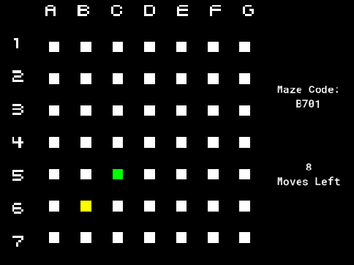

* Maze Sequence 2 (code sequence F32M):

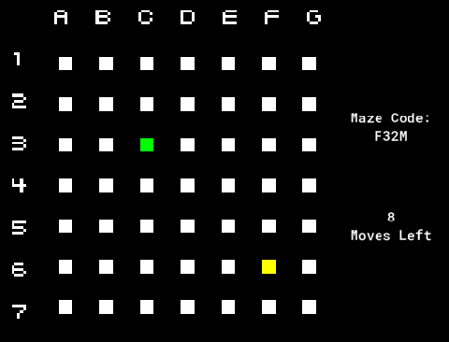

* Maze Sequence 3 (code sequence GBV5):

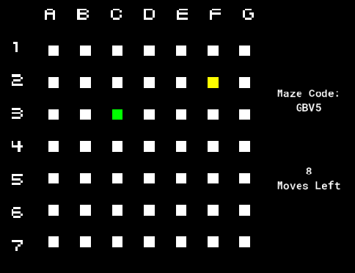

***Wires:*** Attached is the orientation for the **red** wire for each Wire Level. Work with the other players to find the complete orientation.

* Level 1: Node A
* Level 2: Node C
* Level 3: Node C
* Level 4: Node A
* Level 5: Node B
* Level 6: Node B