**Words Can be Things**

*IFC Instruction Manual - General*

ALL PLAYERS MUST READ THIS BEFORE STARTING THE GAME

**Foreword:**

Hello Agents of the IFC. You’ve all been summoned for a top priority mission. We’ve received an encrypted message from the online terrorist organization ‘Joker P’ that threatens to launch a massive cyberattack against our servers. Their conditions? Play their little game. We’ve decrypted what we could to help you through these trials, which are listed below.

**Setup:**

Finish reading through this document, then assign a player to be the **Active Player**. The other two players will then be **Communicator A and Communicator B**. Set up the device to face the **Active Player**. The Communicators should sit directly opposite of the Active Player so that they cannot see the screen but can actively discuss amongst the three players. Hand out the documents accordingly, and adjust the catcher speed if necessary, with higher values decreasing difficulty and lower values increasing difficulty. When ready, press ‘Space’ to begin.

**How to Play:**

The game has been limited to one device between 3 players. Unknowing of their methods, we can only comply with their requests.

The **Active Player** is responsible for manipulating the device and managing the input of the team. They are the only player who can see the screen but cannot see the solutions to the levels, and must convey the current state of the game to the **Communicators**, who cannot see the screen but are responsible for solving the puzzles. They must also solve smaller puzzles during gameplay.

The **Communicators** are responsible for solving the puzzles, but they cannot see the screen or each other’s documents. They are each provided with a document of half-solutions to every level, which they must communicate with the other communicator to piece together the complete answer. They must rely on the information conveyed from the Active Player to determine the current level and thus piece together a solution.

**Levels:**

There are 3 types of main levels for the game: *Hangman*, *Cipher*, and the *Maze*, along with a *Wires* mini level. Below are the rules for each.

* ***Hangman****:* A number of blanks will appear on the screen, with the first letter filled out. The **Active Player** must tell the **Communicators** the leading letter, which corresponds to different answers according to the letter shown. The **Communicators** will each have different letters that follow the leading letter in their half of the solution, which they must combine to find the complete word. There will be missing letters to the final solution, which the players must fill in themselves. Below is an example of what each player might see for a Hangman level with the solution “Hangman”
  + Active Player: H _ _ _ _ _ _
  + Communicator A: H A _ G _ A _
  + Communicator B: H _ N _ M _ _
* ***Cipher***: A number of blanks will appear on the screen, with a series of letters shown above. The **Active Player** must convey the letters to **Communicator B**, who has a graph for the shift value of each letter. Each letter has a shift value that is representative of the number of times it is alphabetical shifts it must make. For example, if the letter ‘A’ has a shift value of 3, ‘A’ would be ‘D’ for the final answer. **Communicator A** has a complete graph of the appropriate shift values of each letter of the alphabet. Work together to decipher the solution through an alphabetical shift. Below is an example of what each player might see for a Cipher level with the solution “Cipher”.
  + Active Player: B H O G D Q

_ _ _ _ _ _

* + Communicator A: *refer to* ***Communicator A*** *sheet*
  + Communicator B: Shift 1: C E H I P R U V W X Y Z

Shift 2: A B D F G J K L M N O Q S T

* ***Maze***: A graph of nodes will appear on the screen along with a Maze Code. The yellow node is the **Active Player’s** current position. The red nodes that will appear tracks the **Active Player’s** movement throughout the maze. Through keys ‘W A S D’ and ‘Backspace’, the **Active Player** can traverse the maze. The maze can be solved in exactly 8 steps, and it must be in a specific order. The maze cannot overlap with itself. The **Active Player** must convey the Maze Code to the **Communicators**. **Communicator A** will see a yellow node representative of the starting position of the maze and a green node representative of the end position of the maze. **Communicator B** will see a series of moves that are part of the solution to solving the maze, with some missing moves. There is always only one correct solution for each level. Below is an example of what each player might see for a Maze level with the solution of Move 1: right, Move 2: up.
  + Active Player:

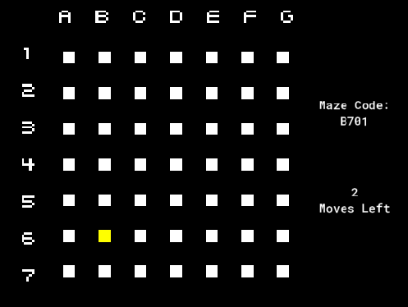

* + Communicator A:

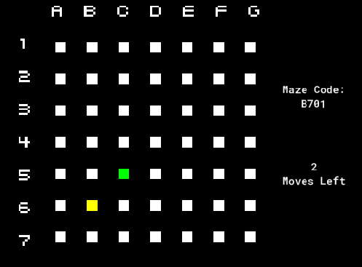

* + Communicator B:
    - Maze Code: B701
    - Move 1: right
    - Move 2: _____
* ***Wires***: When the timer is almost depleted, this mini level will show up. Three wires, red, green, and blue, will show up alongside three nodes labeled A, B, and C and a single number representative of the wire orientation. The Active Player must connect each wire to a node in a specific orientation. Communicator A knows the orientation for the red wire. Communicator B knows the orientation for the blue wire. Below is an example of what each player might see for a Wire level with the solution of Level 1, Node A: Red, Node B: Green, Node C: Blue.
  + Active Player:

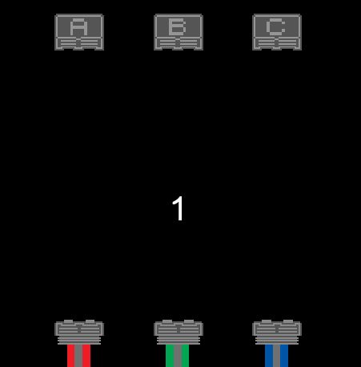

* + Communicator A: Level 1: Node A
  + Communicator B: Level 1: Node C

**End Notes:**

Communication is everything in the game. Always be sure to convey what information you have, since every player has access to information the other players don’t. Be clear and concise always, and try to stay patient even when running out of time.

Also, beware of misleads and one another. We may or may not have a member of ‘Joker P’ amongst ourselves.

Best of luck, Agents. The future of the IFC rests in your hands.