ECA5802 IOE and AI Driven Systems
Modelling and Simulation of a 4-Layer IoE Architecture (Perception–Network–Middleware–Application) using Node-RED, MQTT and a Cloud Dashboard

Objective:
To model and simulate a 4-layer IoE architecture consisting of the Perception, Network, Middleware and Application layers using MQTT and a Node-RED style processing flow, and to evaluate the per-layer latency, throughput and alert generation shown on a cloud dashboard.

Procedure :
- Start the Mosquitto MQTT broker and import NumPy, Matplotlib and paho-mqtt in Python.
- Perception layer: simulate N sensor nodes (N = 5, 20, 50, 100), each publishing temperature, humidity and motion readings to ioe/perception/<id>. Inject about 2 % faulty readings.
- Network layer: use the MQTT broker (publish/subscribe over TCP) to carry the sensor messages and record the transfer time of each message.
- Middleware layer: implement the Node-RED style flow as a subscriber that validates the value ranges, applies a 3-sample moving-average filter, applies the rule temperature > 35 °C to raise an alert, and republishes the result to ioe/app/telemetry.
- Application layer: subscribe to ioe/app/# as the cloud dashboard and record the processed temperature, humidity, motion events and alerts.
- Measure the network, middleware and application latency and the application-layer throughput for each value of N.
- Plot the dashboard views and the per-layer latency and throughput graphs.

Output
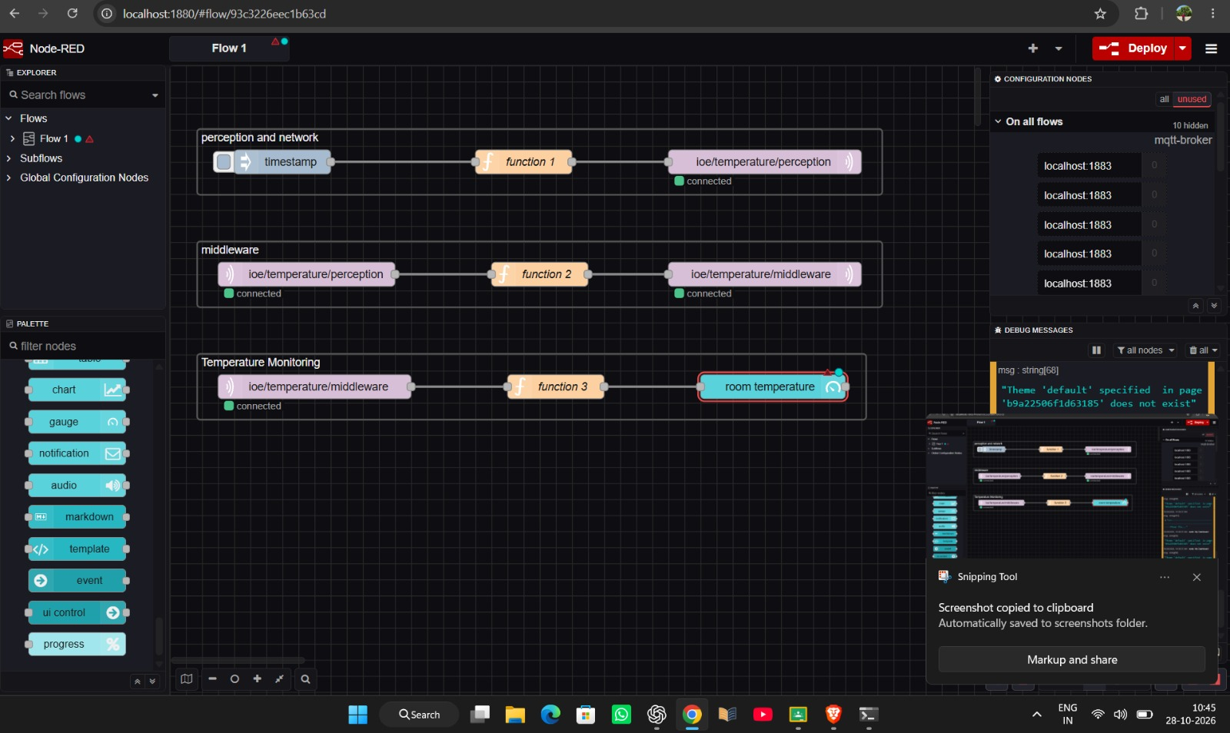
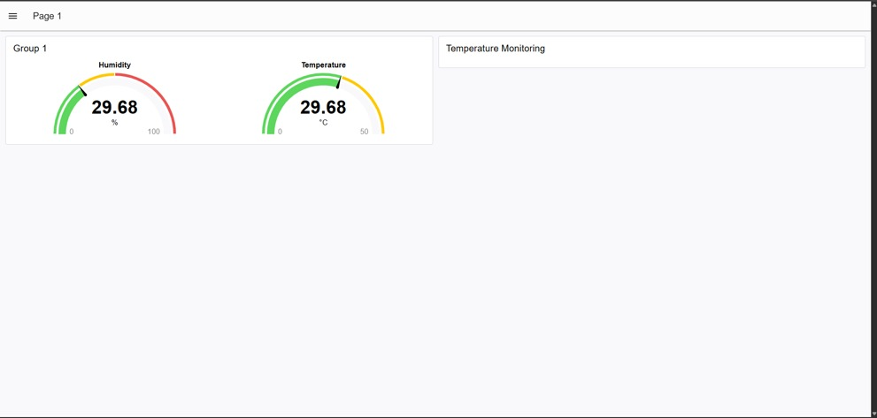

Result :
The 4-layer IoE architecture was simulated successfully. Sensor data from the Perception layer was carried by MQTT (Network layer), validated, filtered and checked against the alert rule in the Middleware layer, and displayed on the dashboard at the Application layer. Faulty readings were removed by the middleware (for example, 2000 messages were sent and 1963 reached the application for N = 100).
The end-to-end latency increased from 10.5 ms (N = 5) to 31.0 ms (N = 100), mainly because of the network (broker) layer, whereas the middleware processing time remained below 0.1 ms. The application-layer throughput increased up to about 5413 messages/s, and temperature alerts were generated when the filtered value crossed 35 °C.

