ECA5802 IOE and AI Driven Systems
Simulation and Performance Evaluation of RFID/NFC-Based Device Identification and IoE Data Integration using Node-RED, MQTT

Objective:
To simulate RFID/NFC-based device identification and evaluate its performance by analysing tag read rate with respect to distance, MQTT message delivery, identification accuracy and end-to-end latency when the tag data is integrated into an IoE application through an MQTT-based Node-RED style flow.

Procedure :
- Install and start the Mosquitto MQTT broker on port 1883, and import NumPy, Matplotlib and paho-mqtt in Python.
- Model the read probability of NFC tags (13.56 MHz, magnetic coupling, range of a few centimetres) and UHF RFID tags (866 MHz, free-space path loss with Rayleigh fading and a tag power-up threshold of -15 dBm).
- Generate N tags (N = 10, 50, 100, 200, 500), each with a unique UID, and place them at random distances from the reader. Register 95 % of the UIDs in the device registry; the remaining 5 % are unregistered.
- Let the reader publish every successful tag read (UID, tag type, CRC status, timestamp) to the MQTT topic ioe/rfid/raw (MQTT-in stage).
- Implement the Node-RED style flow as a subscriber: discard frames with a CRC error, look up the UID in the registry, add the device name, and publish to ioe/devices/identified or ioe/devices/unknown (function and MQTT-out stages).
- Subscribe to ioe/devices/# as the application/dashboard and record the identified devices, unknown tags and the end-to-end latency (reader to dashboard).
- Plot the read probability versus distance, read rate and MQTT delivery versus number of tags, latency, and identification counts, and compare the results.

Tabulation :
sno | Tags ID | Device id | Identified | Temperature | Latency (ms)
1 | RFID004 | DEV-RFID004 | True | 29.8 | 4
2 | RFID002 | DEV-RFID002 | True | 31.8 | 2
3 | RFID003 | DEV-RFID003 | True | 28.6 | 3
4 | RFID005 | DEV-RFID005 | True | 30.4 | 5
5 | RFID006 | DEV-RFID006 | True | 27 | 3

Output :
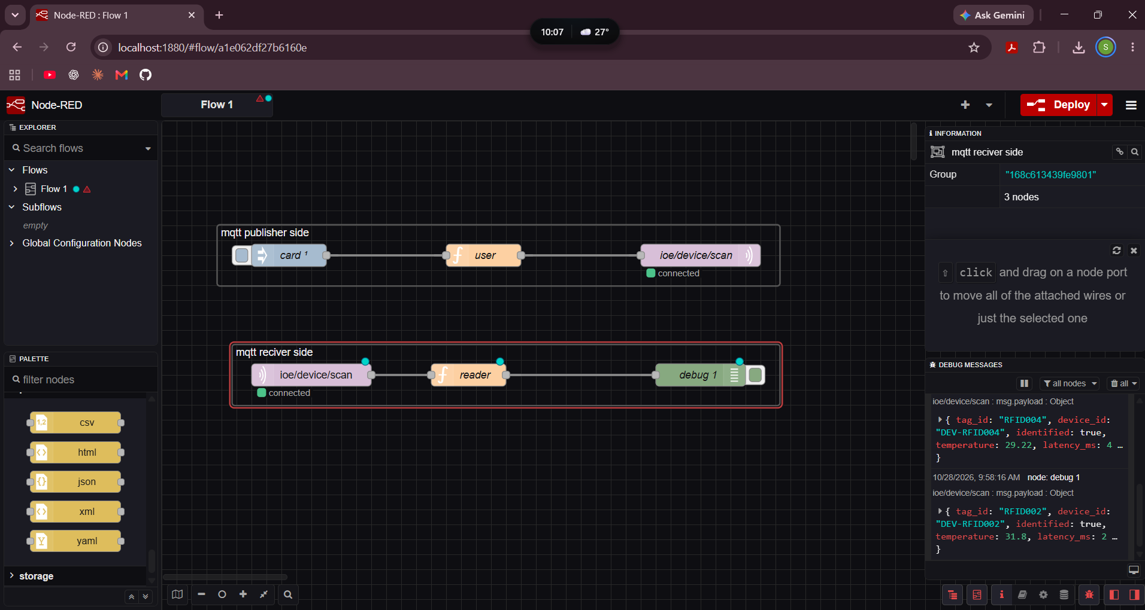
Result :
The RFID/NFC identification and MQTT-based integration pipeline was simulated for 10 to 500 tags. NFC tags are readable only within about 4 cm, while UHF RFID tags are readable over several metres but with decreasing probability near the edge of the field, so the overall read rate was between 70.0 % and 80.0 %.
Every tag read that was published reached the middleware (100 % MQTT delivery). Registered tags were forwarded as identified devices and unregistered tags were flagged as unknown, and corrupted (CRC-error) frames were discarded. The average reader-to-dashboard latency was between 28.5 ms and 55.0 ms, which is suitable for real-time IoE device identification.

