Phase-separation predictors systematically misread membrane proteins: a topology-resolved benchmark of eighteen tools
  - DRAFT — bullet outline for internal review
2026
Status: working draft (bullet form). Numbers are final and trace to output/results_digest.json; prose to be expanded at submission. Figures embedded inline.

Abstract (draft points)
- LLPS predictors are trained almost entirely on soluble proteins but are increasingly applied to membrane proteins, whose TM segments and constrained cytoplasmic domains violate their assumptions.
- We benchmarked 18 predictors against 60 human membrane proteins with curated experimental LLPS evidence, scoring against a same-class (membrane-vs-membrane) background to remove the trivial soluble-vs-membrane signal.
- Structure-aware models led: PSPHunter AUROC 0.80 (0.90 leakage-corrected); PSPire and PdPS ≈ 0.81. LLPhyScore, tuned on soluble IDRs, was at chance (0.49), even sign-flipped.
- Topology-resolved scoring: 7/8 position-aware tools score cytoplasmic regions > TM segments (all FDR < 0.05); SEG (low-complexity masker) is the lone reversal.
- Cross-predictor consensus tracks the soluble-IDR signature, not curated LLPS mechanism: it is dominated by hydrophobicity (ρ = −0.69, strongest correlate), rises with chain length (ρ = +0.56) and disorder (ρ = +0.33), and falls with TMD count (ρ = −0.41). Large single-pass receptors/RTKs with big disordered tails (EGFR, ERBB2, JPH2, CKAP4) rank high; compact, hydrophobic multi-pass transporters/channels and small tail-anchored proteins (MALL, NPY2R, MFSD1) — several with genuine LLPS evidence — are systematically under-ranked.
- Delineates a membrane-protein-specific failure mode — predictors reward the generic disorder/length signature and penalise membrane-embedded architecture irrespective of experimental mechanism; argues for topology-aware training and evaluation.

Introduction (draft points)
- LLPS organises the cell into membraneless compartments; curated databases (You et al. 2020; Li et al. 2020; Ning et al. 2020; Mészáros et al. 2020; Rostam et al. 2023) have enabled many sequence- and structure-based predictors.
- Predictor families span: prion-like / low-complexity composition (Lancaster et al. 2014; Wootton and Federhen 1993); π–π and cation–π interaction models (Vernon et al. 2018); disorder proxies (Walsh et al. 2012; Mészáros et al. 2018); physicochemical scores (Bolognesi et al. 2016); deep sequence models (Saar et al. 2021); and ML classifiers using AlphaFold features (Jumper et al. 2021; Pulido-Quetglas et al. 2024; Hou et al. 2024; Sun et al. 2024; Mierlo et al. 2021; Chen et al. 2022; Li et al. 2025).
- Problem: almost all trained/validated on soluble proteins. Membrane proteins (~25% of the proteome, majority of drug targets) are largely absent from training corpora yet routinely scored.
- Membrane proteins break predictor assumptions three ways:
  - TM segments are hydrophobic α-helices whose composition mimics the low-complexity regions some tools flag as LLPS-prone;
  - extra-membrane domains are split into cytoplasmic vs extracellular/lumenal faces with very different physicochemistry;
  - documented membrane LLPS (TCR/LAT clustering, Wnt signalosome, nephrin/NCK/N-WASP) is driven by cytoplasmic tails, not the membrane-embedded core.
- This study — 18 predictors × 60 curated membrane LLPS proteins, with three membrane-specific design choices:
  - same-class (membrane-vs-membrane) background;
  - protein-by-protein training-set leakage audit + leakage-corrected AUROC;
  - topology-resolved scoring (cytoplasmic / TM / extracellular-lumenal).

Results

1. Structure-aware models lead; a soluble-tuned biophysical model fails
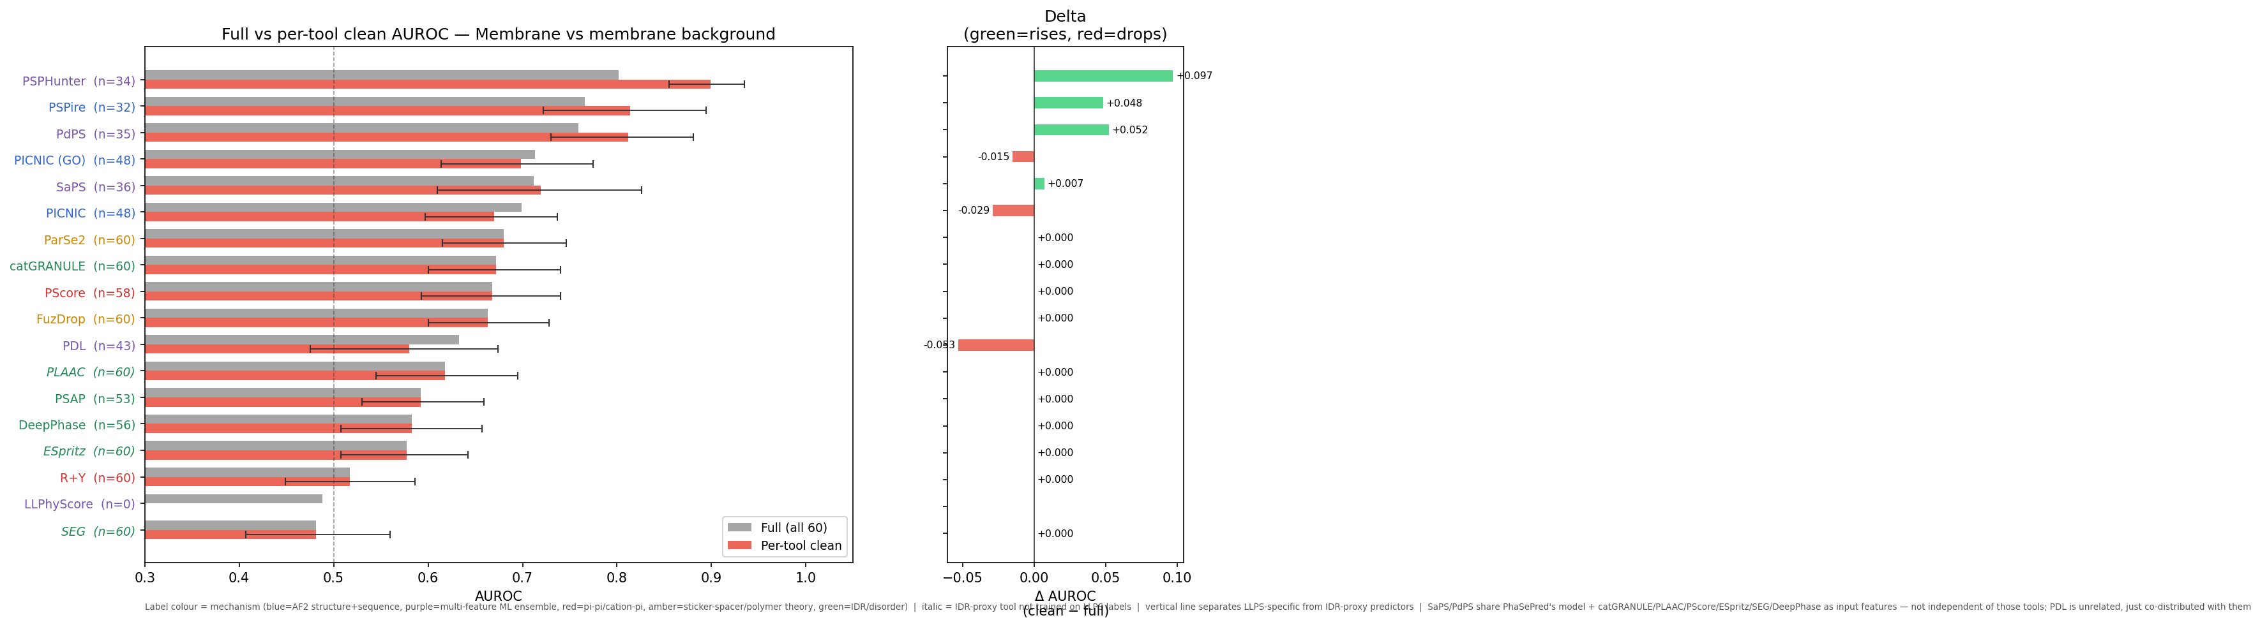
- Set: 60 human membrane proteins with curated LLPS evidence (56 PhaSepDB, rest LLPSDB); each scored by 18 predictors; discrimination = AUROC vs a background of other human membrane proteins.
- Top tier (structure-aware, AlphaFold features): PSPHunter 0.80, PSPire 0.77, PdPS 0.76 (Sun et al. 2024; Hou et al. 2024; Chen et al. 2022).
- Middle tier: PICNIC variants + SaPS, AUROC ≈ 0.70–0.71 (Pulido-Quetglas et al. 2024).
- Compositional / disorder proxies near 0.6: PLAAC 0.62, PSAP 0.59, DeePhase 0.58, ESpritz 0.58.
- At/below chance: R+Y 0.52, SEG 0.48, LLPhyScore 0.49. LLPhyScore is biophysically interpretable but tuned on soluble IDRs (Cai et al. 2022); retains no signal on membrane proteins even sign-flipped. → clearest evidence that soluble-IDR inductive biases do not transfer.
- Training-set leakage (Fig 1, right) — substantial and asymmetric:
  - 25/60 positives (42%) flagged for ≥1 predictor.
  - For the leaders, leaked proteins are mostly negatives in the background (PSPHunter 22 neg vs 4 pos; PdPS 23 vs 2).
  - Removing leaked proteins therefore raises the leaders: PSPHunter → 0.90 (95% CI 0.86–0.94), PSPire → 0.81, PdPS → 0.81.
  - PDL (leaked proteins all positives) drops 0.63 → 0.58.
  - Leakage-corrected values used throughout.

2. Predictor scores follow the membrane topology
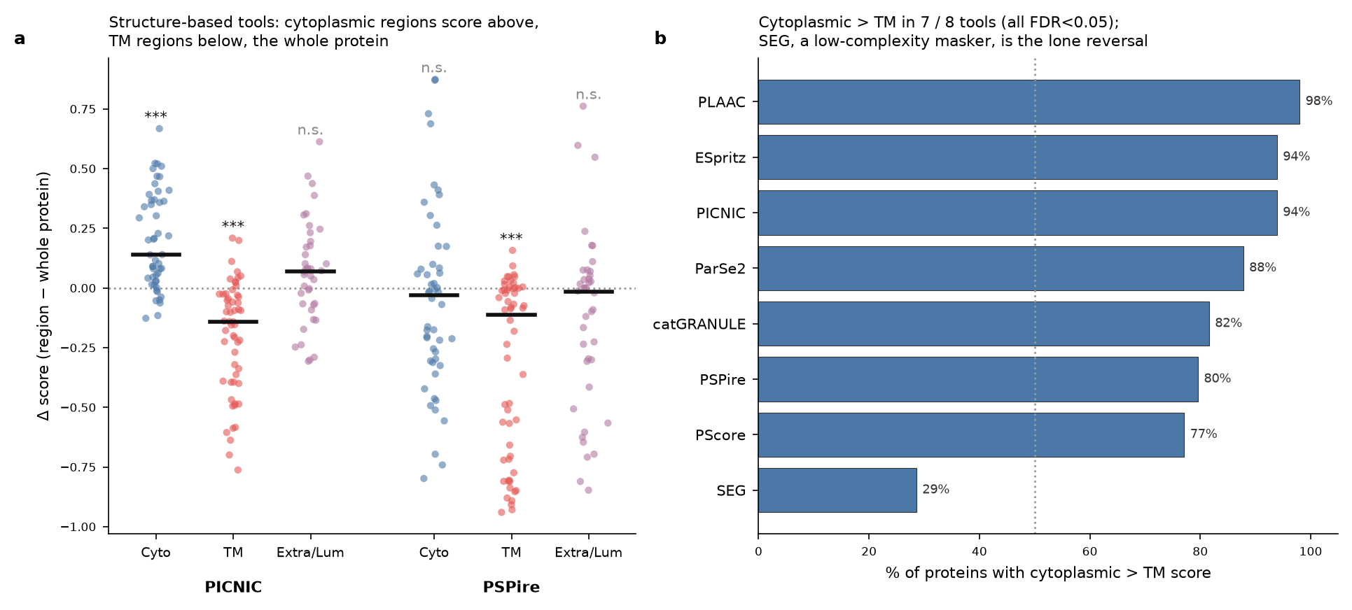
- Test: partition per-residue / per-region scores into cytoplasmic, TM, and extracellular/lumenal using UniProt topology; compare each region vs whole-protein score (paired Wilcoxon, BH-FDR).
- Structure tools on AlphaFold models:
  - PICNIC: cytoplasmic above whole (median Δ = +0.14, FDR < 10⁻⁷); TM below (Δ = −0.14, FDR < 10⁻⁷).
  - PSPire: same TM suppression (Δ = −0.11, FDR < 10⁻⁷).
- Cytoplasmic > TM in 7/8 position-aware tools (all FDR < 0.05, Fig 2b): PLAAC 98% of proteins, ESpritz 94%, PICNIC 94%, ParSe2 88%, catGRANULE 82%, PSPire 80%, PScore 77%.
- Largest median cyto−TM gap: PICNIC Δ = 0.47, PSPire Δ = 0.28.
- Lone reversal: SEG (low-complexity masker) — TM scored higher (29% cyto > TM; median Δ = −0.17, FDR < 10⁻³), as expected for a tool that flags hydrophobic α-helices.
- Read: given topology, the tools localise their signal to the cytoplasmic face — consistent with membrane-condensate biology — even when the whole-protein score is uninformative.

3. A cross-predictor consensus tracks the soluble-IDR signature, not mechanism
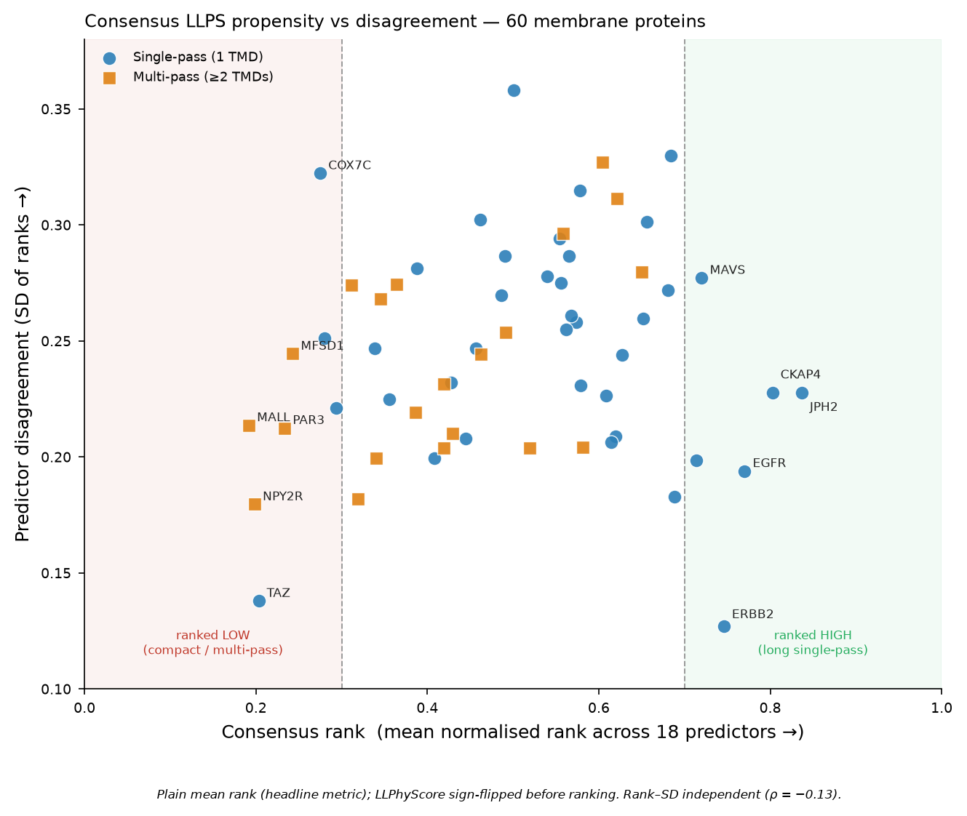
- Consensus = each tool’s per-protein rank (LLPhyScore sign-flipped), averaged across the 18 tools; reported as plain mean rank (headline) with the AUROC-weighted mean as a supplement (the two agree, ρ = 0.996, and give the same top/bottom proteins). Between-predictor SD gives a disagreement score.
- Governed by the classic soluble-IDR signature, not membrane biology:
  - Hydrophobicity is the single strongest correlate: whole-protein Kyte–Doolittle hydropathy ρ = −0.69 — more hydrophobic ⇒ ranked lower.
  - Chain length ρ = +0.56 — longer ⇒ higher; holds within single-pass proteins alone.
  - Disordered fraction ρ = +0.33; LCR fraction and net charge also positive.
  - TMD count ρ = −0.41 — more membrane passes ⇒ ranked lower.
  - Partial-correlation control confirms hydrophobicity, length and disorder are independent axes (each survives adjustment for the others), and the hydrophobicity effect holds within both topology classes — so “multi-pass lower” is not merely a length artifact.
- Consistently high: large single-pass receptors / RTKs with big disordered cytoplasmic tails — JPH2 (0.84), CKAP4 (0.80), EGFR (0.77), ERBB2 (0.75), MAVS (0.72), ALK (0.71), LRP6 (0.69), LAT (0.68), ERBB4 (0.65). These are the best-documented membrane LLPS drivers, and the tools rank them correctly.
- Consistently low: compact / hydrophobic proteins — MALL (4 TMD, 153 aa; 0.19), NPY2R (7-TM GPCR; 0.20), TAZ (0.20), PAR3 (7 TMD; 0.23), MFSD1 (12 TMD; 0.24), COX7C (63 aa; 0.28), SC6A4 (12 TMD; 0.32). Several (MFSD1, PAR3, the multi-pass transporters) carry genuine curated LLPS evidence yet fall to the bottom.
- Why the split (the “large exposed regions” intuition, confirmed): the high-ranked single-pass receptors carry long, disordered cytoplasmic tails that match exactly what soluble-IDR predictors learned; the low-ranked set is either membrane-dominated (multi-pass, hydrophobic) or too short/compact to register. Median length single-pass 770 aa vs multi-pass 503 aa.
- Disagreement (score SD) unrelated to rank (ρ = −0.13, p = 0.32) → both the high and low extremes reflect genuine tool agreement, not uncertainty; no sequence feature explains disagreement (none survive FDR).
- Post-translational modification burden tracks the same axis: total annotated UniProt PTM sites (phosphorylation, ubiquitination/SUMOylation, glycosylation, lipidation) correlate positively with consensus rank (ρ = +0.49, FDR-p < 0.001), and PTM sites restricted to the cytoplasmic region alone give the same signal (ρ = +0.44, FDR-p = 0.001). This tracks chain length (longer proteins accumulate more annotated sites) but is not fully explained by it: partial correlation controlling for length leaves ρ ≈ +0.29–0.33 (still FDR-significant), so PTM density carries information beyond a length proxy. Mechanistically this is consistent with the same signature as disorder and length — heavily modified cytoplasmic tails are also typically long and disordered — rather than evidence that any predictor explicitly encodes PTM state.
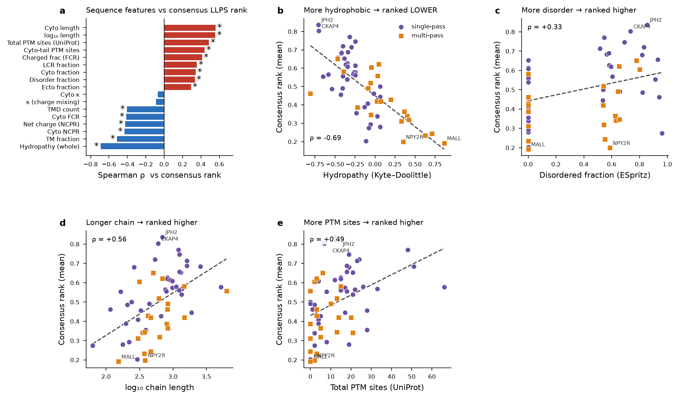
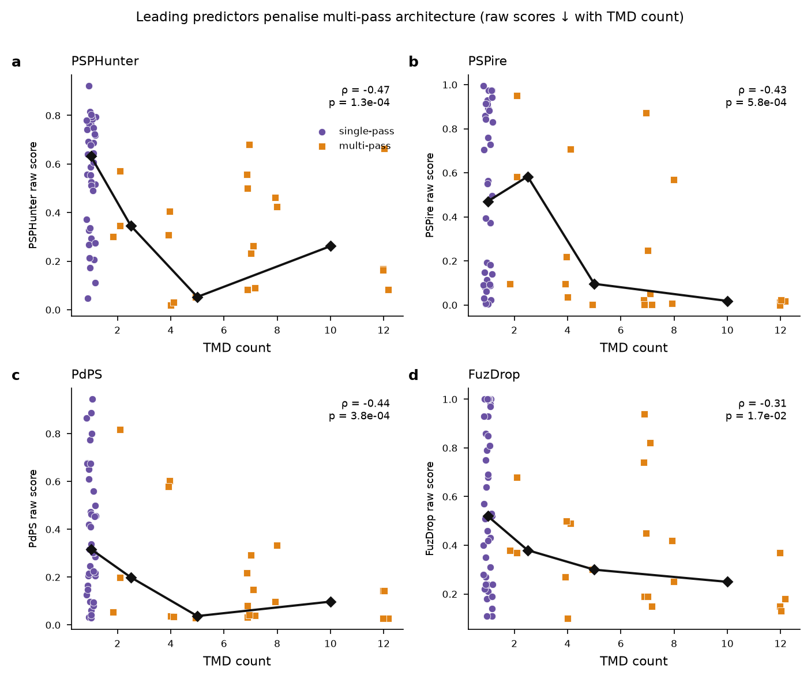
- The architecture bias is not an artifact of the rank-averaging step: it is visible in the raw scores of the individual leading tools. Across the 60 proteins, raw score falls monotonically with TMD count for every leader — PSPHunter ρ = −0.47, PdPS ρ = −0.44, PSPire ρ = −0.43, FuzDrop ρ = −0.31 (all p < 0.02) — mirroring the pattern FuzDrop’s authors reported for multi-pass proteins. Single-pass proteins occupy the high-score band; scores collapse as soon as ≥2 TM helices are present.

4. Failure modes are architectural, not mechanistic
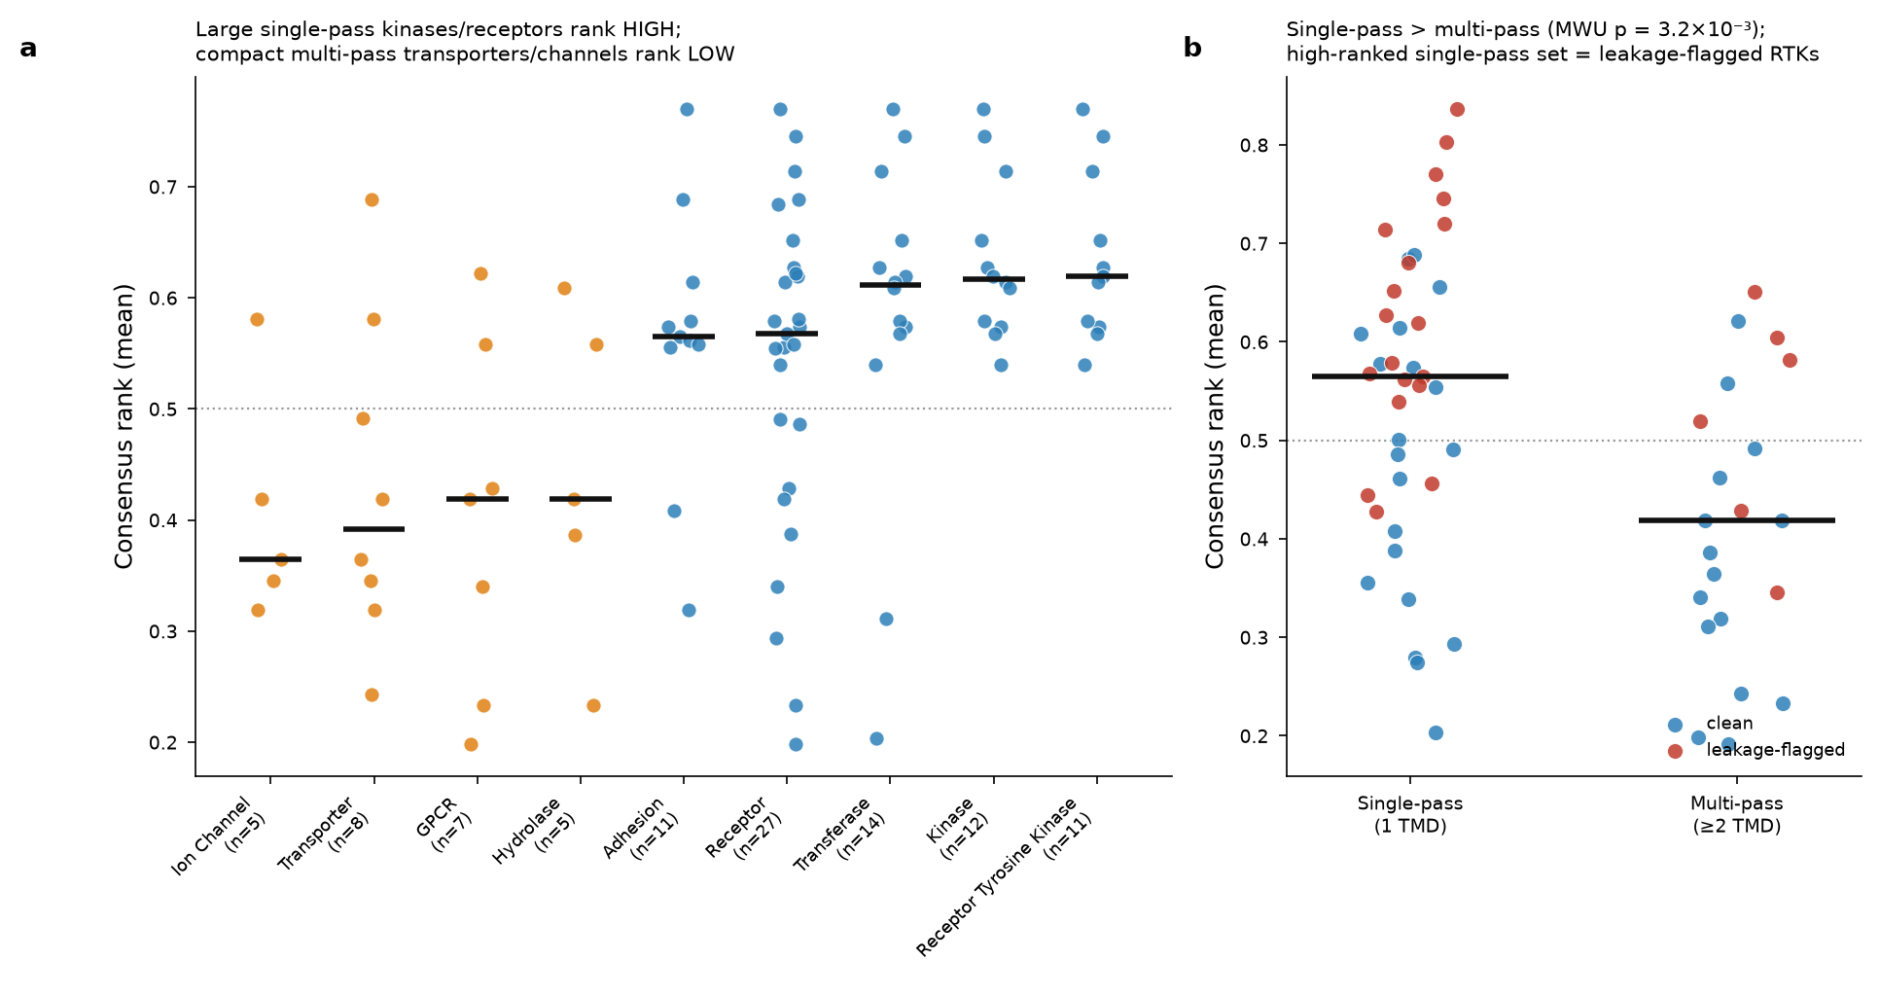
- Annotated all 60 with UniProt functional class, topology, and curated LLPS descriptors (driver/client role; autonomous vs partner-dependent mode); tested each vs plain mean consensus rank (MWU binary, Spearman continuous, Kruskal multi-level; all BH-FDR).
- Significant — all architectural/functional:
  - Chain length (Spearman): FDR = 1 × 10⁻⁴ (strongest).
  - Leakage-flagged higher: 0.58 vs 0.42 (FDR = 6 × 10⁻⁴).
  - Kinase higher: 0.62 vs 0.46 (FDR = 3 × 10⁻³).
  - RTK higher: 0.62 vs 0.46 (FDR = 4 × 10⁻³).
  - TMD count (Spearman, negative): FDR = 4 × 10⁻³.
  - Single-pass > multi-pass: 0.565 vs 0.419 (FDR = 8 × 10⁻³).
  - Transferase higher: 0.61 vs 0.46 (FDR = 0.035).
  - Monotone rise across classes: ion channel 0.36 / transporter 0.39 / GPCR 0.42 → transferase 0.61 / kinase 0.62 / RTK 0.62.
- Not significant — the mechanistic descriptors: driver/client role (Kruskal FDR = 0.46); autonomous vs partner-dependent mode (FDR = 0.46).
- Read: predictors read architecture (size, membrane passes, hydrophobicity, enzyme class), not curated LLPS mechanism. They happen to rank the large single-pass RTKs correctly — because those look like soluble IDR proteins — but for compact or multi-pass proteins that condense via short cytoplasmic motifs, the same signature scores them near the floor regardless of the experimental evidence.

Discussion (draft points)
- Three recurring findings:
  - Best generalisers integrate AlphaFold structural features (PSPHunter, PSPire, PICNIC); a soluble-IDR biophysical model (LLPhyScore) collapses to chance → structural context carries the transferable signal.
  - Given topology, 7/8 tools correctly localise signal to the cytoplasmic face and suppress the membrane core.
  - Consensus is driven by the generic soluble-IDR signature — hydrophobicity (ρ = −0.69), length (+0.56), disorder (+0.33) — and by membrane architecture (TMD count −0.41), not by curated LLPS mechanism (driver/client role and autonomous/partner mode both non-significant). The tools rank large single-pass RTKs correctly only because those resemble soluble IDR proteins; compact and multi-pass proteins with genuine LLPS evidence are penalised for their membrane architecture.
- Two general methodological points:
  - Leakage direction matters: naïve membrane-background AUROCs understate the leaders because leaked proteins are mostly easy negatives; a per-tool, per-protein audit recovers the honest estimate.
  - Same-class background is essential; scoring vs a soluble proteome inflates accuracy by rewarding detection of “membrane-ness.”
- Practical recommendation: score the cytoplasmic domain in isolation, not the full-length chain — TM (and, for most tools, extracellular) regions add noise, and full-length hydrophobicity dominates the consensus; the topology analysis shows the cytoplasmic face is where signal already concentrates. This is most consequential for compact and multi-pass proteins, whose short disordered motifs are swamped by membrane-embedded sequence.
- For developers: topology-aware training/evaluation — topology as an explicit feature, membrane-protein positives in training, same-class background reporting; do not let whole-chain hydrophobicity stand in as a negative LLPS signal for membrane proteins.
- Limitations: 60 curated positives; annotation-based topology; consensus is in-sample. Coiled-coil and post-translational-modification features (phosphorylation of cytoplasmic tails is a known LLPS switch) were not computed here and are the clearest follow-up. But the leakage-corrected benchmark, topology analysis, and feature-resolved consensus converge on the same failure mode: predictors reward the soluble-IDR signature and penalise membrane architecture, independent of experimental mechanism.

Methods
Protein set. Sixty human membrane proteins with curated experimental LLPS evidence were assembled, 56 from PhaSepDB and the remainder from LLPSDB (You et al. 2020; Li et al. 2020). Each was annotated with UniProt membrane topology (single- vs multi-pass; TM-domain count), chain length, functional class, and the source database’s curated LLPS descriptors (driver/client role; autonomous vs partner-dependent mode; in-vitro and in-vivo evidence flags) (The UniProt Consortium 2023). The set comprised 39 single-pass and 21 multi-pass proteins.
Predictors. Eighteen predictor scores were computed or collated: PICNIC and PICNIC (GO) (Pulido-Quetglas et al. 2024), PSPire (Hou et al. 2024), PSPHunter (Sun et al. 2024), PSAP (Mierlo et al. 2021), PhaSePred’s SaPS and PdPS sub-scores (Chen et al. 2022), PDL (Li et al. 2025), FuzDrop (Hardenberg et al. 2020), catGRANULE (Bolognesi et al. 2016), PLAAC (Lancaster et al. 2014), PScore and its residue-composition baseline (R+Y) (Vernon et al. 2018), ParSe 2.0 (Wilson et al. 2023), LLPhyScore (Cai et al. 2022), PSAP-independent DeePhase (Saar et al. 2021), the ESpritz disorder proxy (Walsh et al. 2012), and the SEG low-complexity masker (Wootton and Federhen 1993). Structure-based tools (PICNIC, PICNIC (GO), PSPire) used per-residue AlphaFold2 models (Jumper et al. 2021); disorder was computed with IUPred2A where required (Mészáros et al. 2018).
Benchmarking. Discrimination was quantified by AUROC against a background of other human membrane proteins (membrane-vs-membrane), with additional backgrounds (whole proteome, single-pass-only, multi-pass-only) reported in the supplement. 95% confidence intervals were obtained by bootstrap. Maximum Matthews correlation coefficient (MaxMCC) was recorded as a threshold-free secondary metric. Training-set leakage was audited by matching each of the 60 positives (and each background protein) against every tool’s published training set; per-tool AUROCs were recomputed on the leakage-free subset (“clean”).
Topology-resolved scoring. For tools producing per-residue or per-region output, scores were partitioned into cytoplasmic, transmembrane, and extracellular/lumenal regions using UniProt topology. Each region’s score was compared against the whole-protein score (paired Wilcoxon signed-rank), and cytoplasmic regions were contrasted directly against TM regions. Because raw score ranges differ by orders of magnitude across tools, the summary in Figure 2b uses the scale-free fraction of proteins with cytoplasmic > TM score. All p-values were Benjamini–Hochberg FDR-corrected across tools.
Consensus. Each tool’s raw score was converted to a normalised per-protein rank across the 60 proteins (0 = lowest, 1 = highest predicted propensity; LLPhyScore sign-flipped before ranking so that higher always means more LLPS-prone). The headline consensus is the plain mean normalised rank across the 18 tools; an AUROC-weighted mean (weights = leakage-corrected membrane-vs-membrane AUROC) is reported as a supplement and agrees closely (ρ = 0.996, identical top/bottom proteins). Between-predictor standard deviation gives a per-protein disagreement score. The full 60 × 18 rank matrix is provided as Supplementary Table S1 (output/rank_consensus_matrix.csv). Associations between consensus rank and sequence features / annotations were tested with Spearman correlation (continuous), Mann–Whitney U (binary), and Kruskal–Wallis (multi-level), all BH-FDR corrected. Sequence features (Kyte–Doolittle hydropathy, charge descriptors via localCIDER, disordered fraction from ESpritz, low-complexity fraction from SEG) were computed on whole-protein and cytoplasmic-only sequences. Post-translational modification burden was pulled per protein from the UniProtKB REST API (The UniProt Consortium 2023) (feature types: Modified residue, Cross-link, Glycosylation, Lipidation), counted both across the whole sequence and restricted to residues falling within annotated cytoplasmic topological domains (same topology boundaries used for the region-based score analysis in Figure 2).
Reproducibility. All scores, statistical tests, and figures are regenerated by the analysis scripts in the accompanying repository; every quantitative claim in this manuscript is drawn from a single machine-readable results digest (output/results_digest.json).

Figure legends

Figure 1. Structure-aware predictors lead the membrane-vs-membrane benchmark and training-set leakage is asymmetric. Left: full-set (grey) and per-tool leakage-free (“clean”, red) AUROC for 18 predictors discriminating 60 membrane LLPS proteins from a background of other human membrane proteins; error bars are 95% bootstrap CIs, and n is the leakage-free positive count. Label colour encodes predictor mechanism. Right: change in AUROC after leakage removal (green = rises, red = drops). Removing leaked proteins raises the structure-based leaders (PSPHunter +0.10, PdPS +0.05, PSPire +0.05) because their leaked proteins are predominantly background negatives, and lowers PDL (−0.08), whose leaked proteins are positives.

Figure 2. Predictor scores follow the membrane topology. (a) Per-region minus whole-protein score for the two AlphaFold-based structure tools, PICNIC and PSPire, across cytoplasmic, transmembrane, and extracellular/lumenal regions; cytoplasmic regions score above and TM regions below the whole-protein baseline (paired Wilcoxon, *** FDR < 0.001, n.s. not significant). (b) Fraction of proteins scoring cytoplasmic > TM for eight position-aware tools; seven of eight exceed 50% (all FDR < 0.05), and only SEG, a low-complexity masker, reverses.

Figure 3. A cross-predictor consensus for 60 membrane LLPS proteins. Plain mean normalised rank (x, higher = consistently predicted phase-separation-prone) versus between-predictor standard deviation (y, higher = more disagreement). Point colour/marker encodes single- vs multi-pass topology; shaded bands mark consistently high (>0.7) and low (<0.3) rank. Large single-pass receptors and RTKs with long disordered cytoplasmic tails (EGFR, ERBB2, JPH2, CKAP4, MAVS) populate the high-consensus region; compact and multi-pass transporters, channels and small tail-anchored proteins (MALL, NPY2R, MFSD1, PAR3, COX7C, TAZ) populate the low-consensus region. Rank and disagreement are uncorrelated (ρ = −0.13), so both extremes reflect predictor agreement.

Figure 5. The consensus is driven by the generic soluble-IDR sequence signature. (a) Spearman correlation of each sequence/architecture/PTM feature with consensus rank (* FDR < 0.05); whole-protein hydrophobicity is the strongest (negative) correlate, followed by positive length, total and cyto-tail PTM-site, LCR and disorder terms, and negative TM-fraction / TMD-count / net-charge terms. (b) Consensus rank vs Kyte–Doolittle hydropathy (ρ = −0.69): more hydrophobic proteins rank lower, across both topology classes. (c) Rank vs disordered fraction (ρ = +0.33), (d) vs log chain length (ρ = +0.56), and (e) vs total annotated UniProt post-translational modification sites (ρ = +0.49). Points coloured by topology; extreme proteins labelled.

Figure 2b (supporting Figure 3). Leading predictors penalise multi-pass architecture in their raw scores. Raw score of each of the four leading tools (PSPHunter, PSPire, PdPS, FuzDrop) versus transmembrane-domain count for the 60 proteins; black line = binned median. Raw scores fall with increasing TMD count for all four (Spearman ρ = −0.47, −0.43, −0.44, −0.31; all p < 0.02), confirming that the architecture bias in the consensus is present in the individual tools and not introduced by rank-averaging.

Figure 4. The consensus tracks architecture and function, not curated LLPS mechanism. (a) Mean consensus rank by UniProt functional class (median bars); rank rises from compact multi-pass ion channels, transporters and GPCRs at the bottom to large single-pass transferases, kinases and receptor tyrosine kinases at the top. (b) Consensus rank for single- vs multi-pass proteins, coloured by leakage status; single-pass proteins rank higher (MWU p = 3.2 × 10⁻³), and the high-ranked single-pass set is enriched for leakage-flagged receptors.
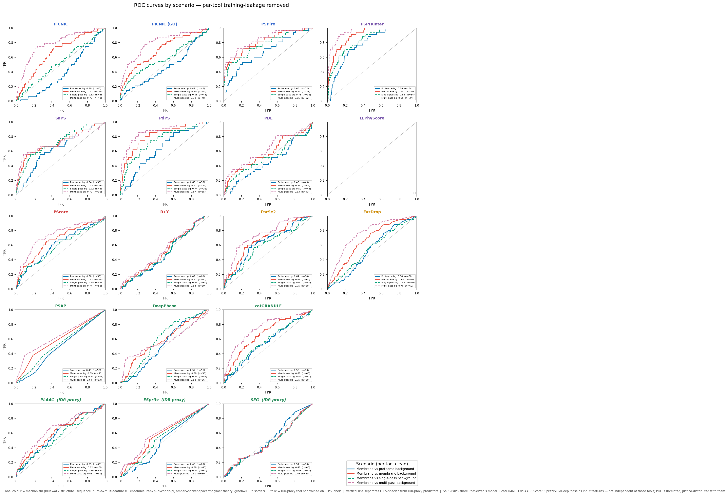
Supplementary Figure S1. ROC curves across background scenarios. Full ROC curves for the leading predictors under the four background definitions (membrane-vs-membrane, vs multi-pass, vs single-pass, vs whole proteome).
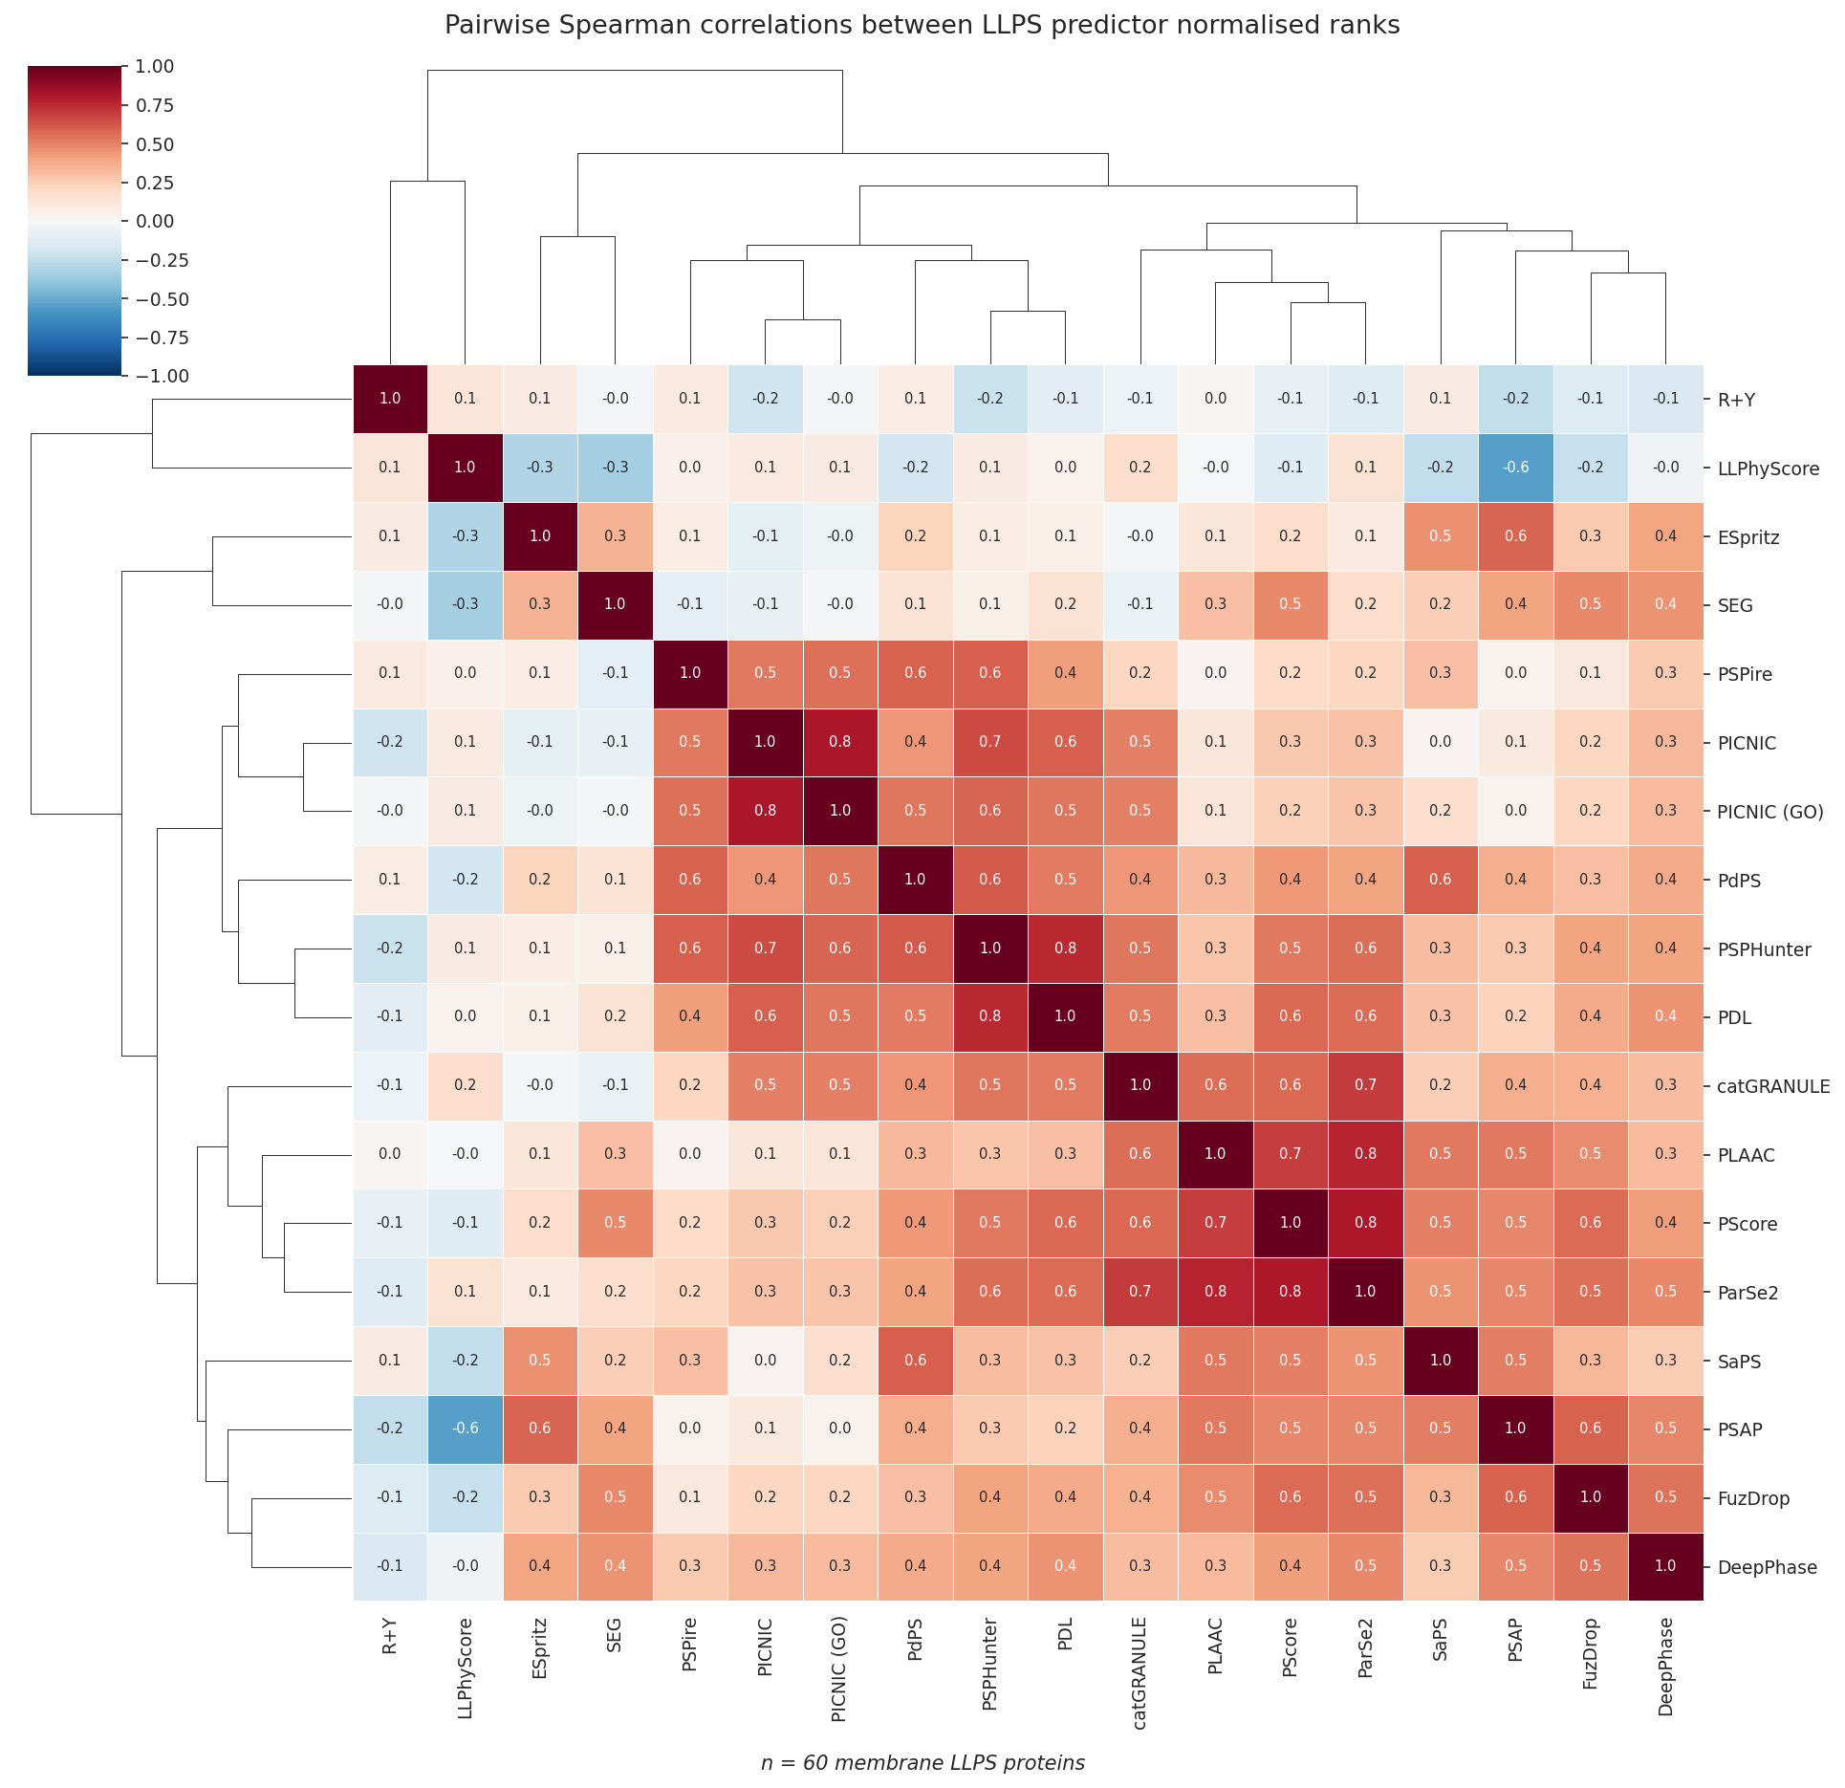
Supplementary Figure S2. Cross-predictor score correlation. Spearman correlation matrix of the 18 predictor scores across the 60 proteins, illustrating which tools share underlying signal (e.g. the PhaSePred-derived sub-scores and the IDR proxies).
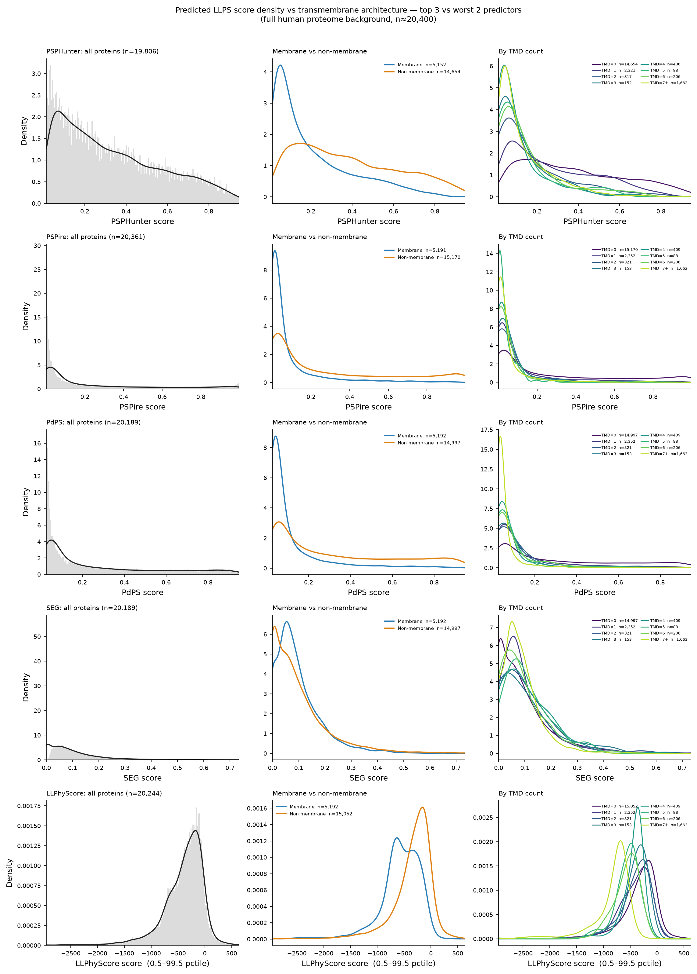
Supplementary Figure S3. The membrane-architecture bias is a proteome-wide property of the leading predictors, not an artifact of the curated 60-protein set. Score density (histogram + KDE, left column), membrane-vs-non-membrane score distributions (centre column), and score distributions stratified by TMD count (right column, viridis) for the three leading predictors (PSPHunter, PSPire, PdPS) and the two worst-performing predictors (SEG, LLPhyScore) by leakage-corrected membrane-vs-membrane AUROC, computed across the full human proteome background (output/background_scored.csv, n ≈ 20,400). LLPhyScore’s unbounded linear-sum score is shown clipped to its 0.5–99.5th percentile range (see Methods) because its raw range spans approximately −19,600 to +10,300 and is otherwise dominated by extreme outliers. Proteome-wide, PSPHunter, PSPire, PdPS and LLPhyScore all show significant negative score-vs-TMD-count correlation (Spearman ρ = −0.35 to −0.41, all p < 10⁻⁵ ) and membrane proteins score significantly lower than non-membrane proteins (Mann–Whitney p < 10⁻⁷ for all four); SEG alone shows negligible architecture dependence (ρ = +0.04) — consistent with its lone reversal in the cytoplasmic-vs-TM topology test (Figure 2b) and its chance-level discrimination in the ROC benchmark (Figure 1).

References
Bolognesi, Benedetta, Nadia Lorenzo Gotor, et al. 2016. “A Concentration-Dependent Liquid Phase Separation Can Cause Toxicity Upon Increased Protein Expression.” Cell Reports 16 (1): 222–31. https://doi.org/10.1016/j.celrep.2016.05.076.
Cai, Hao, Robert M. Vernon, and Julie D. Forman-Kay. 2022. “An Interpretable Machine-Learning Algorithm to Predict Disordered Protein Phase Separation Based on Biophysical Interactions (LLPhyScore).” Biomolecules 12 (8): 1131. https://doi.org/10.3390/biom12081131.
Chen, Zhaoming, Chao Hou, et al. 2022. “Screening Membraneless Organelle Participants with Machine-Learning Models That Integrate Multimodal Features (PhaSePred).” Proceedings of the National Academy of Sciences 119 (24): e2115369119. https://doi.org/10.1073/pnas.2115369119.
Hardenberg, Maarten, Attila Horvath, Viktor Ambrus, Monika Fuxreiter, and Michele Vendruscolo. 2020. “Widespread Occurrence of the Droplet State of Proteins in the Human Proteome (FuzDrop).” Proceedings of the National Academy of Sciences 117 (52): 33254–62. https://doi.org/10.1073/pnas.2007670117.
Hou, Shuang et al. 2024. “Machine Learning Predictor PSPire Screens for Phase-Separating Proteins Lacking Intrinsically Disordered Regions.” Nature Communications 15: 2147. https://doi.org/10.1038/s41467-024-46445-y.
Jumper, John, Richard Evans, et al. 2021. “Highly Accurate Protein Structure Prediction with AlphaFold.” Nature 596: 583–89. https://doi.org/10.1038/s41586-021-03819-2.
Lancaster, Alex K., Andrew Nutter-Upham, Susan Lindquist, and Oliver D. King. 2014. “PLAAC: A Web and Command-Line Application to Identify Proteins with Prion-Like Amino Acid Composition.” Bioinformatics 30 (17): 2501–2. https://doi.org/10.1093/bioinformatics/btu310.
Li, Qian, Xiaojun Peng, et al. 2020. “LLPSDB: A Database of Proteins Undergoing Liquid-Liquid Phase Separation in Vitro.” Nucleic Acids Research 48 (D1): D320–27. https://doi.org/10.1093/nar/gkz778.
Li, Wenbin et al. 2025. “PDL: A Dual-Model Protein Language Framework for Phase-Separation Prediction.” Briefings in Bioinformatics 26 (6): bbaf681. https://doi.org/10.1093/bib/bbaf681.
Mészáros, Bálint, Gábor Erdős, et al. 2020. “PhaSePro: The Database of Proteins Driving Liquid-Liquid Phase Separation.” Nucleic Acids Research 48 (D1): D360–67. https://doi.org/10.1093/nar/gkz848.
Mészáros, Bálint, Gábor Erdős, and Zsuzsanna Dosztányi. 2018. “IUPred2A: Context-Dependent Prediction of Protein Disorder as a Function of Redox State and Protein Binding.” Nucleic Acids Research 46 (W1): W329–37. https://doi.org/10.1093/nar/gky384.
Mierlo, Guido van, Joris R. G. Jansen, et al. 2021. “Predicting Protein Condensate Formation Using Machine Learning.” Cell Reports 34 (5): 108705. https://doi.org/10.1016/j.celrep.2021.108705.
Ning, Wanshan, Yaping Guo, et al. 2020. “DrLLPS: A Data Resource of Liquid-Liquid Phase Separation in Eukaryotes.” Nucleic Acids Research 48 (D1): D288–95. https://doi.org/10.1093/nar/gkz1027.
Pulido-Quetglas, Carlos, Ann-Kathrin Hoffmann, et al. 2024. “Prediction of Biomolecular Condensate Components with PICNIC.” Nature Communications 15: 10668. https://doi.org/10.1038/s41467-024-55089-x.
Rostam, Nadia, Soumyananda Ghosh, et al. 2023. “CD-CODE: Crowdsourcing Condensate Database and Encyclopedia.” Nature Methods 20: 673–76. https://doi.org/10.1038/s41592-023-01831-0.
Saar, Kadi L., Alexey S. Morgunov, et al. 2021. “Learning the Molecular Grammar of Protein Condensates from Sequence Determinants.” Proceedings of the National Academy of Sciences 118 (15): e2019053118. https://doi.org/10.1073/pnas.2019053118.
Sun, Jiwei et al. 2024. “Precise Prediction of Phase-Separation Proteins and Their Drivers with PSPHunter.” Nature Communications 15: 2662. https://doi.org/10.1038/s41467-024-46901-9.
The UniProt Consortium. 2023. “UniProt: The Universal Protein Knowledgebase in 2023.” Nucleic Acids Research 51 (D1): D523–31. https://doi.org/10.1093/nar/gkac1052.
Vernon, Robert McCoy, Paul A. Chong, et al. 2018. “Pi-Pi Contacts Are an Overlooked Protein Feature Relevant to Phase Separation.” eLife 7: e31486. https://doi.org/10.7554/eLife.31486.
Walsh, Ian, Alberto J. M. Martin, Tomas Di Domenico, and Silvio C. E. Tosatto. 2012. “ESpritz: Accurate and Fast Prediction of Protein Disorder.” Bioinformatics 28 (4): 503–9. https://doi.org/10.1093/bioinformatics/btr682.
Wilson, Chandler J. et al. 2023. “ParSe 2.0: A Web Tool to Identify Drivers of Protein Phase Separation at the Proteome Level.” Protein Science 32 (10): e4756. https://doi.org/10.1002/pro.4756.
Wootton, John C., and Scott Federhen. 1993. “Statistics of Local Complexity in Amino Acid Sequences and Sequence Databases.” Computers and Chemistry 17 (2): 149–63. https://doi.org/10.1016/0097-8485(93)85006-X.
You, Kaiqiang, Qian Huang, et al. 2020. “PhaSepDB: A Database of Liquid-Liquid Phase Separation Related Proteins.” Nucleic Acids Research 48 (D1): D354–59. https://doi.org/10.1093/nar/gkz847.

