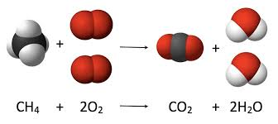**A: Planning**

Scenario:

Stoichiometry is the relationship is the relationship between relative quantities of substances taking part in a reaction forming different compounds. The compounds on the left of the arrow are the reactants the compounds to the right of the arrows are the products. You balance the equation by balancing out all of the molecules so there is the same amount of molecules on the left and on the right. To do this you would need to add coefficients at the front of the molecule. Using the new formula you will be able to find the theoretical yield of the reaction.

A student that is in Chemistry needs assistance in solving Stoichiometry problems, or needs something to check his work. My advisor is my computer science teacher at my high school.

Rationale:

I want to create a program that takes in a compound equation and checks if its correctly balanced. After, I want it to take in an reactant of a compound in moles or grams to calculate how much you need of the other reactant and how much of the product it would yield using the IB Chemistry Periodic Table.

Success Criteria:

* Checks if the equation is balanced
* Calculates all of the others compounds
* Returns all of the results to the user