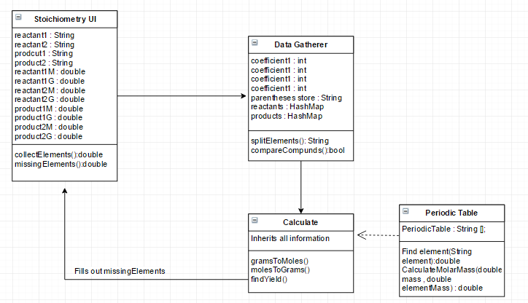**Design**

There are 4 main classes to the program the

* StoichiometryUI
* Data Gatherer
* Calculate
* Periodic Table

Stoichiometry UI:

This class will be the user interface of the program. It will also gather the information to be used for processing.

Data Gatherer:

This will split and calculate the coefficients to gather data and see if its correct. If it’s not correct it will return null to the user and give a “not solvable equation” to them.

Calculate:

This will calculate everything that needs to be calculated inheriting from the periodic table to get element masses.

Periodic Table:

This will store an array of over 100 values of all the molar masses of every element of the Periodic Table referencing the IB Chemistry one. It will find the element it needs and return the mass that it has.

**General Solution:**

This is how an equation will generally be solved.

1. Gather the information from the UI.
2. Splits the equations and checks if it’s correct and balanced or not.
3. Converts the Grams into moles if it’s not given.
4. Uses mole ratio to find other compounds.
5. Return user the results.

Output Solution:

The solution to the equation will be represented to the user in a clean and readable way.

**Test Cases:**

These are the main safety check that will be implemented.

* Checks if the Element exists
* Checks if Coefficients are correct
* Checks if the equation is balanced

To check the equation, I will do the problem by hand before hand to make sure it’s solvable.