**Hive_class_3_Assignment_Solution**

1. Download vechile sales data -> <https://github.com/shashank-mishra219/Hive-Class/blob/main/sales_order_data.csv>.

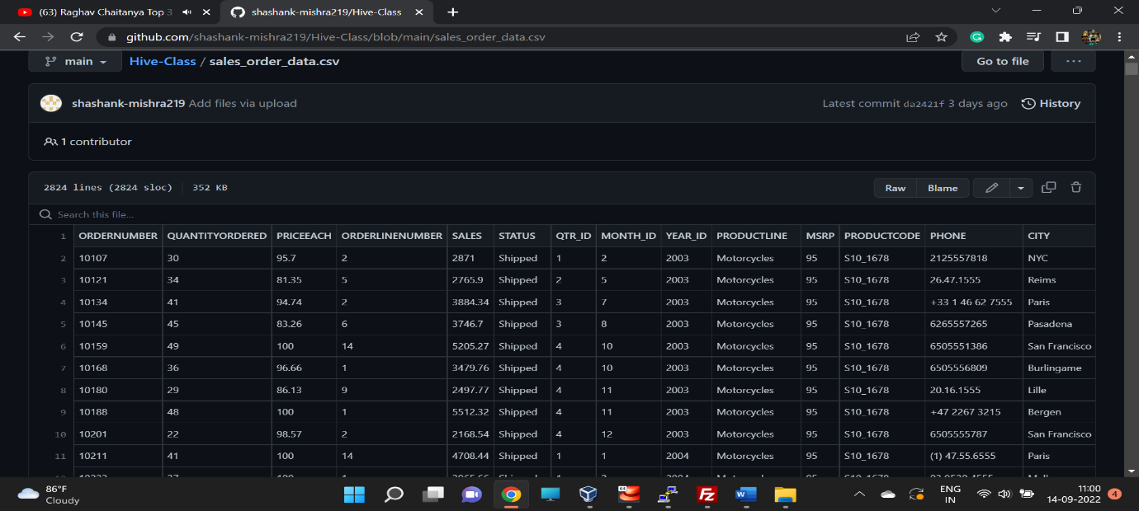

1. Store raw data into hdfs location.

**hdfs dfs -put /home/cloudera/data/sales_order_data.csv /jayesh**

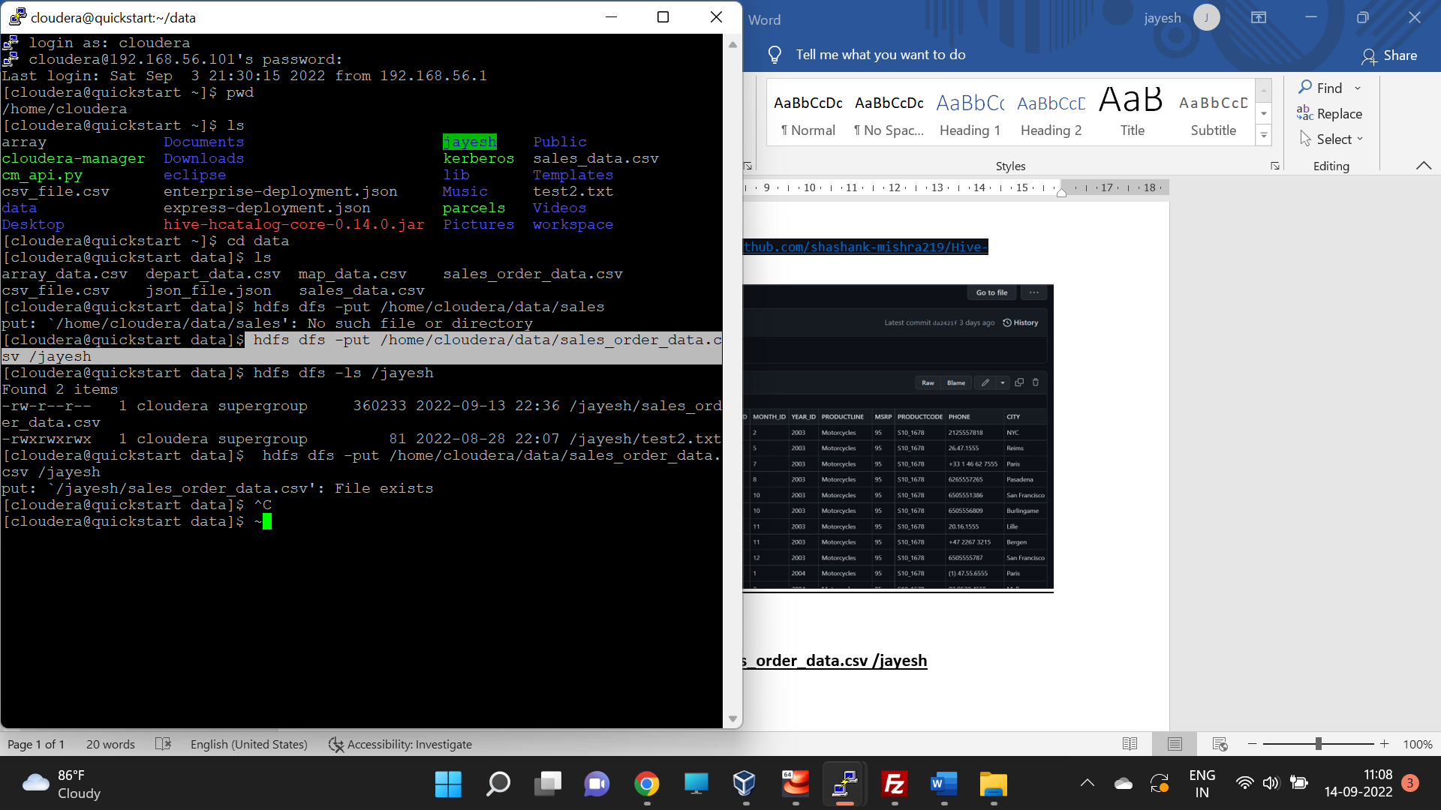

1. Create a internal hive table "sales_order_csv" which will store csv data sales_order_csv .. make sure to skip header row while creating table.

**create table sales_order_data_csv_v1**

**(**

**ORDERNUMBER int,**

**QUANTITYORDERED int,**

**PRICEEACH float,**

**ORDERLINENUMBER int,**

**SALES float,**

**STATUS string,**

**QTR_ID int,**

**MONTH_ID int,**

**YEAR_ID int,**

**PRODUCTLINE string,**

**MSRP int,**

**PRODUCTCODE string,**

**PHONE string,**

**CITY string,**

**STATE string,**

**POSTALCODE string,**

**COUNTRY string,**

**TERRITORY string,**

**CONTACTLASTNAME string,**

**CONTACTFIRSTNAME string,**

**DEALSIZE string**

**)**

**row format delimited**

**fields terminated by ','**

**tblproperties("skip.header.line.count"="1")**

**;**

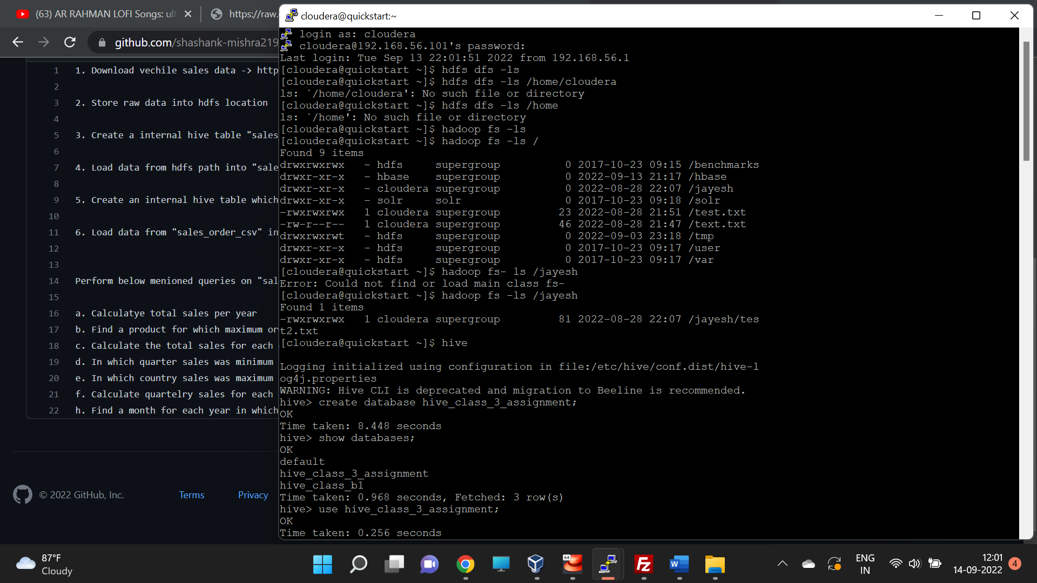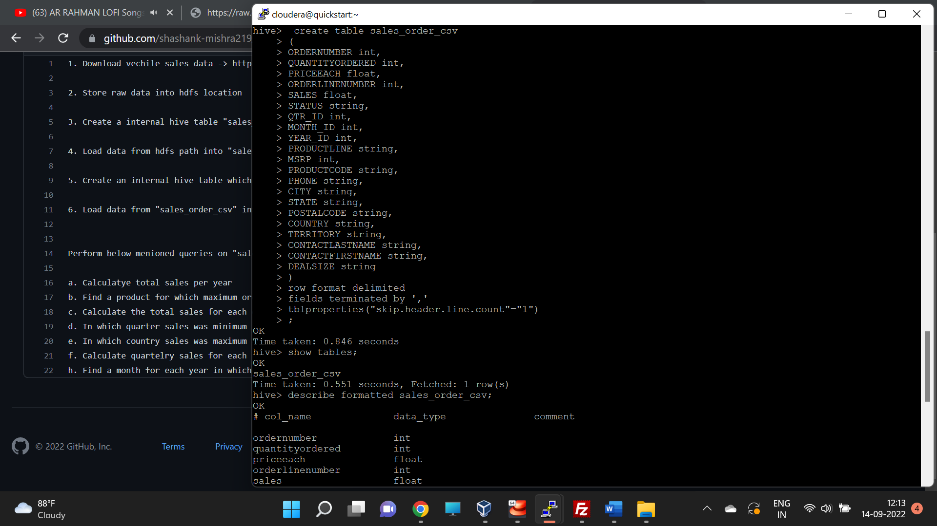

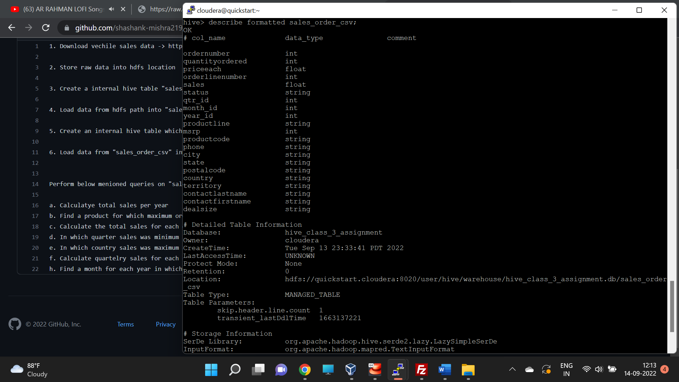

1. Load data from hdfs path into "sales_order_csv"

load data inpath '/jayesh/sales_order_data.csv' into table sales_order_csv;

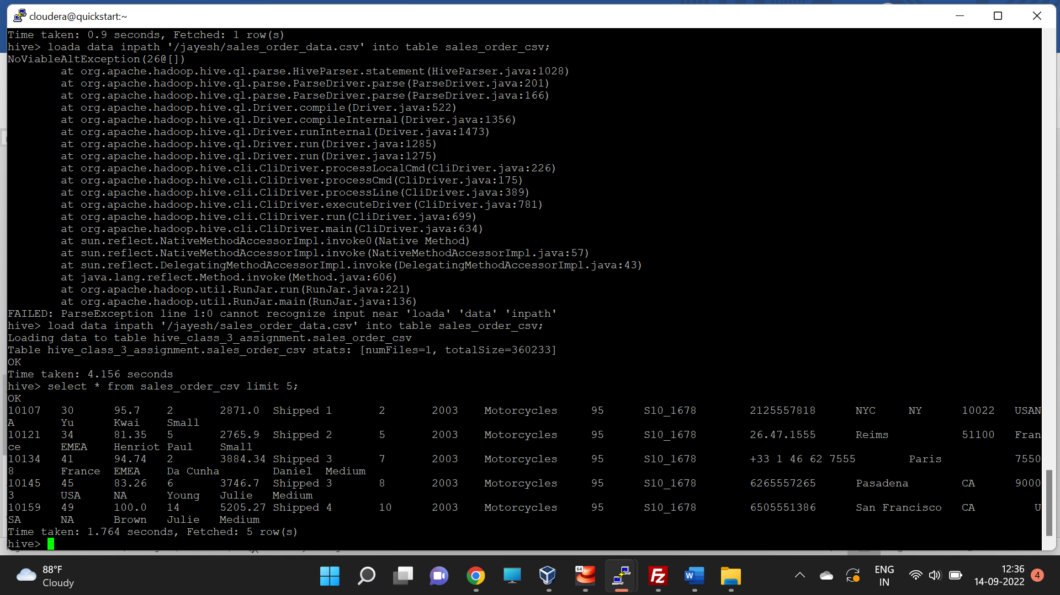

1. Create an internal hive table which will store data in ORC format "sales_order_orc"

**create table sales_order_data_orc**

**(**

**ORDERNUMBER int,**

**QUANTITYORDERED int,**

**PRICEEACH float,**

**ORDERLINENUMBER int,**

**SALES float,**

**STATUS string,**

**QTR_ID int,**

**MONTH_ID int,**

**YEAR_ID int,**

**PRODUCTLINE string,**

**MSRP int,**

**PRODUCTCODE string,**

**PHONE string,**

**CITY string,**

**STATE string,**

**POSTALCODE string,**

**COUNTRY string,**

**TERRITORY string,**

**CONTACTLASTNAME string,**

**CONTACTFIRSTNAME string,**

**DEALSIZE string**

**)**

**stored as orc;** 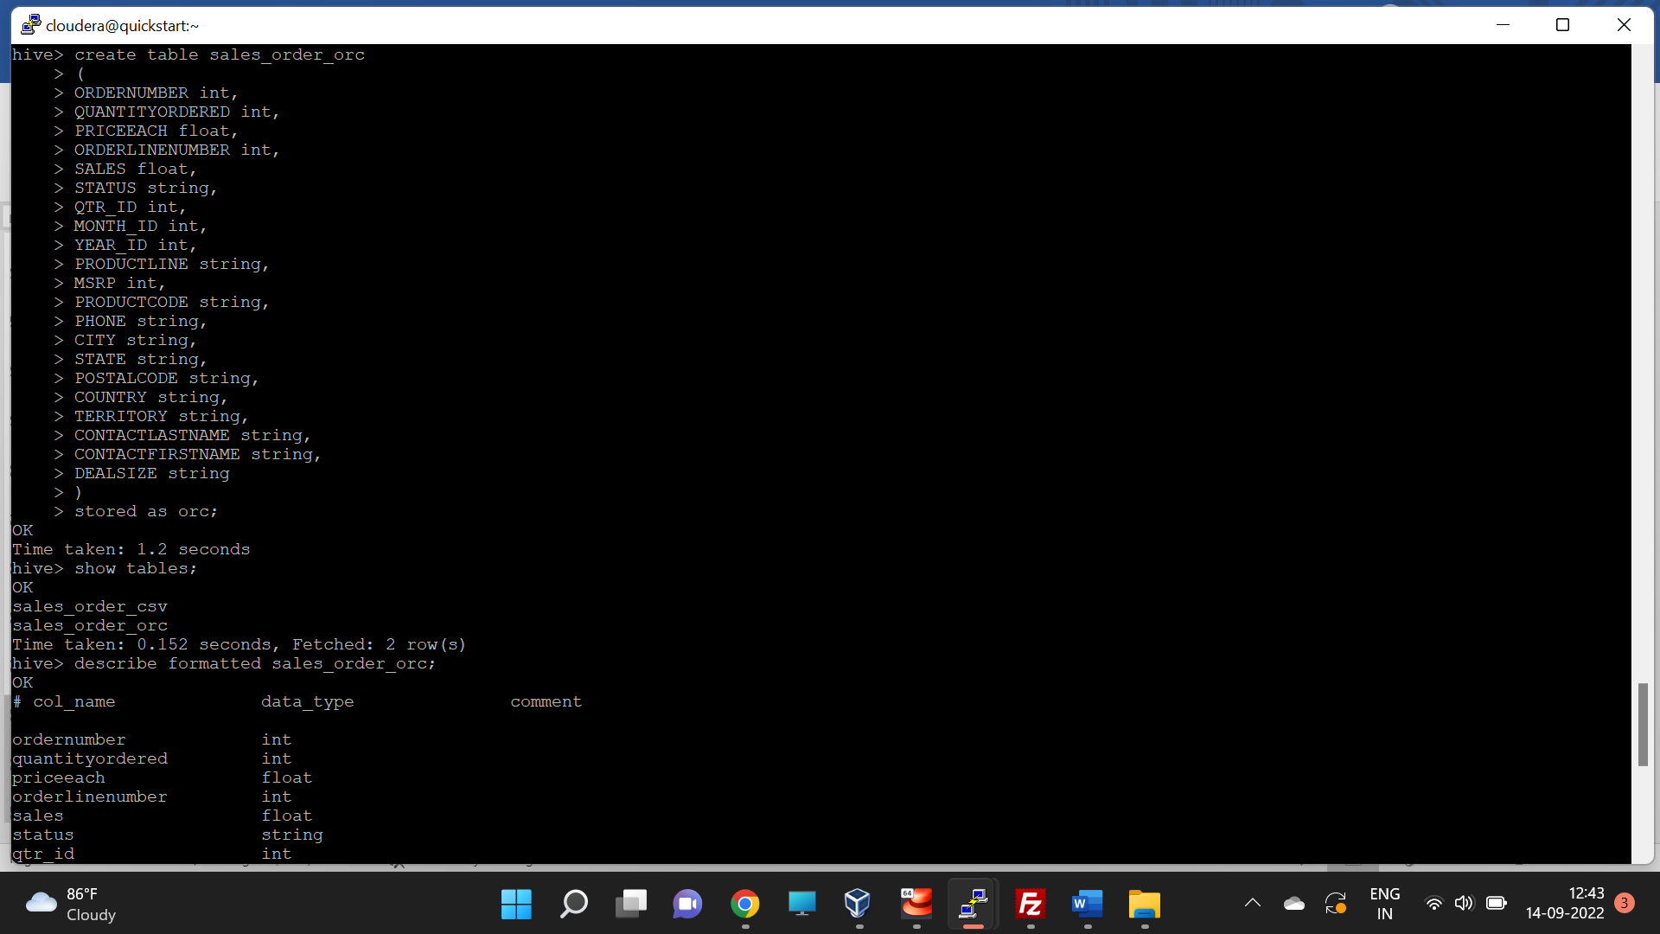

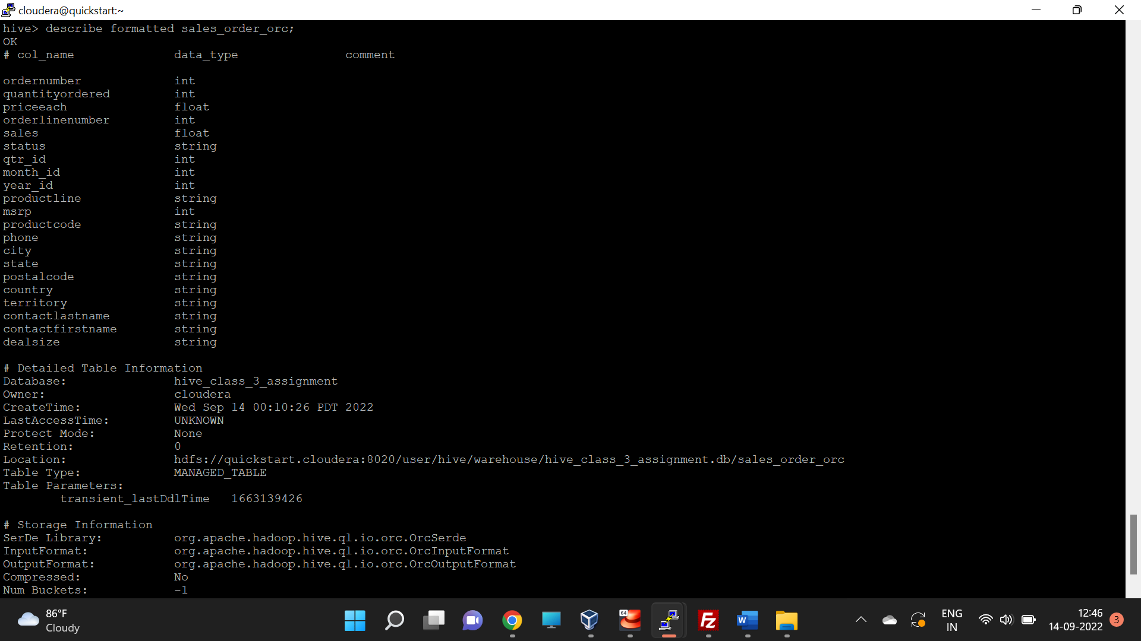

1. Load data from "sales_order_csv" into "sales_order_orc".

**from sales_order_csv insert overwrite table sales_order_orc select *;**

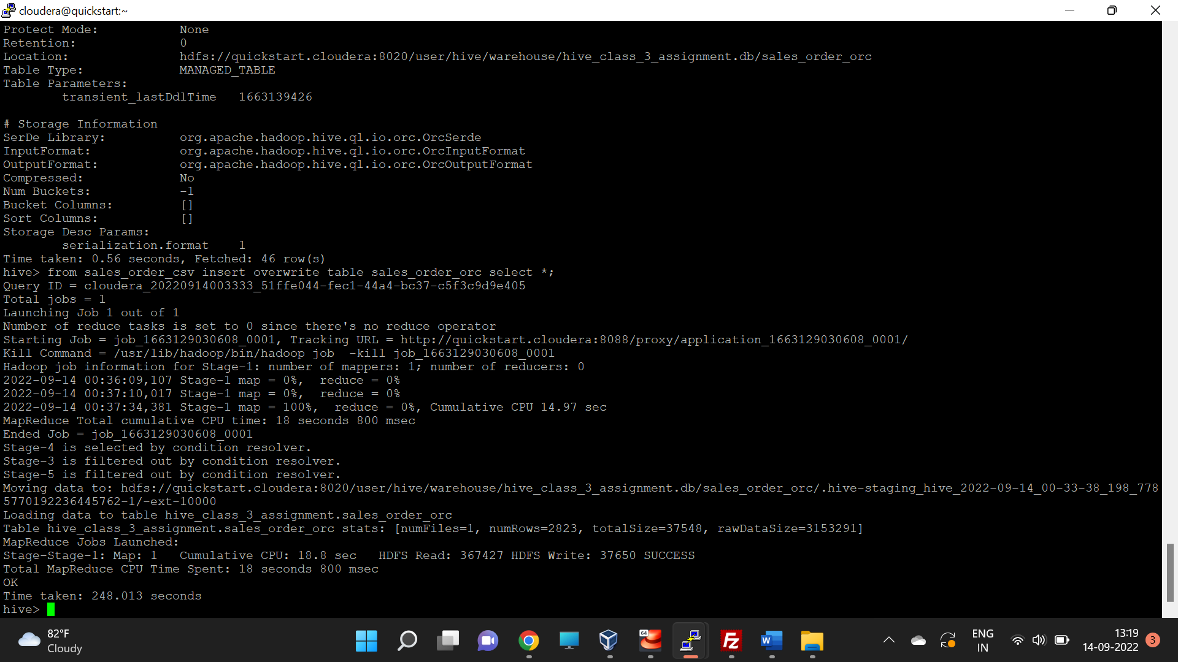

Perform below menioned queries on "sales_order_orc" table :

1. Calculatye total sales per year

**select year_id, sum(sales) as total_sales from sales_order_orc group by year_id;**

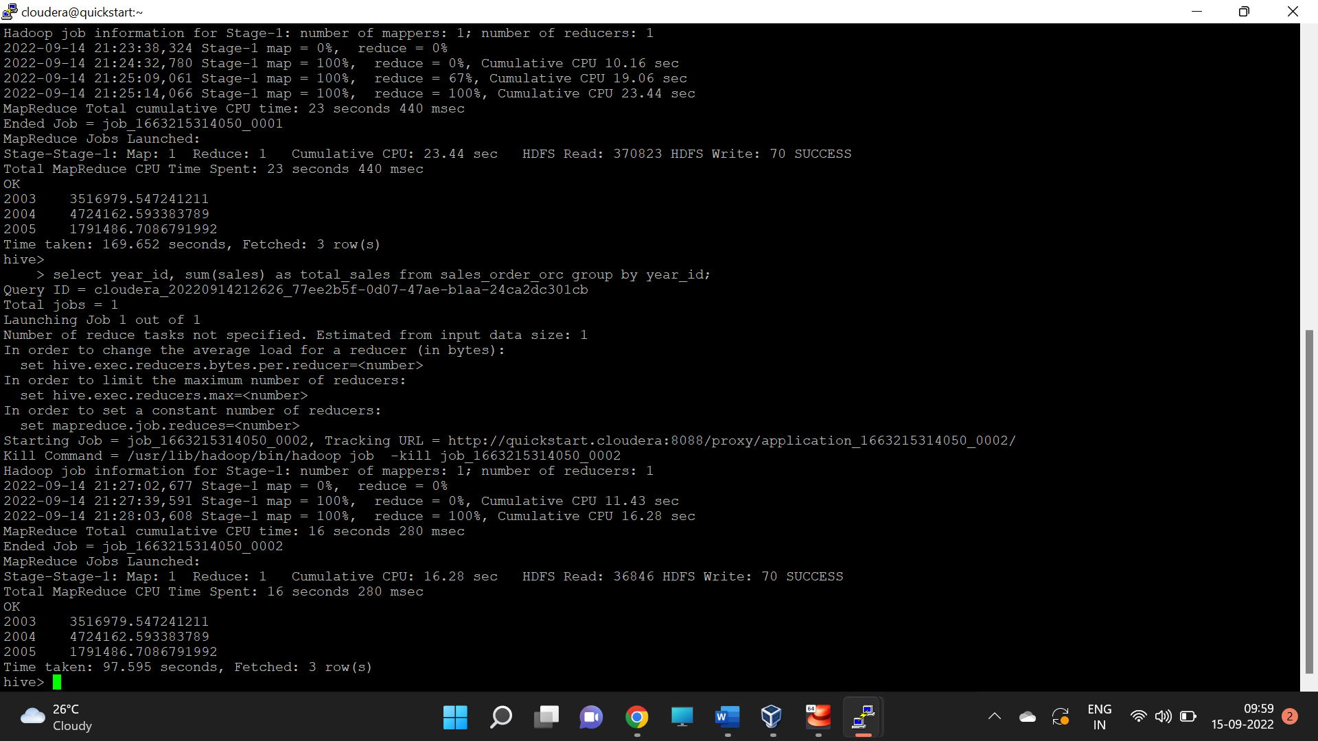

1. Find a product for which maximum orders were placed

select productcode, productline, sum(quantityordered) as total_quantityordered from sales_order_orc group by productcode, productline order by total_quantityordered desc limit 1;

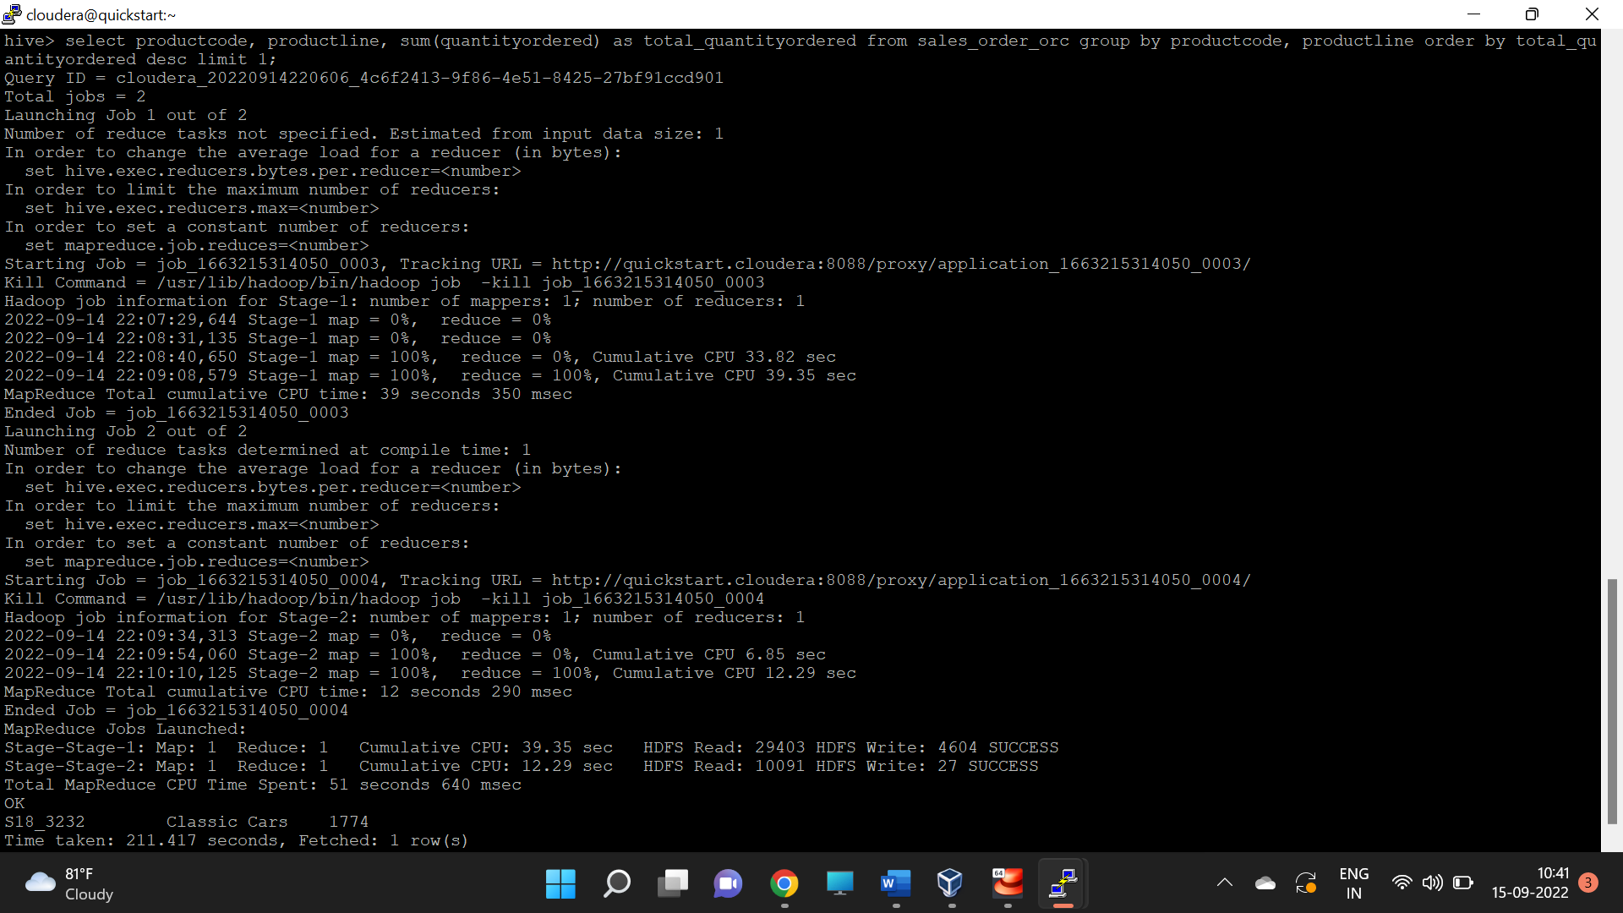

1. Calculate the total sales for each quarter

select qtr_id, sum(sales) from sales_order_orc group by qtr_id;

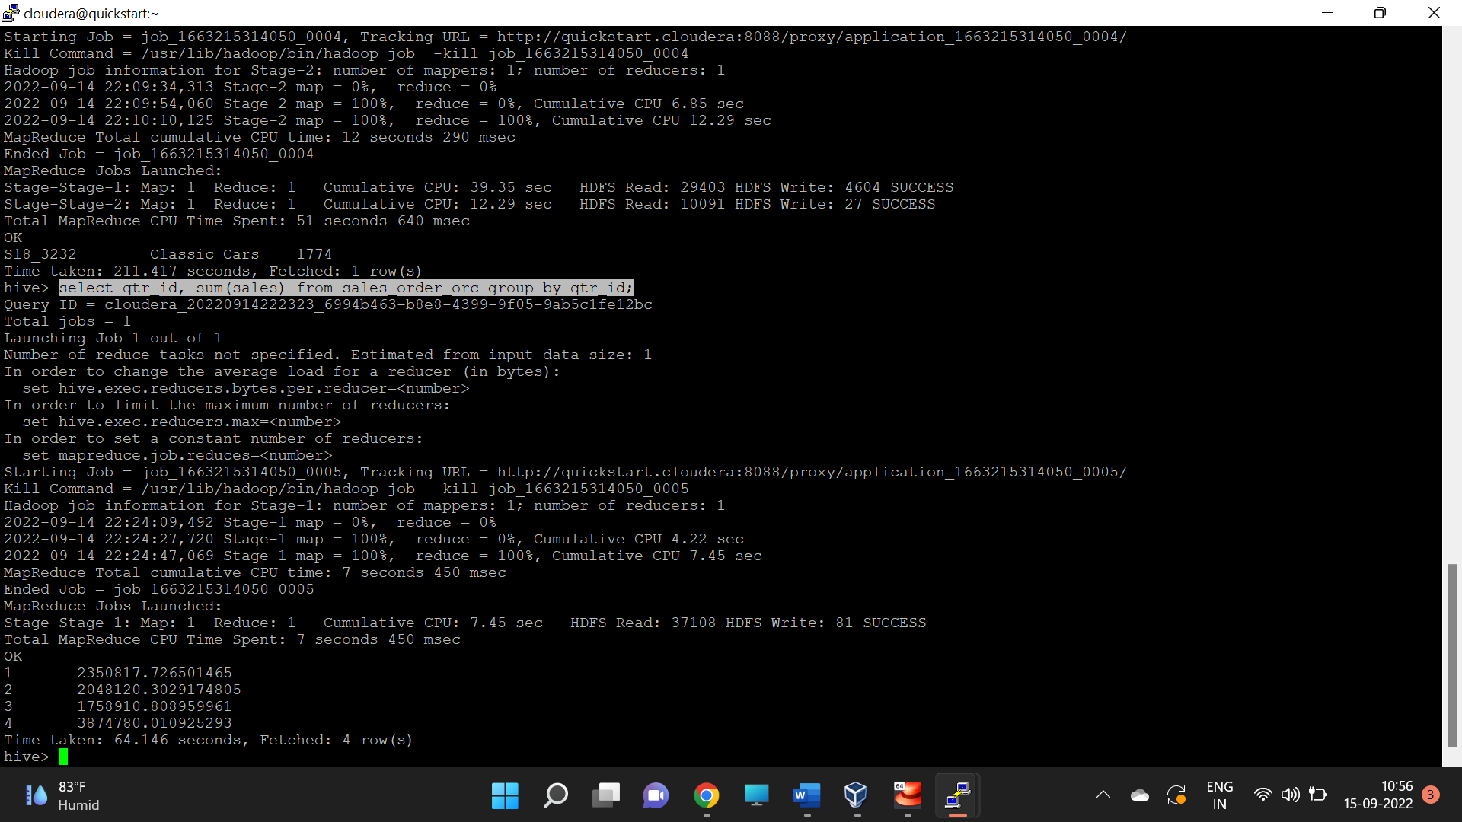

1. In which quarter sales was minimum

select qtr_id, sum(sales) as total_sales from sales_order_orc group by qtr_id order by total_sales limit 1;

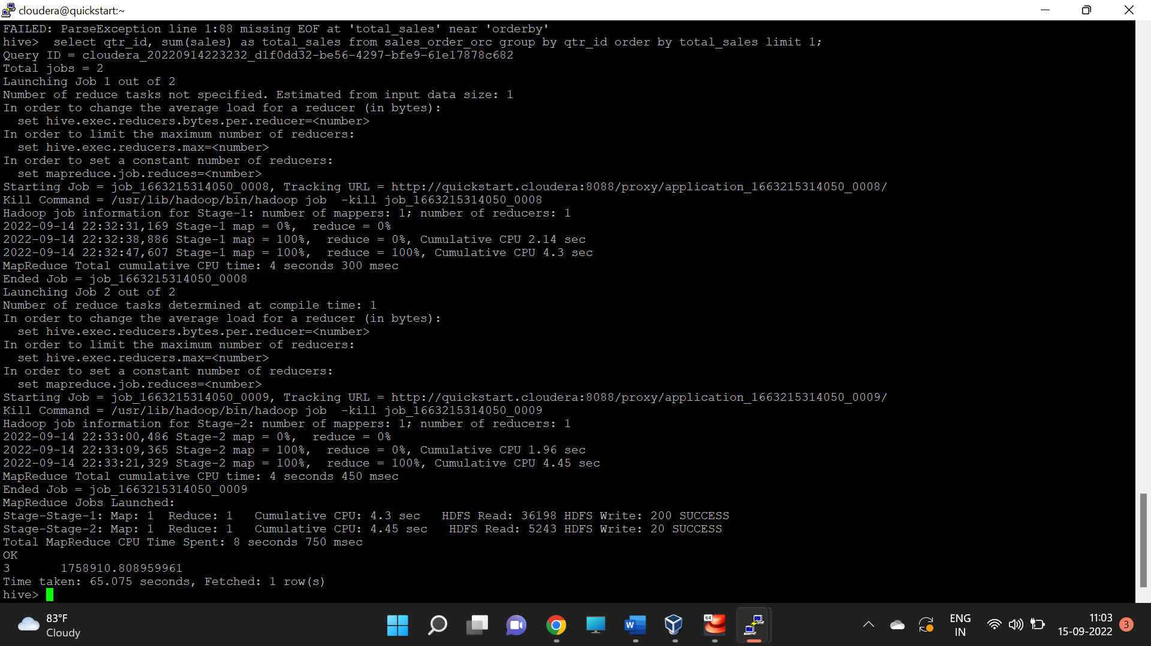

1. In which country sales was maximum and in which country sales was minimum

select country, sum(sales) as total_sales from sales_order_orc group by co untry order by total_sales limit 1

union all

select country, sum(sales) as total_sales from sales_order_orc group by c ountry order by total_sales desc limit 1;

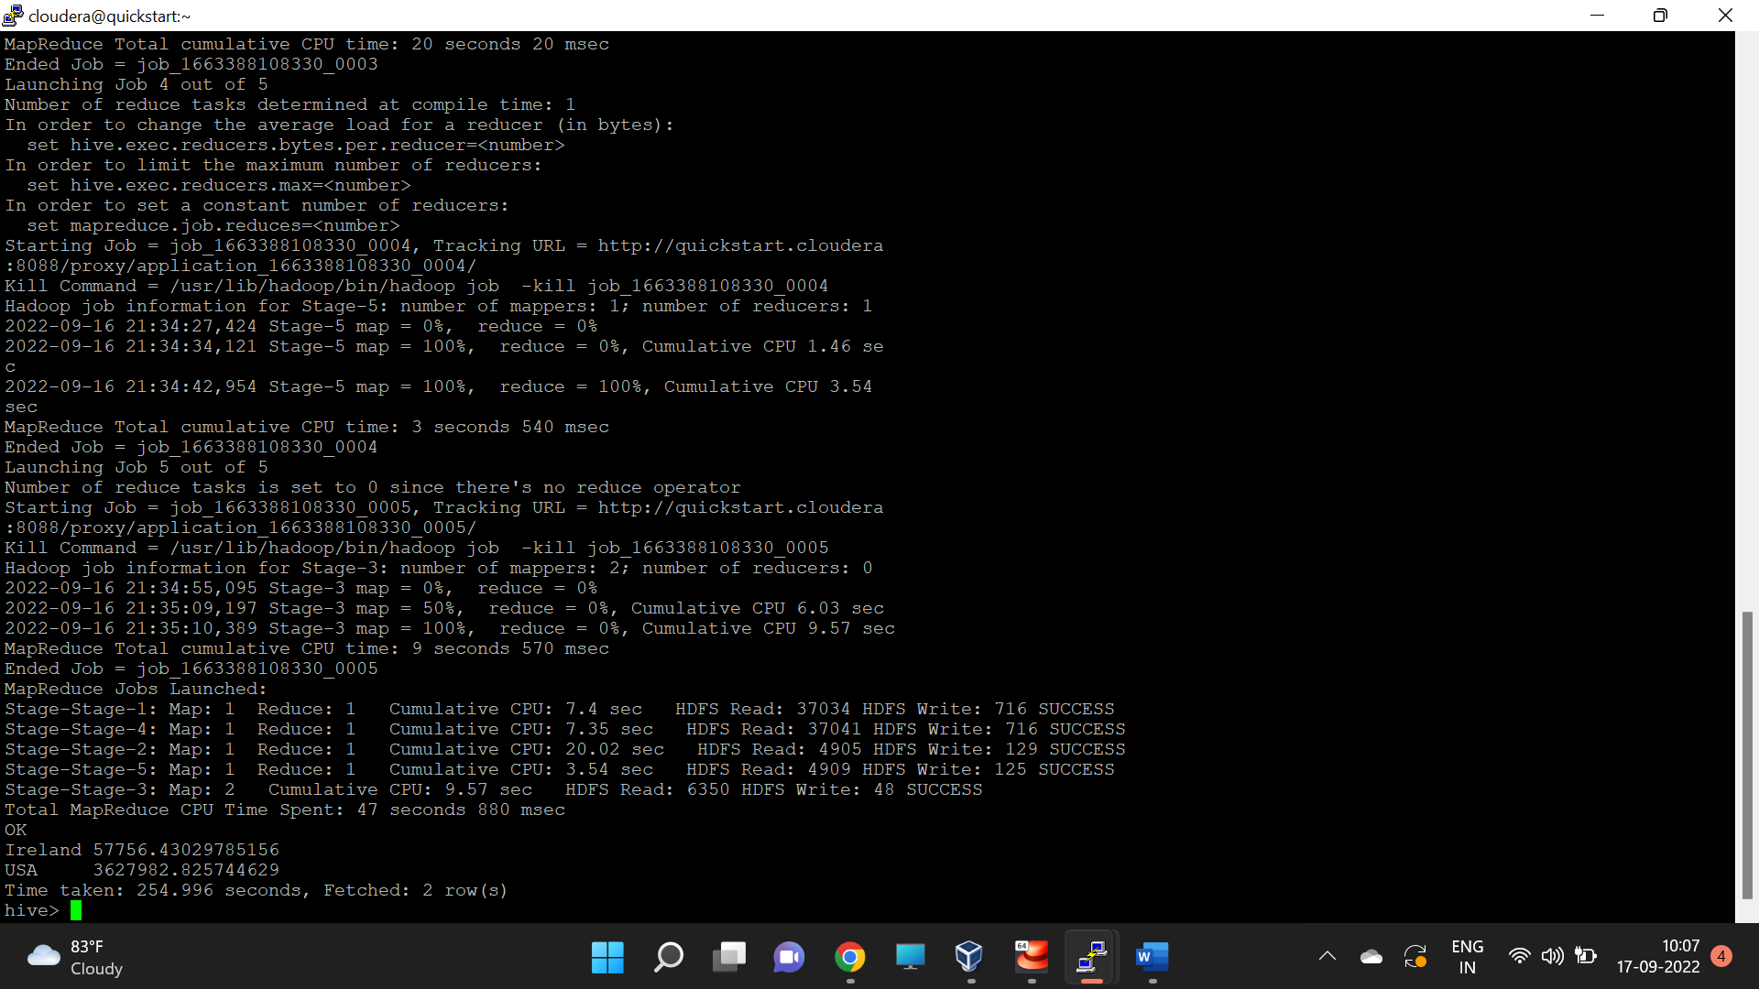

1. Calculate quartelry sales for each city

select city, qtr_id, sum(sales) as total_quarterly_sales from sales_order_orc group by city, qtr_id;

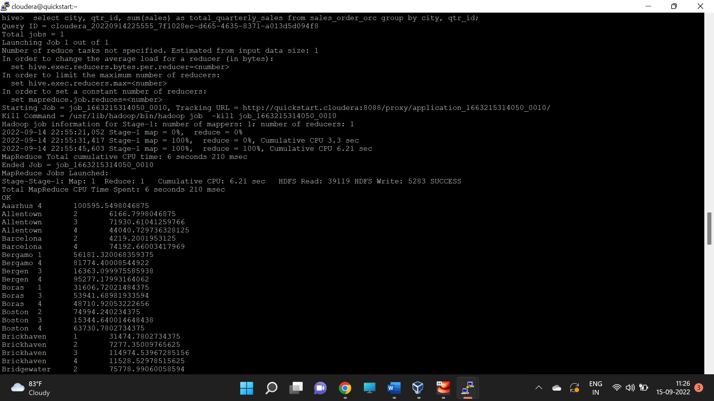

1. Find a month for each year in which maximum number of quantities were sold

select year_id,month_id,total_quantityordered from (select year_id, month_id, total_quantityordered, dense_rank() over (partition by year_id order by total_quantityordered desc) as dns from (select year_id, month_id, sum(quantityordered) as total_quantityordered from sales_order_csv group by year_id, month_id)t1)t2 where dns = 1;

