МИНИСТЕРСТВО НАУКИ И ВЫСШЕГО ОБРАЗОВАНИЯ
РОССИЙСКОЙ ФЕДЕРАЦИИ
федеральное государственное автономное
образовательное учреждение высшего образования
«Самарский национальный исследовательский университет
имени академика С.П. Королева»
(Самарский университет)

Институт информатики, математики и электроники
Факультет информатики
Кафедра суперкомпьютеров и общей информатики

Отчет по лабораторной работе №1
Тема: «VM and RAID1»

Выполнил: Филиппов Р. Р.
Группа: 6411-100503D

Самара 2022

Steps
- Create Virtual Machine with Debian/Ubuntu/CentOS or download preinstalled image (https://www.osboxes.org/). VM without GUI.
- Add simple RAID1 to Virtual Machine: *nix OS System on 1-st HDD, 2d and 3d HDDs are in RAID1. 2 (with star). only two HDDs. OS System on RAID1, based on this two HDD.
- How to test RAID1. Create file on RAID1 file system. Turn off VM and remove one of the HHDs from VM. Turn on VM. File should be accessible.
- Add new HDD and sync it to RAID1.
- Add section with Assignment1 description into docx and send by e-mail for checking.

Description
Step 1
Install an Ubuntu Server 20.04 virtual machine using Virtual Box and add two additional HDDs to the VM:
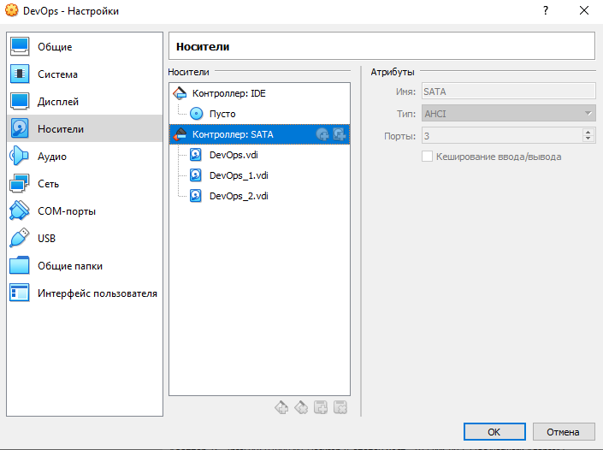
Step 2
Establish the connection from Windows to the VM with SSH in PuTTY:
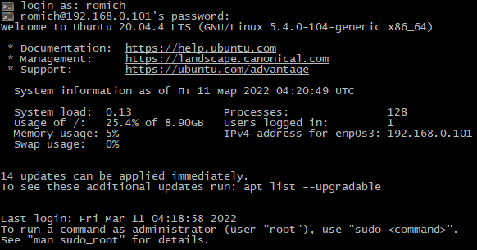

List all disks of the VM using the lsblk command:
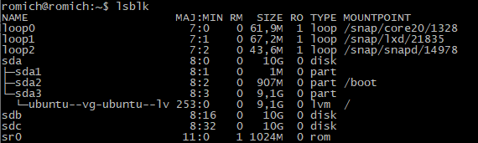
Create two primary partitions sdb1 and sdc1 respectively with the fdisk utility program:
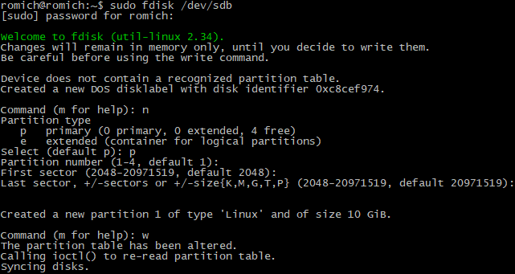
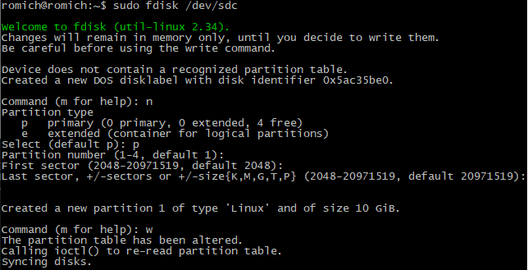

Check for creation success:
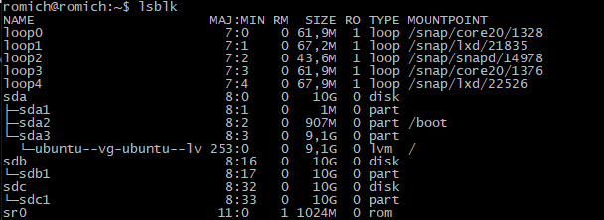
Create a RAID1 array in /dev/md0 based on the created partitions using the mdadm command:
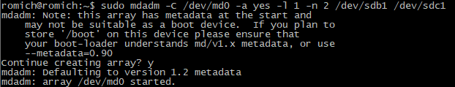
Create a file system based on RAID1:
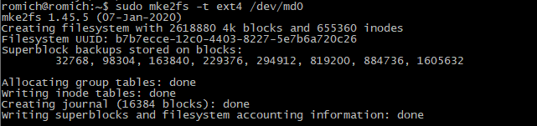
Mount the file system:
Check for success:
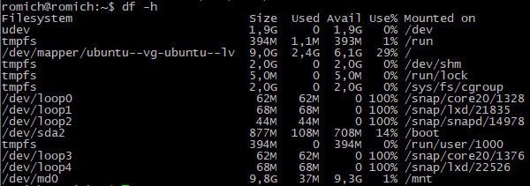
Get the UUID of the RAID1 array:
Then edit the /etc/fstab file containing the boot information and paste the UUID in there with corresponding options:
Edited file:
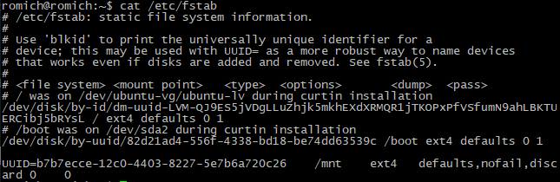
Step 3
Test RAID1:
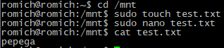
Then remove sdc1 from RAID1 and check if the file is left:
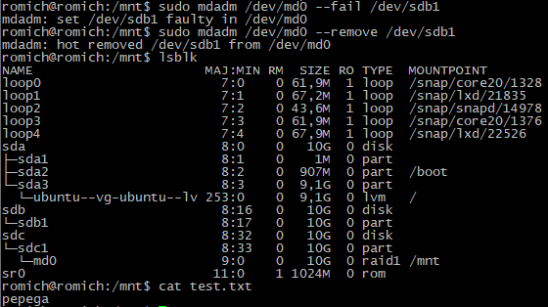

Turn off the VM and remove one of the disks:
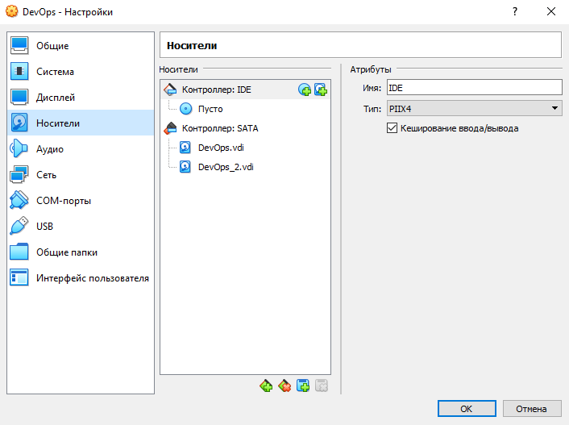
Check for success:
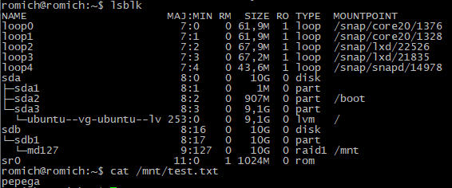

Step 4
Turn the VM off and add a new HDD:
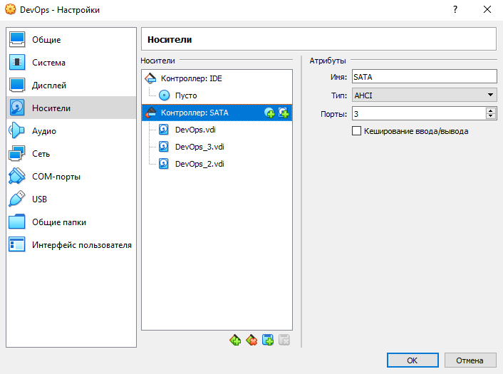
Check for success:
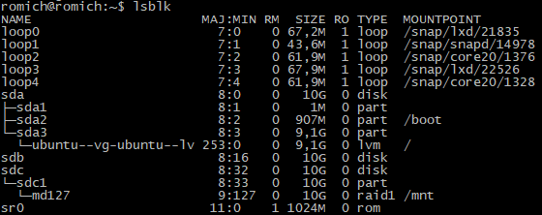

Create primary partition sdb1 respectively with the fdisk utility program:
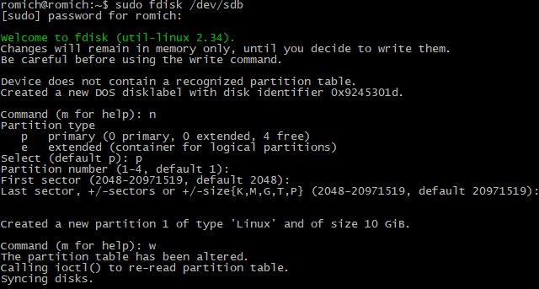
Check for success:
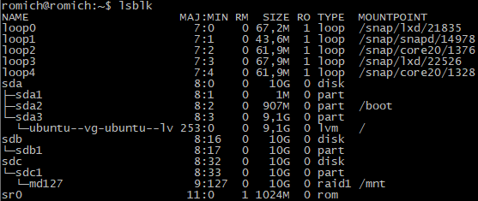
Add new HDD with the following command and check for success:
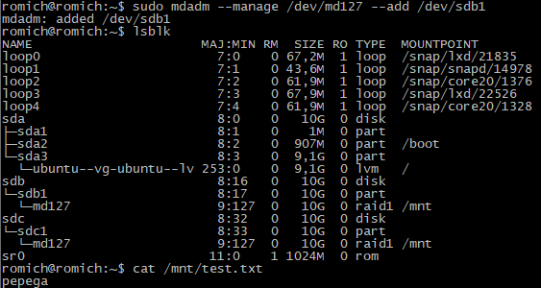

Conclusion
In the conclusion, we studied the basic utilities of the Ubuntu system for working with the file system, partitioning and creating RAID arrays, all steps completed successfully.

