МИНИСТЕРСТВО НАУКИ И ВЫСШЕГО ОБРАЗОВАНИЯ
РОССИЙСКОЙ ФЕДЕРАЦИИ
федеральное государственное автономное
образовательное учреждение высшего образования
«Самарский национальный исследовательский университет
имени академика С.П. Королева»
(Самарский университет)

Институт информатики, математики и электроники
Факультет информатики
Кафедра геоинформатики и информационной безопасности

Отчет по лабораторной работе №1
Дисциплина: «Развертывание и жизненный цикл программного обеспечения»

Тема: «VM and RAID»

Выполнил: Мещеряков А.Е.
Группа: 6412-100503D

Самара 2022
Steps

- Create Virtual Machine with Debian/Ubuntu/CentOS or download preinstalled image (https://www.osboxes.org/). VM without GUI.
- Add simple RAID1 to Virtual Machine: *nix OS System on 1-st HDD, 2d and 3d HDDs are in RAID1. 2 (with star). only two HDDs. OS System on RAID1, based on this two HDD.
- How to test RAID1. Create file on RAID1 file system. Turn off VM and remove one of the HHDs from VM. Turn on VM. File should be accessible.
- Add new HDD and sync it to RAID1.
- Add section with Assignment1 description into docx and send by e-mail for checking.

Create Virtual Machine with Debian/Ubuntu/CentOS or download preinstalled image (https://www.osboxes.org/). VM without GUI.
I downloaded preinstalled Debian 11 Server image.
Add simple RAID1 to Virtual Machine: *nix OS System on 1-st HDD, 2d and 3d HDDs are in RAID1. 2 (with star). only two HDDs. OS System on RAID1, based on this two HDD.
Add two HDDs to our virtual machine.
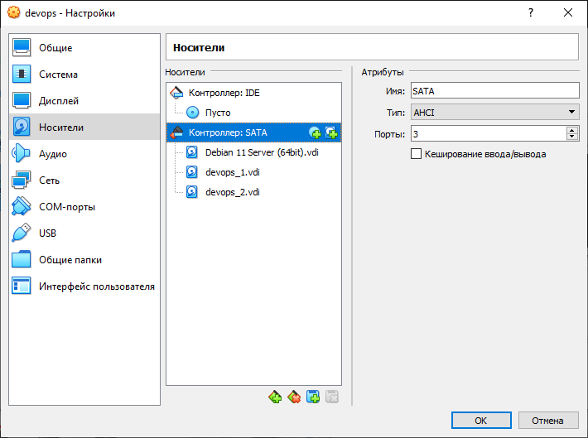
List all disks of our virtual machine.
lsblk
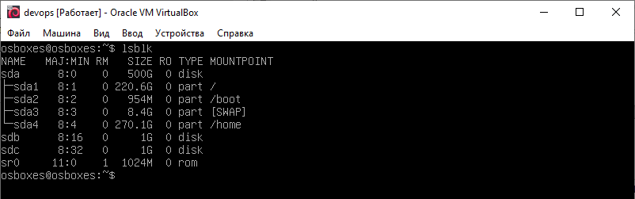

Create RAID 1 on sdb, sdc:
Firstly, create primary partitions on sdb, sdc.
sudo fdsik /dev/sdb
sudo fdisk /dev/sdc
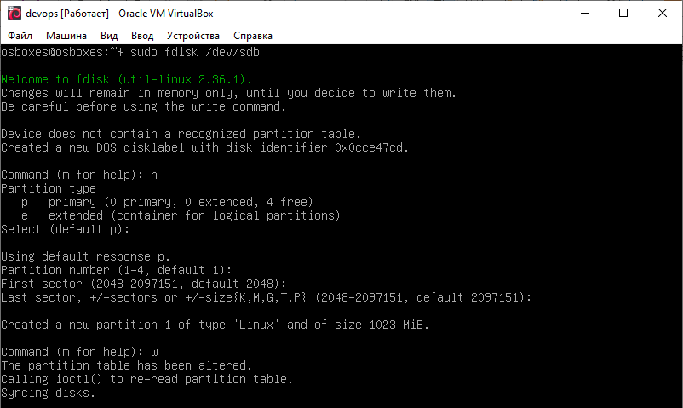
Two partitions (sdb1, sdc1) successfully created.
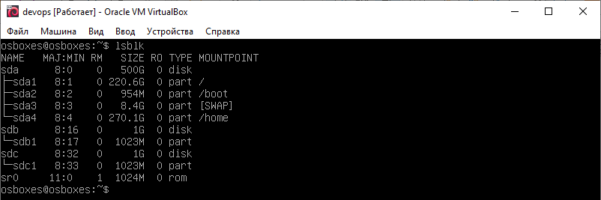
Secondly, create RAID 1 array in /dev/md0.
sudo mdadm -C /dev/md0 -a yes -l 1 -n 2 /dev/sd{b,c}1
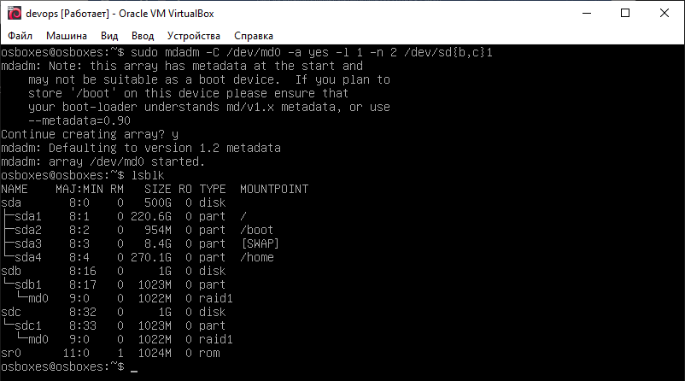
Thirdly, create ext4 filesystem on /dev/md0 and mount it in /mnt.
sudo mke2fs -t ext4 /dev/md0
sudo mount /dev/md0 /mnt
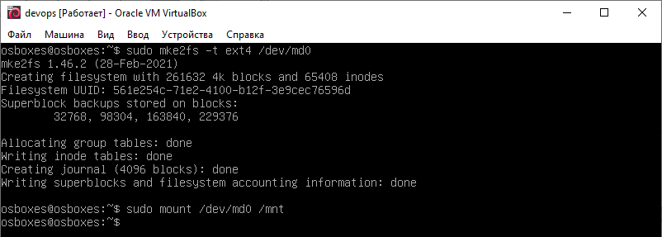

List mounted filesystems.
df -h
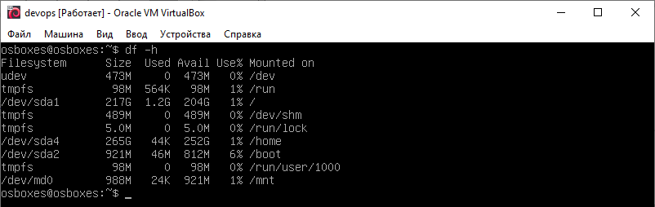
Make created partitions to mount automatically when system boots:
Firstly, get the UUID of RAID 1 array.
sudo blkid /dev/md0
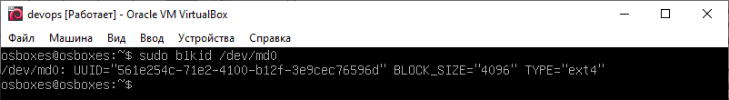
Secondly, edit /etc/fstab file as show on the picture below.
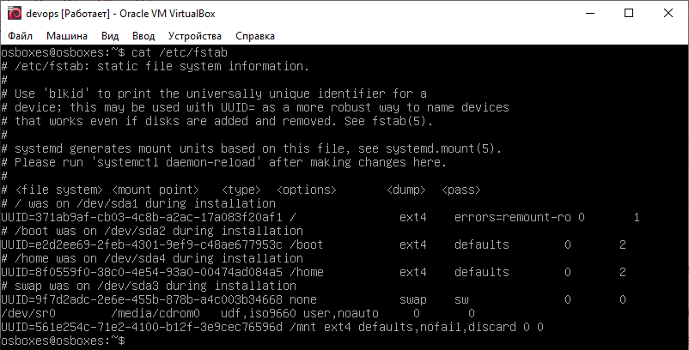

How to test RAID1. Create file on RAID1 file system. Turn off VM and remove one of the HHDs from VM. Turn on VM. File should be accessible.
Firstly, create file test.txt on RAID 1 filesystem.
sudo touch /mnt/test.txt
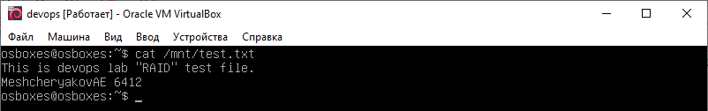
Secondly, remove sdc1 from RAID 1 and wipe filesystem on it.
sudo mdadm /dev/md0 --fail /dev/sdc1
sudo mdadm /dev/md0 --remove /dev/sdc1
sudo wipefs -a /dev/sdc1
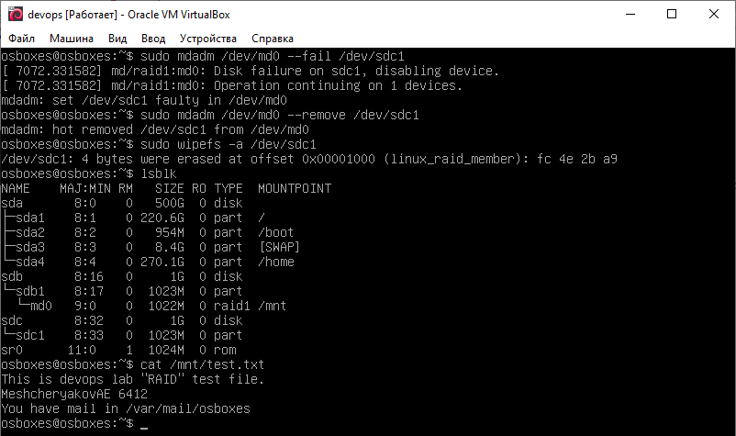
As we can see on the picture above, our file test.txt is still available.

And we got a mail from mdadm about our sdc1 failure. It contains our RAID status.
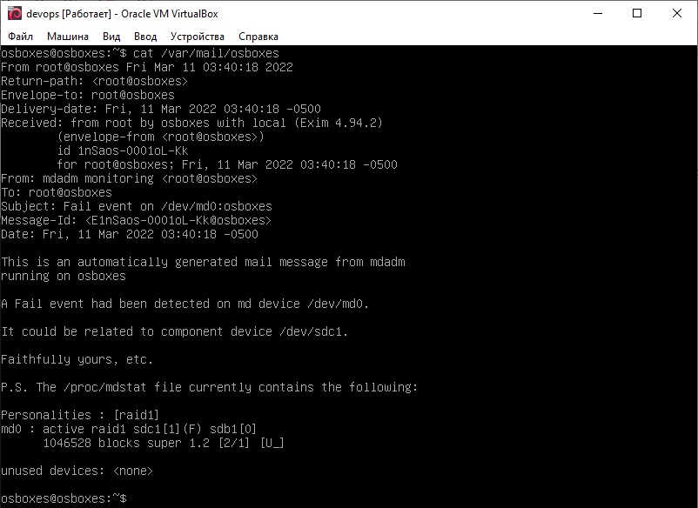

Thirdly, turn off virtual machine and remove devops_2.vdi.
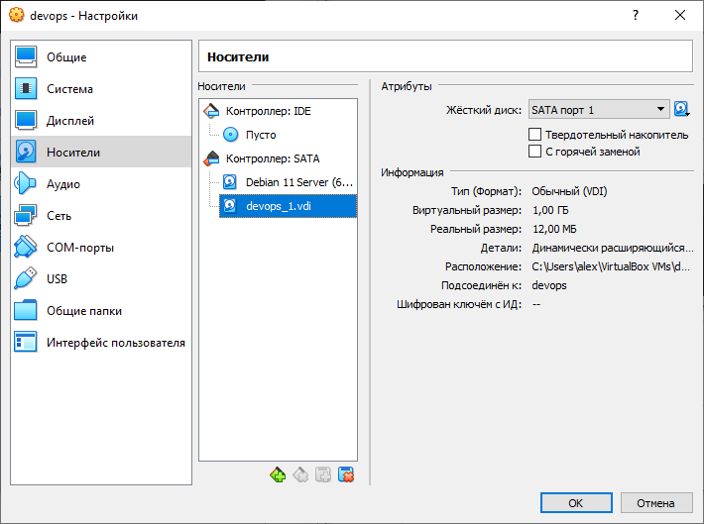
Fourthly, check whether our test.txt is available.
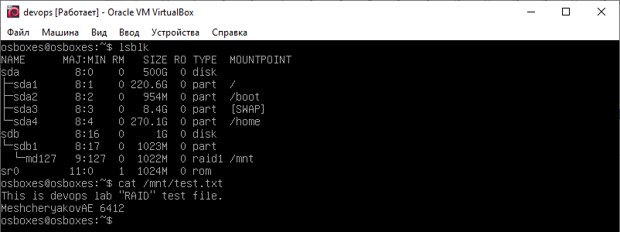

Add new HDD and sync it to RAID1.
Firstly, turn off virtual machine and add new devops_3.vdi.
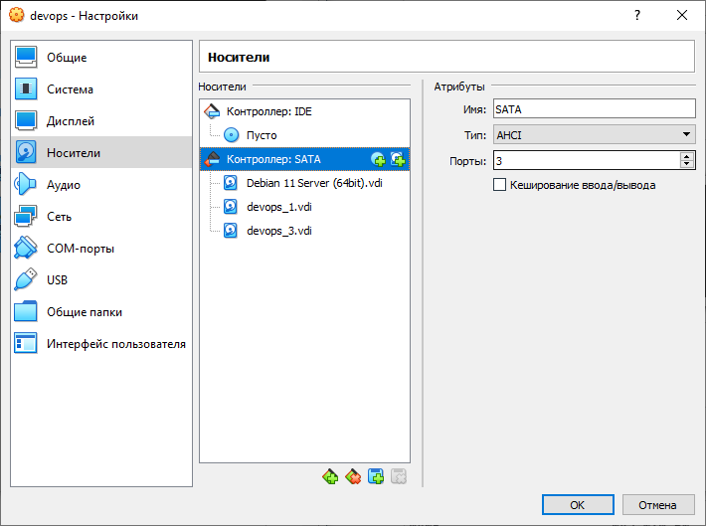
Secondly, create primary partition on our new disk.
sudo fdisk /dev/sdc
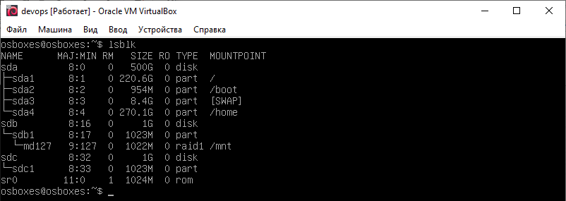

Thirdly, add sdc1 to our RAID 1.
sudo mdadm --manage /dev/md127 --add /dev/sdc1
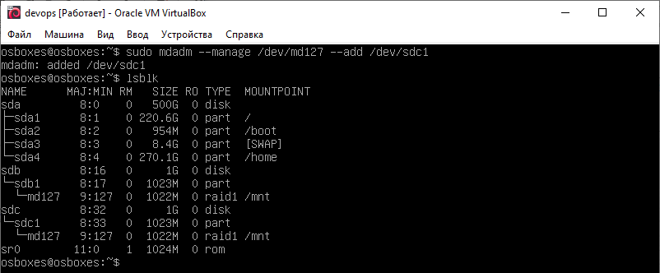
Check our RAID status.
sudo mdadm -D /dev/md127
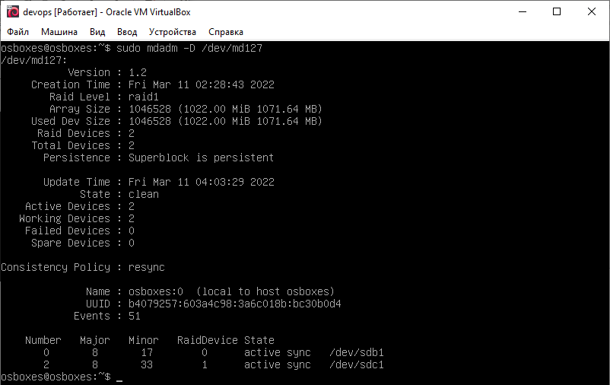

Check our test.txt.
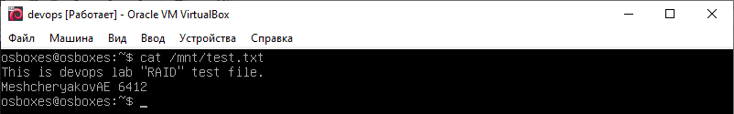
Our file is available.

In the conclusion of the laboratory work, the basic utilities of the Debian system studied for working with the filesystem, partitioning and creating RAID arrays. All steps completed successfully.

