МИНИСТЕРСТВО ОБРАЗОВАНИЯ И НАУКИ РОССИИ
ФЕДЕРАЛЬНОЕ ГОСУДАРСТВЕННОЕ АВТОНОМНОЕ
ОБРАЗОВАТЕЛЬНОЕ УЧРЕЖДЕНИЕ ВЫСШЕГО ОБРАЗОВАНИЯ
«САМАРСКИЙ НАЦИОНАЛЬНЫЙ ИССЛЕДОВАТЕЛЬСКИЙ УНИВЕРСИТЕТ ИМЕНИ АКАДЕМИКА С.П.КОРОЛЕВА»

Институт информатики и кибернетики
Инженерия программного обеспечения
DevOps
Отчёт по лабораторной работе №2
«Git and CI»

Выполнил: Усанов К.В.
Группа: 6411-100503D
Проверил: Авдеев Е.В.

Самара 2022

Steps
- Download Gitlab-Bitnami vm image from https://bitnami.com/stack/gitlab/virtual-machine
- Upload https://github.com/olindata/sample-gitlabci-cpp-project to your Gitlab server.
- To unblock SSH https://docs.bitnami.com/virtual-machine/faq/get-started/enable-ssh/
- https://askubuntu.com/questions/204400/ssh-public-key-no-supported-authentication-methods-available-server-sent-publ
- Install GitLab Runner using the official GitLab repositories https://docs.gitlab.com/runner/install/linux-repository.html
- Update /etc/gitlab/gitlab.rb to disable https on gitlab (yes, it is not for production)
# use here your IP, but is must be HTTP
external_url 'http://192.168.88.228'
nginx['redirect_http_to_https'] = false
nginx['ssl_verify_client'] = "off"
- Reconfigure GitLab for the changes to take effect:
$ sudo gitlab-ctl reconfigure
- Register runner. Choose shell executor type. Use your ip and registration-token for command below:
$ sudo gitlab-runner register --url http://192.168.88.228/ --registration-token yqjsLYNFrbjaC-QhmycE
- Edit .gitlab-ci.yml to run runner in shell mode (without Docker)
job:
script:
- g++ helloworld.cpp -o helloworld
- Run Pipeline: CI/CD > Pipelines > Run pipeline
In Job Logs you should see something like this:
Running with gitlab-runner 14.3.2 (e0218c92)
on debian Zv4xR9-x
Preparing the "shell" executor
00:00
Using Shell executor...
Preparing environment
00:00
Running on debian...
Getting source from Git repository
00:00
Fetching changes with git depth set to 50...
Reinitialized existing Git repository in /home/gitlab-runner/builds/Zv4xR9-x/0/root/sample-gitlabci-cpp-project/.git/
Checking out 69a8ab3b as main...
Removing helloworld
Skipping Git submodules setup
Executing "step_script" stage of the job script
00:01
$ g++ helloworld.cpp -o helloworld
Job succeeded

Completing
- Download Gitlab-Bitnami vm image, import it and log in.
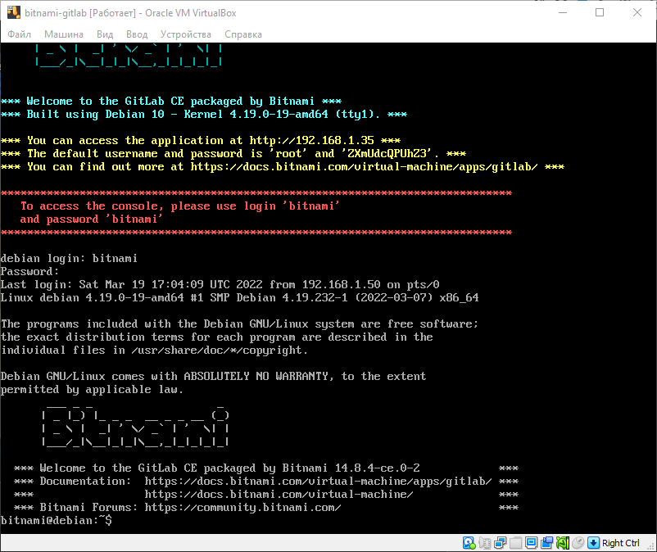

- Go to the deployed GitLab server using the generated login and password and upload the project downloaded from GitHub.
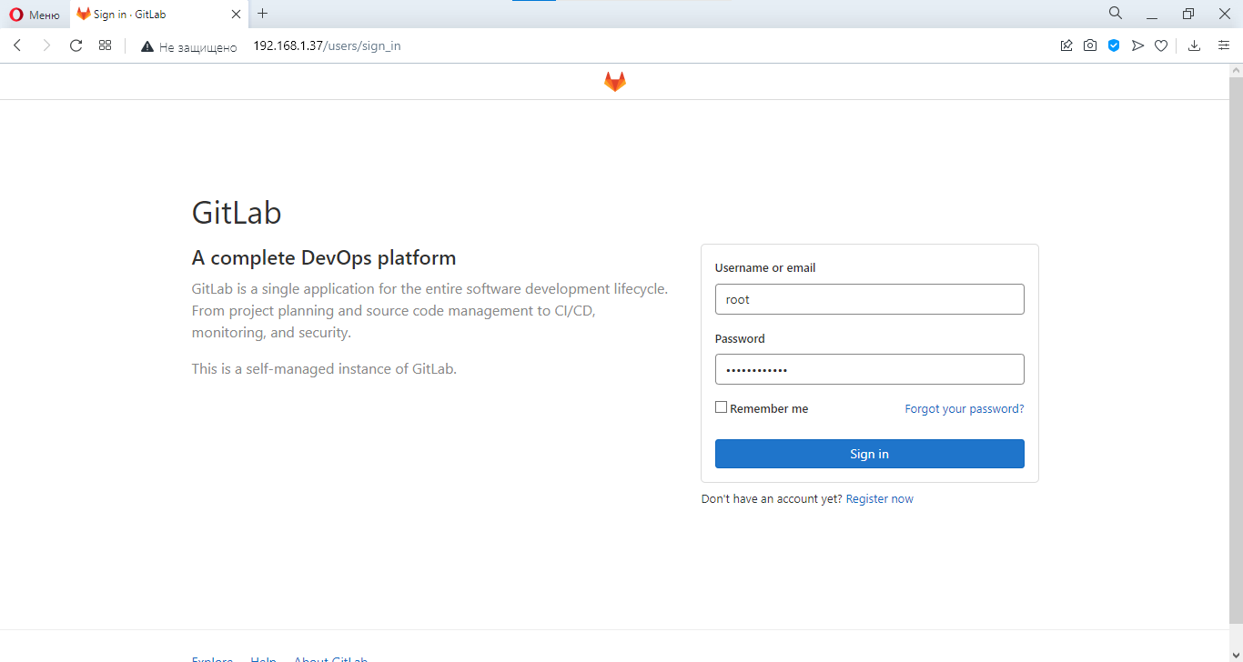

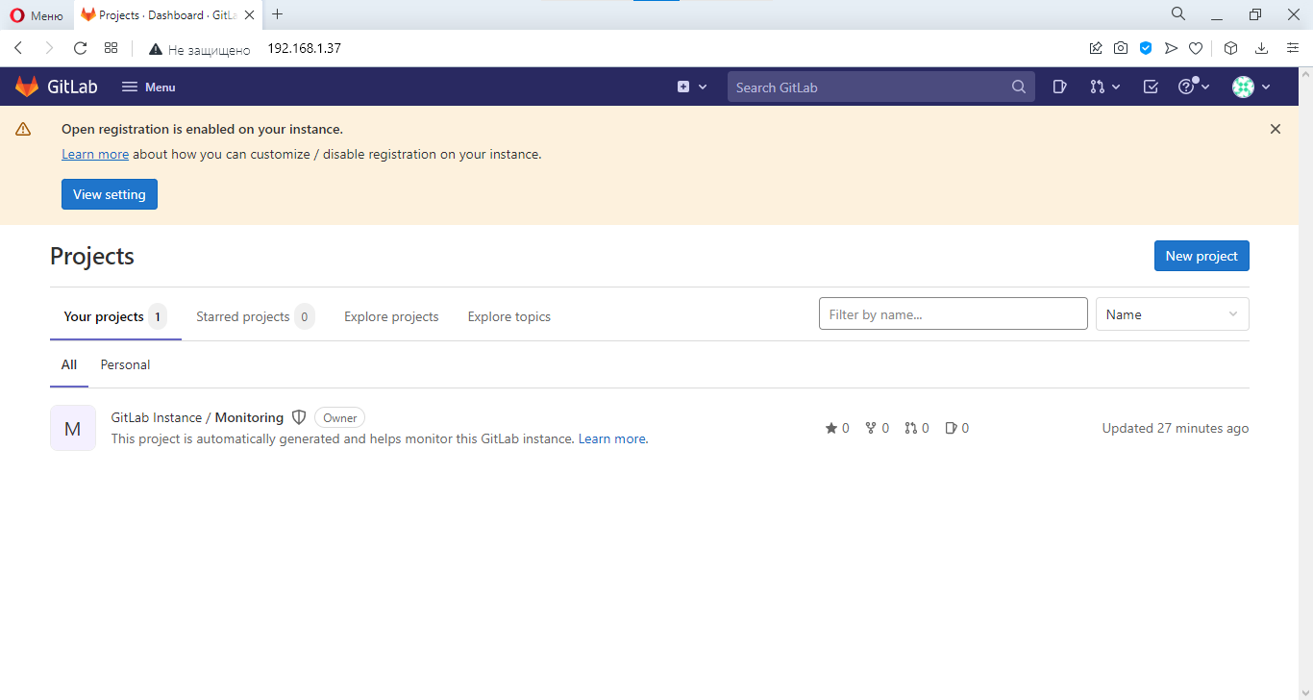

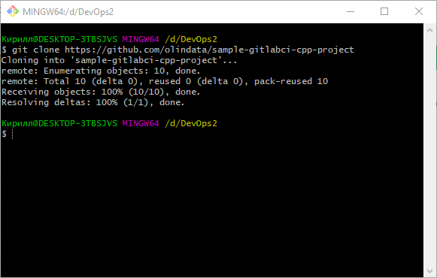

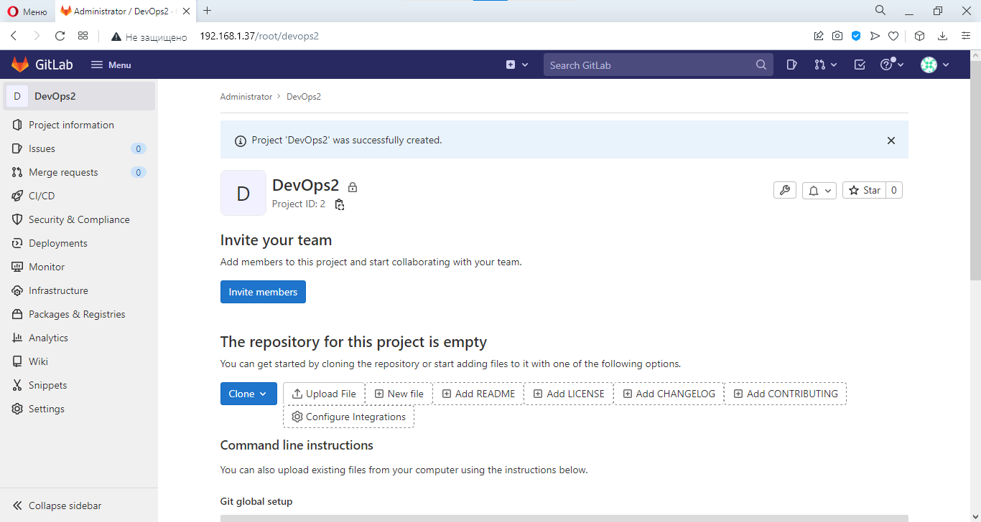

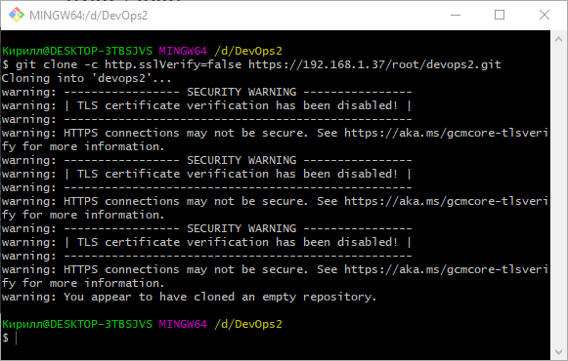

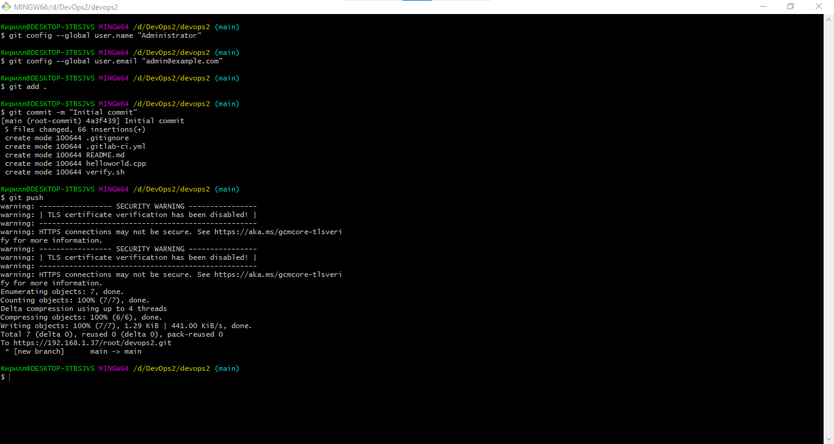

- Unlock SSH and connect via it.

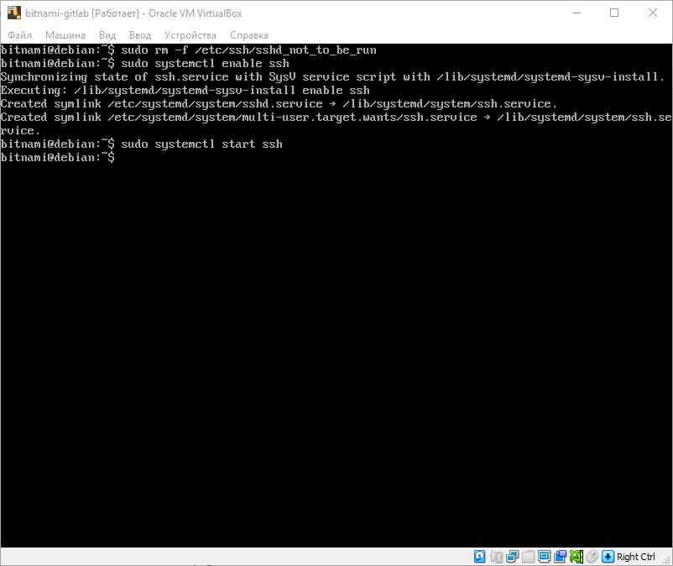
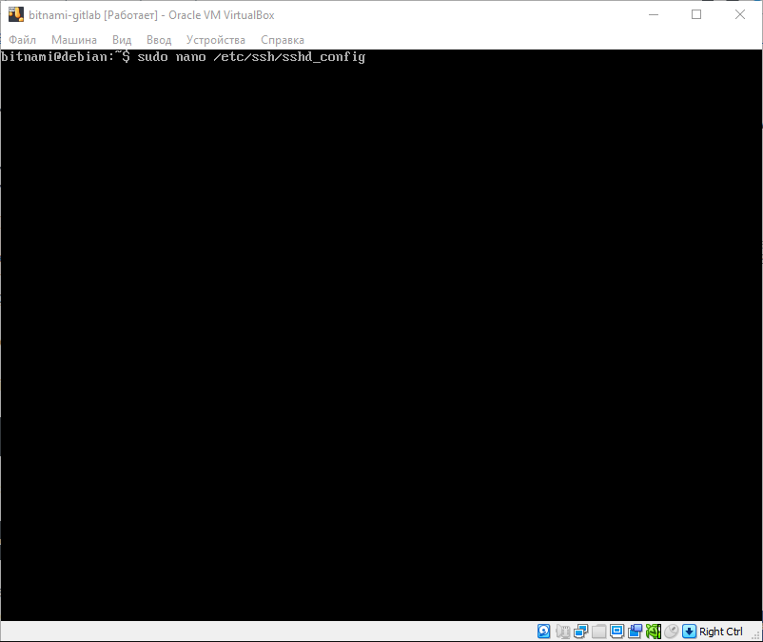

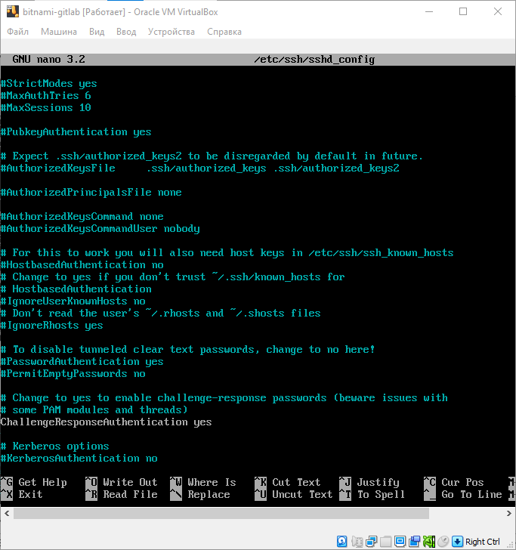
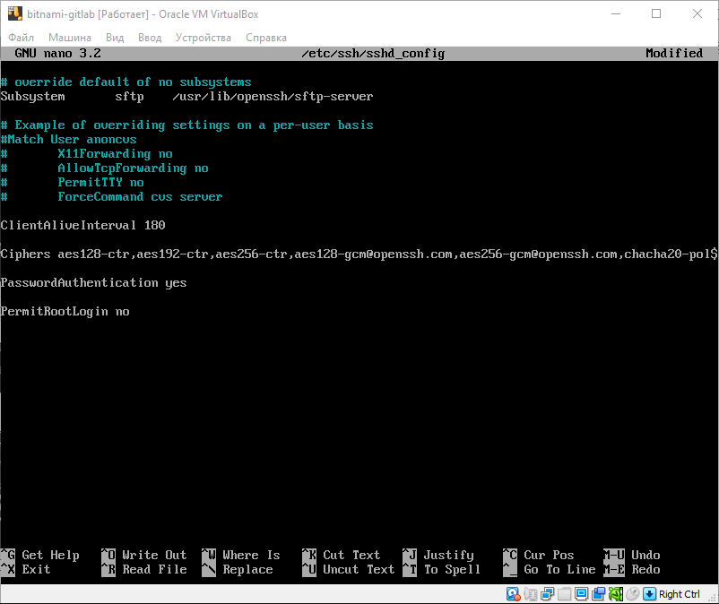

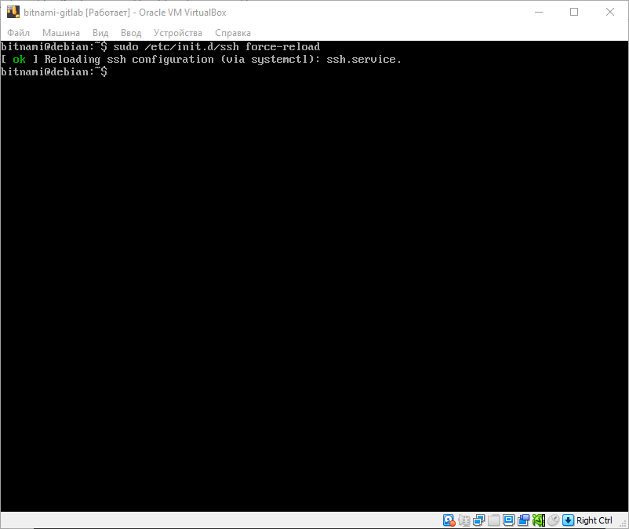

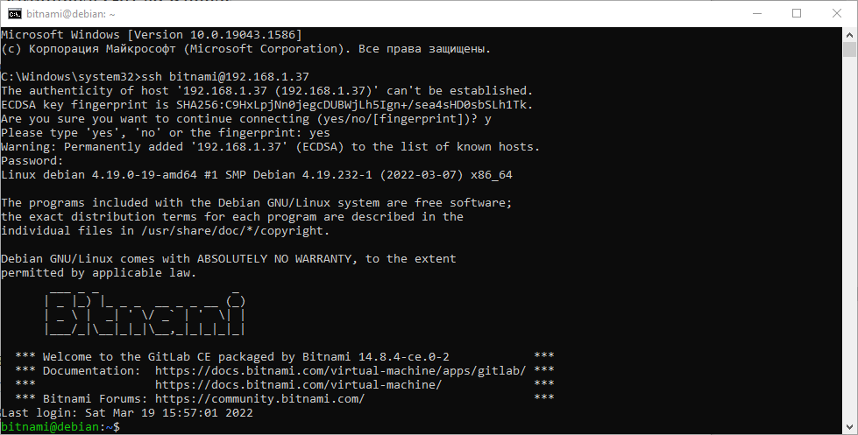

- Install the GitLab Runner

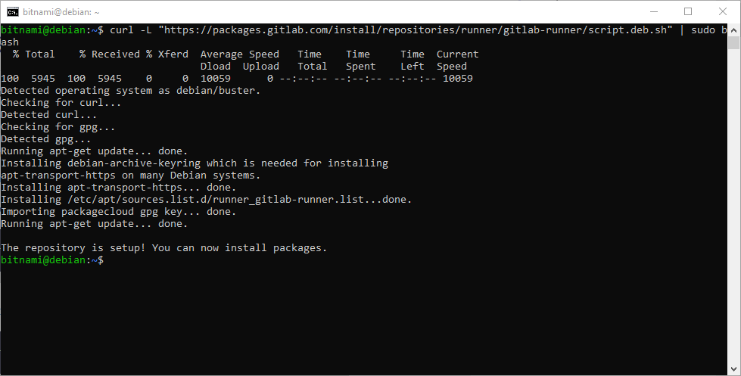

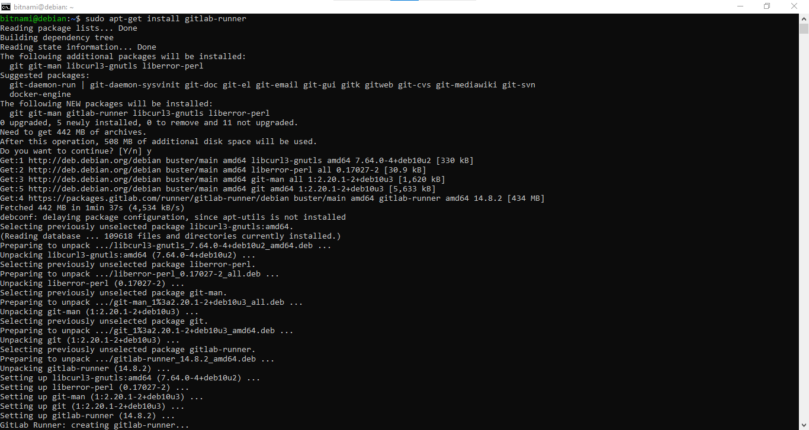

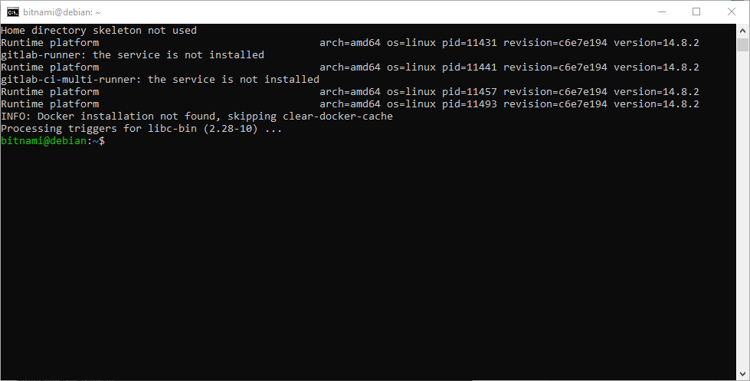

- Update /etc/gitlab/gitlab.rb to disable https on gitlab.

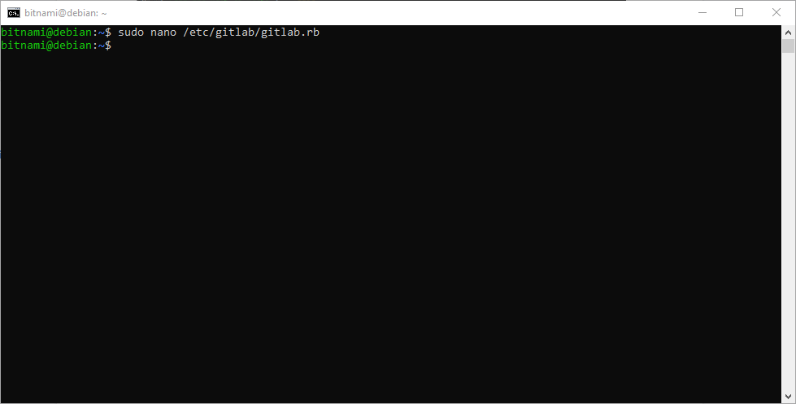

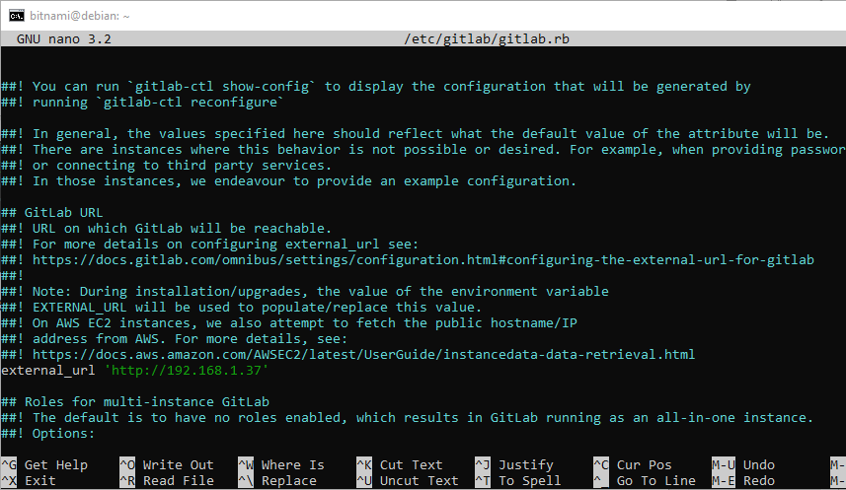

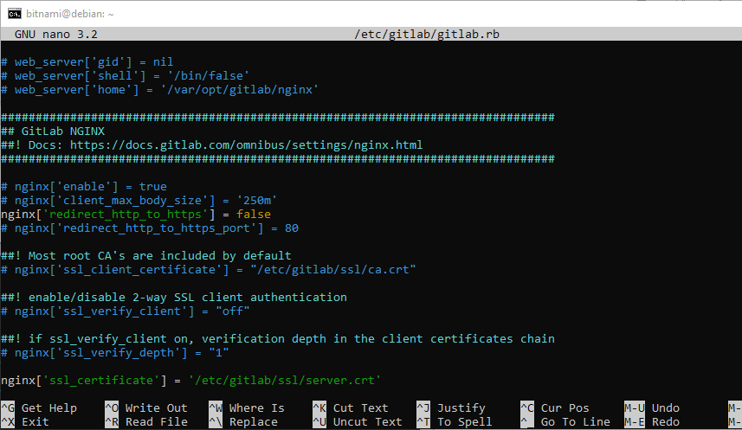

- Reconfigure GitLab for the changes to take effect
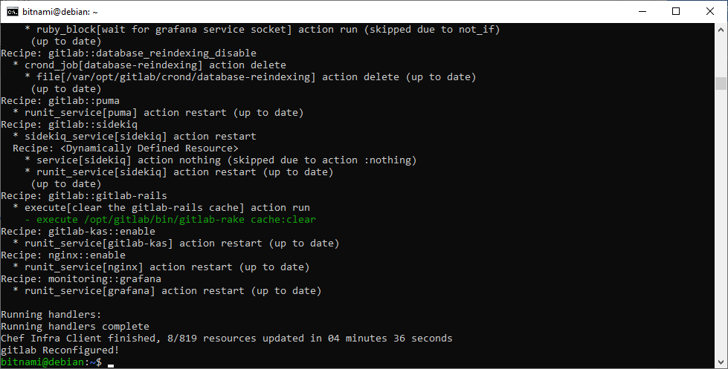

- Register runner.

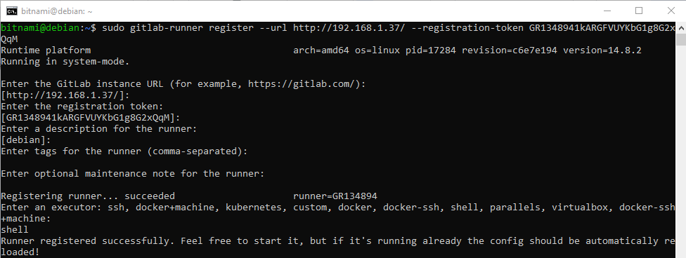

- Edit .gitlab-ci.yml to run runner in shell mode (without Docker), then commit and push.
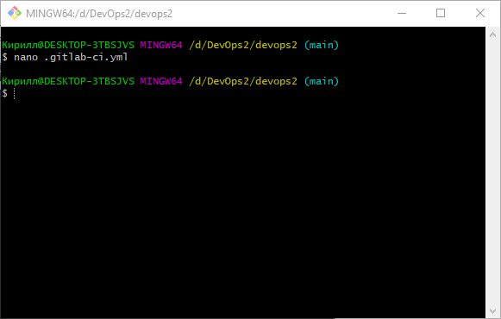

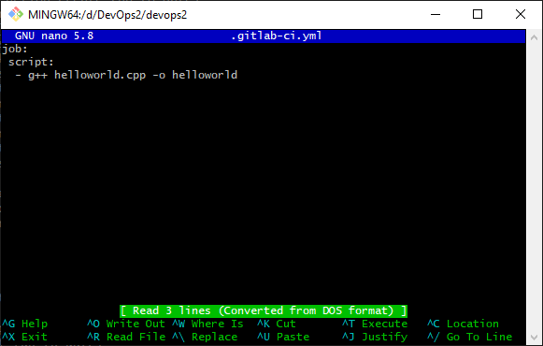

- Run Pipeline: CI/CD > Pipelines > Run pipeline

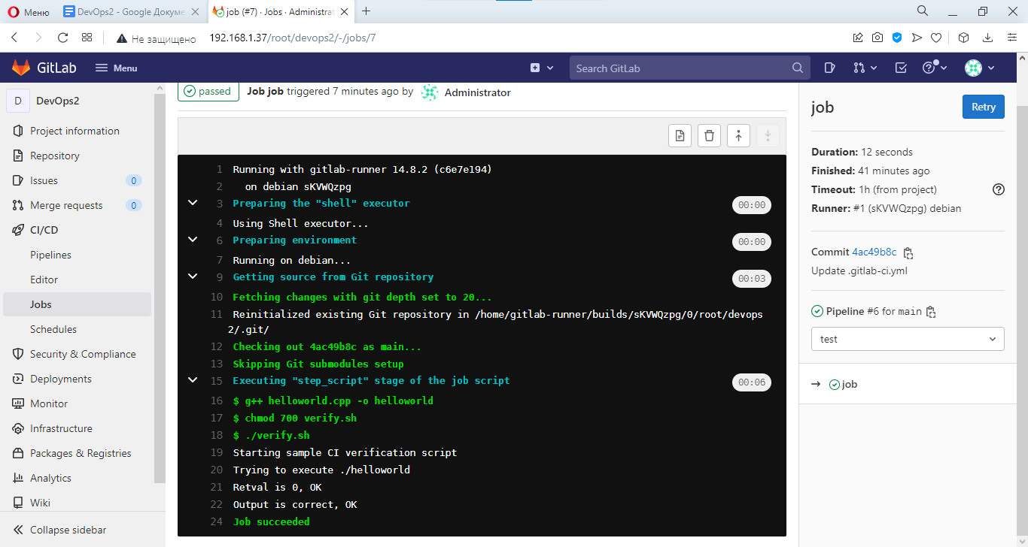

Conclusion
In this lab, we got to know GitLab, GitLab Runner, and CI, explored their interactions, and learned how to configure them.

