МИНИСТЕРСТВО НАУКИ И ВЫСШЕГО ОБРАЗОВАНИЯ  
РОССИЙСКОЙ ФЕДЕРАЦИИ

федеральное государственное автономное   
образовательное учреждение высшего образования  
«Самарский национальный исследовательский университет   
имени академика С.П. Королева»

(Самарский университет)

Институт информатики, математики и электроники

Факультет информатики  
Кафедра суперкомпьютеров и общей информатики

**Отчет по лабораторной работе №3**

Дисциплина: «Методы проектирования и поддержки требований к программному обеспечению»

Тема: **«Specification of system requirements. IDEF0 model»**

Тип предприятия: **Air Tickets chain.**

Выполнил: Нушкарев П.В.

Группа: 6133-010402D

Самара 2021

Objective: To explore the possibilities to describe the requirements for the designed software  
**Tasks**1. Create valid IDEF0 diagrams for the general company processes up to 3d level detailing. At 3d  
decomposition level should be at least one process with at least two actors collaboration.  
2. Add IDEF0 diagrams images to doc report.  
For IDEF0 diagram plotting you can use:  
∙ Ramus Educational (http://www.ramussoftware.com/en/index.php?option=com_docman&Itemid=6)  
does not work with modern JRE.  
∙ Microsoft Visio (non-Free).  
∙ Another available software tools (Libre Office Impress, draw.io, etc.).

**Notice**

You have to prepare at least 4 diagrams: A-0, A0, 2 or more decomposed A0 blocks.

|  |  |
| --- | --- |
| Model level |  |
| 0 | Top level A-0, one block. Arrows show object connection with environment. |
| 1 | A0. First level, contain top processes. |
| 2 | Second level, top processes decompositions. You have to show at least 2 decomposed A0 blocks. |

**PROCESS OF WORK**

The chosen company type is Air Tickets chain.

The purpose of the system: online booking of airline tickets.

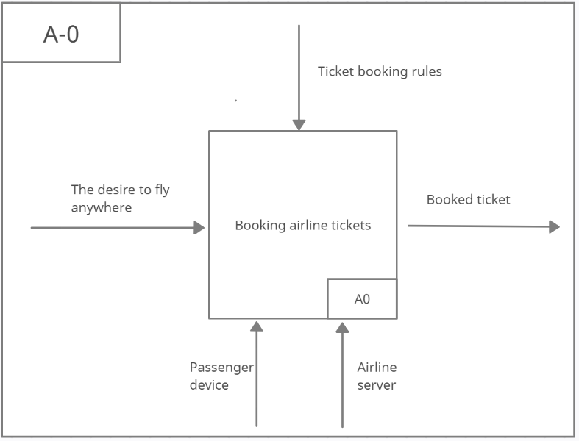

Figure 1 – IDEF0 diagram of the "Ticket booking" process. Level A-0

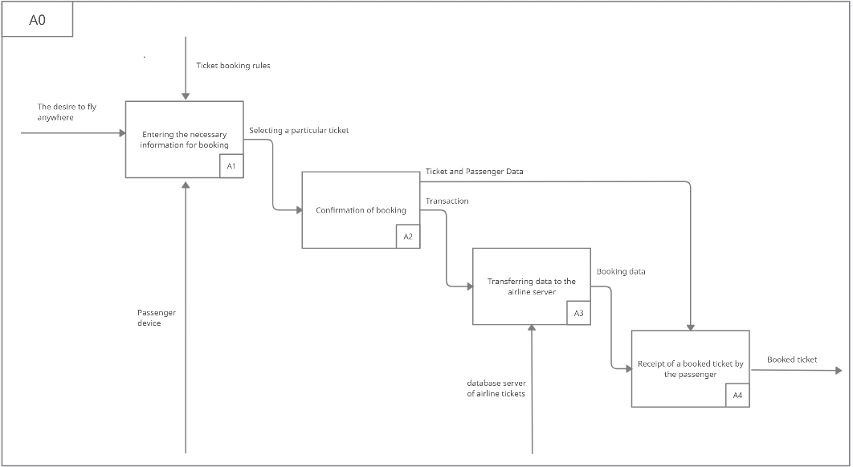

Figure 2 – IDEF0 diagram of the "Ticket booking" process. Level A0

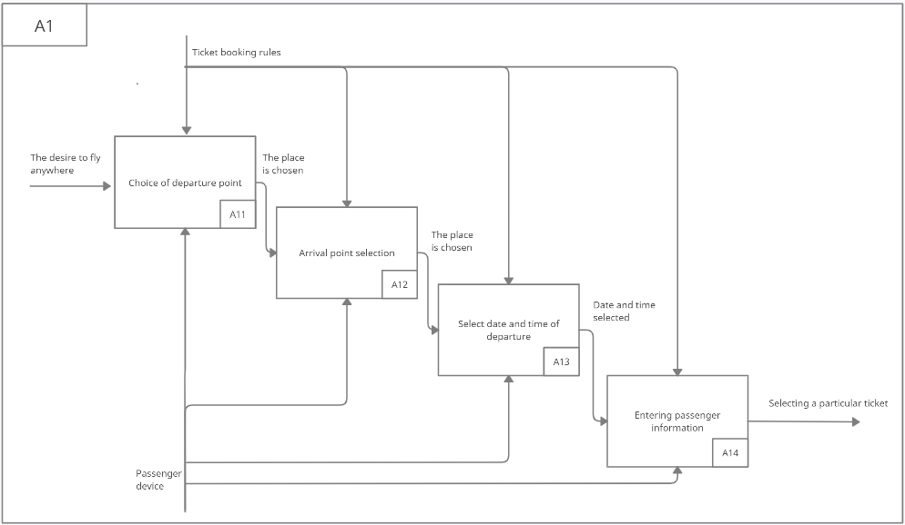

Figure 3 – IDEF0 diagram of the "Entering the necessary information for booking" process. Level A1

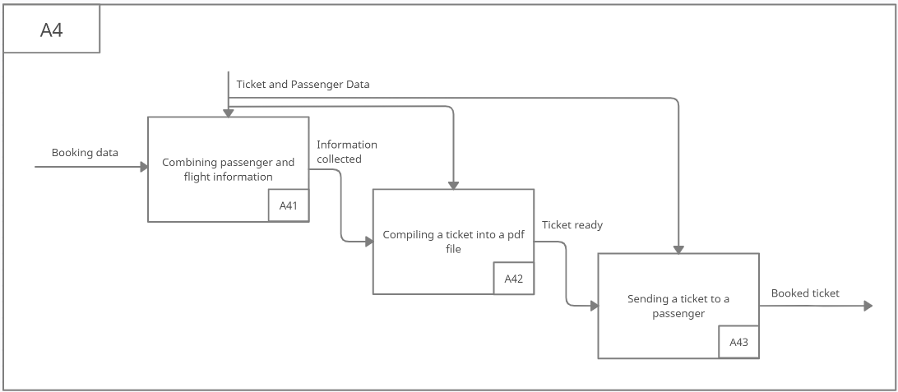

Figure 4 – IDEF0 diagram of the "Receipt of a booked ticket by the passenger" process. Level A4