МИНИСТЕРСТВО НАУКИ И ВЫСШЕГО ОБРАЗОВАНИЯ  
РОССИЙСКОЙ ФЕДЕРАЦИИ

федеральное государственное автономное   
образовательное учреждение высшего образования  
«Самарский национальный исследовательский университет   
имени академика С.П. Королева»

(Самарский университет)

Институт информатики, математики и электроники

Факультет информатики  
Кафедра технической кибернетики

**Отчет по лабораторной работе №2**

Дисциплина: «EnterpriseSystemsDevelopment»

Тема: **«Activity, Sequence, State diagram»**

Выполнила: Газизуллина Я.М.

Группа: 6133-010402D

Самара 2021

**ASSIGNMENT**

Objective: To study the basic features for creating and editing activity diagram

**Tasks**

1. Write scenario for each use case using template: use case name, actors, goal, short description, basic script, exceptions (if exist).

2. Complete scenarios with examples of documents to be created by your information system. For example, Bill in cafe, Internet invoice, Order in the online store, Medical services bill, etc

**WORK FLOW**

Use Case diagram

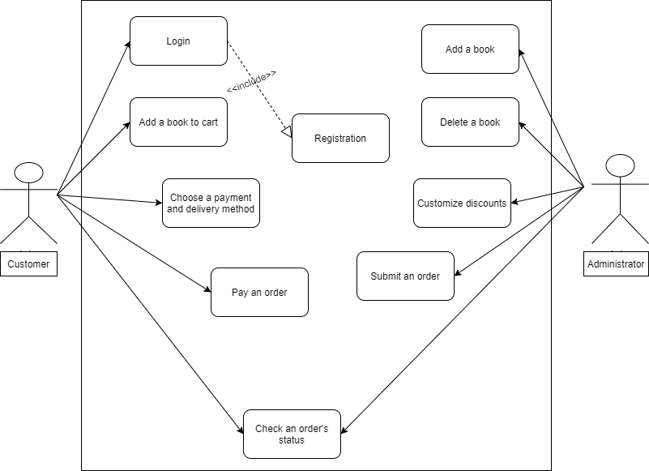

**Task 1**

**Use Case 1**

**Use Case:** Login

**Actors:** Customer

**Goal:** Login to the book shop

**Short description:** The customer logins to the book shop for buying or viewing personal info.

**Scenario:**

1. The customer opens the web-page of the book shop
2. The customer clicks the button “Login”
3. The customer fills input parameters: Username and password
4. The customer clicks the button “Login’.
5. The customer is successfully logged in

**Exception:** This username is not registered in the system.

**Use Case 2**

**Use Case:** Registration

**Actors:** Customer

**Goal:** Create an account in the book shop

**Short description:** The customer creates account for further use of the site and purchase of books.

**Scenario:**

1. The customer opens the web-page of the book shop
2. The customer clicks the button “Registration”
3. The customer fills input parameters: First name, last name, mobile phone number, username and password

**Exception:** Incorrect parameters

1. The customer clicks the button “Register.
2. The customer is successfully registered.

**Use Case 3**

**Use Case:** Add a book to cart

**Actors:** Customer

**Goal:** Add a book to cart for further buying

**Short description:** The customer chooses favourite books for buying

**Scenario:**

1. The customer opens the web-page of the book shop
2. The customer views books on page
3. The customer favourite books adds to cart

**Use Case 4**

**Use Case:** Choose payment and delivery method

**Actors:** Customer

**Goal:** Payment and delivery

**Short description:** The customer chooses payment and delivery method

for buying

**Scenario:**

1. The customer opens the web-page of the book shop
2. The customer favourite books adds to cart
3. The customer clicks the button “Proceed to checkout”
4. The customer logins
5. The customer chooses the way of payment and adds card’s info: First name, last name, number of card.

**Exception:** Incorrect format of card.

1. The customer chooses the way of delivery and fills necessary address.

**Use Case 5**

**Use Case:** Check an order’s status

**Actors:** Customer

**Goal:** Verify an order

**Short description:** The customer checks an order’s status

**Scenario:**

1. The customer opens the web-page of the book shop
2. The customer logins
3. The customer clicks the button “Orders”
4. The customers views the order’s status

The table “Orders”

|  |  |  |
| --- | --- | --- |
| Order’s number | Books | Status |
| The order 3758 | Donna Tartt “The Goldfinch” | Left the store |

**Use Case 6**

**Use Case:** Add a book

**Actors:** Administrator

**Goal:** Add a book

**Short description:** The administrator adds a new book for sale

**Scenario:**

1. The administrator opens the web-page of the book shop
2. The administrator logins
3. The administrator clicks the button “Add new book”
4. The administrator fills necessary fileds:

* Author
* Name of a book
* Description
* Price

1. The administrator clicks the button “Save”

**Exception:** Blank parameters

1. The new book is added

**Use Case 7**

**Use Case:** Delete a book

**Actors:** Administrator

**Goal:** Delete a book

**Short description:** The administrator deletes a book

**Scenario:**

1. The administrator opens the web-page of the book shop
2. The administrator logins
3. The administrator finds a right book
4. The administrator clicks the button “Delete a book”
5. The book is deleted

**Use Case 8**

**Use Case:** Customize discounts

**Actors:** Administrator

**Goal:** Delete a book

**Short description:** The administrator customizes discounts

**Scenario:**

1. The administrator opens the web-page of the book shop
2. The administrator logins
3. The administrator finds a right book
4. The administrator changes the price according to the discount
5. Price of the book was changed according to the discount

**Use Case 9**

**Use Case:** Submit an order

**Actors:** Administrator

**Goal:** Submit an order

**Short description:** The administrator submits the order

**Scenario:**

1. The administrator opens the web-page of the book shop
2. The administrator logins
3. The administrator finds the necessary order
4. The administrator checks all necessary fields and submit the order.
5. The order is submitted

The table “Orders”

|  |  |  |
| --- | --- | --- |
| Order’s number | Books | Status |
| The order 3758 | Donna Tartt “The Goldfinch” | Submitted |

**CONCLUSION**

In the course of the laboratory work basic features for creating and editing activity diagrams were studied, scenarios for each case were written.