МИНИСТЕРСТВО НАУКИ И ВЫСШЕГО ОБРАЗОВАНИЯ  
РОССИЙСКОЙ ФЕДЕРАЦИИ

федеральное государственное автономное   
образовательное учреждение высшего образования  
«Самарский национальный исследовательский университет   
имени академика С.П. Королева»

(Самарский университет)

Институт информатики, математики и электроники

Факультет информатики  
Кафедра технической кибернетики

**Отчет по лабораторной работе №6**

Дисциплина: «EnterpriseSystemsDevelopment»

Тема: **«Business process implementation»**

Выполнила: Газизуллина Я.М.

Группа: 6133-010402D

Самара 2021

**ASSIGNMENT**

Objective: To study the business process implementation with Cuba Platform

**Tasks**

1. Create Cuba Platform project, which will implement one of business processes of previously selected organization.

2. Add section to doc report image, which should include:

* Selected business process description (several sentences). It is desirable that the business process be the same as business process described in assignment #4.
* Instructions for running the application, prerequisites.
* Step-by-step instruction with demonstration of business process automation using the application.

3. Send zipped Cuba Project files and doc report to j-avdeev@yandex.ru

**WORK FLOW**

The created project allows to add new books, customers and create orders and edit these entities,

The picture 1 shows adding a new book.

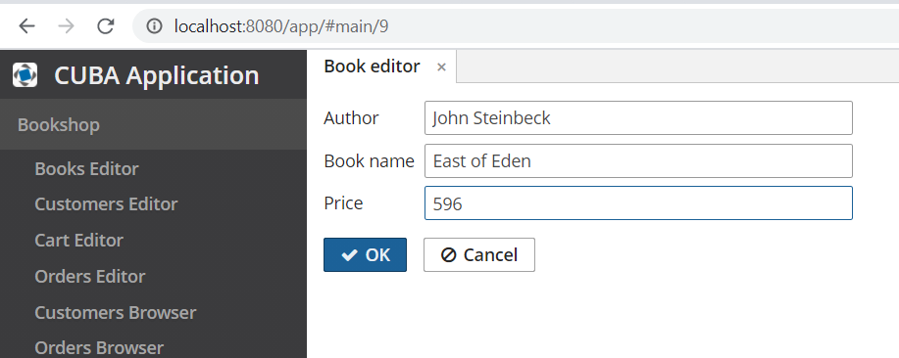

**The picture 1.** Adding a new book

The picture 2 shows adding a new customer.

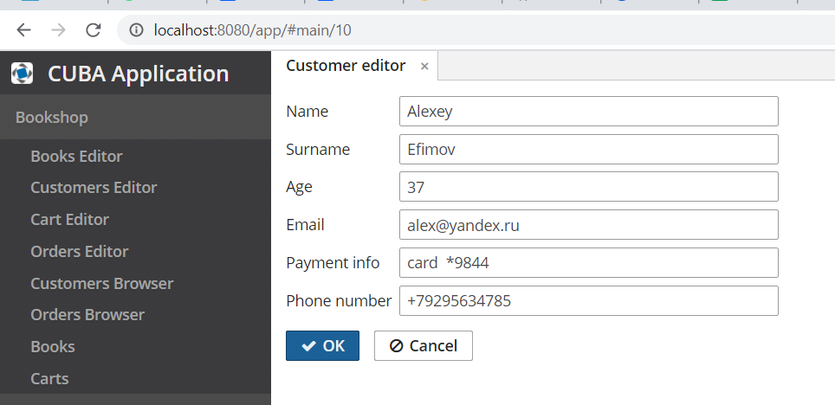

**The picture 2.** Adding a new customer

The picture 3 shows adding a book to cart.

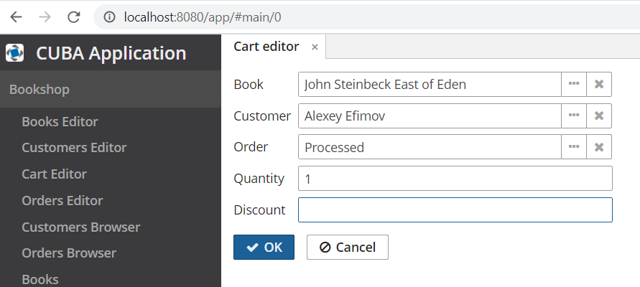

**The picture 3.** Adding a book to cart

The picture 4 shows creation of a new order.

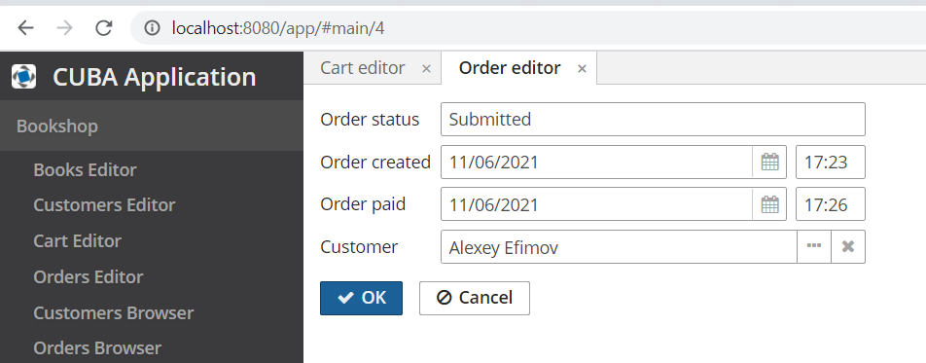

**The picture 4.** Creation of a new order

The picture 5 shows possibilities of the entity “Customers”. We can create a new customer, edit and delete exisited customer.

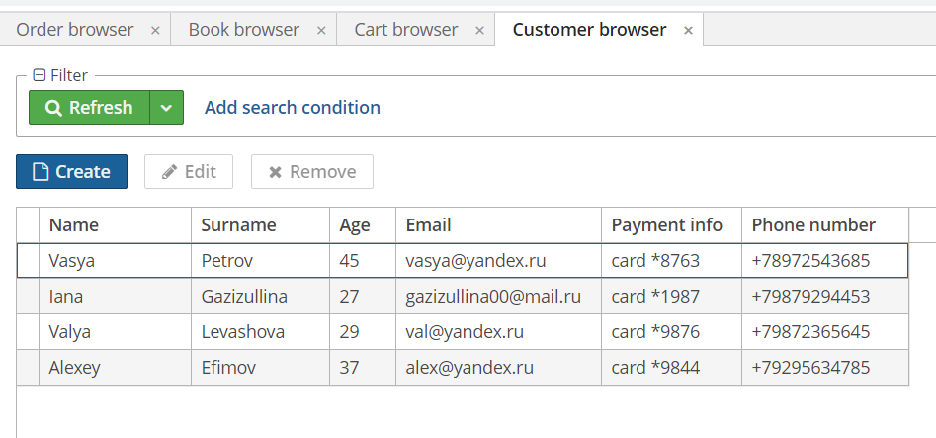

**The picture 5.** Customers

The picture 6 shows possibilities of the entity “Orders”. We can create a new order, edit and delete exisited order.

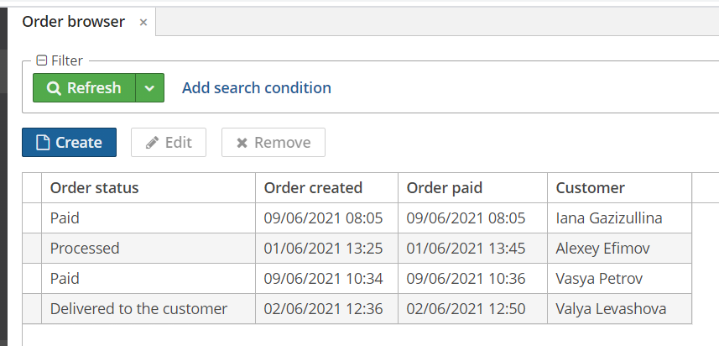

**The picture 6.** Orders

The picture 7 shows possibilities of the entity “Books”. We can create a new order, edit and delete exisited book.

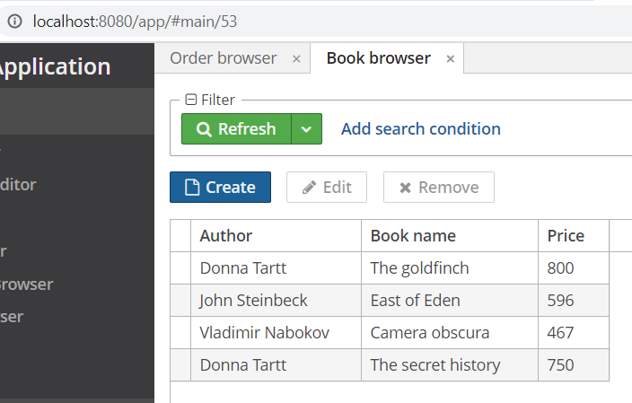

**The picture 7.** Books

The picture 8 shows possibilities of the entity “Carts”. We can create a new cartd, edit and delete exisited cart.

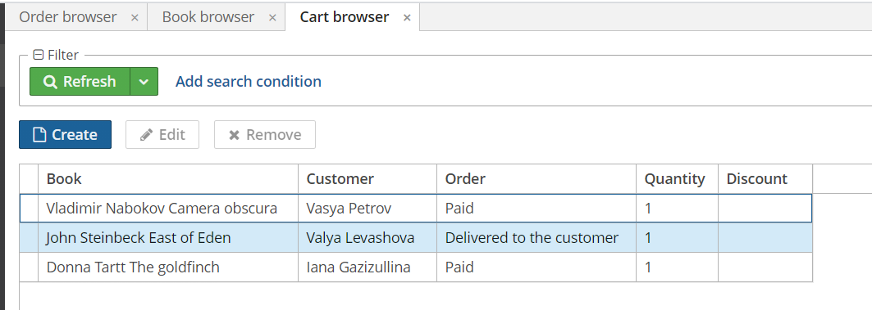

**The picture 8.** Carts

Link to the project: https://drive.google.com/file/d/1-_sAlBumB3zzBDOIbRKA3mA8QZsQw3BX/view?usp=sharing

**CONCLUSION**

In the course of the laboratory work the business process implementation with Cuba Platform were studied. The Cuba project was created.