МИНИСТЕРСТВО НАУКИ И ВЫСШЕГО ОБРАЗОВАНИЯ  
РОССИЙСКОЙ ФЕДЕРАЦИИ

федеральное государственное автономное   
образовательное учреждение высшего образования  
«Самарский национальный исследовательский университет   
имени академика С.П. Королева»

(Самарский университет)

Институт информатики, математики и электроники

Факультет информатики  
Кафедра суперкомпьютеров и общей информатики

**Отчет по лабораторной работе №3**

Дисциплина: «Методы проектирования и поддержки требований к программному обеспечению»

Тема: **«Specification of system requirements. IDEF0 model»**

Выполнил: Печенин В.А.

Группа: 6133-010402D

Самара 2021

**ЗАДАНИЕ**

Objective: To explore the possibilities to describe the requirements for the designed software  
**Tasks**1. Create valid IDEF0 diagrams for the general company processes up to 3d level detailing. At 3d  
decomposition level should be at least one process with at least two actors collaboration.  
2. Add IDEF0 diagrams images to doc report.  
For IDEF0 diagram plotting you can use:  
• Ramus Educational (http://www.ramussoftware.com/en/index.php?option=com_docman&Itemid=6)  
does not work with modern JRE.  
• Microsoft Visio (non-Free).  
• Another available software tools (Libre Office Impress, draw.io, etc.).

**Notice**

You have to prepare at least 4 diagrams: A-0, A0, 2 or more decomposed A0 blocks.

|  |  |
| --- | --- |
| Model level |  |
| 0 | Top level A-0, one block. Arrows show object connection with environment. |
| 1 | A0. First level, contain top processes. |
| 2 | Second level, top processes decompositions. You have to show at least 2 decomposed A0 blocks. |

**ХОД РАБОТЫ**

Option 9 selected. University. Student training.

Purpose of the system: conducting the educational process.

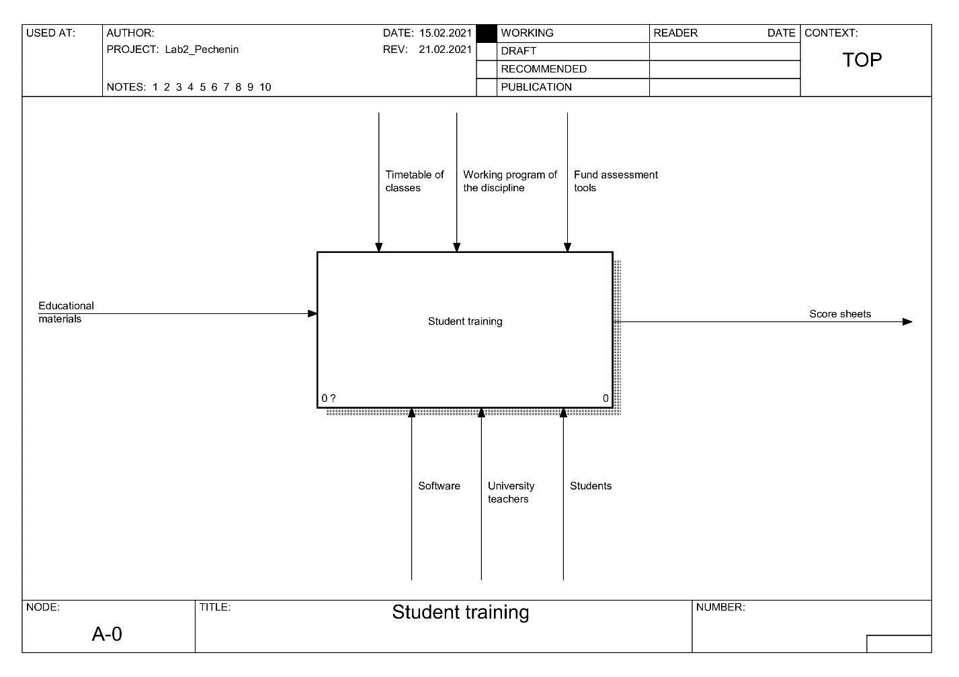

Figure 1 - Diagram IDEF0 of the process "Teaching students". Level A-0

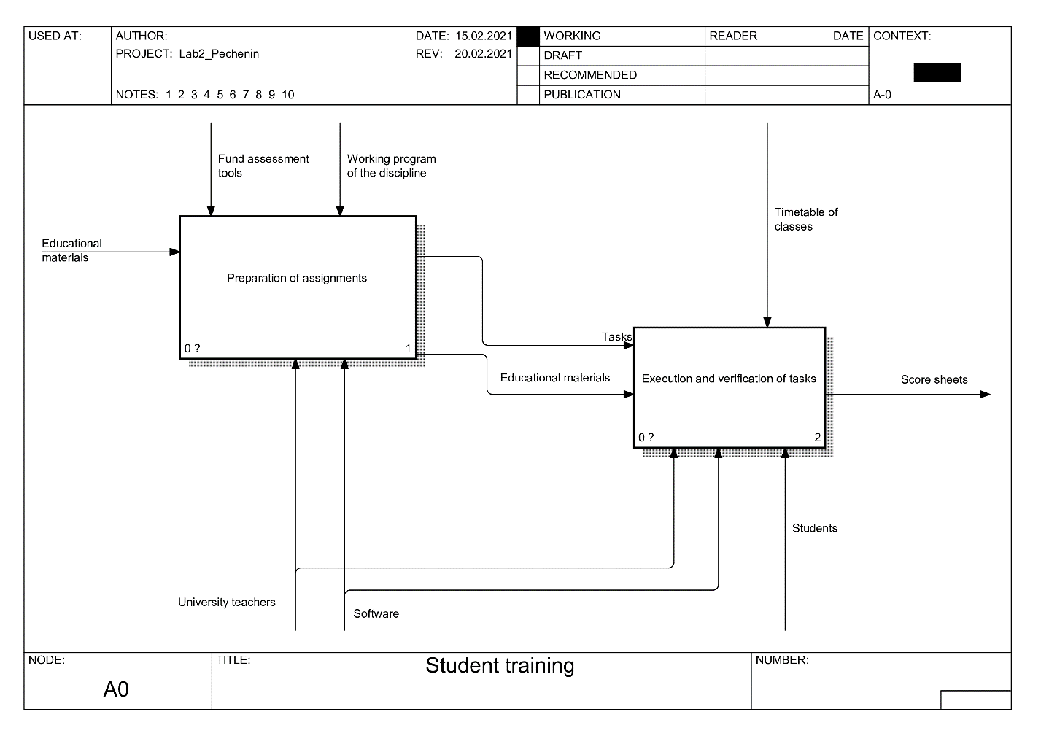

Figure 2 - Diagram IDEF0 of the process "Teaching students". Level A0

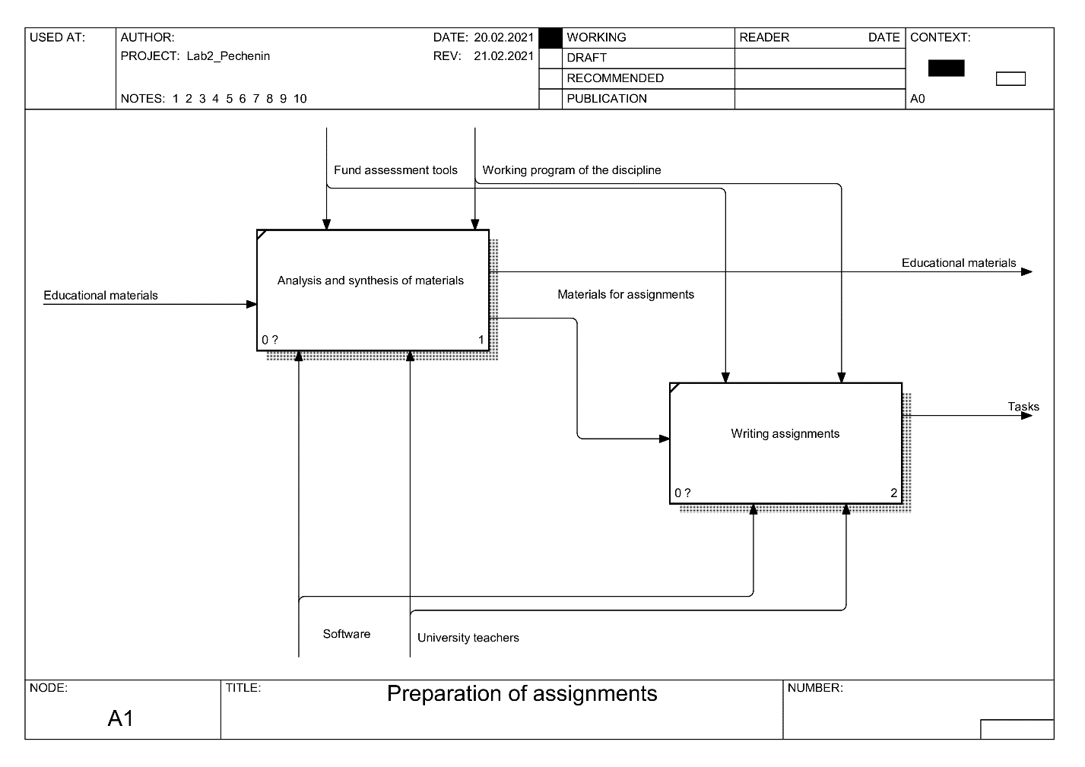

Figure 3 - Diagram IDEF0 of the "Preparation of tasks" process. Level A1

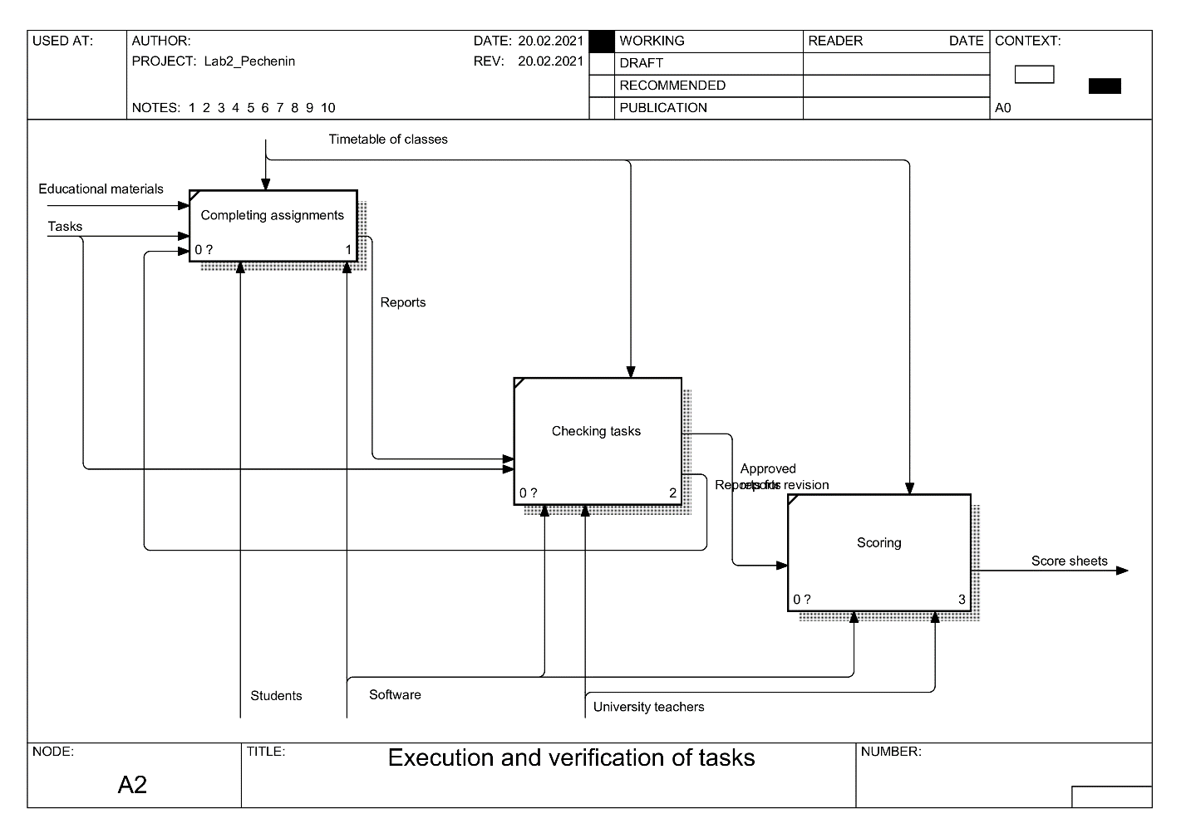

Figure 4 - Diagram IDEF0 of the process "Execution and verification of tasks". Level A2

**ЗАКЛЮЧЕНИЕ**