МИНИСТЕРСТВО НАУКИ И ВЫСШЕГО ОБРАЗОВАНИЯ  
РОССИЙСКОЙ ФЕДЕРАЦИИ

федеральное государственное автономное   
образовательное учреждение высшего образования  
«Самарский национальный исследовательский университет   
имени академика С.П. Королева»

(Самарский университет)

Институт информатики, математики и электроники

Факультет информатики  
Кафедра суперкомпьютеров и общей информатики

**Отчет по лабораторной работе №5**

Дисциплина: «Методы проектирования и поддержки требований к программному обеспечению»

Тема: **«Class diagram»**

Выполнил: Печенин В.А.

Группа: 6133-010402D

Самара 2021

**ЗАДАНИЕ**

Objective: To study the basic features for creating and editing class diagrams

## Tasks

1. Study the possibility of describing the static structure of the information system. Learn how to allocate in the system of the basic classes and describe their properties and behavior. Create Class diagram. Describe at least 5 classes with relations.

2. Add Class diagram image to doc report.

3. Add table with comments:

|  |  |  |
| --- | --- | --- |
| Class name | Attributes/Methods | Data type/Comment about method assigment |
| Class1 | Attribute1 | Char[100] |
|  | Method1 | This method adds new list… |
|  | … |  |

**ХОД РАБОТЫ**

Option 9 is chosen. University. Teaching students.

Purpose of the system: conducting the educational process.

Description of the classes with their relationships: Six classes were distinguished: Person, Student, UniversityTeacher, Task, Report и GradeSheet, one of them is abstract (Person). Relationships are established between the classes.

An image of a class diagram is shown in Figure 1.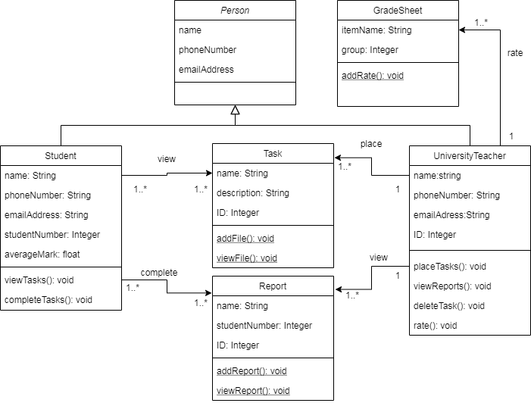

Figure 1 – University system class diagram

Table with comments to the class diagram is given below.

|  |  |  |
| --- | --- | --- |
| Class name | Attributes/Methods | Data type/Comment about method assigment |
| Person | name | String |
|  | phoneNumber | String |
|  | emailAddress | String |
| Student | name | String |
|  | phoneNumber | String |
|  | emailAddress | String |
|  | studentNumber | Integer |
|  | averageMark | float |
|  | viewTask() | This method allows you to view tasks |
|  | completeTask() | This method allows you to post solutions to tasks |
| UniversityTeacher | name | String |
|  | phoneNumber | String |
|  | emailAddress | String |
|  | ID | Integer |
|  | placeTask() | This method allows you to post tasks |
|  | viewReport() | This method allows you to view reports |
|  | deleteTask() | This method allows you to delete reports |
|  | rate() | This method allows you to complete grade sheets |
| Task | name | String |
|  | description | String |
|  | ID | Integer |
|  | addFile() | This method allows you to add files to tasks |
|  | viewFile() | This method allows you to view attached files |
| Report | name | String |
|  | studentNumber | Integer |
|  | ID | Integer |
|  | addReport() | This method allows you to add a file to the report |
|  | viewReport() | This method allows you to view the report files |
| GradeSheet | itemName | String |
|  | group | Integer |
|  | addRate() | This method allows you to fill in grades |

To implement business logic in the application, controller classes are used. (sevices). Let's add them to the previous diagram, slightly changing the relationship between the classes and passing all the methods to the controller classes. Figure 2 shows a diagram with controller classes.

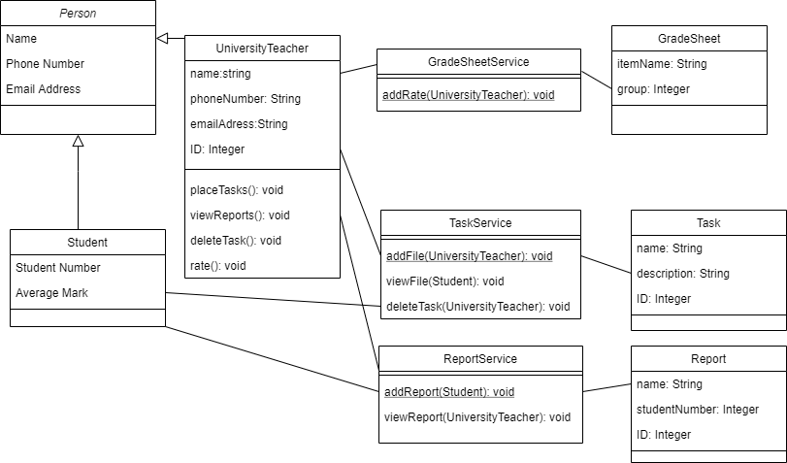

Figure 2 – University system class diagram with services classes

**ЗАКЛЮЧЕНИЕ**

In the process of completing the work for the projects, a class diagram was drawn up and the main attributes and methods of the classes were listed.