МИНИСТЕРСТВО НАУКИ И ВЫСШЕГО ОБРАЗОВАНИЯ  
РОССИЙСКОЙ ФЕДЕРАЦИИ

федеральное государственное автономное   
образовательное учреждение высшего образования  
«Самарский национальный исследовательский университет   
имени академика С.П. Королева»

(Самарский университет)

Институт информатики, математики и электроники

Факультет информатики  
Кафедра суперкомпьютеров и общей информатики

**Отчет по лабораторной работе №6**

Дисциплина: «Методы проектирования и поддержки требований к программному обеспечению»

Тема: **«Business process implementation»**

Выполнил: Печенин В.А.

Группа: 6133-010402D

Самара 2021

**ЗАДАНИЕ**

Objective: To study the business process implementation with Cuba Platform  
**Tasks**1. Create Cuba Platform project, which will implement one of business processes of previously selected  
organization.  
2. Add section to doc report image, which should include:  
• Selected business process description (several sentences). It is desirable that the business process be the  
same as business process described in assignment #4.  
• Instructions for running the application, prerequisites.  
• Step-by-step instruction with demonstration of business process automation using the application.  
3. Send zipped Cuba Project files and doc report to j-avdeev@yandex.ru  
**Notice**Use Cuba Platform documentation (for example https://doc.cuba-platform.com/bpm-latest/bpm.html).  
Yes, can use your preferable framework (not Cuba Platform) to create a web application to automate chosen  
business process.

**ХОД РАБОТЫ**

Option 9 is chosen. University. Teaching students.

Purpose of the system: conducting the educational process.

The CUBA plugin was installed in the IntelliJ IDEA IDE through the Plugins dialog on the Marketplace fold. The CUBA Project "teachingstudents" was created. The DBMS is left by default - HSQLDB.

|  |  |
| --- | --- |
|  |  |

Figure 1 - Creating a project in CUBA

The business process "rate" is selected for automation: the university teacher gives marks for the received reports. Grade sheets are grouped by subject name, group number and are associated with one teacher by a many-to-one relationship. Go to the section "grade sheets". Select a group and subject. Record the grades in the statement.

The entities were created: Student, UniversityTeacher, Task, Report and GradeSheet.

In the created classes, the necessary associative attributes are created, for example, in Figure 2, the universityTeacher attribute is shown, which links the GradeSheet entity to the UniversityTeacher entity (many to one).

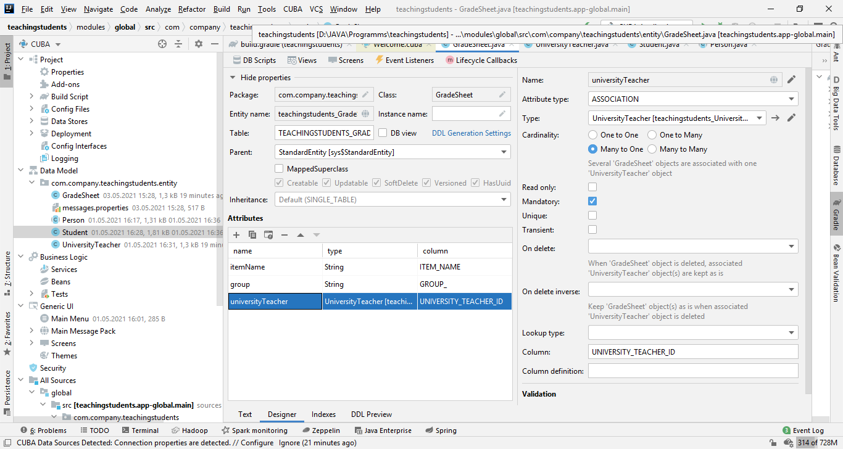

Figure 2 - Attribute for linking entities

Figure 3 shows the contents of entities from the database.

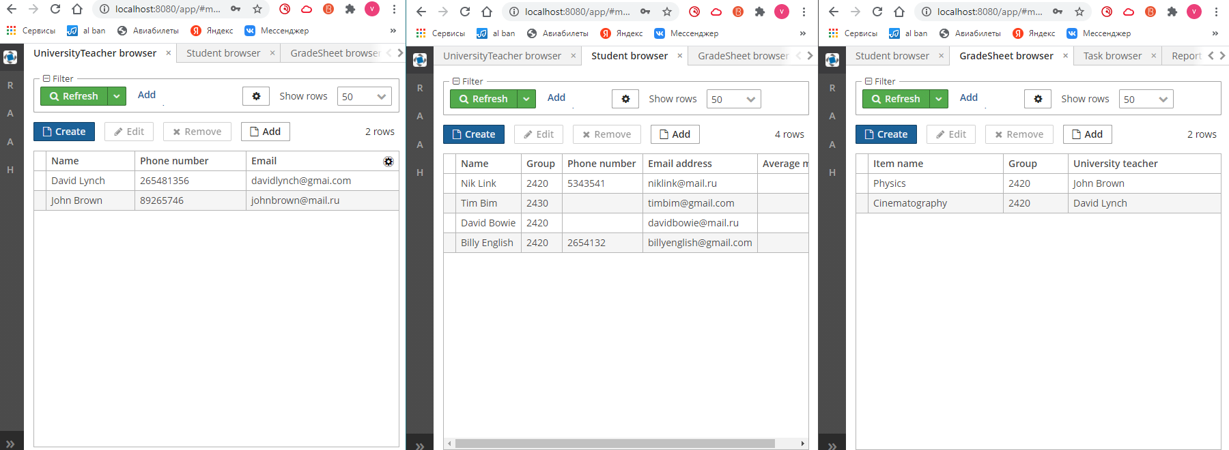

Figure 3 - Completed entity fields

Two additional screen objects were created to automate the selected business process - ScreenRateReport and GradesheetcontrollerScreen. In the first, the subject, group number and teacher are selected, according to the selected parameters, a table of students with grades opens in GradesheetcontrollerScreen; after filling in the ratings and clicking on the button, the changes in the ratings are saved in the database. Figure 4 shows the interfaces of the selected screens.

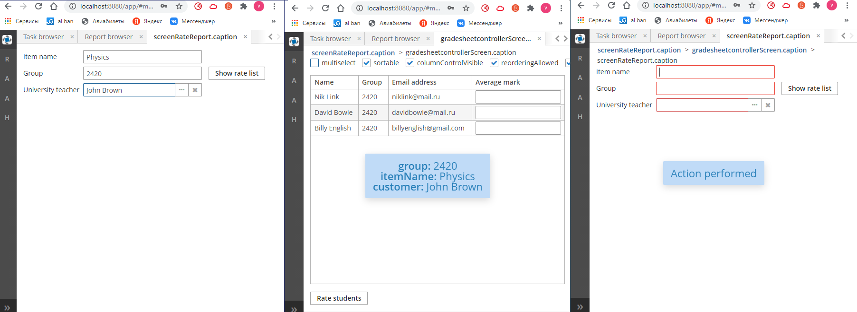

Figure 4 - Screens for automating the filling of lists

The project has been saved to GitHub https://github.com/vadimpechenin/teachingstudents.git.

**ЗАКЛЮЧЕНИЕ**

In the process of performing the work, the software implementation of the classes and methods of the project was performed using the CUBA platform.