МИНИСТЕРСТВО НАУКИ И ВЫСШЕГО ОБРАЗОВАНИЯ  
РОССИЙСКОЙ ФЕДЕРАЦИИ

федеральное государственное автономное   
образовательное учреждение высшего образования  
«Самарский национальный исследовательский университет   
имени академика С.П. Королева»

(Самарский университет)

Институт информатики, математики и электроники

Факультет информатики  
Кафедра технической кибернетики

**Отчет по лабораторной работе № 5**

Дисциплина: «Enterprise Systems Development (Методы проектирования и поддержки требований к программному обеспечению)»

Тема: «Class diagram»

Тип предприятия: **«**Automotive Dealer chain**»**

Выполнил: Овчинников И.В.

Группа: 6133-010402D

Самара 2021

**ЗАДАНИЕ**

## Class diagram

Objective: To study the basic features for creating and editing class diagrams

## Tasks

1. Study the possibility of describing the static structure of the information system. Learn how to allocate in the system of the basic classes and describe their properties and behavior. Create Class diagram. Describe at least 5 classes with relations.

2. Add Class diagram image to doc report.

3. Add table with comments:

|  |  |  |
| --- | --- | --- |
| Class name | Attributes/Methods | Data type/Comment about method assigment |
| Class1 | Attribute1 | Char[100] |
|  | Method1 | This method adds new list… |
|  | … |  |

**Class diagram**

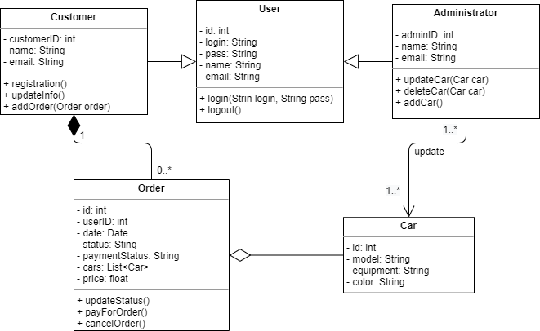

Рисунок 1 – Class diagram

Таблица 1 – Table with comments

|  |  |  |
| --- | --- | --- |
| Class name | Attributes/Methods | Data type/Comment about method assigment |
| User | id | int, user id |
| User | login | String, login |
| User | pass | String, password |
| User | name | String, user name |
| User | email | String, user email |
| User | login(Strin login, String pass) | void, authorization in the system |
| User | logout() | void, log out |
| Customer | CustomerID | int, customer id |
| Customer | name | String, customer name |
| Customer | email | String, customer email |
| Customer | registration() | void, registration in the system |
| Customer | updateInfo() | void, updating user information |
| Customer | addOder(Order oredr) | void, creating a new order |
| Administrator | adminID | int, administrator id |
| Administrator | name | String, administrator name |
| Administrator | email | String, administrator email |
| Administrator | updateCar(Car car) | void, update car |
| Administrator | addCar() | void, add car |
| Administrator | deleteCar(Car car) | void, delete car |
| Car | id | int, car id |
| Car | model | String, car model |
| Car | equipment | String, car equipment |
| Car | color | String, car color |
| Order | id | int, order id |
| Order | userID | int, user id |
| Order | date | Date, order creation date |
| Order | status | String, order status |
| Order | paymentStatus | String, order payment status |
| Order | cars | List<Car>, list of cars in order |
| Order | price | float, order price |
| Order | updateStatus() | void, update order status |
| Order | payForOrder() | void, pay for the order |
| Order | cancelOrder() | void, сancel the order |