МИНИСТЕРСТВО НАУКИ И ВЫСШЕГО ОБРАЗОВАНИЯ  
РОССИЙСКОЙ ФЕДЕРАЦИИ

федеральное государственное автономное   
образовательное учреждение высшего образования  
«Самарский национальный исследовательский университет   
имени академика С.П. Королева»

(Самарский университет)

Институт информатики, математики и электроники

Факультет информатики  
Кафедра суперкомпьютеров и общей информатики

**Отчет по лабораторной работе №1**

Дисциплина: «Методы проектирования и поддержки требований к программному обеспечению»

Тема: **«Specification of system requirements. Use Case diagram»**

Тип предприятия: **Air Tickets chain.**

Выполнил: Нушкарев П.В.

Группа: 6133-010402D

Самара 2021

Objective: To study the basic features for creating and editing use case diagrams  
**Tasks**

1. Choose one of the company type from the excel list or use your own company type. In the course of the assignments, you will have to describe and suggest some business processes automating of the selected company.
2. Define list of high-level customer’s needs, which going to be solved by the information system implementation. Not less than 5 use cases in list, volume 0,5-1 sheet A4.
3. Create Glossary of subject domain terms, which you will use next.
4. Create Use Case diagram for the described use cases. Diagram should include situation with at least two actors collaboration. Create Use Case diagram image (png/jpeg/gif).  
   Add image to doc report (see template in [https://github.com/javdeev/EnterpriseSystemsDevelopment/tree/master/Assignment%20Reports%20Template](https://github.com/javdeev/EnterpriseSystemsDevelopment/tree/master/Assignment Reports Template))

**Task 1.**

The chosen company type is Air Tickets chain.

The purpose of the system: online booking of airline tickets.

Actors: passenger, airline server, bank payment portal.

**Task 2.**

Options for use:

1) For passengers:

* viewing current airline tickets
* ticket booking
* cancellation option

2) For airline:

* providing current airline tickets
* ticket sale

1) For the bank:

* Carrying out all monetary transactions

The system must allow for authorization. The passenger must register himself or herself and enter the data required for future ticket reservations. An electronic ticket is a pdf-file with a qr-code, data about the passenger and the reserved seat. If the reservation is cancelled, a certain amount of money is refunded to the passenger (depends on how late the passenger decided to cancel the reservation).

**Task 3.**

Glossary:

Passenger - a person who is transported by a vehicle in accordance with the contract of carriage (ticket).

Airline server - a server that provides up-to-date and available for booking airline tickets.

Bank payment portal - a portal that conducts online money transactions.

Reservations - Making a record of assigning a resource to someone. Reservations involve an obligation to pay for that resource at the end of the reservation period.

**Task 4.**

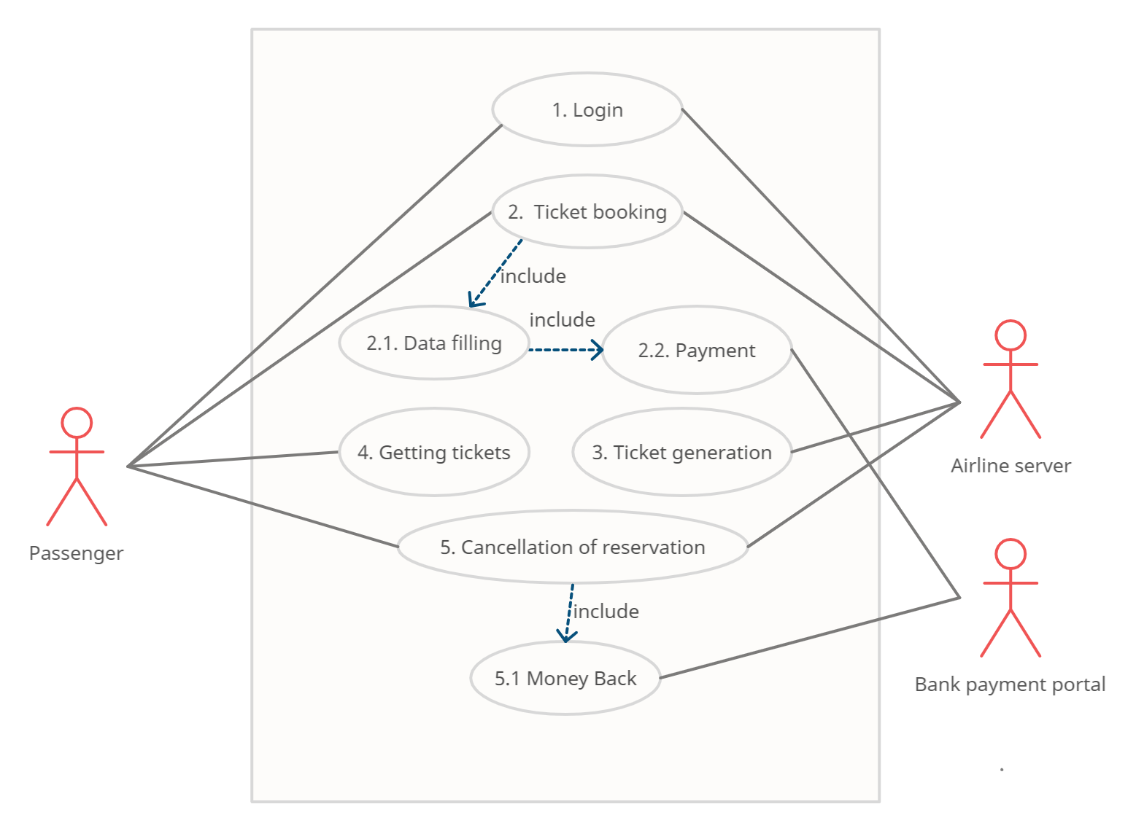Figure 1 – Use Case diagram