МИНИСТЕРСТВО НАУКИ И ВЫСШЕГО ОБРАЗОВАНИЯ  
РОССИЙСКОЙ ФЕДЕРАЦИИ

федеральное государственное автономное   
образовательное учреждение высшего образования  
«Самарский национальный исследовательский университет   
имени академика С.П. Королева»

(Самарский университет)

Институт информатики, математики и электроники

Факультет информатики  
Кафедра суперкомпьютеров и общей информатики

**Отчет по лабораторной работе №5**

Дисциплина: «Методы проектирования и поддержки требований к программному обеспечению»

Тема: **«Class diagram»**

Тип предприятия: **Air Tickets chain**

Выполнил: Нушкарев П.В.

Группа: 6133-010402D

Самара 2021

**ЗАДАНИЕ**

Objective: To study the basic features for creating and editing class diagrams

## Tasks

1. Study the possibility of describing the static structure of the information system. Learn how to allocate in the system of the basic classes and describe their properties and behavior. Create Class diagram. Describe at least 5 classes with relations.

2. Add Class diagram image to doc report.

3. Add table with comments:

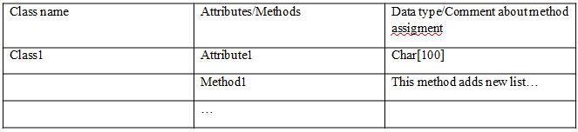

**ХОД РАБОТЫ**

The chosen company type is Air Tickets chain.

The purpose of the system: online booking of airline tickets.

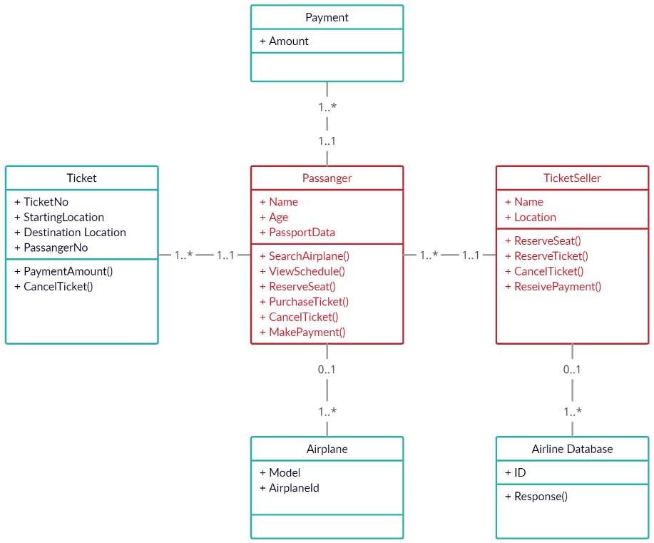

Figure 1 - Class diagram

|  |  |  |
| --- | --- | --- |
| Class name | Attributes/Method | Data type/Comment |
| Passanger | Name | string |
| Age | int |
| PassportData | int |
| SearchAirplane() | The method searches for affordable airplane |
| ViewSchedule() | The method allows you to view the schedule |
| ReserveSeat() | The method reserves a seat for the passenger |
| PurchaseTicket() | The method assigns a ticket to the passenger |
| CancelTicket() | The method detaches the ticket from the passenger |
| MakePayment() | The method allows the passenger to pay for the ticket |
| Payment | Amount | decimal |
| Ticket | TicketNo | int |
| StartingLocation | string |
| Destination Location | string |
| PassangerNo | int |
| PaymentAmount() | Method adds ticket price |
| CancelTicket() | Method nullifies the ticket |
| TicketSeller | Name | string |
| Location | string |
| ReserveSeat() | The method reserves a seat for a specific passenger |
| ReserveTicket() | Method reserves a ticket for a specific passenger |
| CancelTicket() | Method cancels ticket |
| ReseivePayment() | The method processes the payment |
| Airline Database | ID | int |
| Response() | The method requests a ticket from the database |
| Airplane | Model | int |
| AirplaneId | int |