МИНИСТЕРСТВО НАУКИ И ВЫСШЕГО ОБРАЗОВАНИЯ  
РОССИЙСКОЙ ФЕДЕРАЦИИ

федеральное государственное автономное   
образовательное учреждение высшего образования  
«Самарский национальный исследовательский университет   
имени академика С.П. Королева»

(Самарский университет)

Институт информатики, математики и электроники

Факультет информатики  
Кафедра технической кибернетики

**Отчет по лабораторной работе №1**

Дисциплина: «EnterpriseSystemsDevelopment»

Тема: **«Specification of system requirements. Use Case diagram»**

Выполнила: Газизуллина Я.М.

Группа: 6133-010402D

Самара 2021

**ASSIGNMENT**

Objective: To study the basic features for creating and editing use case diagrams

**Tasks**

1. Choose one of the company type from the excel list or use your own company type. In the course of the assignments, you will have to describe and suggest some business processes automating of the selected company.
2. Define list of high-level customer’s needs, which going to be solved by the information system implementation. Not less than 5 use cases in list.
3. Create Glossary of subject domain terms, which you will use next.
4. Create Use Case diagram for the described use cases. Diagram should include situation with at least two actors collaboration. Create Use Case diagram image (png/jpeg/gif).

Add image to doc report (see template in https://github.com/javdeev/EnterpriseSystemsDevelopment/tree/2021/Assignment%20Reports%20Template)

**Notice**

For UML diagram plotting you can use draw.io (https://www.draw.io/), StarUML (http://staruml.io/) or another available software tools.

**WORK FLOW**

**Task 1**

I chose “Book Shop Chain”.

**Task 2**

High-level customer’s needs:

* To view books
* To add books to cart
* To choose a payment and delivery method
* To pay an order
* To check order’s status
* To apply discounts
* To read and write rewiews

**Task 3**

Glossary:

Customer – user who wants to buy a book

Book – offered item for sale

Book shop – system allowing to buy books

Administrator - user managing the entire system

Order - business process that includes a description of the transaction between the customer and the book shop

**Task 4**

Use Case diagram for the described use cases

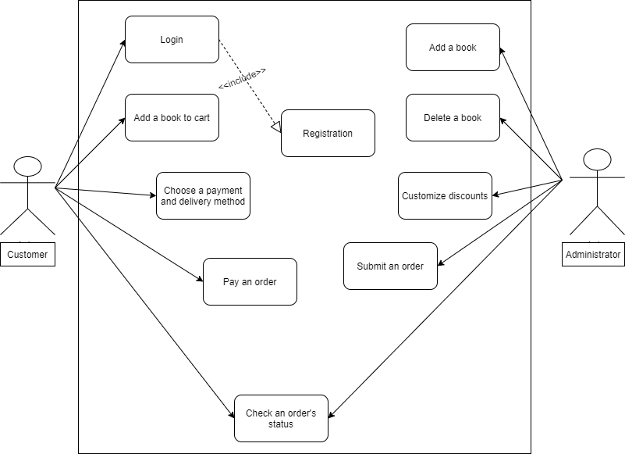

**CONCLUSION**

In the course of the laboratory work basic features for creating and editing use case diagrams were studied, high-level customer’s needs were defined, glossary of subject domain terms was created, use case diagram was created.