МИНИСТЕРСТВО НАУКИ И ВЫСШЕГО ОБРАЗОВАНИЯ  
РОССИЙСКОЙ ФЕДЕРАЦИИ

федеральное государственное автономное   
образовательное учреждение высшего образования  
«Самарский национальный исследовательский университет   
имени академика С.П. Королева»

(Самарский университет)

Институт информатики, математики и электроники

Факультет информатики  
Кафедра технической кибернетики

**Отчет по лабораторной работе №5**

Дисциплина: «EnterpriseSystemsDevelopment»

Тема: **«Class diagram»**

Выполнила: Газизуллина Я.М.

Группа: 6133-010402D

Самара 2021

**ASSIGNMENT**

Objective: To study the basic features for creating and editing class diagrams **Tasks**

1. Study the possibility of describing the static structure of the information system. Learn how to allocate in the system of the basic classes and describe their properties and behavior. Create Class diagram. Describe at least 5 classes with relations.

2. Add Class diagram image to doc report.

3. Add table with comments:

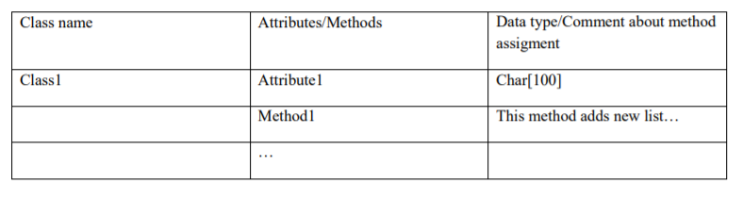

**WORK FLOW**

Class diagram “Book shop”

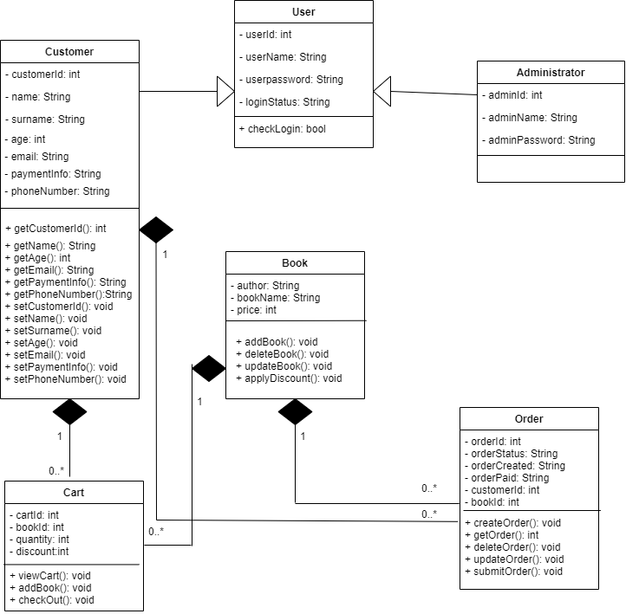

**Table with comments**

|  |  |  |
| --- | --- | --- |
| **Class name** | **Attributes / Methods** | **Data type / Comment about method assigment** |
| **Customer** | customerId | int |
|  | name | String |
|  | surname | String |
|  | age | int |
|  | email | String |
|  | paymentInfo | String |
|  | phoneNumber | String |
|  | GetCustomerId() | This method gets customer’s id |
|  | GetName() | This method gets customer’s name |
|  | GetEmail() | This method gets customer’s email |
|  | GetPaymentInfo() | This method gets customer’s payment information |
|  | GetPhoneNumber() | This method gets phone number |
|  | SetCustomerId() | This method sets customer’s id |
|  | SetName() | This method sets customer’s name |
|  | SetSurname() | This method sets customer’s surname |
|  | SetAge() | This method sets customer’s age |
|  | SetEmail() | This method sets customer’s email |
|  | SetPaymentInfo() | This method sets customer’s payment informatio |
|  | SetPhoneNumber() | This method sets customer’s phone number |
| **User** | userId | int |
|  | userName | String |
|  | userPassword | String |
|  | loginStatus | String |
|  | CheckLogin() | This method checks that user is logged |
| **Administrator** | adminId | int |
|  | adminName | String |
|  | adminPassword | String |
| **Book** | author | String |
|  | bookName | String |
|  | price | int |
|  | AddBook() | This method adds a book |
|  | DeleteBook() | This method deletes a book |
|  | UpdateBook() | This method updates a book |
|  | ApplyDiscount() | This methods applies a discount to book’s price |
| **Cart** | cartId | int |
|  | bookId | int |
|  | quantity | int |
|  | discount | int |
|  | ViewCart() | This method allows to view a cart |
|  | AddBook() | This method adds a book to cart |
|  | CheckOut() | This method check out the order |
| **Order** | orderId | int |
|  | orderStatus | String |
|  | orderCreated | String |
|  | orderPaid | String |
|  | customerId | int |
|  | bookId | int |
|  | CreateOrder() | This method creates a new order |
|  | GetOrder() | This method gets an order |
|  | DeleteOrder() | This method deletes an order |
|  | UpdateOrder() | This method updates an order |
|  | SubmitOrder() | This method submits an order |

**CONCLUSION**

In the course of the laboratory work the basic features for creating and editing class diagrams were studied. The class diagram was created and was described in the table.