МИНИСТЕРСТВО НАУКИ И ВЫСШЕГО ОБРАЗОВАНИЯ  
РОССИЙСКОЙ ФЕДЕРАЦИИ

федеральное государственное автономное   
образовательное учреждение высшего образования  
«Самарский национальный исследовательский университет   
имени академика С.П. Королева»

(Самарский университет)

Институт информатики, математики и электроники

Факультет информатики  
Кафедра суперкомпьютеров и общей информатики

**Отчет по лабораторной работе №1**

Дисциплина: «Методы проектирования и поддержки требований к программному обеспечению»

Тема: **«Specification of system requirements. Use Case diagram»**

Выполнил: Печенин В.А.

Группа: 6133-010402D

Самара 2021

**ЗАДАНИЕ**

Objective: To study the basic features for creating and editing use case diagrams  
Tasks

1. Choose one of the company type from the excel list or use your own company type. In the course of the assignments, you will have to describe and suggest some business processes automating of the selected company.
2. Define list of high-level customer’s needs, which going to be solved by the information system implementation. Not less than 5 use cases in list, volume 0,5-1 sheet A4.
3. Create Glossary of subject domain terms, which you will use next.
4. Create Use Case diagram for the described use cases. Diagram should include situation with at least two actors collaboration. Create Use Case diagram image (png/jpeg/gif).  
   Add image to doc report (see template in <https://github.com/javdeev/EnterpriseSystemsDevelopment/tree/master/Assignment%20Reports%20Template>)

**ХОД РАБОТЫ**

**Task 1.**

Option 9 selected. University. Student training.

Purpose of the system: conducting the educational process.

Actors: university teacher, student.

**Task 2.**

Use case: 1) Actors student and university teacher must be authorized;

2) For student:

viewing tasks;

completing tasks.

3) For university teacher:

add user;

preparation and place tasks;

view task;

view report;

rate;

delete task.

The system must allow authorization, and student profiles are created by the teacher. Tasks are a set of laboratory tasks, an explanation to them in the form of lecture sections. The task block can contain tasks of various types (the number is indicated). Students should be able to attach reports to posted tasks.

**Task 3.**

Glossary.

Student - a student in an educational institution, attends lectures and completes assignments.

The university teacher is an actor who is responsible for the preparation of assignments and lecture material and checks the assimilation of knowledge among students.

Task - a document created by the teacher, containing tasks and exercises for students to independently complete, as well as assessment criteria.

Report - a document created by a student containing answers to the assigned tasks and exercises from the assignment.

**Task 4.**

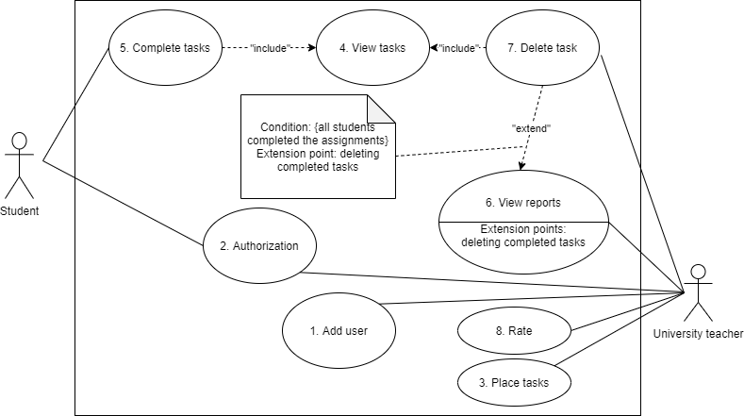

Figure 1 - University. Use Case chart.

**ЗАКЛЮЧЕНИЕ**