МИНИСТЕРСТВО НАУКИ И ВЫСШЕГО ОБРАЗОВАНИЯ  
РОССИЙСКОЙ ФЕДЕРАЦИИ

федеральное государственное автономное   
образовательное учреждение высшего образования  
«Самарский национальный исследовательский университет   
имени академика С.П. Королева»

(Самарский университет)

Институт информатики, математики и электроники

Факультет информатики  
Кафедра технической кибернетики

**Отчет по лабораторной работе № 6**

Дисциплина: «Enterprise Systems Development (Методы проектирования и поддержки требований к программному обеспечению)»

Тема: «Business process implementation»

Тип предприятия: **«**Automotive Dealer chain**»**

Выполнил: Овчинников И.В.

Группа: 6133-010402D

Самара 2021

**ЗАДАНИЕ**

## Business process implementation

Objective: To study the business process implementation with Cuba Platform

## Tasks

1. Create Cuba Platform project, which will implement one of business processes of previously selected organization.
2. Add section to doc report image, which should include:

* Selected business process description (several sentences). It is desirable that the business process be the same as business process described in assignment #4.
* Instructions for running the application, prerequisites.
* Step-by-step instruction with demonstration of business process automation using the application.

1. Send zipped Cuba Project files and doc report to j-avdeev@yandex.ru

## Notice

Use Cuba Platform documentation (for example <https://doc.cuba-platform.com/bpm-latest/bpm.html> or <https://doc.cuba-platform.com/bpm-latest-ru/bpm.html> (on Russian)).

Yes, can use your preferable framework (not Cuba Platform) to create a web application to automate chosen business process.

**Business process implementation**

Implementation of the business process of registering for a test drive. The user can see the cars and sign up for a test drive of the car he liked.

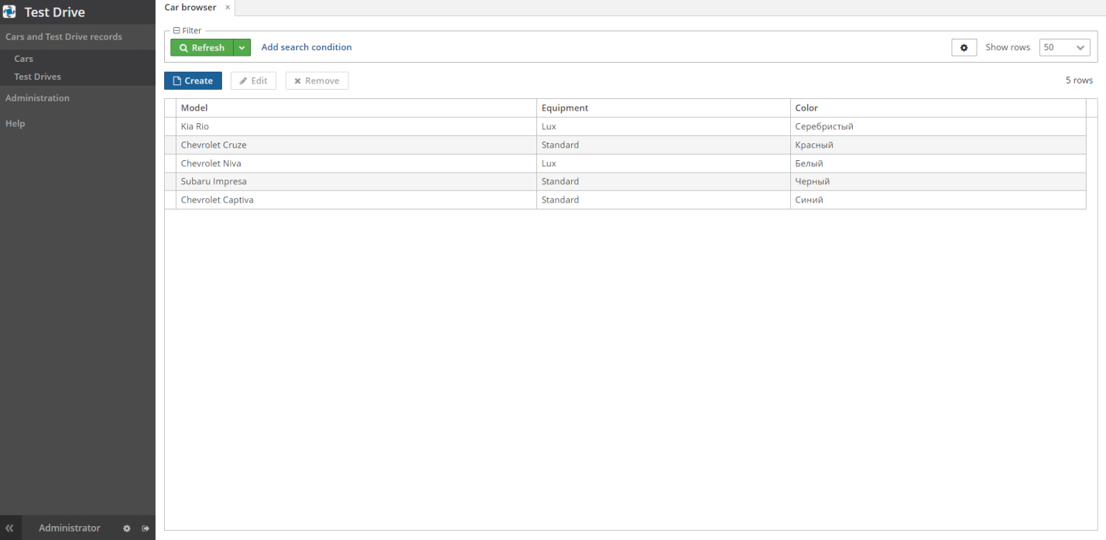

Figure 1 – Screen with a list of available cars

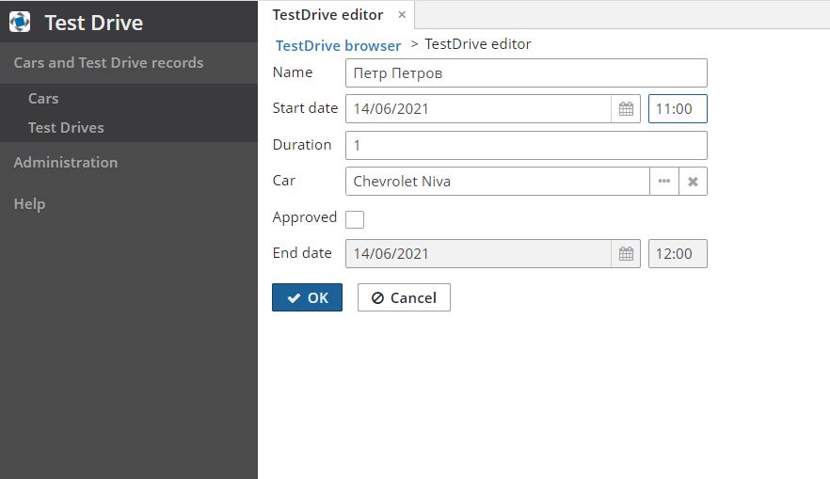

Figure 2 – Test Drive recording screen

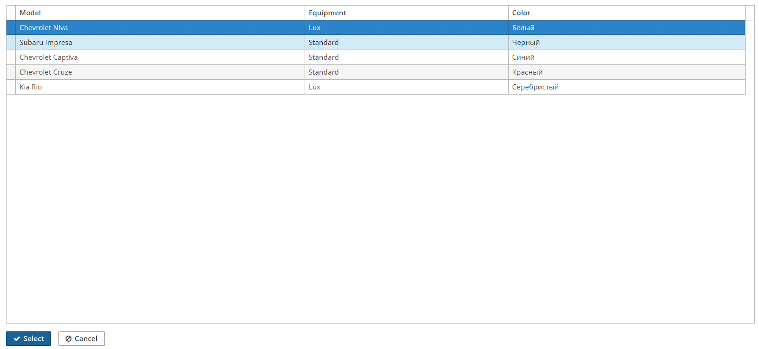

Figure 3 – Choosing a car when registering for a test drive

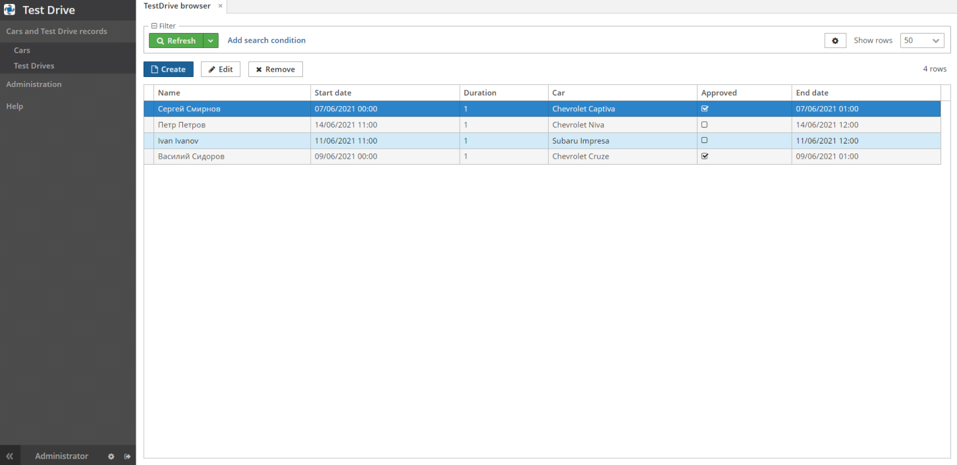

Figure 4 – Recording information screen