МИНИСТЕРСТВО НАУКИ И ВЫСШЕГО ОБРАЗОВАНИЯ  
РОССИЙСКОЙ ФЕДЕРАЦИИ

федеральное государственное автономное   
образовательное учреждение высшего образования  
«Самарский национальный исследовательский университет   
имени академика С.П. Королева»

(Самарский университет)

Институт информатики, математики и электроники

Факультет информатики  
Кафедра суперкомпьютеров и общей информатики

**Отчет по лабораторной работе №2**

Дисциплина: «Project Management   
(Менеджмент разработки ПО)»

Тема: **«Redmine»**

Выполнил: Фатхутдинова Э. Ф.

Группа: 6233-010402D

Самара 2018

**ЗАДАНИЕ**

1. Install and run Redmine by any convenient for you way. You can use a ready-made virtual machine or docker-container provided by Bintami: <https://bitnami.com/stack/redmine>
2. It is necessary to configure the Redmine system to send e-mail messages-notifications. <http://www.redmine.org/projects/redmine/wiki/EmailConfiguration> Yes, for the redmain, you will need to provide a login, an e-mail password, from which the redmine will send notifications to its users.
3. Login to redmine as administrator and add new developer with the name and surname: Avdeev Eugeniy; e-mail: [j-avdeev@yandex.ru](mailto:j-avdeev@yandex.ru) If the Redmine e-mail settings correct, Redmine will send login and password information on e-mail address of new user.
4. Create new project, add Avdeev Evgeniy to this project participants.
5. Create a Task in the new created project and assign this task to Evdeniy Avdeev.

**ХОД РАБОТЫ**

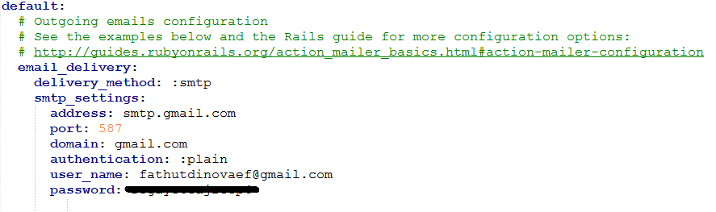

Figure 1 – configuration for the Redmine system to send e-mail messages-notifications

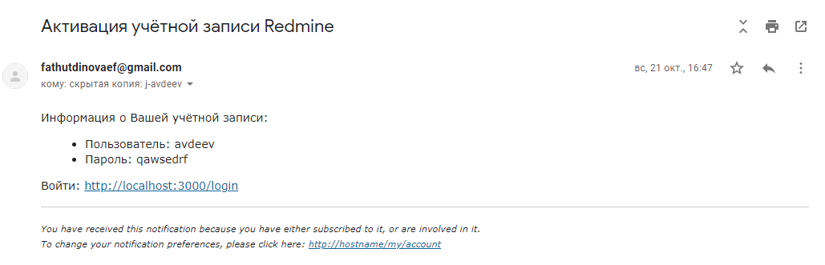

Figure 2 – account activation message

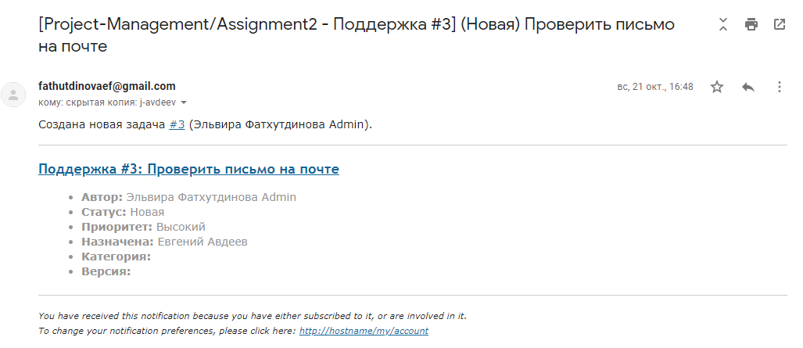

Figure 3 – task assignment message

**ЗАКЛЮЧЕНИЕ**

In this assignment I installed and run Redmine using docker-container provided by Bintami, configured the Redmine system to send e-mail messages-notifications, created new developer with the name and surname: Avdeev Eugeniy; e-mail: j-avdeev@yandex.ru, created new project, added Avdeev Evgeniy to this project participants, created a Task in the new created project and assigned this task to Evdeniy Avdeev for check e-mail messages-notifications of Redmine.