Title: A Deep Learning Method for Microaneurysm Detection in Fundus Images
Author: Thao Truong
Department: College of Science and Engineering
University: Seattle University

Report of Summer Research 2020

Procedure
- Preprocessing

- I forked Xing ChenCong’s project repository on GitHub to extract blood vessels into separate images.
Source Code: https://github.com/DeepTrial/Retina-VesselNet/tree/master#pretrained-model

Results:

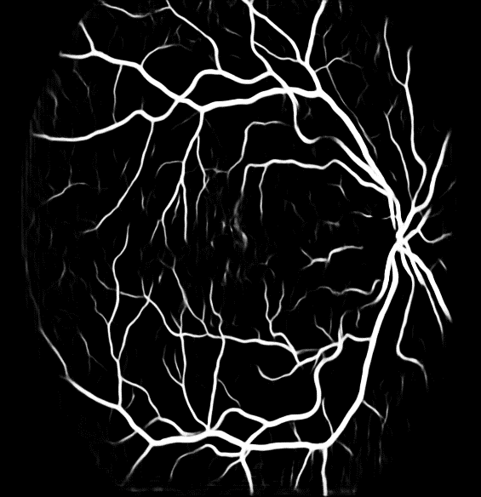
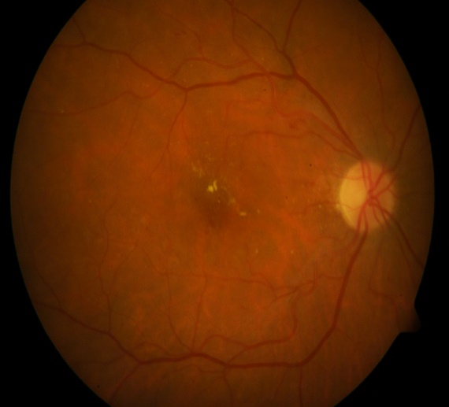

Ddb1_img_001.png Ddb1_img_001_bloodvessle.png

- I subtracted the extracted blood vessel images from the extracted-green channel of the original RGB images to get new images where the blood vessels are blackened. The green channel makes MAs have the highest contrast compared to other color planes.

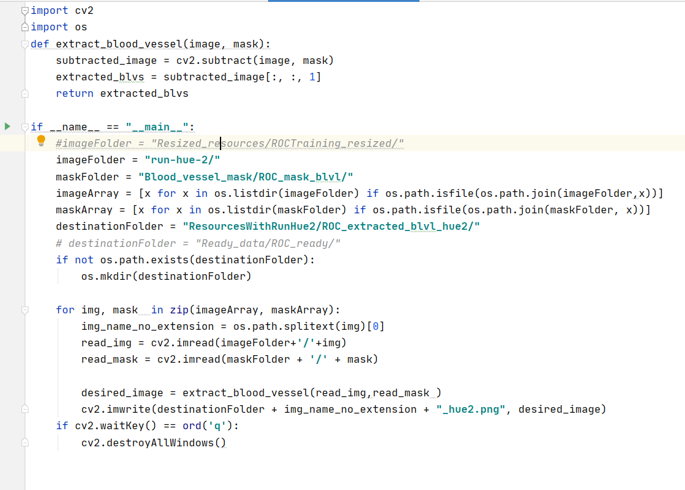
Code:

Results:
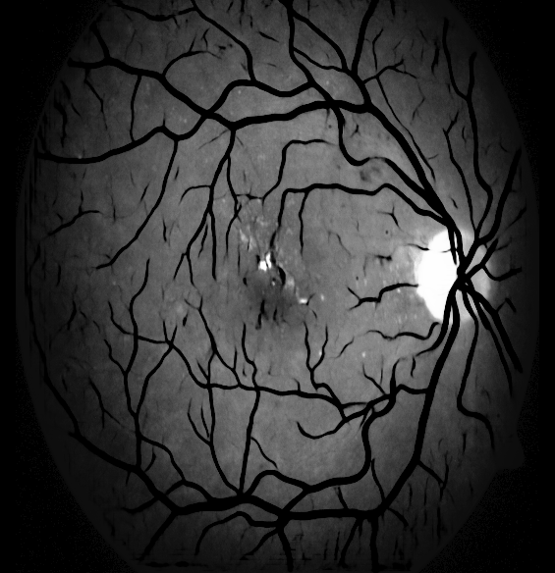

- Data augmentation
Because of the limit of dataset, I did data augmentation to increase number of the pictures by rotating images in different angles.
- Rotate images:
- I forked Rob Dswson’s project repository on GitHub to generates new images by performing a specified set of augmentation operations on each image in a folder.
- Source Code https://github.com/codebox/image_augmentor
- Result:
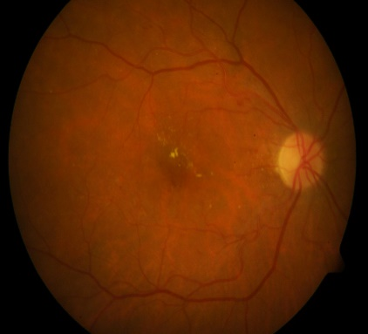
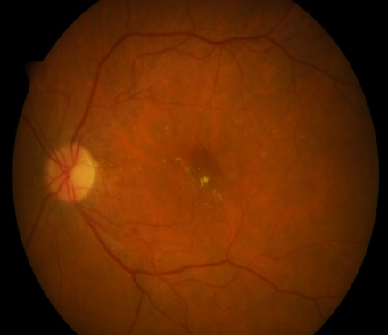
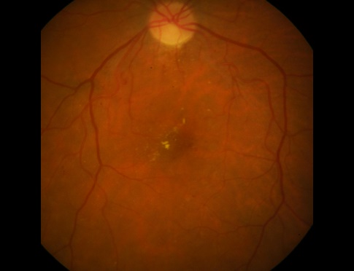

Ddb1_image001.png image001__rot180.png image001__rot90.png

- Get equivalent radius and center points after rotating:
- Code: the file below is used to get equivalent radius and center points of the MA signs for different angles:
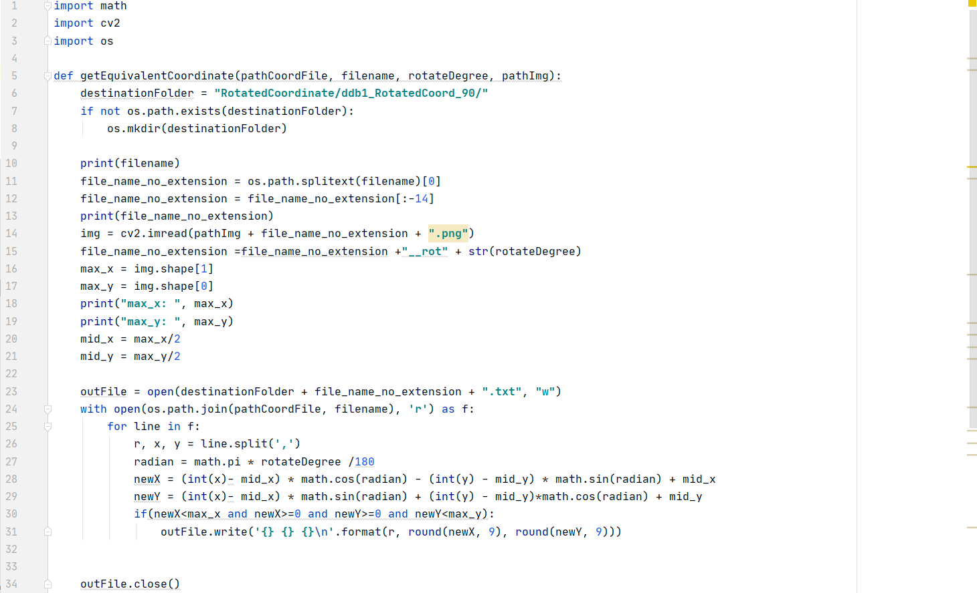
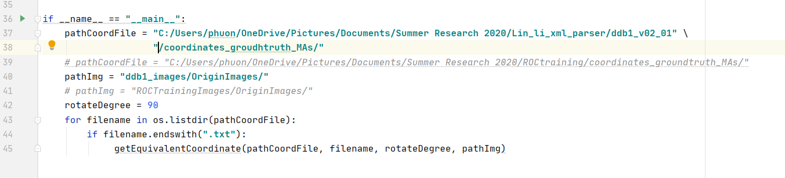

- Prepare Dataset
- Parse XML files:
From provided XML files for each type of dataset, I parsed them into .txt where each line contains radius, x_center, and y_center respectively and they are separated by commas. Each .txt files contains all the locations of MA signs of each images in the dataset.

- Code (Java):

- Ddb1 dataset:
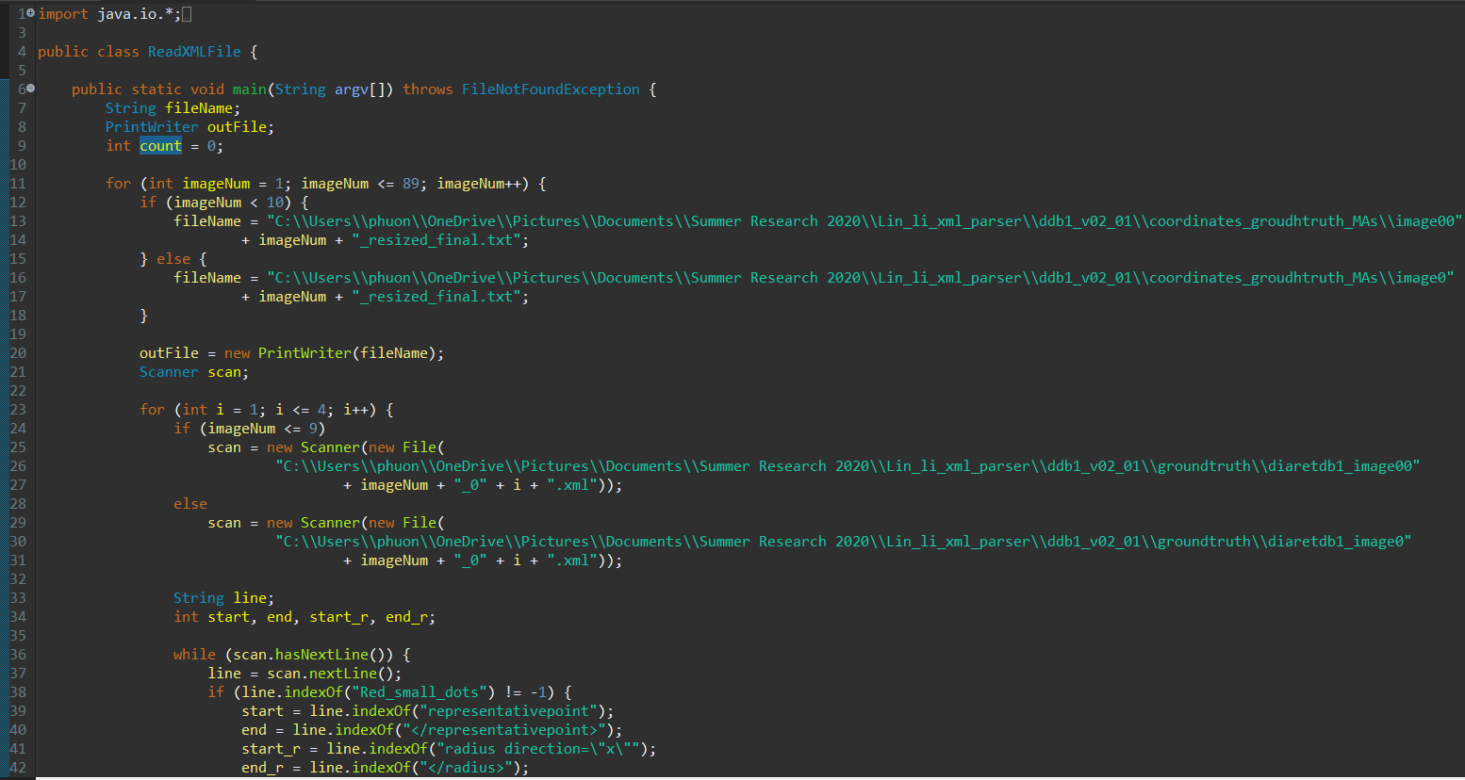
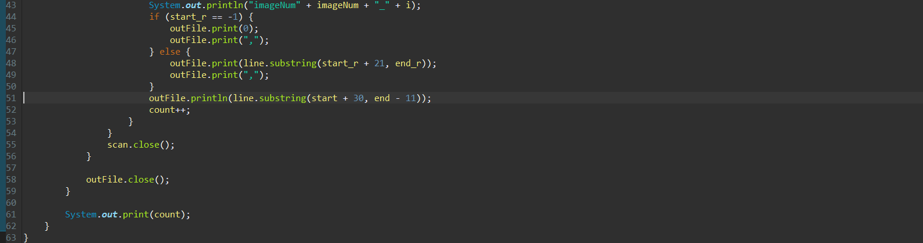

- ROC dataset:
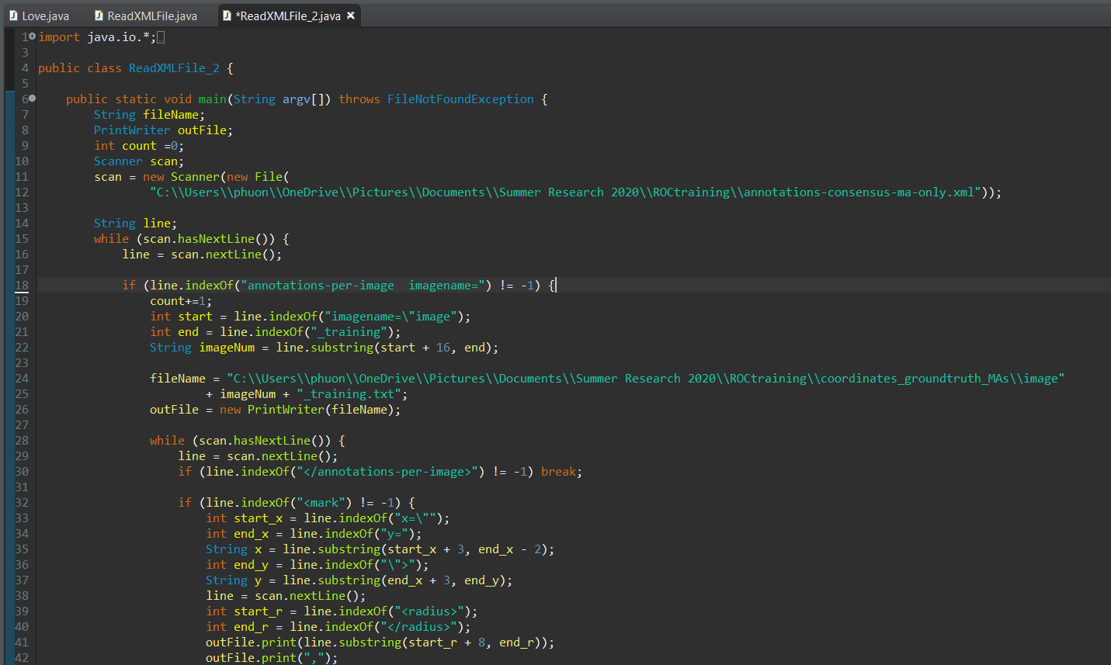
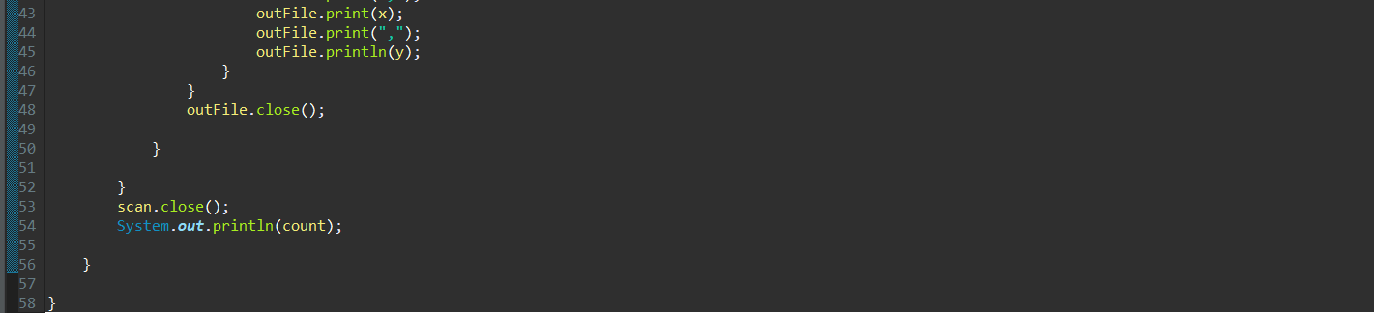

- Result:
Example of image001.txt:

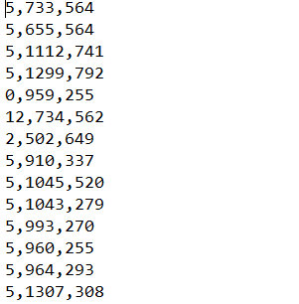
- Label Images:
From provided XML files, I labeled each object on images from the dataset with YOLO format and saved into .txt files.

Code:
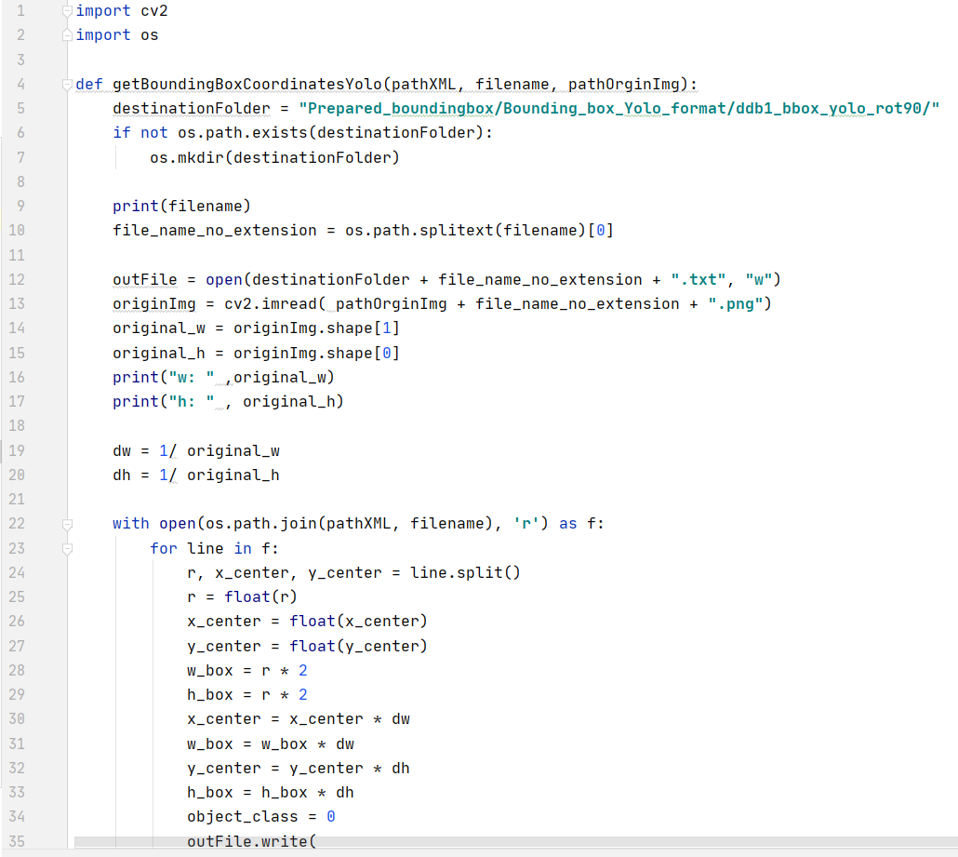
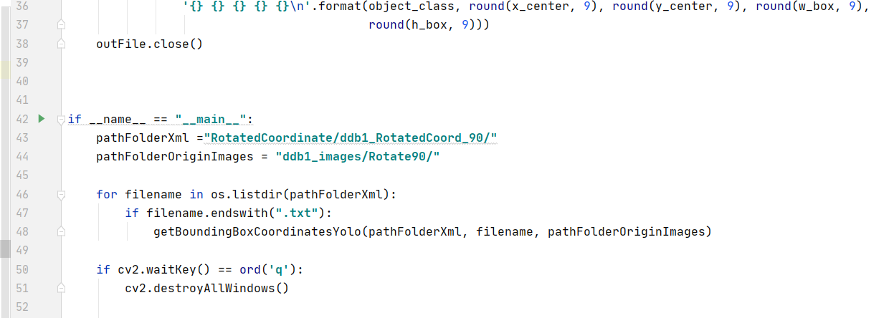

Result:
- For image001.png in Dbbq1 dataset, the corresponding YOLO label file is like below:
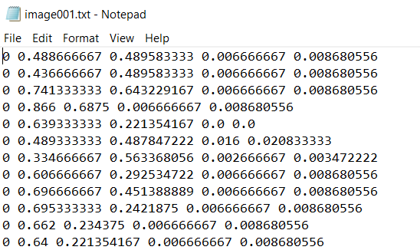

- Training

- Model: YOLOv3
- Transfer Learning: pre-trained weights darknet53.conv.74
- Framework: Darknet (framework’s author is AlexAB)
- Development environment: Google Colab
- Computing Power: GPU Tesla V100-SXM2-16GB

- How to download and compile Darknet on Colab:
+ !git clone https://github.com/pjreddie/darknet
+ Modify file MakeFile: change GPU =0 to =1 and change OPENCV =0 to =1
+ cd /content/darknet
+ !make

- Upload data
+ Create folder MyImages in the directory darknet/data
+ upload all processed images into MyImages folder
+ Create a processing.py file to split the images into 2 files, one is train.txt and one is test.txt
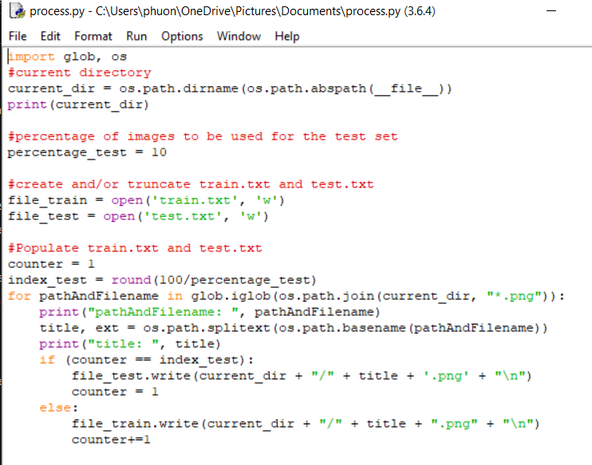

+ Go to the directory: cd darknet/MyImages
+ Run the file processing.py by using the command: !python process.py
This will create 2 files in the same directory which are test.txt and train.txt
+ Copy these two files to data folder like this:
- Create files .data, .names
- Create file named images_retina.data on your window, then add these lines to the file:

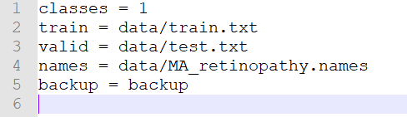

- Create file named MA_retinopathy.names on your window , then add these lines to the file:
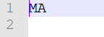

- Upload images_retina.data and MA_retinopathy.names in folder darknet/data
Therefore, we will see these files in the data folder:
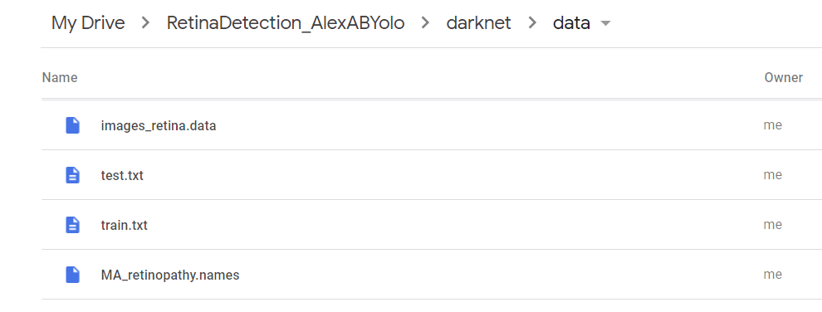

- Modify yolov3.cfg (tune the model):
+ Go to the cfg directory under the Darknet directory and make a copy of yolov3.cfg:
cd cfg
cp yolov3.cfg yolov3_obj.cfg

+ Open yolov3_obj.cfg with a text editor and edit as following:
- In line 3, I set batch =64
- In line 4, I set subdivisions=32
- In line 8, I set width = 832
- In line 9, I set height = 832
- In line 603, I set filters = (classes +5) *3 = 18
- In line 610, I set classes=1
- In line 689, I set filters = (classes +5) *3 = 18
- In line 696, I set classes=1
- In line 776, I set filters = (classes +5) *3 = 18
- In line 783, I set classes=1
+ Save yolov3_obj.cfg and upload it in cfg folder

- Modify image.c to remove visualized label names on predicted images:
+ go to folder src, then open image.c and edit it as following:
+ Look for the function void draw_detections_v3 () and then comment out the lines from 434 to 451 like below:

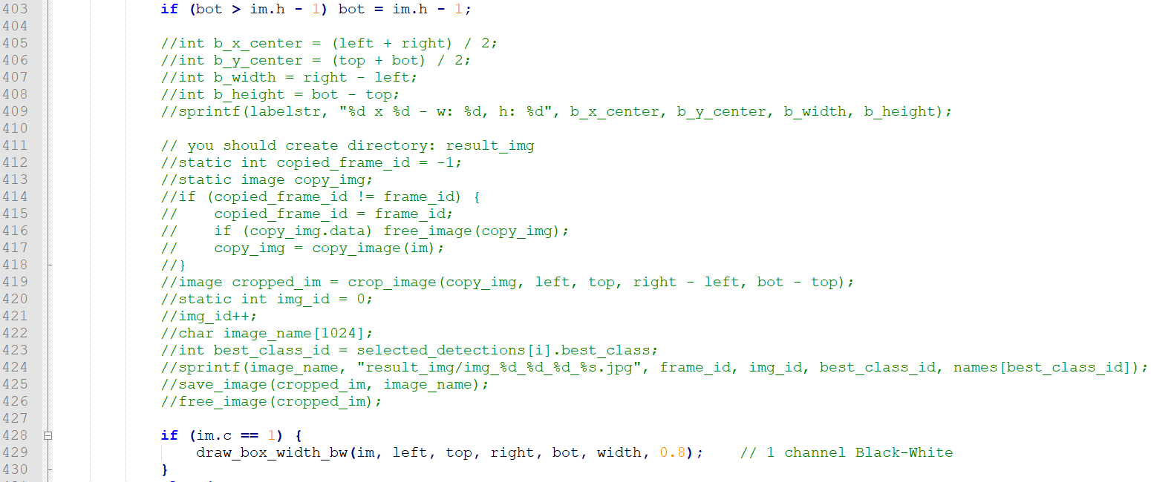

+ then compile Darknet again:
cd darknet/
!make

- Start training:
+ Go back to folder darknet: %cd /content/darknet
+ download the pre_trained model:
!wget https://pjreddie.com/media/files/darknet53.conv.74
+ Run this training command:

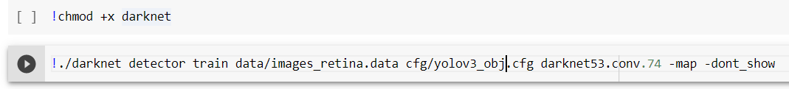
+ If the internet is interrupted, instead of retraining for everything I can keep start training by using new weights files which are created in the backup folder during the training process/

- When to stop training:
I stopped straining after 2300 iterations and when the avg loss is not decreasing.
- Find Accuracy score:
To see F1 score, recall, precision, and average IOU scores, use this command:

This is what we will see after executing the command:

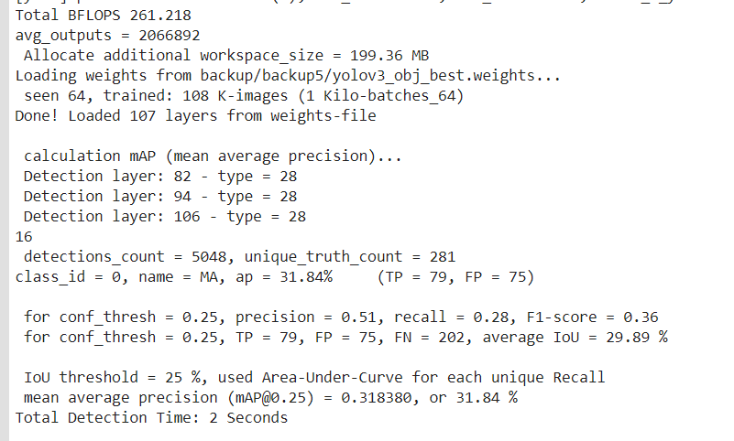

- Testing:
+ use this command to test images

+ Output of predicted images:

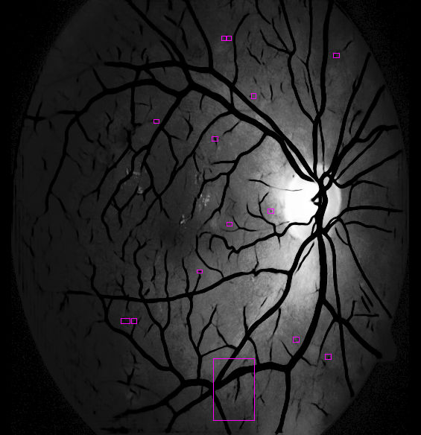

- Discussion:
The best F1 score my model can achieve is 0.26 and it is not that good. Due to the limited of the dataset (only 139 images in total), the model has very modest accuracy score. I think my model can have better accuracy score if it is trained with thousands of images.

