**Technological Institute of the Philippines**

**Manila**

**Systems Administration and Maintenance**

**Instructions**:

1. Install your Virtual Machine
2. Download your image of Ubuntu Server (no GUI)
3. For each task, write your Linux command on the rectangle/table provided. Use the “Courier New” font to distinguish the command from the rest of the text.
4. Filename when uploading should be: “**LinuxDay1_Lastname_Firstname.pdf**”

**Tasks**:

1. Create “assignment” directory

|  |
| --- |
| mkdir assignment |

1. Create the following directories inside your “assignment” directory
   1. prelim
   2. midterm
   3. finals

|  |
| --- |
| cd assignment  mkdir prelim  mkdir midterm  mkdir finals |

1. Create the following directories inside your “prelim” directory
   1. day1
   2. day2
   3. day3

|  |
| --- |
| cd prelim  mkdir day1  mkdir day2  mkdir day3 |

1. Create the following files inside your “/prelim/day1” directory
   1. exer1.docx
   2. exer1.pdf

|  |
| --- |
| cd day1  touch exer1.docx  touch exer1.pdf |

1. Create the following directories inside your “/midterm” directory
   1. executablefiles
   2. projectdocument

|  |
| --- |
| cd ..  cd ..  cd midterm  mkdir executablefiles  mkdir projectdocument |

1. Create the following files inside your “/midterm/projectdocument” directory
   1. finaldocument.docx
   2. preliminarydocument.docx

|  |
| --- |
| cd projectdocument  touch finaldocument.docx  touch preliminarydocument.docx |

1. Create “config.INI” file in your “/finals” directory

|  |
| --- |
| cd ..  cd ..  cd finals  touch config.INI |

1. Open your “config.INI” and have the following text inside

|  |
| --- |
| nano config.INI |

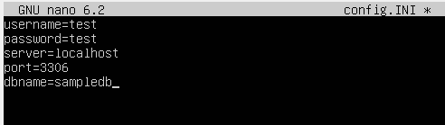

1. Install the tree view by issuing the following commands

sudo apt install tree

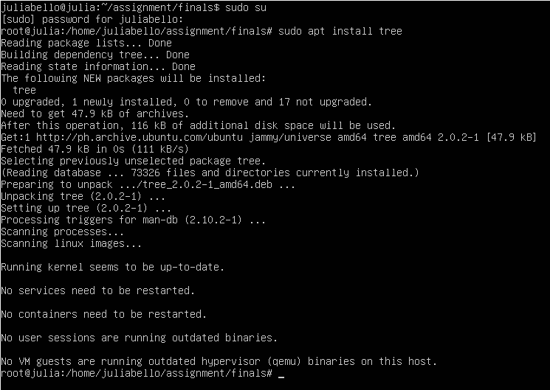

1. Issue the “tree” command and you should see an output like my output.

Paste your screenshot/copy of your tree. In your screenshot make sure to put a watermark or any indication that it is your desktop.

|  |
| --- |
| tree |

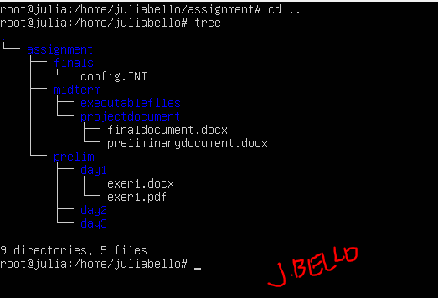

**Honor Pledge:**

*“I affirm that I have not given or received any unauthorized help on this assignment, and that this work is my own.”*



Bello, Julia Christine O.