T7-SWA – Architecture
  - T-ARC-700

Cash manager
  - Software Architecture Specifications

Table of contents
Introduction 3
1. Project context 3
2. Global architecture 3
3. Component description 12
a. MVC Pattern Architecture 12
b. Errors handling 12
c. Log 12
d. Payment Method Handling (Payment Factory) 13
e. Requests Handling (Requests Factory) 13
f. Cashier system (Decorator Pattern) 13
g. Scanning system (Observer Pattern) 14
4. Traceability matrix 14

Introduction

The aim of this software architecture specification (SAS) is to present the technical elements necessary for the CashManager project.

Project context

The provider will have to create the software architecture of this cash manager project. The boal is to create a graphic client with 3 screens, a payement server and a common database.

Global architecture

Global view of the project, what are the different components and how they interact between each other.
Client diagram:

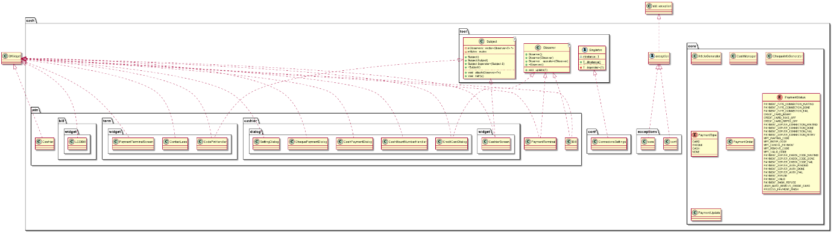

Presentation of the few patterns for the project:

MVC Pattern architecture:
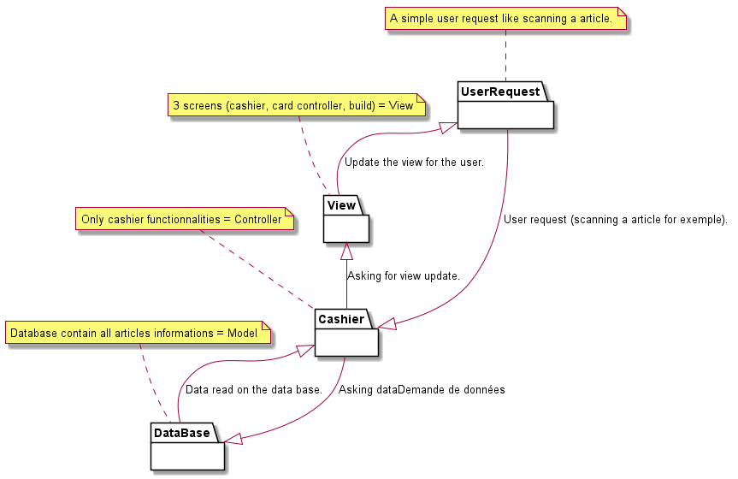

Factory Pattern architecture for requests

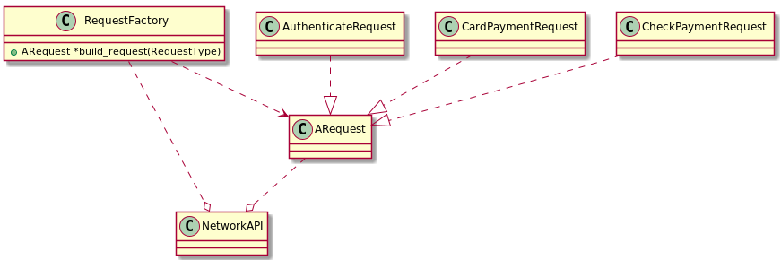

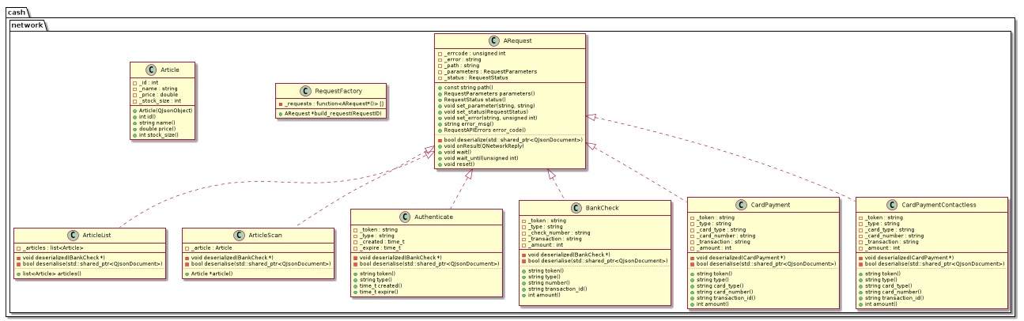

Decorator Pattern architecture for cashier and mobile payment temrinal

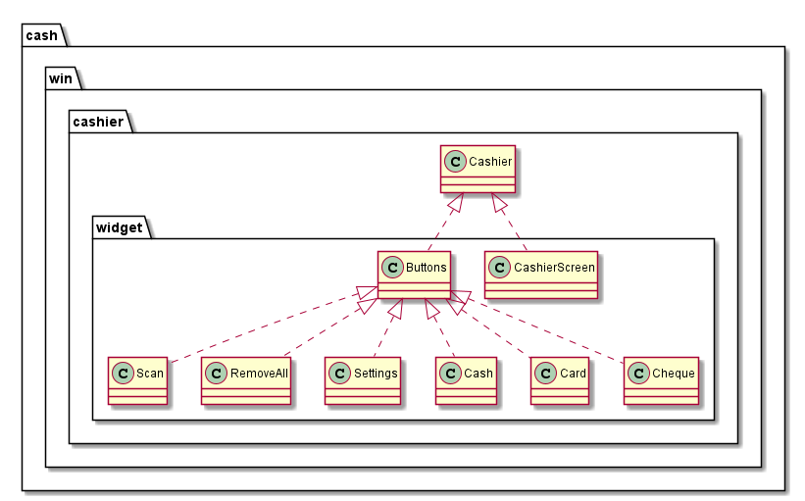

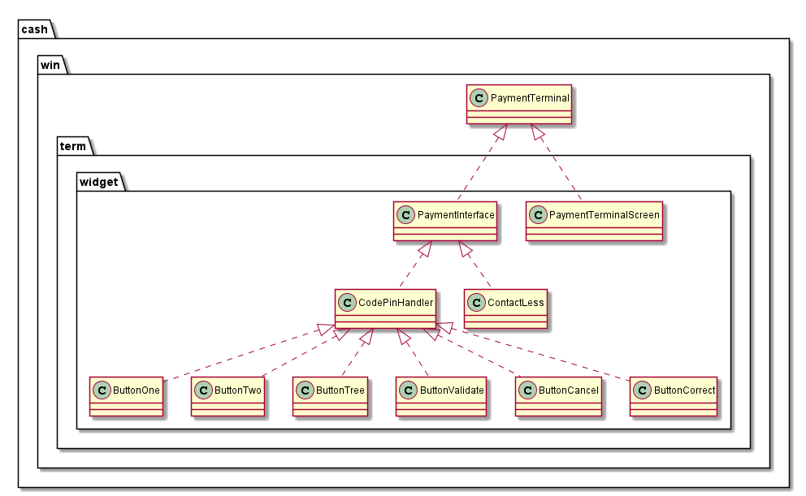

Observatory Patterns architecture for bill, payment status and mobile payment terminal.

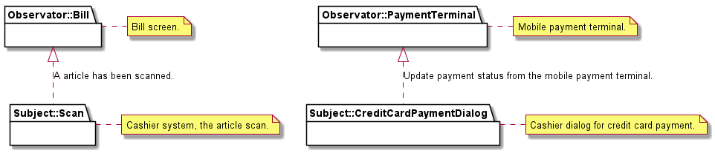
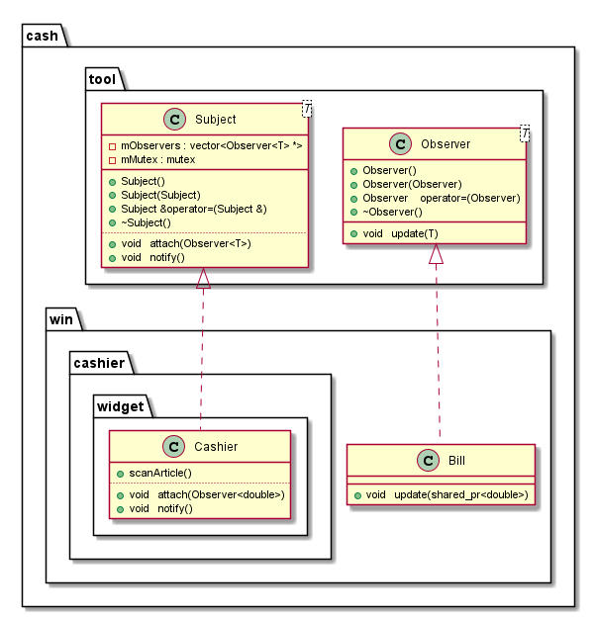

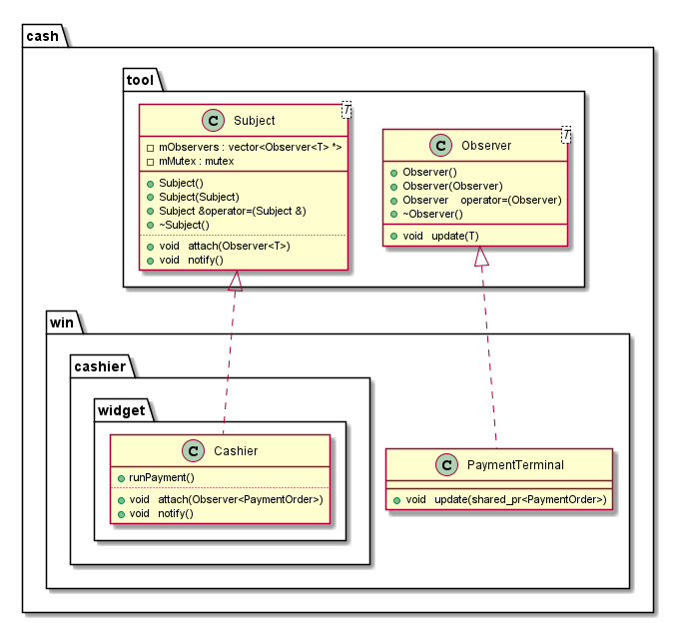

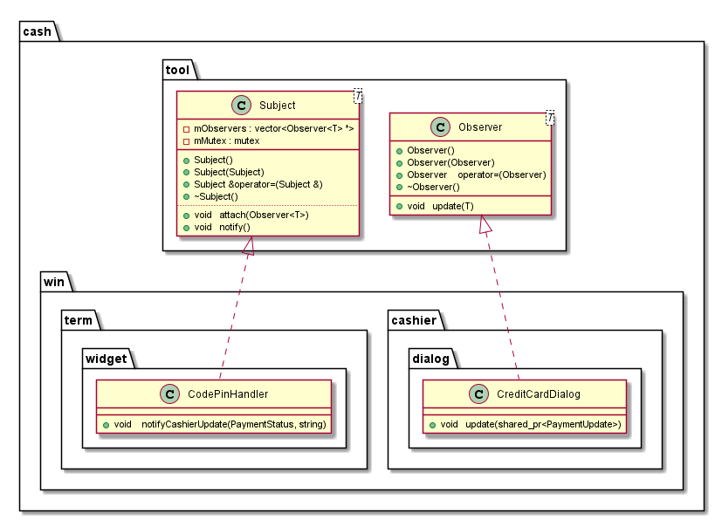

State machine Patterns architecture.

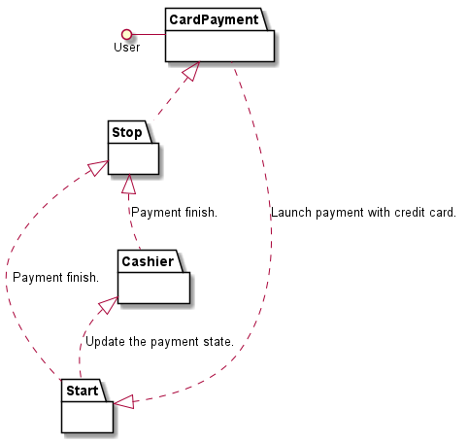

Singleton Patterns architecture for settings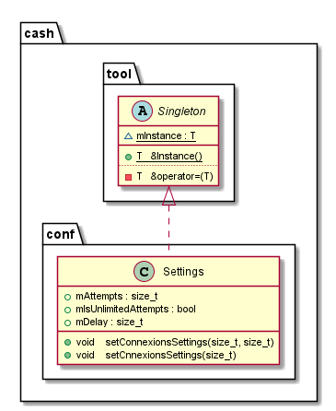.

Exceptions architecture for errors handling

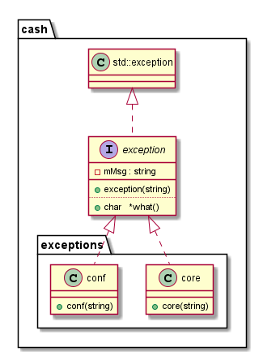

Component description

MVC Pattern Architecture

Component name | MVC Pattern Architecture
Utility | Clear composition of graphic client, database, functionalities managing.
Main classes | Cashier
Main classes | DataBaseAPI
Main classes | UserViews
Key functions and actions | Update() |  | Update the view.
 | Click() |  | User click.
 | Select() |  | Select from the database.
Link to other components | Configuration | Exceptions |  | Log

Errors handling

Component name | Exception system
Utility | Allow the application to have his own exception type and handling.
Main classes | IException
Main classes | ConfException
Main classes | CoreException
Main classes | HelpException
Key functions and actions | what () | Give the exception message.
Link to other components | All components

Log

Component name | Log
Utility | Own logging system using plog lib.
Main classes | PLogConsoleFormatter
Key functions and actions | initialize () | Initialize the log system with own format and multi outputs.
Link to other components | All components

Payment Method Handling (Payment Factory)

Component name | Payment Factory
Utility | Generic payment method handling using common interface and factory.
Main classes | PaymentFactory
Main classes | IPaymentMethod
Key functions and actions | makePayment() | Create shared pointer for payment method.
 | getPaymentMethod() | Extract current payment method from the class.
Link to other components | Exceptions | Log

Requests Handling (Requests Factory)

Component name | Request Factory
Utility | Generic requests handling.
Main classes | PaymentFactory
Main classes | IPaymentMethod
Key functions and actions | makePayment() | Create shared pointer for payment method.
 | getPaymentMethod() | Extract current payment method from the class.
Link to other components | Exceptions | Log

Cashier system (Decorator Pattern)

Component name | Cashier system
Utility | Generic cashier functionalities handling.
Main classes | PaymentFactory
Main classes | IPaymentMethod
Key functions and actions | scanAndBill() | Scan a code bare and compute the bill.
Link to other components | Exceptions | Log

Scanning system (Observer Pattern)

Component name | Scanning system
Utility | Scanner and clients (system) interaction.
Main classes | PaymentFactory
Main classes | IPaymentMethod
Key functions and actions | attach() | Attach subject / observer.
 | notify() | Notify subjects.
 | update() | Update call.
Link to other components | Exceptions | Log

Traceability matrix

This matrix makes the correspondence between components, classes, functions and requirements developed in the request for proposal.

Id requirement | Requirement description | Component | Function / action
REQ_DESIGN_010 | A maximum of design patterns must be used. | All components. | All main components functions.
REQ_DESIGN_020 | A state machine must represent the payment process. | Cashier | getState()  Current state machine in the cashier.
REQ_DESIGN_030 | The state machine must be implemented. | Cashier | getState()  Current state machine in the cashier.
REQ_FUNC_010 | The payment process must allow credit card payment. | Payment Method Handling | Payement(PayementMethod)  Create a payment.
REQ_FUNC_020 | The payment process must allow cash payment. | Payment Method Handling | Payement(PayementMethod)  Create a payment.
REQ_FUNC_030 | The payment process must allow cheque payment | Payment Method Handling | Payement(PayementMethod)  Create a payment.
REQ_FUNC_040 | A setting window is available in the central cash register. | Cashier | showOptionsWin()  Update the layout for the windows options.
REQ_FUNC_050 | In case of a credit card payment, before the pin code entry, the terminal must be connected to the payment server. | Payment Method Handling | setCodePin(codepin)  Initialize code pin.
REQ_FUNC_060 | In case of a credit card payment, if connexion delay of 30 seconds between the terminal and the payment server is exceeded, a new connexion attempt must be made. | Payment Method Handling | setTimeOut()  Initialize timeout.
REQ_FUNC_060 |  | Cashier | setTimeOut()  Initialize timeout.
REQ_FUNC_070 | The connexion delay is configurable in a setting window but cannot be more than 180 seconds. | Payment Method Handling | setCoTimeOut()  Initialize connexion time out.
REQ_FUNC_070 |  | Cashier | setCoTimeOut()  Initialize connexion time out.
REQ_FUNC_080 | In case of a credit card payment, if after two successive attempts the connexion is not effective, the payment process must be cancelled. | Payment Method Handling | cancelPayment()  Cancel a payment.
REQ_FUNC_080 |  | Cashier | cancelPayment()  Cancel a payment.
REQ_FUNC_090 | The number of attempts before cancelling action is configurable in a setting window | Payment Method Handling | setMaxAttemp()  Initialize max attempt for payment.
REQ_FUNC_090 |  | Cashier | setMaxAttemp()  Initialize max attempt for payment.
REQ_FUNC_100 | In case of a credit card payment, the payment is cancelled after three successive wrong codes. | Payment Method Handling | cancelPayment()  Cancel a payment.
REQ_FUNC_100 |  | Cashier | cancelPayment()  Cancel a payment.
REQ_FUNC_110 | There are 2 types of credit card payment • With terminal • Contactless | Payment Method Handling | setCreditCardTypePayment()  Initialize payment card type.
REQ_FUNC_120 | For both type of credit card payment, the payment server must allow or refuse the payment. | Payment Method Handling | checkPayment()  Check the payment.
REQ_FUNC_130 | In case of a cheque payment, the cheque must be scanned and checked by the payment server before being accepted. | Payment Method Handling | checkChequePayment()  Check cheque validity.
REQ_FUNC_140 | All payment modes can be cancelled at any moment. | Payment Method Handling | cancelPayement()  Cancel a payment.
REQ_FUNC_150 | Default money devise can be chosen in the setting window. • Credit card • Cheque • Cash | Payment Method Handling | setMoneyDevise()  Initialize the current money.
REQ_FUNC_160 | The system must allow article’s scan | Scanning system | scan()  Scan a article.
REQ_FUNC_170 | The bill must be update in real time (after each new scan) | Scanning system | update()  Observer pattern call for update.
REQ_IHM_010 | Three screens are available. | View | runScreens()  Run all 3 screens.
REQ_IHM_020 | Screen 1 is the cash register used by the company. | Cashier | runCashierScreen()  Run cashier screen.
REQ_IHM_030 | Screen 1 contains a setting window. | Cashier | showSettingWindow()  Update layout for setting cashier window.
REQ_IHM_040 | Screen 1 allows user to choose payment mode. | Cashier | setPaymentMethod()  Initialize payment method.
REQ_IHM_050 | Screen 1 allows user to cancel the operation. | Cashier | cancelOperator()  Cancel operator.
REQ_IHM_060 | Screen 1 displays the bill’s total. | Cashier | UpdateBill()  Update the total bill.
REQ_IHM_070 | Screen 1 displays the cheque status: cheque authorized, cheque refused, status pending authorization. | Cashier | updateChequeStatus()  Update the cheque status on screen.
REQ_IHM_080 | Screen 1 displays the payment server connexion status: connexion established, connexion refused, connexion in progress. | Cashier | updateServerConnexionStatus()  Update the server connexion status on screen.
REQ_IHM_090 | Screen 1 displays the card code status: pending code, correct code, wrong code | Cashier | updateCardCodeStatus()  Update the card code status on screen.
REQ_IHM_100 | Screen 1 displays the card payment status: pending authorization, card payment accepted, card payment refused. | Cashier | updateCardPaymentStatus()  Update the card payment status on screen.
REQ_IHM_110 | Screen 2 only displays the bill’s total. | View | runBillScreen()  Run the bill screen.
REQ_IHM_120 | No action can be made from screen 2. | View | …………..
REQ_IHM_130 | Screen 3 is the client payment terminal. | View | runTPE()  Run the TPE screen.
REQ_IHM_140 | Screen 3 allows user to enter its code. | View | setCardCode()  Initialize the card payment code.
REQ_IHM_150 | Screen 3 allows user to cancel the operation. | View | cancelPayment()  Cancel the payment from the user.
REQ_IHM_160 | Screen 3 displays the bill’s total. | View | updateBill()  Update the bill on screen.
REQ_IHM_170 | Screen 3 displays the payment server connexion status: connexion established, connexion refused, connexion in progress. | View | updatePaymentServerConnexion()  Update the payment server connexion on screen.
REQ_IHM_180 | Screen 3 displays the card code status: pending code, correct code, wrong code. | View | updateCardCodeStatus()  Update card code status on screen.
REQ_IHM_190 | Screen 3 displays the card payment status: pending authorization, card payment accepted, card payment refused. | View | updateCardPaymentStatus()  Update card payment status on screen.
REQ_DATA_010 | Common data must be centralized in a same component. | WarehouseAPI | articles()  Select on database.
REQ_DATA_010 | Cache manager must be designed in a dedicated component. | WarehouseAPI | Own instance.

