T8-DEV-Embedded
  - T-EMB-800

Faillist
  - Software Architecture Specifications

Table of contents
Introduction 3
1. Project context 3
2. Component description 4
a. FileReader 4
b. FileParser 4
c. Logger 5
3. Traceability matrix 6

Introduction

The aim of this software architecture specification (SAS) is to present the technical elements necessary for the Faillist project.

Project context

The project consists of creating a failure reporter software. The aim of this software is to write in a log failure file all error codes raised by the planeGlobal architecture.
Global view of the project, what are the different components and how they interact between each other.

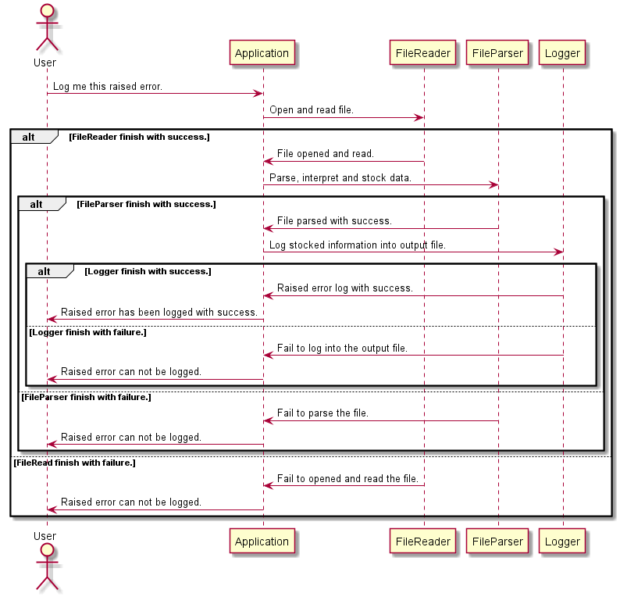

Component description

FileReader

Description of component 1: utility, main classes, key functions and actions, link to other components

Component name | FileReader
Utility | Open and read a given file.
Main classes | C NOT C++ – NO CLASS
Key functions and actions | bool file_reader(const char *filename, char in[FILE_MAX_SIZE]); | Open and read a file.
Link to other components | Main function.

FileParser

Description of component 1: utility, main classes, key functions and actions, link to other components.

Component name | FileParser
Utility | Open and read a given file.
Main classes | C NOT C++ – NO CLASS
Key functions and actions | bool pars_raised_error(char in[FILE_MAX_SIZE], struct report *raised_error); | Pars raised error with json parser.
Link to other components | Main function. | FileReader

Logger

Description of component 1: utility, main classes, key functions and actions, link to other components.

Component name | Logger
Utility | Log information into the output file.
Main classes | C NOT C++ – NO CLASS
Key functions and actions | bool write_failure(int fd, size_t idx, struct failure *failure); |  | Write into the file a faillure information.
 | bool write_failure_date(int fd, unsigned int date); |  | Write failure date.
 | bool write_id_component_failure(int fd, unsigned int id_component); |  | Write id component failure.
 | bool write_failure_id(int fd, size_t idx, unsigned int failure_id); |  | Write failure id on log file.
 | int open_report(struct report *raised_error); |  | Open file report.
Link to other components | Main function. | FileReader |  | FileParser

Traceability matrix

This matrix makes the correspondence between components, classes, functions and requirements developed in the request for proposal.

Id requirement | Requirement description | Component | Function / action
REQ_FUNC_010 | Raised errors must be encoded with the following format: | FileParser | bool pars_raised_error(char in[FILE_MAX_SIZE], struct report *raised_error);  Parse the raised error.
REQ_FUNC_020 | Field ID_PLANE must contain the identification of the plane. | FileParser | bool pars_raised_error(char in[FILE_MAX_SIZE], struct report *raised_error);  Parse the raised error.
REQ_FUNC_030 | Field TYPE_PLANE must contain the type of the plane. | FileParser | bool pars_raised_error(char in[FILE_MAX_SIZE], struct report *raised_error);  Parse the raised error.
REQ_FUNC_040 | Field NB_FAILURES must indicate the number of raised failure. | FileParser | bool pars_raised_error(char in[FILE_MAX_SIZE], struct report *raised_error);  Parse the raised error.
REQ_FUNC_050 | Field DATETIME_FAILURE_X must indicate the date and the time of the error X. | FileParser | bool pars_raised_error(char in[FILE_MAX_SIZE], struct report *raised_error);  Parse the raised error.
REQ_FUNC_060 | Field ID_COMPONENT_FAILURE_X must indicate which component is concerned by the error X. | FileParser | bool pars_raised_error(char in[FILE_MAX_SIZE], struct report *raised_error);  Parse the raised error.
REQ_FUNC_070 | Field LEVEL_CRITICITY_FAILURE_X must indicate which is the criticity level of the failure X. | FileParser | bool pars_raised_error(char in[FILE_MAX_SIZE], struct report *raised_error);  Parse the raised error.
REQ_FUNC_080 | Field ID_FAILURE_X must indicate the id of the failure X. | FileParser | bool pars_raised_error(char in[FILE_MAX_SIZE], struct report *raised_error);  Parse the raised error.
REQ_FUNC_090 | Field COMMENT_FAILURE_X_SIZE must indicate the size in bytes of the CAUSE_FAILURE_X field | FileParser | bool pars_raised_error(char in[FILE_MAX_SIZE], struct report *raised_error);  Parse the raised error.
REQ_FUNC_100 | Field COMMENT_FAILURE_X must describe the failure X cause. | FileParser | bool pars_raised_error(char in[FILE_MAX_SIZE], struct report *raised_error);  Parse the raised error.
REQ_FUNC_110 | The file must contain data extracted from the error code described in REQ_FUNC_010. | FileParser | bool pars_raised_error(char in[FILE_MAX_SIZE], struct report *raised_error);  Parse the raised error.
REQ_FUNC_120 | The file must have the following contents: | Logger | void write_report(int fd, struct report *report);  Write all report information into the log file.
REQ_FUNC_130 | Field [TYPE_PLANE] in REQ_FUNC_120 must be converted to a readable type string which can be retrieved in file “Embedded_WorldRequest_for_proposal-Annex1.xlsx”, sheet “TYPE_PLANE”, column “Type plane”. | Logger | void write_type_plane(int fd, unsigned int raised_type_plane);  Write type plane information into the log file.
REQ_FUNC_140 | Field [NATIONALITY] in REQ_FUNC_120 must be retrieved from the [ID_PLANE] field (see “Embedded_World-Request_for_proposalAnnex1.xlsx”, sheet “ID_PLANE” sheet for more precisions). | Logger | void write_id_plane(int fd, unsigned char *raised_id_plane);  Write id plane.
REQ_FUNC_150 | Field [ID_FAILURE_X] in REQ_FUNC_120 must be converted to a readable id string which can be retrieved in file “Embedded_WorldRequest_for_proposal-Annex1.xlsx”, sheet “ID_FAILURE_X”, column “Failure type”. | Logger | bool write_failure_id(int fd, size_t idx, unsigned int failure_id);  Write failure id on log file.
REQ_FUNC_160 | Field [DATETIME_FAILURE_X] in REQ_FUNC_120 must be converted to a readable date following the format “YYYY/MM/DD – hh:mm:ss” with: • YYYY: the year of the error • MM: the month of the error DD: the day of the error • hh: the hour of the error • mm: the minute of the error ss: the second of the error | Logger | bool write_failure_date(int fd, unsigned int date);  Write failure date.
REQ_FUNC_170 | Field [ID_COMPONENT_X] in REQ_FUNC_120 must be converted to a readable id string which can be retrieved in file “Embedded_WorldRequest_for_proposal-Annex1.xlsx”, sheet “ID_COMPONENT_FAILURE_X”, column “Component”. | Logger | bool write_id_component_failure(int fd, unsigned int id_component);  Write id component failure.
REQ_FUNC_180 | The name of the extracted file must follow this format: Extraction_report_[ID_PLANE]_[DATETIME].txt | Logger | int open_report(struct report *raised_error);  Open report file.
REQ_FUNC_190 | Field [ID_PLANE] in the name of the extracted file must be the ID_PLANE contained in the error code. | Logger | int open_report(struct report *raised_error);  Open report file.
REQ_FUNC_200 | Field [DATETIME] must be the date of the extraction. | Logger | int open_report(struct report *raised_error);  Open report file.
REQ_DATA_010 | Field ID_PLANE is an array of unsigned char[12]. | FileParser | unsigned char id_plane[ID_PLANE_MAX_SIZE];  # define ID_PLANE_MAX_SIZE 12
REQ_DATA_020 | The description of possible values of the field ID_PLANE is described in file “Embedded_World-Request_for_proposal-Annex1.xlsx”, sheet “ID_PLANE”. | FileParser | static const struct id_plane id_planes[MAX_ID_PLANE]  Variable how define all id_plane relationship with documentation.
REQ_DATA_030 | ID_PLANE string must be terminated by a ‘\0’. | FileParser | void init_report(struct report *raised_error)  Initialize all report variable.
REQ_DATA_040 | Field TYPE_PLANE is an unsigned int value. | FileParser | unsigned int type_plane;
REQ_DATA_050 | Field TYPE_PLANE must be one of the values described in file “Embedded_World-Request_for_proposal-Annex1.xlsx”, sheet “TYPE_PLANE”. | FileParser | static const struct type_plane type_planes[TYPE_PLANE_MAX]  Define all type planes available has define in documentation.
REQ_DATA_060 | Field NB_FAILURES is an unsigned int value. | FileParser | unsigned int nb_failures;
REQ_DATA_070 | Field NB_FAILURES range is [0;999]. | FileParser | void init_report(struct report *raised_error)  Initialize all report variable.
REQ_DATA_080 | Field DATETIME_FAILURE_X is an unsigned int value | FileParser | unsigned int date;
REQ_DATA_090 | The date and time format of the DATETIME_FAILURE_X field is the number of second since 00:00 January the 1rst 1970 UTC. | FileParser | bool write_failure_date(int fd, unsigned int date);  Write failure date.
REQ_DATA_100 | Field ID_FAILURE_X is an unsigned int value. | FileParser | unsigned int id_failure;
REQ_DATA_110 | Field ID_FAILURE_X must be one of the values described in file “Embedded_World-Request_for_proposal-Annex1.xlsx”, sheet “ID_FAILURE_X”. | FileParser | static const struct failure_id id_failures[FAILURE_ID_MAX]  Define all id failure has asked in the documentation.
REQ_DATA_120 | Field ID_COMPONENT_FAILURE_X is an unsigned int value | FileParser | unsigned int id_component;
REQ_DATA_130 | Field ID_COMPONENT_FAILURE_X must be one of the values described in file “Embedded_World-Request_for_proposal-Annex1.xlsx”, sheet “ID_COMPONENT_FAILURE_X”. | FileParser | static const struct id_component  _failure id_components  _failure[COMPONENT_ID_MAX]  Define all id component failure has asked in the documentation
REQ_DATA_140 | Field LEVEL_CRITICITY_FAILURE_X is an unsigned int value. | FileParser | unsigned int level_criticity;
REQ_DATA_150 | Field LEVEL_CRITICITY_FAILURE_X range must be [0;10], with 0 the minimum level of criticity, 10 the maximum. | FileParser | bool write_failure(int fd, size_t idx, struct failure *failure)  Write into the file a faillure information.
REQ_DATA_160 | Field COMMENT_FAILURE_X_SIZE is an unsigned int value | FileParser | unsigned int comment_failure_size
REQ_DATA_170 | Field COMMENT_FAILURE_X_SIZE range is [0;MAX_COMMENT_SIZE]. | FileParser | bool write_failure(int fd, size_t idx, struct failure *failure)  Write into the file a faillure information.
REQ_DATA_180 | MAX_COMMENT_SIZE is equal to 1000. | FileParser | bool write_failure(int fd, size_t idx, struct failure *failure)  Write into the file a faillure information.
REQ_DATA_190 | Field COMMENT_FAILURE_X is an array of unsigned char[MAX_COMMENT_SIZE]. | FileParser | unsigned char comment_failure  [MAX_COMMENT_SIZE];
REQ_DATA_200 | Field DATETIME of the file name must follow the format: YYYY_MM_DD_hh_mm_ss with: • YYYY: the year of the extraction • MM: the month of the extraction • DD: the day of the extraction • hh: the hour of the extraction • mm: the minute of the extraction ss: the second of the extraction | Logger | int open_report(struct report *raised_error)  Open report file, generation the date (file name) has asked.

