T7-SWA – C++
  - T-CPP-700

SpaceBattle
  - Software Architecture Specifications

Table of contents
Introduction 3
1. Project context 3
2. Global architecture 3
3. Component description 4
a. Exception System 4
b. Log 4
c. Configuration 4
d. Core 4
e. Battle API 5
f. Server 5
g. ClientManager 5
h. PacketManager 5
i. Client 6
j. Pattern observer 6
k. BufferDataManager 6
l. Request Loader 6
4. Traceability matrix 7

Introduction

The aim of this software architecture specification (SAS) is to present the technical elements necessary for the SpaceBattle project.

Project context

The provider will have to create new game based on standard naval battle across network. The Space Battle has same rules than the original game.

Global architecture

Global view of the project, what are the different components and how they interact between each other.
Server side:

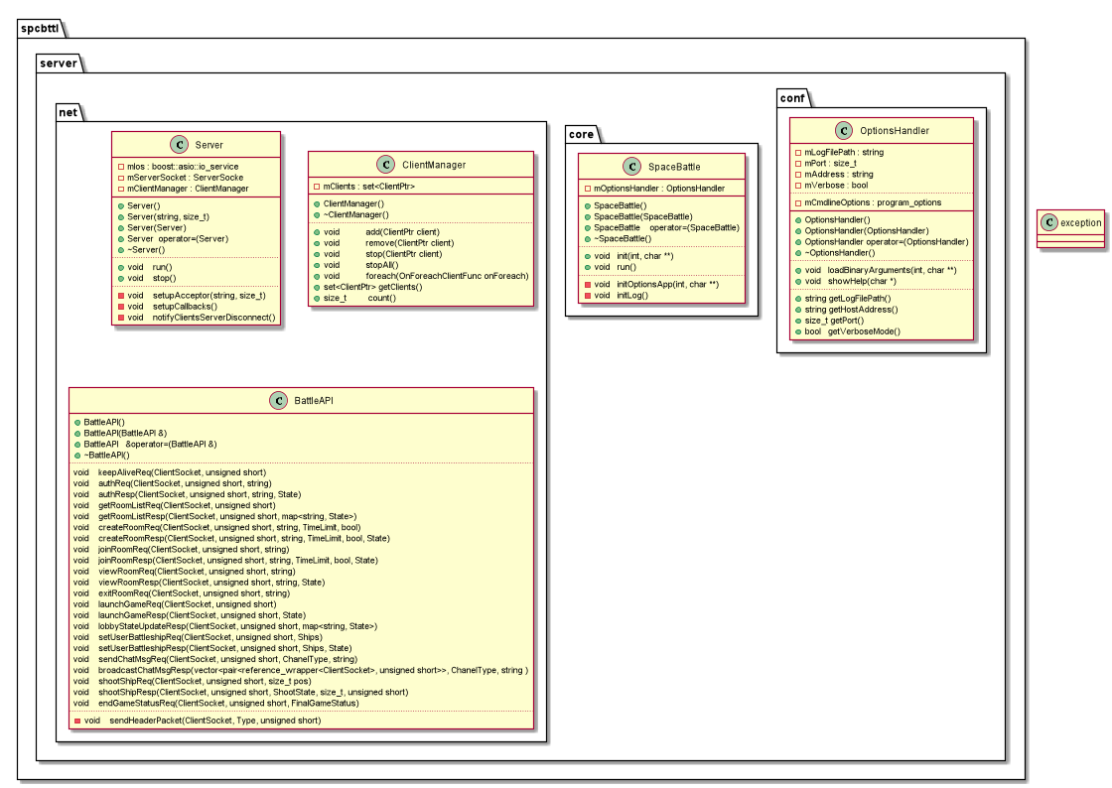

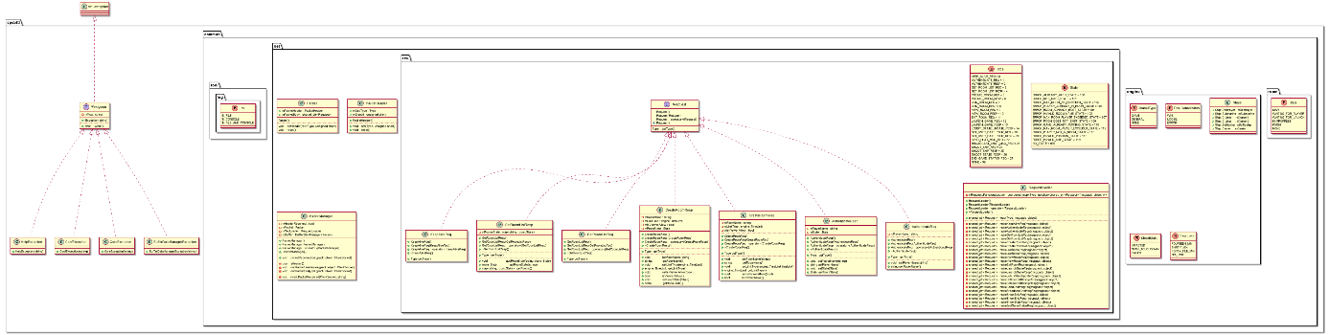

Component description

Exception System

Component name | Exception system
Utility | Allow the application to have his own exception type and handling.
Main classes | IException
Main classes | ConfException
Main classes | CoreException
Main classes | HelpException
Key functions and actions | what () | Give the exception message.
Link to other components | All components

Log

Component name | Log
Utility | Own logging system using plog lib.
Main classes | PLogConsoleFormatter
Key functions and actions | initialize () | Initialize the log system with own format and multi outputs.
Link to other components | All components

Configuration

Component name | Configuration
Utility | Application configuration with boost program_options lib.
Main classes | OptionsHandler
Key functions and actions | loadBinaryArguments () |  | Load all arguments from the application.
Link to other components | Core | Log |  | Exception

Core

Component name | Core
Utility | Application core.
Main classes | SpaceBattle
Key functions and actions | init () |  | Prepare all the application configuration before running.
 | run() |  | Run server game.
Link to other components | Configuration | Log |  | Exception

Battle API

Component name | Battle API
Utility | API for client et server, pre-create requests.
Main classes | BattleAPI.
Key functions and actions | *Req () |  | Send a request to a client or the server.
Link to other components | Core | Log |  | Exception

Server

Component name | Server
Utility | Server main network instance
Main classes | Server.
Key functions and actions | run() |  | Run the server.
Key functions and actions | stop() |  | Stop the server.
Link to other components | Core | Log | Exception | ClientManager

ClientManager

Component name | ClientManager
Utility | Manage all the client from the server.
Main classes | ClientManager
Key functions and actions | add() |  | Add a client.
Key functions and actions | remove() |  | Remove a client.
Link to other components | Server | Log | Exception

PacketManager

Component name | PacketManager
Utility | Manage all packet.
Main classes | PacketManager
Key functions and actions | packetReceived() |  | Handle a new packet.
Link to other components | Server | Log | Exception

Client

Component name | Client
Utility | Client main network class.
Main classes | Client
Key functions and actions | connect() |  | Connect to the server.
 | run() |  | Run the client listener.
Link to other components | Server | Log | Exception

Pattern observer

Component name | Pattern Observer
Utility | Notify system.
Main classes | Observer |  | Subject
Key functions and actions | update() |  |  | Callback.
 | attach |  |  | Attach a observer.
 | notify() |  |  | Notify observer.
Link to other components | Server | Log |  | Client

BufferDataManager

Component name | Buffer data manager
Utility | Stack packet.
Main classes | BufferDataManager
Key functions and actions | push_back() |  | Add on back a data.
 | pop_front() |  | Take first data on stack.
Link to other components | Server | Log | Client

Request Loader

Component name | Requests loader.
Utility | Load request.
Main classes | RequestLoader
Key functions and actions | load() |  | Load a request.
Link to other components | Server | Log | Client

Packet Dispatcher

Component name | Packet Dispatcher.
Utility | Dispatch request on different threads and room.
Main classes | PAcketDispatcher
Key functions and actions | start() |  | Start all threads.
Key functions and actions | stop() |  | Stop all treads
Link to other components | RoomManager | Log | Server

Room Manager

Component name | Room Manager.
Utility | Receive packet from Packet Dispatcher and execute each room management function and if necessary forward packet to room.
Main classes | PacketDispatcher
Key functions and actions | room_commands() |  | Forward packet to room.
Key functions and actions | Keep_alive() |  | Keep player alive.
Key functions and actions | Authenticate() |  | Authenticate player.
Key functions and actions | Cerate_room() |  | Create new room.
Key functions and actions | Get_room_list() |  | List rooms on server.
Key functions and actions | Join_room() |  | Player join a room.
Key functions and actions | View_room() |  | Player view a room.
Key functions and actions | Send_chat_msg |  | Player send a message.
Key functions and actions | Exit_room() |  | Player quit a room.
Key functions and actions | Execute() |  | Redirect packet to command with id.
Key functions and actions | Checks() |  | Checks players alive, game end, …
Link to other components | Room | Log | PacketDispatcher

Room

Component name | Room.
Utility | Store the player and viewers and execute packet related to game logic.
Main classes | Room
Key functions and actions | Send_chat_msg() |  | Send forward room messages to other players.
Key functions and actions | Shoot_ship() |  | Shoot a ship
Key functions and actions | Launch_game |  | Player notify he is ready to play.
Key functions and actions | Execute() |  | Execute request in room.
Key functions and actions | Add_player() |  | Insert player in room.
Key functions and actions | Add_viewer() |  | Insert viwers in room.
Key functions and actions | Del_viewer() |  | Viewer leave room.
Key functions and actions | Full_player() |  | Room is full
Key functions and actions | Allow_viwers() |  | Room allow viewers
Key functions and actions | load() |  | Load a request.
Link to other components | Battlefield | Log | RoomManager

Battlefield

Component name | Battlefield.
Utility | Manage the game logical related to ships and board.
Main classes | Battlefield
Key functions and actions | Game_start() |  | Start the game.
Key functions and actions | Set_players() |  | Load players joined on game.
Key functions and actions | Set_ship() |  | Set thip on the board abd check his coordinates.
Key functions and actions | Clear_ship() |  | Remove ship of board.
Key functions and actions | Ship_not_destroyed() |  | Count number of ship not destroyed.
Key functions and actions | shoot() |  | Shoot on case of the board.
Link to other components |  | Log | Room

GameGraphics

Component name | GameGraphics.
Utility | Handle the client’s 3D graphics capabilities.
Main classes | GameGraphics, IGameGraphics
Key functions and actions | showGrid () | Show the game’s grid
Key functions and actions | hideGrid() | Hides the game’s grid
Key functions and actions | init() | Loads all game’s objects
Key functions and actions | reset() | Reset the game, clear the the viewport
Key functions and actions | placeShip () | Place a ship
Key functions and actions | setImpact () | Set a board’s impact
Key functions and actions | startShipPlacementPhase () | Viewer leave room.
Key functions and actions | startShootingPhase() | Start shooting phase
Key functions and actions | start() | Start the game

GameUI

Component name | GameUI
Utility | Handle the client’s UI capabilities
Main classes | IGameUI, GameUI
Key functions and actions | init() | Init the client’s UI.
Key functions and actions | hideUI () | Hides the current shown UI.
Key functions and actions | addChatMessage() | Add a chat message into the chat screen.
Key functions and actions | addRoom() | Add a room into the room list.
Key functions and actions | clearRooms() | Clears the room list.

GameUI

Component name | GameBoard
Utility | Abstraction for a player’s gameboard.
Main classes | GameBoard, IGameBoard
Key functions and actions | init() | Init the board at a specific size.
Key functions and actions | TestShip () | Test a ship placement.
Key functions and actions | PlaceShip() | Place a ship on the board.
Key functions and actions | UpdateShip() | Updates a ship’s position.
Key functions and actions | RemoveShip() | Remove a ship from the board.

Traceability matrix

This matrix makes the correspondence between components, classes, functions and requirements developed in the request for proposal.

Id requirement | Requirement description | Component | Function / action
REQ_DESIGN_010 | You must create and implement a protocol | BattleAPI | *req()  Send a specific request.
REQ_DESIGN_020 | You must have command protocol | BattleAPI | *req()  Send a specific request.
REQ_DESIGN_030 | You must have game protocol | BattleAPI | *req()  Send a specific request.
REQ_DESIGN_040 | Server have no GUI | Server | No GUI only on stdout.
REQ_DESIGN_050 | Client must have GUI
REQ_FUNC_010 | Your server must accept multiple connections. | ClientManager | Add()  Add a client.
REQ_FUNC_020 | Game has status | Room | get_status()
REQ_FUNC_030 | Game must have 2 players | Room | Full_player
REQ_FUNC_040 | Game can have viewers | Room | Allow_viewers()
REQ_FUNC_050 | Game can have limit of time: | RoomManager | Create_room
REQ_FUNC_060 | Every player must confirm to launch the game | Room | Launch_game()
REQ_FUNC_070 | You must implement 5 battleship types: | Battlefield | Set_ship()
REQ_FUNC_080 | A ship cannot be in diagonal position | Battlefield | Set_ship()
REQ_FUNC_090 | Your server can manage several games | RoomManager | Execute()
REQ_FUNC_100 | Your server must implement chat system with general room and one room by game | RoomManager | Send_chat_msg()
REQ_FUNC_110 | A client must connect himself to server | RoomManager | Authenticate()
REQ_FUNC_120 | A client can ask create game | RoomManager | Create_room()
REQ_FUNC_130 | When creating game, a client can choose name, limit of time, if game has viewers | RoomManager | Create_room()
REQ_FUNC_140 | A client can join game as player or viewers (if possible) | RoomManager | Join_room()
REQ_FUNC_150 | Clients can discuss between them on general room Clients can discuss on game room | RoomManager | Sendz_chat_msg()
REQ_FUNC_160 | You must 2 dimensions model | GameGraphics | showGrid()
REQ_IHM_010 | You must have a connection page with nickname, IP and port | GameUI | showConnectServerMenu()
REQ_IHM_020 | You must have a main menu with: | GameUI | showMainMenu()
REQ_IHM_030 | You must have a launching game scene with: | GameUI | showWaitingGame ()
REQ_IHM_040 | You must have a create game scene with: | GameUI | showCreateGameMenu()
REQ_IHM_050 | You must have a set battleship positions game scene with: | GameGraphics | startShipPlacementPhase()
REQ_IHM_060 | You must have a battle game scene (for players) with 2 panels: | GameGraphics | startShootingPhase()

