Jeremy Calvert
Assignment 1
CSEP 573
October 17, 2007

1. (28 points) You have two jugs measuring 4 gallons and 7 gallons respectively, and a water faucet. You can fill the jugs up or empty them out from one to another or onto the ground. Filling a full jug or emptying an empty jug is not allowed. Initially both jugs are empty, and your goal is to measure out exactly 2 gallons. There can be multiple solutions, in which the one using least amount of water from the faucet is optimal.
(a) (6 points) Give the state description, initial state, goal test, actions and cost function.

The state is quantified by integers i and j, such that , representing the volume of water in each jug. We know that this covers all possible states because in order for us to know the volume is exact, at each stage change, one of the jugs has been filled completely or emptied completely. This can only happen if the net volume remains an integer multiple, so this covers all states.

The initial state is .

The goal test is that the net volume is known to be 2 gallons, so . This is an acceptable goal test because it costs nothing to dump one of the containers, so that if one of the containers has exactly 2 gallons, dumping the other one is a zero cost step to a goal test satisfying state.

The actions are:
Fill(i): filling jug(i) from the faucet.
Pour(i, j): pouring jug(i) into jug(j) as much as j will bear.
Dump(i): Dumping contents of jug(i) in the ground.

The cost is born at F(i), and is incremented by the volume added to jug(i).

(b) (7 points) Draw a state diagram to show the steps for finding a solution by breadth first search (assuming you can avoid expanding duplicate states).
Here is the state diagram.

And here is an outline of the BFS

(3 points) Is the above solution optimal, why?

The solution is optimal in this case because other possible solutions cost more. However, for a similar question posed where all is the same except, say, cost is the amount of water dumped into the ground, the BFS would not find the optimal solution. In this case, we'd stop short of dumping the 7 gallons in the larger jug when we reached the goal of having 2 gallons in the first jug, wasting less net water.

(c) (5 points) You will use A* search with a poor heuristic that estimates 0 cost from any state to a goal state. Given the actions are considered in the same order for successors as in (b), is it possible that this naive A* search will expend more nodes than (b), why?

It is possible in general. In this specific case, it does not happen that A* search expands more nodes than BFS because in this case BFS is optimal. In fact, A* search expands less nodes to find the ideal solution. In the example of cost being amount of water dumped in the ground, A* search will expand more nodes, and find the ideal solution, whereas BFS will return earlier with a sub-optimal solution.

(d) (7 points) Draw a state diagram of all the states in the state space by depth first search (no stop at goal states), labeled with the order that they are expanded, and mark all the goal states (assuming you can avoid expanding duplicate states).

2. (20 points) A 7-puzzle is the same as the 8-puzzle except that there are two blank spaces instead of one.
(a) (3 points) What is the number of states of the 7-puzzle?

We can achieve any state by placing the numbered tiles on open spaces, sequentially. For the 1 tile, there are 9 choices, for the 2 tile, there are 8 choices, and so on, up to the 7 tile, for which there are 3 choices. So there are states for the 7 puzzle.

(b) (17 points) Show that every state is reachable from any initial state.
We'll show, as hinted, that any state can transform to and from a Regular state (as defined in the hint). Then that any regular state can transform into any other regular state.
In fact, all operations that we'll discuss are reversible, so proof that we can get from a given state into a regular state also demonstrates that we can get from a regular state to that given state.
Assertion: Any arbitrary state can be transformed into a regular state and back.
Consider an arbitrary state.
Case 1: Two spaces on the middle row.
Simply slide the sole tile on the middle row all the way to the, say, left. Then it's in a regular state.

Case 2: One space on the middle row.
There is either a space on the top or bottom row. Let's say it's on the top row. Slide both tiles on the middle row so that one of them is under the space in the top row, then slide it up. Now we're in Case 1. The same applies for the case where the second space is on the bottom row (by symmetry).

Case 3: No space on the middle row.
There are three tiles in the middle row. One of the tiles in the middle row must be above or below a space in the bottom or top row, resp. Choose such a tile in the middle row, shift it up or down into the space, now we're in Case 2.

Assertion: Any regular state can be transformed into any other regular state.
We'll show this in 3 steps. First, we'll show that we can transform the first regular state to have the same tile on the middle row as the second regular state. Second, we'll show that we can transform a regular state to any permutation of the top row. Third, we'll show that we can exchange tiles on the top and bottom row of regular states, regardless of their position. Finally, we'll show that given these, we have demonstrated the above assertion.

The first assertion is almost trivial. Given a puzzle in regular state, choose any tile. Simply rotate the pieces as shown below:
Here we can see that any tile in the first row can be placed in the second row, without affecting the third row. By symmetry, the same is true of the bottom row.
a
b
c
d
a
b
c
d
a
b
c
d
a
b
c
d

For the second assertion, observe that we can perform the following permutation of tiles b and c as seen below.
a
b
c
d
b
c
d
a
c
d
a
b
d
a
c
b
Similarly, we can permute tiles a and b by shifting tile d to the right, doing the mirror image of the above, and then shifting d back to the left.

It's a well known result of combinatorics that any permutation of elements in a list can be decomposed into transpositions, and we've just show that we can do any transposition of elements in the top row of a regular state. So the second assertion holds.

For the third assertion, choose any two tiles a and b, a in the top row, b in the bottom. Permute the top and bottom rows so that we have the initial condition seen below, then do the transformations illustrated.
u
a
v
w
x
y
b
u
a
v
w
x
y
b
u
a
v
w
x
y
b
u
a
v
w
x
y
b
u
a
v
w
x
y
b
Now given any two regular states, transform the first so that it has the same tile in the middle row as the second. Then swap tiles between the top and bottom rows so that it has the same sets of tiles in these rows as the second state. Finally, permute the top and bottom rows with no net change in state for the other rows to achieve the second regular state.

3. (26 points) Seven people meet at an European conference and they want to talk to each other. However, there is no common language for them all, so they decide to divide themselves into two groups with 3 people and 4 people each, such that within a group any two people can talk in a common language. Every person can speak up to three languages:
A speaks English, Italian, and Spanish,
B speaks English, German, and Italian,
C speaks English and Russian,
D speaks English French, and Italian,
E speaks German, Italian, and Russian,
F speaks French and Spanish,
G speaks English and German.
(a) (8 points) Formulate the above problem as a constraint satisfaction problem (CSP) and give variables, domains and constraints. (Hint: carefully define your constraints such that setting a variable will force some other variables to be set by forward checking and constraint propagation.)

Our variables are the people, with value being the group the belong to (the first of size 3 or the second of size 4). Since choosing members of the first group determines the overall grouping, the domain consists of 7 choose 3 = 35 unique choices. The constraint is that for each pair of participants X and Y of a group G (either the first or the second) there is a non-empty intersection of the sets L(X) and L(Y) where L(X) are the languages spoken by X.

(b) (6 points) Use the uninformed backtracking algorithm and start from A to G. Show the steps leading to the second backtracking point. Can you roughly estimate the number of backtrackings needed for the problem to be solved in this way?

Backtracking amounts to uniformed depth-first search on the tree pictured above. The nodes in the tree are choices of participants to be in the first group (of size 3). The first 5 backtrackings involve trying different participants being in this group along with A and B. None of these work, so we backtrack on the assignment of B to group 1, and try C in group 1. This leads to another 3 backtrackings, until A and C being in group 1 is ruled out. Next we try members joining A and D in group 1. We backtrack once when A, D, E fails to be a valid choice of members of group 1, and then find that A, D, F succeeds. So the number of backtrackings in this particular search before finding a solution is 5 + 3 + 1 = 9.

(c) (6 points) Use forward checking + constraint propagation (that is, when an unassigned variable has only one domain value left, it is set and propagated. The propagation process is repeated until nothing more can be propagated.) and start from A to G. Show the steps leading to a solution.
The primary operational constraint is that when a given member is assigned to a group, and another member shares no common language with that member, then the other member must be assigned to the other group. To this end, these are the pairs of members that must be assigned to separate groups:
B and F, C and F, D and F, and E and F
We also know that if one group has four participants assigned to it, the other group must have the other three participants.
So once B, C, D or E is assigned to a group, F must be assigned to the other group, and once F is assigned to a group, B, C, D, and E must be assigned to the other group. If we take no care to choose the first variable to assign to group 1 (work from A to G as in part (b)), then the steps are.
Assign A to group 1, no constraints to propagate.
Assign B to group 1. Propagating one level, we deduce F must be in group 2. Propagating a second level, we find that C, D and E must be in group 1. But this violates the constraints of the problem (that the larger group is size 4, not 5), so we conclude this isn't a solution.
Next, leave A undefined, and assign B to group 1. Propagating as above, deduce that F is in group 2, and then that C, D, and E are in group 1. Finally, we deduce that A and G must be in group 2 along with F. We verify that this is in fact a solution.

(d) (4 points) Show that with forward checking + constraint propagation, you can select a variable to start and find a solution without backtracking.
If we start with participant F, assign it to group 1, then by propagating constraints, we conclude that B, C, D, and E must be in the other group.
(2 points) What kind of heuristic will likely give you such a start variable?
We would want to start with the participant that has the least net language commonality with other participants. More precisely, if we define the commonality of a language as the number of participants that speak that language divided by the total number of participants, then a participant's net language commonality is the sum of the language commonality over all the languages that the participant speaks. So in this example, the commonality of the languages is as follows:
English: 5/7
French: 2/7
German: 3/7
Italian: 4/7
Russian: 2/7
Spanish: 2/7
and the net language commonality of the participants is
A: (5+4+2)/7 = 11/7
B: (5+3+2)/7 = 10/7
C: (5+2)/7 = 1
D: (5+2+2)/7 = 9/7
E: (3+4+2)/7 = 9/7
F: (2+2)/7 = 4/7
G: (5+3)/7 = 8/7
The least of these is F, which as we saw above lead to a solution with 0 backtracking.

4. (26 points) Consider a variation of minimax search where two players view utility values differently. Assume A (the max player) and B (the min player) have their own utility functions UA and UB, which do not agree on all leaves (terminal states) of the search tree. As shown in the figure, each leaf is labeled with both utility values by UA and UB. A's goal is to maximize its outcome measured by UA, while B's goal is to minimize its outcome measured by UB. As a rational player, A (or B) always assumes the opponent will make the strongest move, based on all the information available to itself. Therefore, A (or B) plays against the worst case to itself, taking into account all its information.
Mark the leaf that will be reached by alternate moves of A and B for the following cases (always assuming A knows UA and B knows UB):
(For each case, you may briefly show your reasoning process for partial credits in case your result is incorrect.)
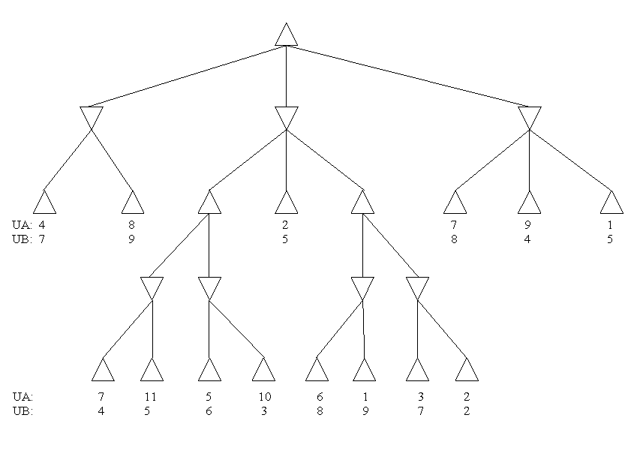
d
a
b, c
(a) (4 points) A does not know UB and B does not know UA
Basic minimax executed by A leads to child 1 in first move by A, and node indicated in first move by B.
(b) (6 points) A knows UB.
A concludes that if moving to child 3 in first move, then B will choose node indicated to maximize his own final score.
(c) (6 points) A knows UB and B knows UA.
A has no additional information than in part (b) so makes same first move. Since B is only concerned with his own score, he also makes the same first move.

(d) (6 points) A knows UB, B knows UA, and A knows that B knows UA
Now that A knows that B knows UA, she can conclude that if B has the option of choosing at the second child of the initial state, he will deduce that his possible scores come from the leaves (11,5), (10,3), (2,5), (6, 8), or (3, 7). She also knows that he'll choose the right hand side in this case, making the possible scores (11,5) and (10, 3), and that B will choose the latter, leaving A with a score of 10.

(e) (1 point) Is it always true that the more A knows the better utility value A can get?
No, sometimes the information doesn't guarantee getting a better utility value.
(1 point) Is it always true that if A knows more than in (a), A can do at least no worse than in (a)?
Yes!
(2 points) Give some intuitive explanation of the above. ("always true" means not restricted by (a)-(d).)
We're always preventing the worst possible scenario. The less scenarios there are (through knowledge), the less bad they can be.

