Error correction is the detection of errors and reconstruction of the original data.

Error correction may generally be realized in two different ways:

Automatic repeat request (ARQ)

Automatic Repeat ReQuest (ARQ), is an error-control protocol that automatically initiates a call to re-transmit any data packet or frame after receiving flawed or incorrect data. When the transmitting device fails to receive an acknowledgment signal to confirm the data has been received, it usually re-transmits the data after a predefined timeout and repeats the process a predetermined number of times until the transmitting device receives the acknowledgment.
ARQs are often used to assure reliable transmissions over an unreliable service.
There are three different protocols in ARQ :
• Stop and wait
• Go Back N
• Selective Repeat

Forward error correction (FEC)

The sender encodes the data using an error-correcting code (ECC) prior to transmission. The additional information (redundancy) added by the code is used by the receiver to recover the original data. In general, the reconstructed data is what is deemed the "most likely" original data.
Examples of FEC:
- Hamming Code

Stop and wait
It is the simplest protocol of automatic repeat-request (ARQ) method. In this technique the sender
sends one frame/packet at a time. After sending each frame/packet the sender waits and doesn't send
any further frames until he receives the ACK signal from the receiver.
When the receiver doesn't send a frame in an expected interval of time the sender re-transmits the same packet. Theses intervals of time is know as timeouts. This process is repeated until there are no more frames to be sent. Stop-and-wait ARQ is inefficient compared to other ARQs, because the time between packets.
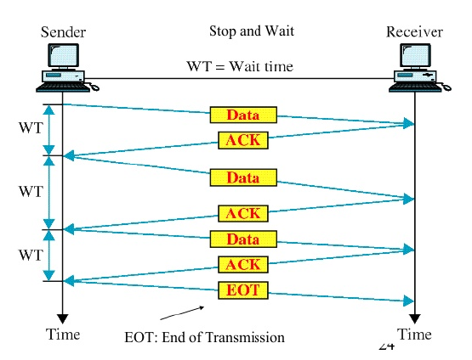
Go Back N
In this protocol the sender keeps sending the number of frames/packet specified by the window size
even without receiving the ACK packet from the receiver.
The receiver keeps track of the sequence number of the next frame that expects to receive, and sends that number with every ACK that it sends. The receiver discards any frame that doesn’t have the exact expected sequence number then it resend an ACK with the right expected number of sequence frame.
When the sender has sent all of the frames in its window, it will spot that all of frames since the first
lost frame were discarded by the receiver and will go back to the sequence number of the last ACK it received and process and fill its window starting with that frame and continue the process over again.
This protocol is more efficient than Stop and wait because in time that Stop-and-wait consumes waiting for the packet Go Back N is sending packets.

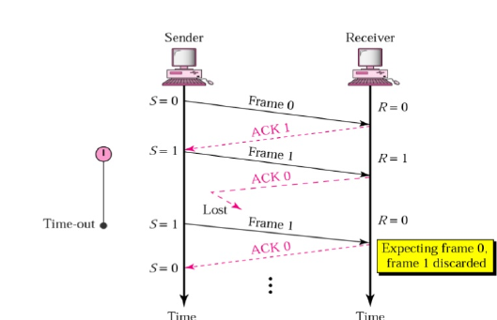
Selective Repeat
In this protocol the sender continues to send a number of frames/packets designated in the window size even after a frame loss.
The receiver will continue to accept and data frames even after the first error. The window size must be greater than one.
The receiver keeps track of these sequence number of the first non received frame, and sends that
number with every ACK that sends. If a frame from the sender doesn't reach the receiver, the sender
continues to send the following frames until the windows is empty, at the same time the receiver
continues to fill up is windows, and in each reply we will send the sequence number of the first missing frame.
Once the sender emptied is windows it will start to resend the frame number given by ACK and then continues where it left off.

