Name: Joaquim Miguel Conceição Espada

Login: con0004

Date: 20th September of 2016

Report of measuring

Title: Data transmission over analog network

Task: Send data over analog network with modems and computers.

Scheme:
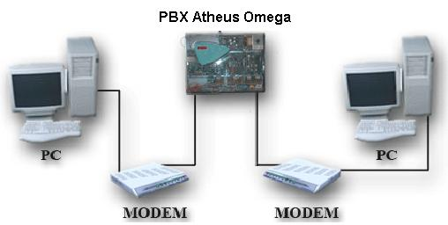

Introduction to problematics:

The main objective of this experiment is to transfer data among two computers through an analog network without connection to a telephone company. To fulfill the objective is needed some software and hardware.
The needed hardware is the following list : two desktops computers (with serial ports), two modems, one PBX (telephone switching system), 2 Ethernet cables and 2 voice cables.
The needed software is a Linux distribution with kermit installed.

Elaboration:

This experiment was conducted in pairs because one had the role of sending data and the other had role of receiving data.

The first step was to set up the scheme, to do that we used two serial cables connecting the computers to the modems, two voice cables connecting the modems the analog network and two Ethernet cables connecting the patch panel to the PBX.

The second step was configuring kermit so that we could communicate with the modem in command mode. To achieve this goal open the terminal switch to root user with the command sudo -i.

After launching kermit write the following commands:

- kermit> set line /dev/ttyS5 → setting up line of communication between kermit and modem through serial port
- kermit> set speed 115200 → setting the speed communication between computer and modem in bits per seconds.
- kermit> set carrier-watch off → turning off the carrier-watch to be sure that is possible to establish a connecting between computer and modem
- kermit> connect → connecting kermit to modem and entering command mode in modem

The third step was to make connection between the computers and get acquainted with the basic modem commands.
The basic commands are :
- AT I4 → modem settings .
- AT → check if router is ok
- ATI6, ATI11 → link diagnostics
- ATDT 33xx → dial tone 33xx
- AT A → answer
- pause +++ pause → escape sequence from data mode
- AT O → return to data mode

After writing the command ATDT 3312 the modem dial toned my colleague and he answered by writing AT A. The connection was established successfully. After this the characters I wrote would appear in the monitor of my colleague.

The fourth step was sending a file between computers. To generate a random file open a net terminal then use following command dd if=/dev/urandom of=file2.txt bs=100K count=1.
Back to the main terminal activate the sequence CTRL + \ + C to go back kermit but be aware the connection between the modems must be on-line.

File transmission commands with kermit:
- kermit> receive → this command must be use by receiver of the file
- kermit> send file → this commands must be use by the sender of the file
- kermit> statistics /verbose →show the statistics about the file transference

Data of the transference of the file
- elapsed time : 00:00:30 (30.178 sec)
- file size : 100K
- effective rate : 3393 cps

Conclusion:

The experiment of measuring with analog modems was a success. All the objectives were successfully achieved. We could send and receive the file as well send characters between the computers. Although there were some connectivity problems in the class regarding the voice cables.

References:
- Ing. Pavel Nevlud lectures

